GLOWUP
MARKETING CAMPAIGN
PERFORMANCE ANALYSIS
A data-driven review of campaign ROI, channel effectiveness,
customer acquisition and future budget allocation

Item | Details
Reporting period | 05 Jul 2025 – 08 May 2026
Source dataset | glowup_campaigns.csv
Campaigns analysed | 30
Prepared for | GlowUp Management

Executive Summary

GlowUp analysed 30 campaigns across four marketing channels. The campaigns generated ₹511,853.73 in attributed revenue from ₹445,664.29 in spend, producing an overall revenue-based ROI of 14.85%. The dataset records 28,063 leads and 5,903 conversions, with a conversion rate of 21.03% and blended CPA of ₹75.50.

Headline Performance

Metric | Result
Campaigns | 30
Total spend | ₹445,664.29
Revenue generated | ₹511,853.73
Revenue less spends | ₹66,189.44
Overall ROI | 14.85%
Leads / conversions | 28,063 / 5,903
Conversion rate | 21.03%
Blended CPA | ₹75.50

Management Takeaways

- Email has the strongest aggregated ROI and lowest CPA.
- Events contribute the largest revenue and conversion volume but absorb most of the spend.
- Influencer campaigns show positive aggregate returns but uneven campaign-level outcomes.
- Social media is negative in aggregate and should be optimized before scaling.

Recommended Direction

Shift incremental budget toward Email and proven Influencer campaigns, retain selected Events where conversion volume and local reach justify the cost, and place social media on a controlled test-and-improve plan. Treat the proposed allocation as a pilot starting point and review marginal returns after each campaign cycle.
ROI is revenue-based, not net-profit ROI. It excludes product costs, fulfilment, discounts, salaries and other operating costs not captured in campaign Spend.

Business Background, Objective and Questions

GlowUp is a beauty and skincare startup that has run online and offline campaigns, including Email, Social Media, Influencer and Event activity. Management wants to understand which campaigns deliver the strongest returns and how to use the next quarter’s marketing budget more effectively.

Business Objective

Evaluate campaign effectiveness using revenue, spend, leads, conversions, ROI, CPA and available engagement data; identify strong and weak campaigns; and translate findings into practical budget and optimization actions.

Business Questions

Question | Analytical approach
Which campaigns delivered the highest ROI? | Calculate campaign-level ROI and rank campaigns.
Which channels are most effective for conversions and CPA? | Aggregate spend, conversions, conversion rate and CPA by channel.
Are there high-lead, low-conversion campaigns? | Compare lead volume with conversion rate and CPA.
How should next quarter’s budget be allocated? | Use historical ROI, CPA, conversion volume and execution risk to propose a test allocation.
How can ROI improve? | Recommend channel focus, targeting, creative, timing and measurement improvements.

Scope and Success Criteria

The supplied data contains 30 campaigns. Start dates run from 05 Jul 2025 to 10 Apr 2026; the latest campaign end date is 08 May 2026. This is approximately ten months of campaign start-date coverage, rather than a complete 12 months.
A useful outcome is not simply a list of high-ROI campaigns. It is a repeatable process that protects budget from weak activity, scales channels with evidence of efficient acquisition, and measures incremental performance consistently.

Dataset Profile, Cleaning and Assumptions

Profile item | Finding
Rows / columns | 30 rows / 16 columns
Unique campaigns | 30
Channels | Email, Event, Influencer, Social Media
Start date range | 05 Jul 2025 to 10 Apr 2026
Latest end date | 08 May 2026
Duplicate CampaignIDs | 0
Missing Clicks | 13
Missing Impressions | 13

Data Preparation and Missing Values

CampaignID is treated as a unique campaign key. Dates, currency values and count fields should use appropriate data types. No duplicate CampaignIDs were found. The supplied file contains 13 null values in Clicks and 13 in Impressions.
All 13 missing Clicks and Impressions observations occur in the Event channel. Because offline events may not generate directly comparable digital clicks and impressions, these fields are treated as not applicable or unreported for Event campaigns rather than imputed as zero. Digital engagement totals should therefore be interpreted as online-channel totals.

Validation Checks

- Check for negative spend, revenue, leads or conversions.
- Confirm conversions do not exceed leads.
- Check StartDate is not after EndDate.
- Confirm that currency values use a consistent unit.

Limitations and Assumptions

Revenue is assumed to be attributable to the listed campaign because no attribution model or customer-level sales data was supplied. Campaigns may overlap in time, and the analysis cannot prove causality or incremental lift. The dataset has no product margin, customer lifetime value, audience, creative, frequency or geographic detail. These gaps limit profitability and root-cause conclusions.

KPI Definitions and Methodology

KPI | Formula | Purpose
Campaign Spend | SUM(Spend) | Marketing investment
Revenue Generated | SUM(RevenueGenerated) | Attributed sales value
Leads | SUM(LeadsGenerated) | Potential customers acquired
Conversions | SUM(Conversions) | Purchases / acquired customers
ROI (%) | (Revenue − Spend) ÷ Spend × 100 | Revenue return relative to spend
CPA | Spend ÷ Conversions | Cost per acquired customer
CPL | Spend ÷ Leads | Cost to generate a lead
Conversion Rate | Conversions ÷ Leads × 100 | Share of leads converting
Engagement | Clicks and impressions | Digital attention and response

Aggregate Calculations

Overall ROI = (₹511,853.73 − ₹445,664.29) ÷ ₹445,664.29 × 100 = 14.85%.
CPA = ₹445,664.29 ÷ 5,903 = ₹75.50. CPL = ₹445,664.29 ÷ 28,063 = ₹15.88.

Power BI DAX Measures

Total Spend = SUM(GlowUp_Campaigns[Spend])
Total Revenue = SUM(GlowUp_Campaigns[RevenueGenerated])
Total Leads = SUM(GlowUp_Campaigns[LeadsGenerated])
Total Conversions = SUM(GlowUp_Campaigns[Conversions])
ROI (%) = DIVIDE([Total Revenue]-[Total Spend],[Total Spend],0)*100
CPA = DIVIDE([Total Spend],[Total Conversions],0)
Conversion Rate (%) = DIVIDE([Total Conversions],[Total Leads],0)*100

Exploratory Data Analysis

Channel | Campaigns | Spend | Revenue | Leads | Conversions | ROI | CPA
Email | 7 | ₹17,332.75 | ₹37,742.31 | 3,382 | 698 | 117.75% | ₹24.83
Event | 13 | ₹293,360.51 | ₹324,789.98 | 10,176 | 3,294 | 10.71% | ₹89.06
Influencer | 5 | ₹88,922.22 | ₹121,500.63 | 10,510 | 1,440 | 36.64% | ₹61.75
Social Media | 5 | ₹46,048.81 | ₹27,820.81 | 3,995 | 471 | -39.58% | ₹97.77

ROI by Marketing Channel

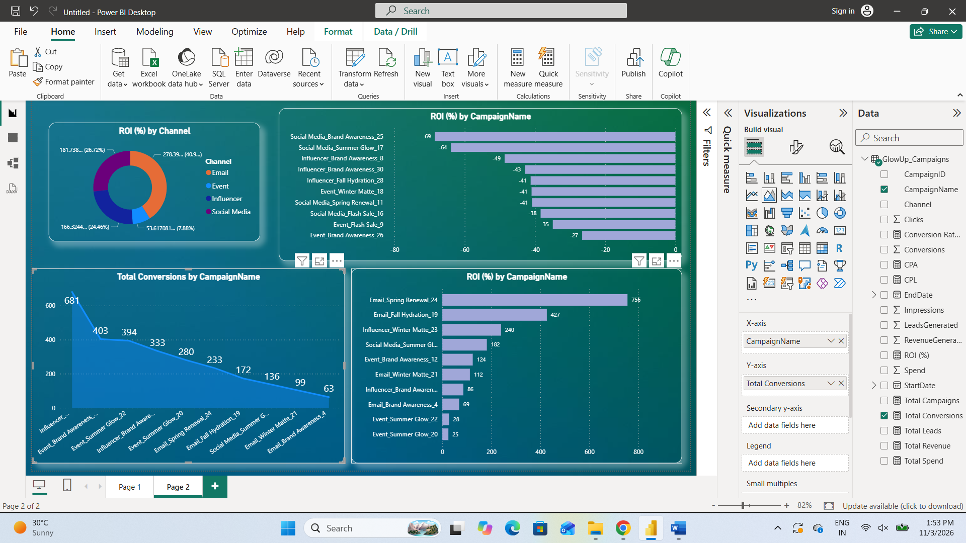

Email leads on aggregate ROI and CPA. Events deliver the highest revenue and conversions, but use approximately 65.8% of total spend. Social Media has negative aggregate ROI and the highest CPA.

Spend vs Revenue by Channel

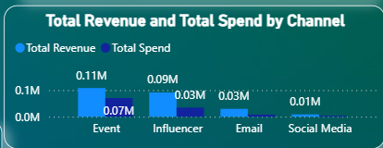

The Event channel produces the largest absolute revenue, but its lower ROI shows why absolute sales volume alone is not enough to determine budget priority.

6. Campaign and Monthly Performance Insights

Top Five Campaigns by ROI

ID | Campaign | Channel | Spend | Revenue | ROI | CPA
CMP1024 | Email Spring Renewal 24 | Email | ₹1,402.80 | ₹12,004.33 | 755.74% | ₹6.02
CMP1019 | Email Fall Hydration 19 | Email | ₹1,496.94 | ₹7,882.12 | 426.55% | ₹8.70
CMP1023 | Influencer Winter Matte 23 | Influencer | ₹17,903.46 | ₹60,826.82 | 239.75% | ₹26.29
CMP1003 | Social Media Summer Glow 3 | Social Media | ₹3,105.99 | ₹8,750.77 | 181.74% | ₹22.84
CMP1012 | Event Brand Awareness 12 | Event | ₹19,573.17 | ₹43,874.28 | 124.16% | ₹48.57

The top campaign is Email Spring Renewal 24 (CMP1024), with ROI of 755.74% and CPA of ₹6.02. Strong campaign-level results should be tested for repeatability before committing larger budgets.

Bottom Five Campaigns by ROI

ID | Campaign | Channel | Spend | Revenue | ROI
CMP1025 | Social Media Brand Awareness 25 | Social Media | ₹16,506.27 | ₹5,199.15 | -68.50%
CMP1017 | Social Media Summer Glow 17 | Social Media | ₹8,288.53 | ₹2,991.06 | -63.91%
CMP1008 | Influencer Brand Awareness 8 | Influencer | ₹21,890.68 | ₹11,243.07 | -48.64%
CMP1030 | Influencer Brand Awareness 30 | Influencer | ₹14,734.84 | ₹8,420.12 | -42.86%
CMP1028 | Influencer Fall Hydration 28 | Influencer | ₹18,039.23 | ₹10,601.41 | -41.23%

The weakest campaign is Social Media Brand Awareness 25 (CMP1025), with ROI of -68.50%. Review its audience, offer, creative, landing page and tracking before repeating the activity.

Monthly ROI Trend
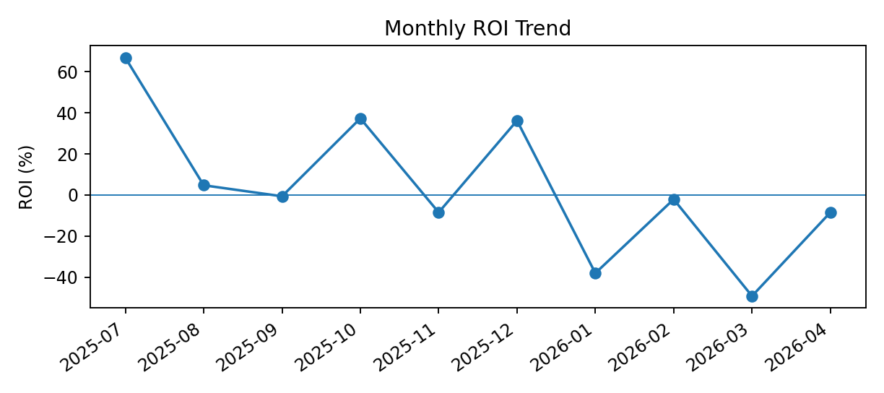
Monthly results vary substantially. Monthly comparisons are descriptive only because campaign count and channel mix differ by month.

7. Lead Quality, Channel Efficiency and Recommendations

High Lead Volume vs Conversion

Campaign | Channel | Leads | Conversions | Conv. rate | ROI
Influencer Winter Matte 23 | Influencer | 3,967 | 681 | 17.17% | 239.75%
Influencer Brand Awareness 30 | Influencer | 2,995 | 105 | 3.51% | -42.86%
Social Media Summer Glow 3 | Social Media | 1,615 | 136 | 8.42% | 181.74%
Influencer Brand Awareness 7 | Influencer | 1,561 | 333 | 21.33% | 85.94%
Event Winter Matte 2 | Event | 1,540 | 450 | 29.22% | 14.67%

One campaign-level example to investigate is Influencer Brand Awareness 30: 2,995 leads and 105 conversions, a conversion rate of 3.51% and ROI of -42.86%. This signals a funnel or lead-quality question, not proof of a particular cause.

Cost per Acquisition by Channel

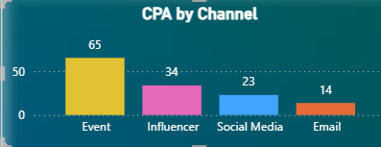

Quick Wins

- Replicate offer, audience and timing patterns of high-ROI Email campaigns, scaling in controlled increments.
- Prioritize Influencer partners and content formats with positive ROI; use unique links or promo codes for attribution.
- Audit Social Media targeting, creative, landing-page relevance and conversion tracking; cap inefficient ad sets until improved.
- For Events, track qualified leads, post-event follow-up speed, attendance-to-lead and lead-to-purchase conversion.

Long-term Improvements

- Introduce consistent UTM tags, campaign naming standards and channel-specific attribution rules.
- Capture audience segment, creative, offer, geography and customer cohort fields.
- Track gross margin and customer lifetime value so investment decisions use contribution profit, not revenue alone.
- Run A/B tests on subject lines, influencer formats, ad creative, landing pages and offers.

8. Next-quarter Budget Plan and Conclusion

The following allocation is a recommended pilot starting point. It is more diversified than a pure ROI ranking: Email has the best efficiency but a small historical spend base; Events have strong volume but high cost; Influencer is promising; Social Media remains a capped test until its economics improve.
Channel | Proposed share | Rationale
Email | 35% | Highest aggregate ROI and lowest CPA; scale gradually and monitor saturation.
Influencer | 30% | Positive aggregate ROI; shift toward partners and campaign types with proven conversion.
Event | 25% | Retain selective events for volume and local engagement; require event-level ROI tracking.
Social Media | 10% | Controlled experimentation only; optimize targeting and creative before increasing spend.

Budget Governance

Release the budget in stages (monthly or campaign sprints) rather than committing the full quarter upfront. Review ROI, CPA, conversion rate and lead quality after each cycle. Move budget only when results are repeatable and tracking is reliable. Set channel-specific CPA guardrails and define a minimum sample size before judging a campaign.

Conclusion

GlowUp’s campaigns generated ₹511,853.73 in attributed revenue on ₹445,664.29 of spend, for 14.85% revenue-based ROI. Email is the strongest channel on return and acquisition cost; Events are the largest source of volume but need tighter cost control; Influencer campaigns warrant selective expansion; and Social Media requires a structured optimization programme.

