FASHIONWAVE SALES ANALYSIS
Business Intelligence Report | Exploratory Data Analysis, Insights & Recommendations

Presented by Junior Data Analyst
Dataset period: 20 November 2023 – 20 November 2025
Prepared using the provided fashionwave_sales.csv dataset
Scope: category performance, weekday/weekend sales, discount impact, store performance and customer segmentation

Executive Summary
This report analyzes 15,000 transaction records across 50 stores and 115 product IDs from 20 Nov 2023 to 20 Nov 2025. Estimated net sales total 192.98M, estimated profit is 139.96M, and overall profit margin is 72.52%. Accessories is the largest category by net sales and has the strongest category margin. Weekend transactions have a higher average transaction value and average daily sales than weekdays. Profit margin declines as discount rate rises, and a small set of stores rank lowest on sales or margin. Returning-customer transactions contribute most net sales, but the dataset lacks a unique customer identifier for deeper individual-level segmentation.

Headline Findings
- Accessories contributes 42.8% of net sales and has a 79.5% profit margin.
- Average daily net sales are 31.2% higher on weekends than weekdays.
- Profit margin is 75.4% at 0% discount versus 64.6% at 30% discount.
- STR037 has the lowest net sales (2.02M); STR027 has the lowest margin (69.2%).
- Returning-customer transactions account for 70.9% of net sales.

1. Business Context and Questions
FashionWave wants to understand which products and sales patterns create value, where profitability may be at risk, and which operational or marketing actions should be prioritized. The analysis is descriptive: it identifies patterns in the supplied dataset and proposes hypotheses to validate.

Business Questions
- Which product categories generate the highest revenue and profit?
- How do weekend sales compare with weekday sales?
- What is the relationship between discount rates and profit margins?
- Which stores underperform on sales or profitability, and what factors should be investigated?
- How can new and returning customer transactions be approached with targeted strategies?

Scope and Constraints
- Only the supplied dataset is used; no external data is introduced.
- The observed period is approximately two years (20 Nov 2023–20 Nov 2025); the first and last calendar years are partial.
- The maximum observed discount is 30%; no transactions above 30% are available to assess.
- Seasonal effects may influence results, but festival and holiday indicators are not included.
- No unique customer ID, product names, store locations or operating expense fields are provided.

Analysis Method
- InvoiceNo is treated as a transaction identifier because all 15,000 values are unique.
- Net sales are calculated as Quantity × UnitPrice × (1 − Discount/100).
- Estimated cost is Quantity × CostPerUnit.
- Estimated profit is Net Sales − Estimated Cost.
- Profit margin is Estimated Profit ÷ Net Sales × 100.
- Weekend means Saturday and Sunday; all other days are weekdays.

2. Dataset Profile and Data Quality
Profile item | Finding
Rows / transactions | 15,000
Columns | 11 source columns + derived analysis fields
Date range | 20 Nov 2023 – 20 Nov 2025
Stores | 50
Distinct product IDs | 115
Categories | Accessories, Clothing, Shoes
Customer types | New, Returning
Payment modes | Card, Cash, Digital
Missing values | 0
Exact duplicate rows | 0
Discount range | 0%–30%

Problem statement
- Analyze revenue, profit and profit margins across product categories.
- Compare weekday and weekend sales performance.
- Evaluate the relationship between discount percentages and profitability.
- Identify underperforming stores and investigate possible reasons.
- Analyze new versus returning customer purchasing patterns.
- Develop actionable recommendations to improve business performance.

Summary Statistics
Metric | Mean | Median | Range
Quantity per transaction | 3.46 | 3 | 1–13
Unit price | 4,089.98 | 3,766.93 | 300.50–9,998.87
Discount | 7.44% | 5% | 0%–30%
Net sales / transaction | 12,865.55 | 10,049.86 | 289.21–86,616.99
Profit / transaction | 9,330.65 | 6,855.18 | -15,951.00–77,420.12

One important anomaly is that some transactions have negative estimated profit. This occurs when calculated net sales are lower than Quantity × CostPerUnit

Strategic goal for next quarter
- Review high-discount transactions and reduce unnecessary discounts.
- Review Clothing pricing, costs, and product mix because it has the lowest category margin (58.72%).
- Investigate low-performing stores such as STR037 and STR023.
- Use weekend promotions and product bundles to build on higher average weekend sales.
- Introduce loyalty offers and targeted campaigns for returning customer.

3. Key Performance Indicator for next quarter
KPI | Formula | Current baseline | Next-quarter target
Net Sales | Gross Sales – Discount Amount | 192.98M | Increase by 5%
Total Profit | Net Sales -Total Coast | 139.96M | Increase by 5%
Overall Profit Margin | (Total Profit ÷ Net Sales) *100 | 72.52% | 74%
Clothing Profit Margin | (Clothing Profit ÷ Clothing net sales) *100 | 58.72% | 60.72%
Store Sales Growth | ((Current Sales − Previous Sales) ÷ Previous Sales) × 100 | To be measured | 10% for targeted stores
Average Weekend Sales | Weekend Net Sales ÷ Number of Weekend Days | 317,758 per day | Increase by 5%
Returning Customer Sales | Returning Customer Net Sales | 136.76M | Increase by 5%
Discount Impact on Margin | Compare profit margin across discount levels | 75.4% at 0% discount; 64.6% at 30% | Reduce unnecessary high discounts and protect margins

4. Product Category Performance

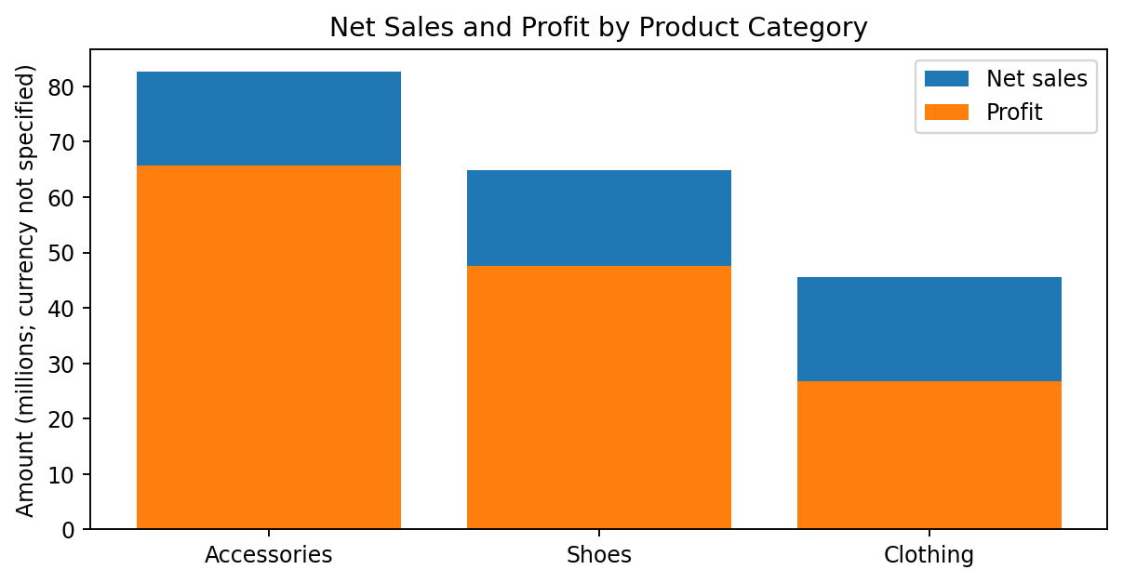
Figure 1. Net sales and estimated profit by category.
Category | Transactions | Net sales | Profit | Margin | Sales share
Accessories | 5,147 | 82.58M | 65.62M | 79.46% | 42.79%
Shoes | 4,642 | 64.85M | 47.59M | 73.39% | 33.60%
Clothing | 5,211 | 45.55M | 26.75M | 58.72% | 23.60%

Findings
Accessories leads with 82.58M in net sales, a 79.46% margin, and 42.79% of total net sales. Shoes is second by sales, while Clothing has the lowest category margin at 58.72%. Clothing also has the highest transaction count (5,211), so its lower margin is not explained simply by fewer transactions.

Recommendations
- Protect availability and visibility for Accessories, while checking stock-outs and product-level demand before expanding inventory.
- Review Clothing pricing, cost structure, discount use and product mix to identify the specific items pulling down margin.
- Use category-level net sales, profit and margin together; high sales alone do not guarantee high profitability.

5. Weekday vs Weekend Performance

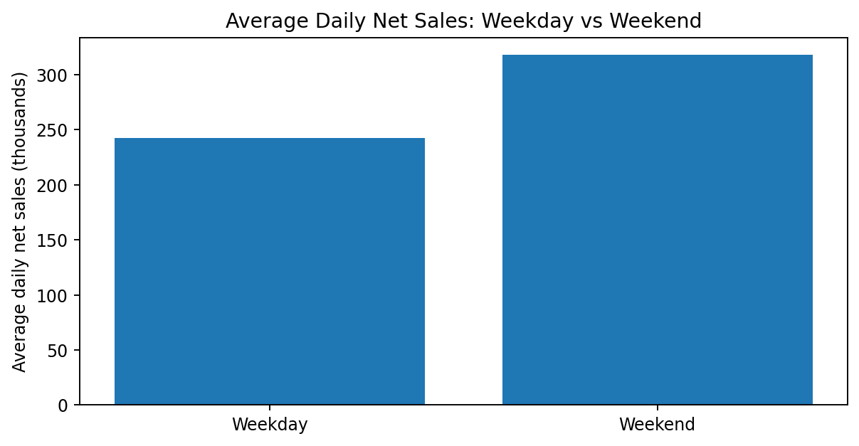
Figure 2. Average daily net sales, accounting for the number of weekday and weekend dates in the dataset.
Day type | Transactions | Net sales | Avg sales / transaction | Avg sales / day | Margin
Weekday | 10,641 | 126.89M | 11,924.59 | 242,155.69 | 72.45%
Weekend | 4,359 | 66.09M | 15,162.58 | 317,758.19 | 72.66%

Findings
Weekdays account for more total sales because they occur more often. After normalizing by observed calendar days, average daily net sales are 31.2% higher on weekends. Average net sales per transaction are 27.2% higher on weekends. Profit margins are similar (72.45% weekdays vs 72.66% weekends), so the difference is primarily transaction value rather than a large margin shift.

Recommendations
- Test weekend bundles and complementary-product displays to increase basket value.
- Compare Saturday and Sunday separately and track performance after each promotion.
- Evaluate campaign success using incremental profit and average transaction value, not sales totals alone.

6. Discounting and Profit Margin

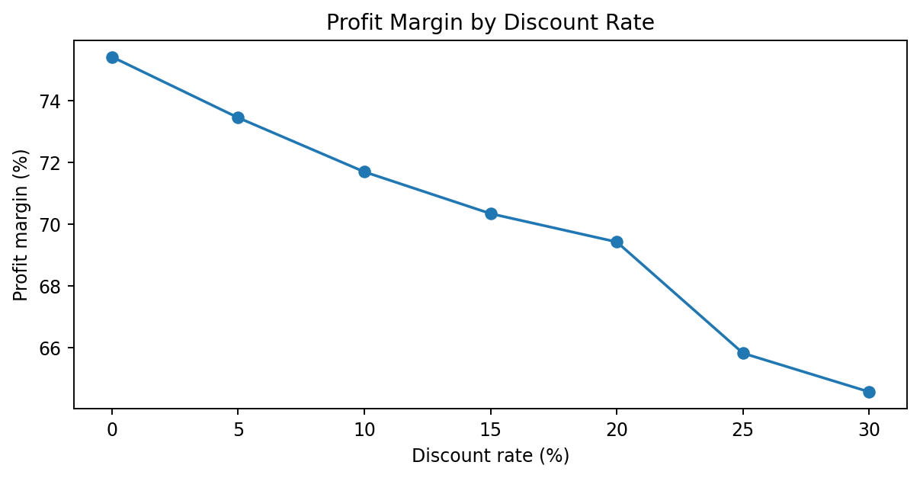
Figure 3. Estimated profit margin by observed discount rate.
Discount | Transactions | Net sales | Profit margin
0% | 5,993 | 71.90M | 75.42%
5% | 2,987 | 33.44M | 73.45%
10% | 2,274 | 32.84M | 71.70%
15% | 1,532 | 20.53M | 70.34%
20% | 1,195 | 19.14M | 69.42%
25% | 709 | 9.97M | 65.81%
30% | 310 | 5.17M | 64.56%

Findings
The margin falls from 75.42% at 0% discount to 64.56% at 30% discount, a decline of 10.86 percentage points. The trend is consistent across observed discount levels. However, this is a descriptive association; product mix, unit costs and customer purchasing patterns may also differ between discount groups.

Recommendations
- Set a margin floor for promotions and require review for discounts near the 30% policy cap.
- Prioritize discounts on products with enough unit margin and a clear commercial objective.
- Run controlled tests comparing discount levels and measure incremental profit, units sold and net sales.
- Do not infer the effect of discounts above 30%, because no such records exist in the dataset.

7. Store Performance and Anomalies

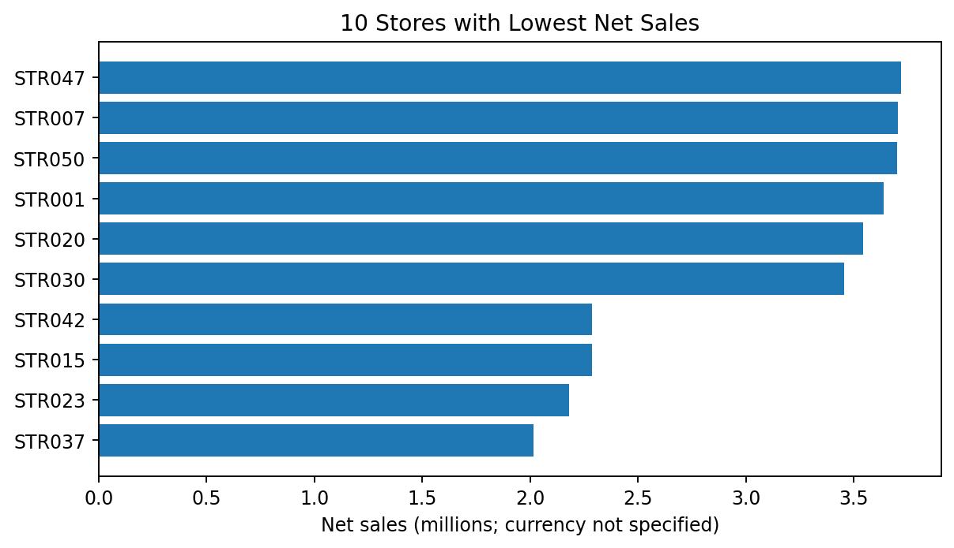
Figure 4. Ten stores with the lowest net sales.
Lowest-sales store | Transactions | Net sales | Profit | Margin
STR037 | 282 | 2.02M | 1.46M | 72.33%
STR023 | 269 | 2.18M | 1.61M | 74.01%
STR015 | 294 | 2.29M | 1.66M | 72.46%
STR042 | 289 | 2.29M | 1.65M | 72.11%
STR030 | 267 | 3.45M | 2.61M | 75.54%

Lowest Margin Stores
Store | Transactions | Net sales | Profit | Margin
STR027 | 302 | 4.09M | 2.83M | 69.18%
STR001 | 291 | 3.64M | 2.53M | 69.46%
STR004 | 298 | 4.06M | 2.83M | 69.74%
STR034 | 321 | 4.21M | 2.99M | 70.85%
STR046 | 308 | 4.02M | 2.85M | 70.98%

Findings and Investigation Plan
STR037 has the lowest net sales (2.02M) and STR023 is second-lowest (2.18M). STR027 has the lowest margin (69.18%). These are different performance issues and should not be treated as one problem.
- For low-sales stores, compare transaction count, average transaction value and category mix.
- For low-margin stores, compare discount levels, product costs and the mix of products sold.
- Use peer comparisons and store-level drill-through pages before assigning causes; the dataset contains no location, rent, staffing or footfall fields.

8. Customer Segmentation and Payment Patterns

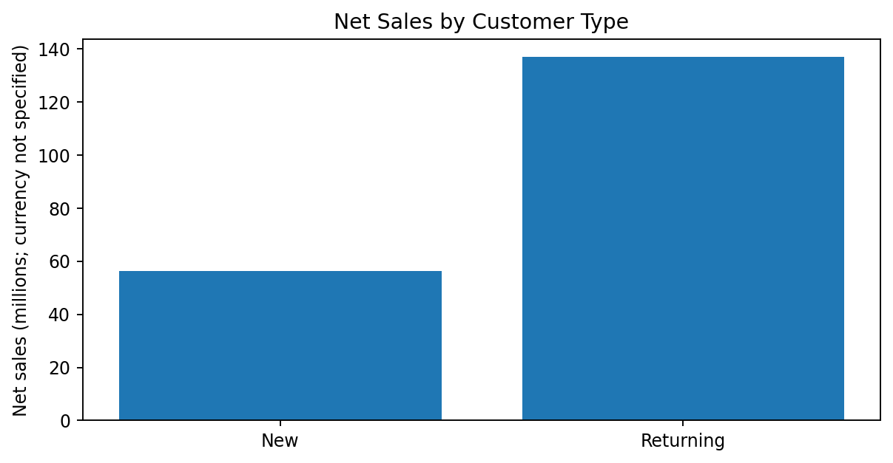
Figure 5. Net sales by transaction customer type.
Customer type | Transactions | Net sales | Sales share | Avg transaction | Margin
New | 4,438 | 56.23M | 29.14% | 12,669.30 | 72.18%
Returning | 10,562 | 136.76M | 70.86% | 12,948.02 | 72.66%

Suggested Strategies
- New customers: use welcome journeys, category recommendations and second-purchase incentives; measure conversion to a subsequent transaction once a customer ID is available.
- Returning customers: test loyalty benefits, cross-sell bundles and early access; monitor repeat purchase and incremental profit.
- Add a stable customer identifier to support recency, frequency and monetary (RFM) segmentation. Current CustomerType labels alone do not support individual-level lifetime value.

Payment Mode
Payment mode | Transactions | Net sales | Sales share
Card | 5,991 | 76.55M | 39.66%
Cash | 4,561 | 58.91M | 30.53%
Digital | 4,448 | 57.53M | 29.81%

Payment mode is useful as a descriptive slice, but differences should not be interpreted as payment method causing higher or lower sales.

9. Seasonal Trends, Recommendations and Conclusion

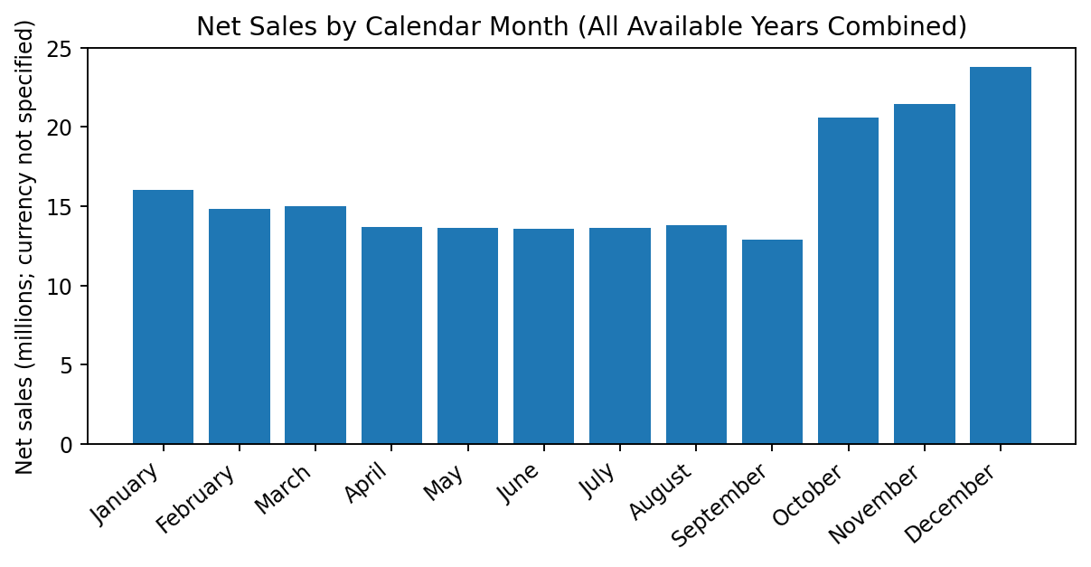
Figure 6. Net sales by calendar month, combining all available years.
December has the highest combined net sales by calendar month (23.81M), followed by November (21.47M) and October (20.60M). This pattern is consistent with a possible seasonal effect, but the data contains no festival labels and the first and last years are partial. Compare equivalent months year-over-year before planning around a recurring peak.

Prioritized Action Plan
Horizon | Action | Success measures
Quick win | Review high-discount transactions and set a minimum margin guardrail. | Net sales, margin, profit by discount band
Quick win | Investigate STR037/STR023 for sales and STR027 for margin. | Transactions, average transaction value, category mix, margin
Quick win | Test weekend bundles and accessory cross-sell. | Average transaction value, incremental profit
Medium term | Improve Clothing category margin through product and cost review. | Category/product margin, discount rate
Long term | Add customer ID and build repeat-purchase/RFM reporting. | Repeat rate, frequency, customer value
Long term | Build comparable year-over-year seasonal reporting. | Monthly net sales, profit, margin

Conclusion
FashionWave's dataset suggests that Accessories is the strongest category, weekends produce higher average daily sales and transaction values, profit margin declines as discounts increase, and store performance varies depending on whether sales or margin is considered. Returning-customer transactions account for most net sales. The best next step is to use these findings to run targeted tests and monitor profit alongside revenue. Findings should be treated as descriptive, and hypotheses about seasonality or store causes should be validated with additional internal data.

Appendix: Core Metric Definitions
- Gross sales = Quantity × UnitPrice.
- Discount amount = Gross sales × Discount percentage ÷ 100.
- Net sales = Gross sales − Discount amount.
- Estimated cost = Quantity × CostPerUnit.
- Estimated profit = Net sales − Estimated cost.
- Profit margin = Estimated profit ÷ Net sales × 100.

