TASTYBITES
PRODUCT PROFITABILITY
& PRICING STRATEGY
Business Analysis Report
Analysis period: 1 January 2024 – 31 December 2025
Prepared using Power BI, DAX and exploratory data analysis

Executive Summary
TastyBites recorded 1,000 unique orders and sold 2,979 units across eight products during the two-year period. The dataset contains gross revenue of ₹530,730, discounts of ₹27,495, net revenue of ₹503,235, product cost of ₹270,085 and profit of ₹233,150. Overall profit margin was 46.33% and average order value (AOV) was ₹503.
Combo Meal was the largest revenue and profit contributor (₹123,070 net revenue and ₹51,790 profit). Lemonade had the highest margin (57.28%) but the lowest total profit, reflecting its lower sales volume. French Fries sold the most units (401) but contributed only 8.05% of total profit.
Positive-discount transactions generated ₹295,615 net revenue and had a 44.36% margin, compared with 49.22% for explicitly zero-discount transactions. This is an observed association, not proof that discounts caused the margin difference.

Management priorities
- Review Combo Meal and Meals/Combos cost structures because they lead profit in absolute terms but have lower margins.
- Protect high-margin Beverages and test carefully targeted cross-sell bundles.
- Audit discount records: 25.9% of rows have a missing discount value.
- Validate the 25% discount policy: 13 Lemonade records imply a 31.25% discount rate if Discount is a currency amount per unit.

1. Business Context, Objective and Scope

Business scenario
TastyBites is a food delivery app operating across multiple cities. Management has observed that some products can generate substantial sales without delivering equivalent profit, while other products contribute strongly to the bottom line. The business needs to optimize product pricing and promotions while protecting customer demand.

Business objective
Identify high- and low-profit products, understand how discounts relate to profit margins, and recommend practical pricing and promotional strategies that can improve overall profitability.

Business questions addressed
- Which products and categories generate the highest revenue and profit?
- How do discounts affect profitability at product and category level?
- Are there products that sell a lot but contribute relatively little profit?
- Which products are candidates for price adjustments without materially affecting sales volume?
- Which promotions or bundles could improve overall profitability?

Scope and constraints
Constraint / assumption | How it is handled in this report
Only past two years of data | Dataset covers 1 Jan 2024 to 31 Dec 2025; no conclusions are made beyond this period.
Discount cap of 25% | Discount is assumed to be a currency amount per unit. Discount rate is calculated as Discount ÷ UnitPrice and checked against 25%.
Profit = Revenue − Cost | Profit is calculated as net revenue after discount less product cost. Delivery costs are excluded.
Price sensitivity above 10% | Any proposed price test is limited to a small change, initially 3–5%, and must remain below the 10% sensitivity threshold.
Missing discount values | Missing values are treated as zero only for headline revenue/profit calculations, but separated as 'Missing' for discount-effect comparisons.

Important interpretation
The dataset does not include city, campaign, customer identifier, promotion code or experimental control-group fields. It therefore supports descriptive product and category analysis, but cannot establish causal discount lift, customer price elasticity, or city-level performance.

2. Exploratory Data Analysis (EDA)

Dataset profile
Profile item | Result
Rows / order lines | 1,000
Unique OrderID values | 1,000
Products | 8
Raw category labels | Beverages, Combos, Drinks, Meal, Meals, Snack, Snacks
Standardized categories | Beverages, Combos, Meals, Snacks
Date range | 01 Jan 2024 – 31 Dec 2025
Missing Discount values | 259 (25.9%)
Completely duplicated rows | 0

Data preparation performed
- Converted OrderDate to a date field and retained numeric types for Quantity, UnitPrice, CostPerUnit and Discount.
- Standardized category labels: Meal → Meals, Snack → Snacks, and Drinks → Beverages.
- Created gross revenue, discount amount, net revenue, total cost, profit, profit margin and discount status fields.
- Preserved missing discount values as a separate analytical group for discount comparisons.

Summary statistics
Metric | Total / average
Quantity sold | 2,979 units
Unit price (average row-level) | ₹178
Cost per unit (average row-level) | ₹90
Gross revenue | ₹530,730
Discount amount | ₹27,495
Net revenue | ₹503,235
Total product cost | ₹270,085
Total profit | ₹233,150
Profit margin | 46.33%
Average order value | ₹503

3. Product-Level Revenue and Profitability
The product analysis compares net revenue, units sold, total profit, profit margin and share of total profit. This prevents management from judging performance using sales volume or revenue alone.

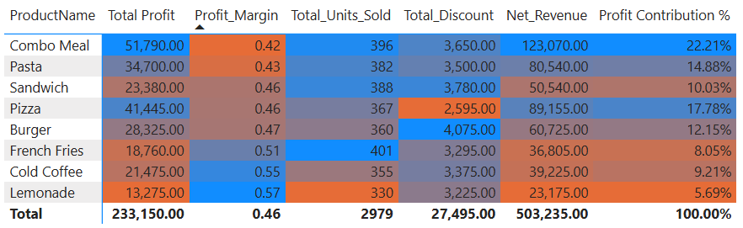

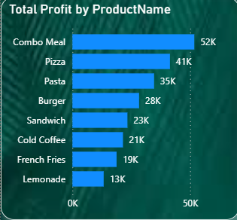

Findings
- Combo Meal leads both net revenue (₹123,070) and total profit (₹51,790), contributing 22.21% of total profit.
- Lemonade has the highest margin (57.28%) but the lowest total profit (₹13,275) because it sells fewer units.
- French Fries has the highest unit volume (401) but produces ₹18,760 profit and contributes only 8.05% of total profit.
- Cold Coffee and Lemonade have the two strongest product margins; these are candidates for controlled cross-selling, not necessarily blanket discounts.

4. Category Performance and High-Volume / Low-Profit Products
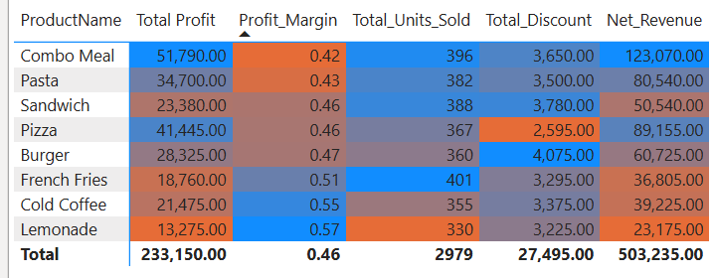
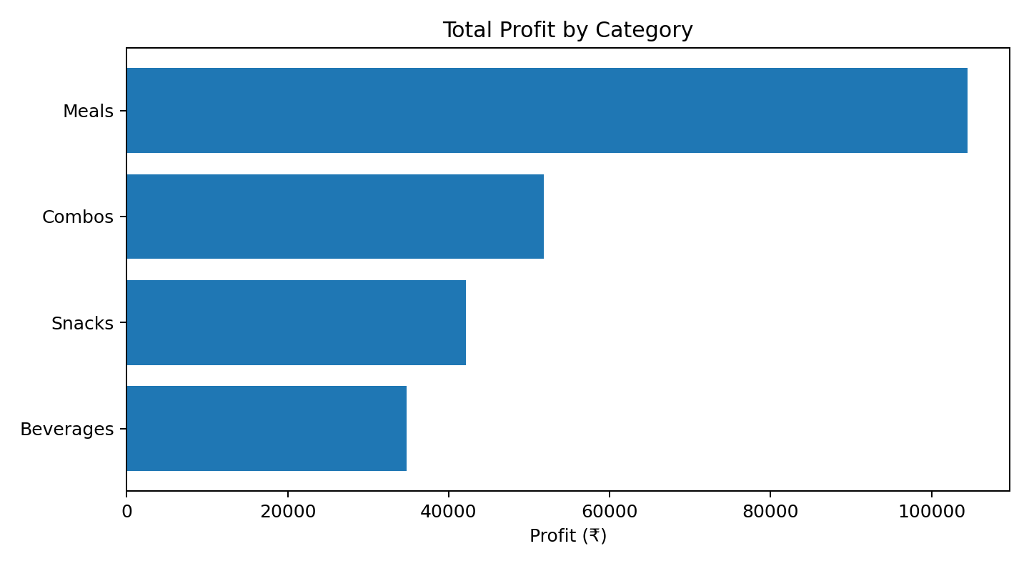

Category findings
- Meals is the largest category by net revenue (₹230,420) and profit (₹104,470); it contributes 44.81% of total profit.
- Beverages has the highest category margin (55.69%), making it a strong candidate for carefully designed add-ons.
- Combos has the lowest category margin (42.08%) and is a priority for cost and discount review.

Do high-volume products contribute little profit?
Yes. French Fries is the clearest example: it is the highest-volume product with 401 units sold, yet its profit is ₹18,760 and its profit contribution is 8.05%. Its margin is not the lowest, so the issue is more about its lower price and profit dollars per unit than a poor margin. Lemonade has the lowest absolute profit, but it is also the lowest-volume product and has the highest margin.

5. Discount Impact Analysis
For the analysis, a missing Discount is not assumed to be a confirmed no-discount transaction. The data is split into positive discount, explicit zero discount and missing discount groups.

Discount status | Rows | Discount | Net revenue | Profit | Margin
Discounted | 609 | ₹27,495 | ₹295,615 | ₹131,140 | 44.36%
No Discount | 132 | ₹0 | ₹69,060 | ₹33,990 | 49.22%
Missing | 259 | ₹0 | ₹138,560 | ₹68,020 | 49.09%

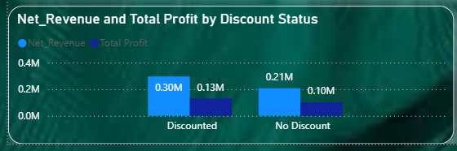

Overall discount findings
- 609
- Positive-discount rows account for 609 order lines and ₹27,495 total discount.
- Discounted transactions show a 44.36% margin versus 49.22% for explicitly zero-discount transactions, a difference of 4.86 percentage points.
- 259 rows (25.9%) have missing discount values; these must be validated before using the comparison to change policy.

Discount impact by product
Product | Discount amount | Discounted margin | Zero-discount margin
Combo Meal | ₹3,650 | 41.11% | 43.75%
Pizza | ₹2,595 | 45.14% | 48.00%
Pasta | ₹3,500 | 41.28% | 45.45%
Burger | ₹4,075 | 45.21% | 50.00%
Sandwich | ₹3,780 | 43.28% | 50.00%
Cold Coffee | ₹3,375 | 52.32% | 58.33%
French Fries | ₹3,295 | 46.28% | 55.00%
Lemonade | ₹3,225 | 53.85% | 62.50%

Across all eight products, the margin on discounted rows is lower than on explicitly zero-discount rows. The size of the gap differs by product. This is descriptive evidence; products and order quantities may differ between groups.

6. Discount Impact by Category and Policy Compliance

Category | Discount amount | Discounted margin | Zero-discount margin | Gap
Meals | ₹10,170 | 43.86% | 47.34% | 3.48 pp
Combos | ₹3,650 | 41.11% | 43.75% | 2.64 pp
Snacks | ₹7,075 | 44.41% | 52.44% | 8.03 pp
Beverages | ₹6,600 | 52.89% | 60.47% | 7.58 pp

Category-level interpretation
- Beverages retains the strongest margins in both discounted and zero-discount groups, although the discounted margin is lower.
- Meals and Snacks show noticeable margin gaps between discounted and zero-discount records; promotional rules should be reviewed at product level within these categories.
- Combos has a lower baseline margin than the other categories, so broad discounting may put additional pressure on its contribution.

25% discount policy check
Assuming Discount is a currency amount per unit and the policy cap means Discount ÷ UnitPrice must not exceed 25%, 13 records exceed the cap. All 13 are Lemonade transactions with UnitPrice ₹80 and Discount ₹25, which implies a discount rate of 31.25%. This is above the stated 25% limit.
Action: validate whether the Discount field is truly a per-unit currency amount and confirm the policy definition. If the assumption is correct, correct the 13 records or flag them for policy review. A 25% maximum on an ₹80 Lemonade price would correspond to a maximum discount of ₹20 per unit.

Data quality risk
The 259 missing discount values are material. If missing values represent unrecorded promotions rather than no discount, the current discounted-versus-no-discount comparison may be biased. Fix the source-system capture before making a permanent policy change.

7. Pricing Opportunities and Promotional Strategy

Which products can be considered for price adjustment?

The dataset does not provide a clean price experiment or sufficient variation in selling price to estimate customer price elasticity. Therefore, it is not possible to guarantee that a price change will leave sales volume unaffected. The following are test candidates, not proven price recommendations.
Product / group | Evidence | Recommended test
Combo Meal | Highest profit (₹51,790) but lowest product margin (42.08%). | Review recipe, packaging and discount cost first. Pilot a 3–5% price increase only if competitor and customer research support it.
French Fries | Highest volume (401) but modest profit contribution (8.05%). | Test a small 3–5% price adjustment or attach as a profitable add-on; monitor unit volume.
Lemonade | Highest margin (57.28%) but lowest total profit and lowest volume. | Avoid blanket price increases. Test visibility and meal add-ons to grow units while preserving margin.
Beverages | Highest category margin (55.69%). | Use targeted cross-sell offers rather than deep standalone discounts.

Pricing guardrails
- Start with a 3–5% test, not a full rollout. Keep any price change below the 10% sensitivity threshold specified in the brief.
- Use a holdout/control group or matched periods to compare unit volume, conversion, net revenue and profit per order.
- Roll back if unit volume or conversion falls beyond a pre-agreed tolerance, even if margin per unit rises.
- Review competitor pricing, portion sizes, supplier costs and customer feedback before changing list prices.

Promotion and bundling recommendations
- Meal + Beverage add-on: offer Cold Coffee or Lemonade with a meal at a modest bundle saving. Set the bundle price so incremental profit remains positive.
- Combo Meal optimization: test a lower-cost side or beverage substitution instead of discounting the entire combo.
- French Fries cross-sell: show fries as an optional add-on at checkout; measure attach rate and incremental profit.
- Targeted offers: restrict promotions to selected customer segments or low-demand periods once customer-level data becomes available.
- Margin floors: require every promotion to meet a minimum contribution margin after discount and product cost.

8. Final Insights, Recommendations and Conclusion

1. Which products and categories generate the highest revenue and profit?
Combo Meal is the top product for both net revenue (₹123,070) and profit (₹51,790). Meals is the leading category for net revenue (₹230,420) and profit (₹104,470).

2. How do discounts affect profitability at product and category level?
Discounted records have a 44.36% overall margin compared with 49.22% on explicit zero-discount records. At product and category levels, discounted-record margins are lower than zero-discount margins in the observed data. This is association, not proof of causation; missing discount data is a major limitation.

3. Are there products that sell a lot but contribute little profit?
Yes. French Fries sells the most units (401) but contributes 8.05% of total profit. Its margin is reasonably healthy, so focus on increasing profit dollars per order and add-on rate rather than assuming the product is inherently unprofitable.

4. Which products can have price adjustments without significantly affecting sales volume?
The dataset cannot prove which products are price-insensitive because it does not provide controlled price variation or elasticity estimates. Combo Meal and French Fries are candidates for small 3–5% tests after cost and competitor review. Any change should remain below 10% and be monitored against a control group.

5. Recommend promotions or bundling strategies to improve profitability.
Prioritize meal-plus-beverage add-ons, French Fries checkout add-ons, and Combo Meal substitutions that preserve contribution. Use targeted offers rather than blanket discounts, enforce a margin floor and measure incremental profit, not only revenue.

Recommended action plan
Priority | Action | Success measure
Immediate | Validate missing discount values and review the 13 apparent >25% discount records. | Discount completeness; policy exceptions resolved
Immediate | Review Combo Meal and Combos cost and discount structure. | Combo Meal margin and profit per order
30 days | Pilot 3–5% price test for selected products with a control group. | Units, conversion, net revenue and profit vs control
30 days | Test beverage add-ons and fries cross-sell. | Attach rate and incremental profit per order
Ongoing | Refresh product/category dashboard monthly. | Revenue, profit, margin, discount and units trend

Limitations
- No delivery costs are included, as required by the case assumptions; actual contribution profit may be lower after delivery, platform, packaging or overhead costs.
- No city, campaign, customer identifier or controlled promotion fields are available.
- The analysis assumes Discount is a currency amount per unit; confirm the source definition before final submission.
- Historical association cannot establish that discounts caused lower margins or that price changes will not affect volume.

Conclusion
TastyBites should protect its strong profit contributors while addressing the margin structure of Combo Meal and the low absolute profit contribution of high-volume French Fries. The strongest near-term opportunities are discount-data cleanup, targeted cross-selling and controlled small price tests. A disciplined test-and-learn approach can improve profitability without making unsupported assumptions about customer price sensitivity.

