TOYJOY
SEASONAL INVENTORY
MANAGEMENT ANALYSIS
Business Case Study Report | Power BI

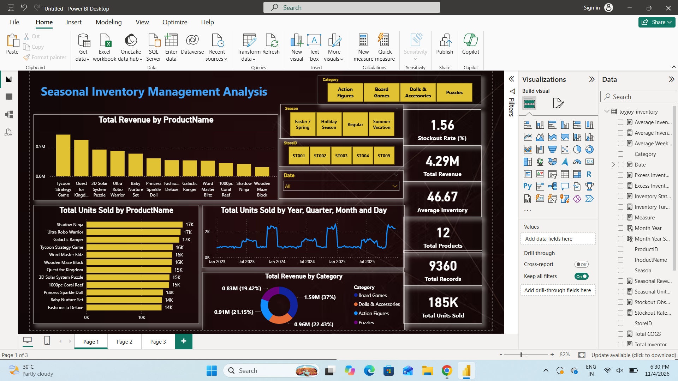
Prepared by: Junior Analytic Team
Project: Inventory planning, demand seasonality and stock risk
Analysis period visible in dashboard: January 2023 – September 2025

1. Executive Summary
Management overview and headline findings
ToyJoy sells toys across multiple stores and product categories. Management needs a clearer view of where inventory is at risk of running out, where capital may be tied up in slow-moving stock, and how demand changes across seasonal periods. This report interprets the completed Power BI dashboard and translates its results into practical inventory actions.

Dashboard KPI | Reported value | Business interpretation
Total revenue | 4.29M | Revenue generated across the records in the selected dashboard context.
Total units sold | 185,124 | Overall sales volume; rounded to 185K on the dashboard.
Average inventory | 46.67 | Dashboard measure; confirm its unit and aggregation before operational use.
Stockout rate | 1.56% | Reported stockout rate; validate numerator/denominator definition.
Total products | 12 | Distinct product count shown.
Total records | 9,360 | Number of rows/records represented in the dashboard.

Key findings from the visuals:
Board Games contribute the largest category revenue: 1.59M (37% of total revenue). Dolls & Accessories contribute 0.96M (22.43%), Action Figures 0.91M (21.15%), and Puzzles 0.83M (19.42%).
Holiday Season records the highest seasonal unit volume at 60,301 units, followed by Summer Vacation (52,637), Regular (50,545), and Easter / Spring (21,641).
The product-level table reports every listed product as “Stockout Risk”, with weeks of supply between 0.37 and 0.61. This points to a potential replenishment-coverage issue that should be investigated.
The stockout-observation chart shows the highest counts for 3D Solar System Puzzle and Tycoon Strategy Game, while Fashionista Deluxe and Baby Nurture Set are among the lowest shown.

Overall conclusion: ToyJoy should move toward demand-led replenishment, increase seasonal readiness before the Holiday and Summer Vacation peaks, and validate the stockout and excess-inventory calculations before committing to large inventory transfers or purchases.

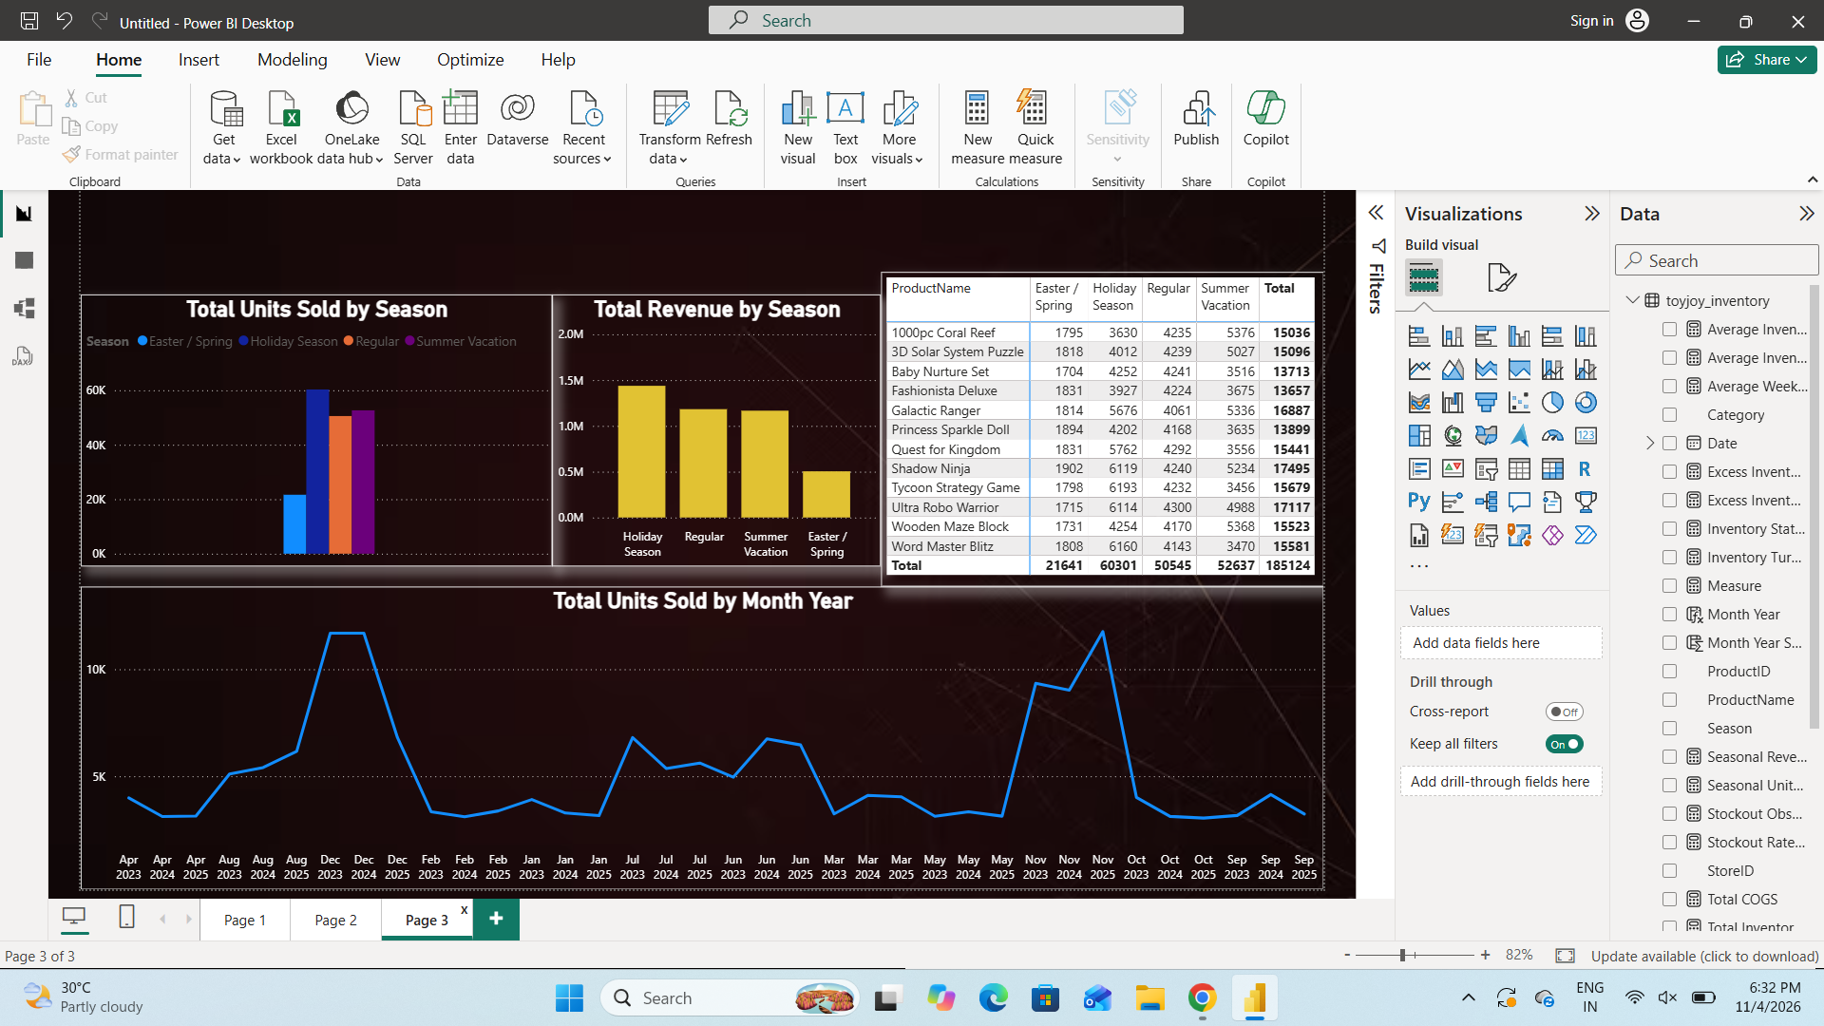

2. Business Problem, Objectives and Dataset

Business context
Following the holiday period, management observed both excess inventory and stock availability problems. These conditions create opposing costs: excess stock occupies warehouse space and ties up working capital, while stockouts can cause lost sales, customer dissatisfaction and missed seasonal demand.

Project objectives
- Identify products and categories that may have excess inventory or weak sales velocity.
- Understand demand changes by season, month and year.
- Highlight products with stockout observations or low weeks of supply.
- Recommend inventory actions that balance service levels, warehouse capacity and cash flow.

Dataset profile
The Power BI model shown in the screenshots uses a table named toyjoy_inventory. The dashboard reports 9,360 records and 12 products, with five store identifiers (ST001–ST005) available as a slicer. The date trend visual spans approximately January 2023 through September 2025.
Visible fields include Category, Date, ProductID, ProductName, Season, StoreID and measures/columns relating to inventory, units sold, weekly sales, weeks of supply, inventory status, excess inventory, revenue, cost of goods sold and stockout observations.

Data preparation considerations
- Standardize category and season labels so that spelling or spacing variations do not split the same group.
- Check date data types and create a continuous calendar table for year, quarter, month and day analysis.
- Inspect missing or negative stock, sales and cost values; document whether missing inventory is imputed, excluded or treated as unknown.
- Confirm the grain of each row (for example, product-store-date) to avoid double-counting inventory or sales.
- Validate product and store keys, remove unintended duplicates, and reconcile totals against source records.

3. Analytical Methodology and KPI Definitions

The report follows a descriptive analytics approach: summarize performance, compare products and categories, inspect stock-risk indicators, and identify recurring seasonal patterns. The Power BI report uses slicers for Category, Season, StoreID and Date, enabling the user to narrow the analysis to a specific business context.

KPI | Typical calculation / interpretation | Decision supported
Units sold | SUM of units sold over the selected period | Identify volume leaders and slow movers.
Revenue contribution | Product/category revenue ÷ total revenue | Prioritize commercially important products.
Inventory turnover | Units sold ÷ average inventory (use consistent time units) | Assess how quickly stock is converted into sales.
Weeks of supply | Available inventory ÷ average weekly unit sales | Estimate how long current stock may last.
Stockout rate | Stockout events or stockout periods ÷ eligible observations | Measure availability problems; define denominator explicitly.
Excess inventory value | Excess units × unit cost | Estimate cash tied up in stock above target.
Seasonal demand | Units sold/revenue grouped by season and time period | Plan inventory ahead of predictable demand peaks.

4. Dashboard Overview and Revenue Performance

The dashboard provides an executive overview. It combines revenue by product, units sold by product, a time-series view, category revenue share, slicers and headline KPI cards.

Revenue by category

Category | Revenue | Share
Board Games | 1.59M | 37.00%
Dolls & Accessories | 0.96M | 22.43%
Action Figures | 0.91M | 21.15%
Puzzles | 0.83M | 19.42%

Board Games are the largest revenue contributor, accounting for a little over one-third of total revenue. The remaining three categories have relatively balanced contributions, each near one-fifth to one-quarter of revenue. This suggests that category-level inventory policies should protect the Board Games revenue base while continuing to monitor demand and stock efficiency in the other categories.

The product revenue visual identifies Tycoon Strategy Game as the largest revenue contributor among the displayed products, followed by Quest for Kingdom and 3D Solar System Puzzle. Exact product-level revenue values are not legible in the supplied screenshot, so the report does not assign precise amounts.

5. Product-Level Inventory and Stockout Analysis

The dashboard combines stockout observations, a detailed product inventory table and weeks of supply by product and store. The detailed table is particularly useful because it connects sales velocity with the stock-coverage indicator.

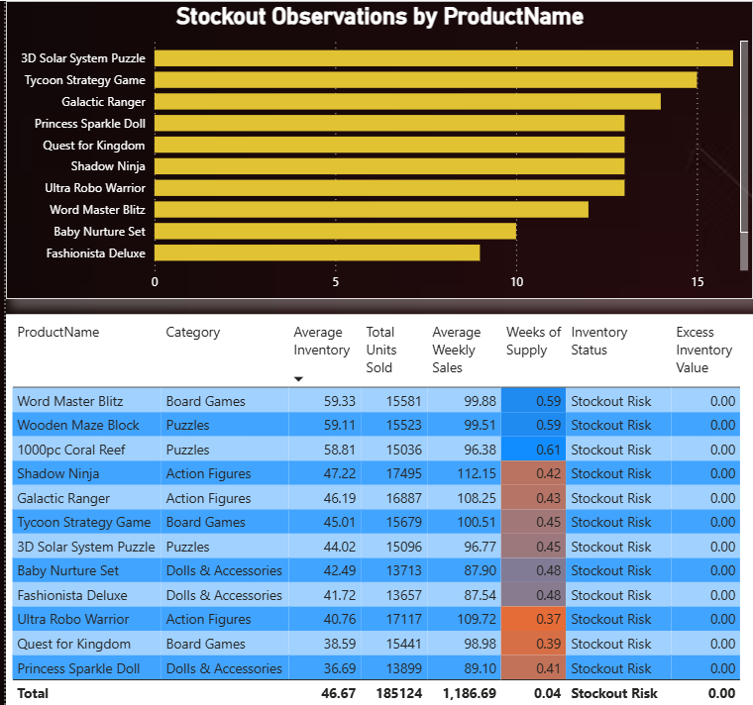

Key interpretation:

- Shadow Ninja and Ultra Robo Warrior have the highest unit sales among the 12 products, and their weekly sales rates are also high. These items warrant close replenishment monitoring.
- Ultra Robo Warrior has the lowest weeks of supply shown (0.37), followed by Quest for Kingdom (0.39) and Princess Sparkle Doll (0.41). These are the strongest immediate candidates for a stock-coverage review.
- 1000pc Coral Reef, Wooden Maze Block and Word Master Blitz have the highest weeks of supply in the table (0.61, 0.59 and 0.59), but these values are still below one week. They are relatively better covered, not necessarily overstocked.
- The stockout-observation chart shows 3D Solar System Puzzle and Tycoon Strategy Game at the top of the displayed list. Investigate whether these observations cluster in particular stores or seasons.

6. Seasonal Demand and Time-Series Analysis

Season | Units sold | Share of total units (approx.)
Holiday Season | 60,301 | 32.6%
Summer Vacation | 52,637 | 28.4%
Regular | 50,545 | 27.3%
Easter / Spring | 21,641 | 11.7%
Total | 185,124 | 100%

Holiday Season is the strongest demand period, contributing approximately 32.6% of total units sold. Summer Vacation accounts for 28.4%, Regular for 27.3%, and Easter / Spring for 11.7%. The combined Holiday and Summer periods account for about 61% of unit volume, making them the most important seasonal planning windows.
The monthly trend contains visible peaks around December 2023, December 2024 and November 2025 is not shown; the dashboard actually ends around September 2025, with pronounced peaks around December 2023, December 2024 and late 2024/early 2025 depending on the plotted month sequence. The visible line suggests recurring year-end demand spikes and lower-volume intervals between peaks. The monthly chart labels are crowded, so exact month-to-month values should be exported from Power BI for forecasting.
The product-by-season matrix can be used to identify which products drive each seasonal peak. For example, the visible totals show Holiday Season has 60,301 units overall, materially above the other seasons. Use this matrix to create product-specific seasonal uplift factors rather than applying one blanket uplift to every toy.

7. Business Insights and Inventory Recommendations

Immediate actions (next 2–4 weeks)

- Review the lowest-coverage products first. Validate on-hand, committed, in-transit and safety stock for Ultra Robo Warrior, Quest for Kingdom, Princess Sparkle Doll, Shadow Ninja and Galactic Ranger.
- Investigate store-level availability. Use the StoreID slicer and weeks-of-supply visual to find stores where high-demand products are under-covered; transfer stock between stores where feasible before placing new orders.
- Check stockout observations for 3D Solar System Puzzle and Tycoon Strategy Game. Identify the affected dates and stores, then determine whether stockouts were caused by forecast error, delayed replenishment or uneven allocation.
- Do not liquidate products solely because their unit sales are lower. Compare sales velocity with inventory age, weeks of supply, margin, seasonality and the excess-inventory value measure.

Seasonal planning actions (next 1–2 quarters)

- Build a pre-season buying calendar for Holiday Season and Summer Vacation. Start supplier and capacity planning before the demand ramp, with a review of lead times and supplier minimum order quantities.
- Create separate demand forecasts by product and store, using monthly history, season, promotions and trend. Apply seasonal uplift only where historical product-level evidence supports it.
- Set target service levels by product class: high-volume/high-risk products receive tighter monitoring and higher protection; slower-moving items receive smaller, more frequent replenishment where supplier economics allow.

Long-term inventory control

- Implement reorder point = expected demand during replenishment lead time + safety stock. Estimate safety stock from demand variability and supplier lead-time variability.
- Use order-up-to quantity = target stock level − (on-hand + on-order − backorders), subject to warehouse capacity and pack-size constraints.
- Introduce ABC/XYZ segmentation: ABC by revenue or gross margin contribution; XYZ by demand variability. Combine the segments to prioritize planning effort.
- Track excess inventory in both units and currency, with ageing buckets and a clear excess threshold. Use markdowns, bundles, channel transfers or supplier returns only after validating margin impact.

Suggested control targets

Establish targets after a baseline period rather than inventing arbitrary thresholds. Recommended controls include weekly coverage review for A-items, monthly forecast-bias review, seasonal readiness checkpoints, stockout root-cause tracking, and a warehouse-capacity ceiling.

8. Conclusion and Assumptions

The dashboard provides a useful starting point for improving ToyJoy’s inventory decisions. It shows 185,124 units sold and 4.29M in revenue across 12 products and 9,360 records. Board Games are the largest revenue category, while Holiday Season and Summer Vacation together represent approximately 61% of unit demand. Product-level weeks of supply are low across the displayed list, and stockout observations are concentrated among a subset of products.
The strongest operational message is to protect availability for high-volume products and prepare early for seasonal peaks. However, the supplied screenshots do not establish which products are genuinely overstocked: the visible excess inventory value is zero for all products in the table. Before making stock-reduction decisions, ToyJoy should validate the excess inventory measure and the stockout-rate definition against source transactions.

Assumptions and limitations

- The dashboard’s displayed totals and product table values are treated as the source of truth for this report; values are rounded where shown in the visuals.
- The visible date trend covers approximately January 2023 to September 2025; confirm exact start/end dates in the source model.
- The report assumes the seasonal labels represent business-defined demand periods, not necessarily standard calendar quarters.
- The report does not invent missing product-level revenue, unit costs, lead times, stockout event definitions or forecast accuracy values.
- Weeks of supply below one week are interpreted as low coverage only if the inventory and weekly sales measures use compatible units and filter contexts.

