DEEP LEARNING FUNDUS IMAGE ANALYSIS FOR EARLY DETECTION OF DIABETIC RETINOPATHY

1. Abstract
Diabetic Retinopathy (DR) is a diabetes complication that affects the retina and may lead to blindness if not detected early. This project aims to develop a deep learning-based system for early detection and classification of diabetic retinopathy using retinal fundus images. A Convolutional Neural Network (CNN) model is trained to classify images into five categories: No_DR, Mild, Moderate, Severe, and Proliferative_DR. The trained model is deployed using a Flask web application that allows users to upload retinal images and receive real-time predictions.
2. Introduction
Diabetic Retinopathy is one of the leading causes of vision impairment worldwide. Early detection can significantly reduce the risk of blindness. Traditional screening methods require expert ophthalmologists and manual evaluation, which can be time-consuming.
This project proposes an automated deep learning-based system that can classify retinal fundus images efficiently and accurately.

3. Problem Statement
Manual diagnosis of diabetic retinopathy:
- Requires expert medical professionals
- Is time-consuming
- Can be expensive
- May not be accessible in rural areas
The goal of this project is to develop an automated system that detects and classifies diabetic retinopathy stages using deep learning.

4. Objectives
- To build a CNN model for diabetic retinopathy classification
- To classify retinal images into five severity levels
- To deploy the trained model using Flask
- To provide a user-friendly web interface
- To integrate cloud database support (Cloudant DB)

5. Dataset Description
The dataset consists of retinal fundus images categorized into:
- No_DR
- Mild
- Moderate
- Severe
- Proliferative_DR
The images were preprocessed and resized to 224x224 pixels before training.

6. Technologies Used
- Python
- TensorFlow / Keras
- Flask
- HTML
- CSS
- IBM Cloudant DB
- GitHub

7. System Architecture
The system works in the following steps:
- User uploads retinal image
- Image preprocessing is performed
- The trained CNN model predicts the class
- The result and confidence score are displayed
- Data can be stored in Cloudant DB

8. Model Architecture
- Convolutional Layers
- MaxPooling Layers
- Flatten Layer
- Dense Layers
- Softmax Output Layer (5 classes)
Loss Function: Categorical Crossentropy
Optimizer: Adam
Evaluation Metric: Accuracy

9. Implementation
The backend is implemented using Flask.
The trained model (dr_model.h5) is loaded and used to predict uploaded images.
Prediction process:
- Load image
- Resize to 224x224
- Normalize pixel values
- Predict class
- Return highest probability class

10. Results
The model successfully classifies retinal images into five categories.
Example Output:
- Prediction: Moderate
- Confidence: 94.32%
The web interface displays:
- Uploaded image
- Predicted class
- Confidence score
- Highlighted disease category
11. Conclusion
This project demonstrates how deep learning can assist in early detection of diabetic retinopathy. The system provides quick and accurate classification of retinal images. With further improvements and larger datasets, this system can support healthcare professionals in screening programs.

12. Future Enhancements
- Improve model accuracy using larger datasets
- Deploy application on cloud server
- Integrate patient record storage in Cloudant DB
- Add real-time camera support

13. GitHub Repository Link
(Add your GitHub link here after uploading)

14. Screenshots
- Home page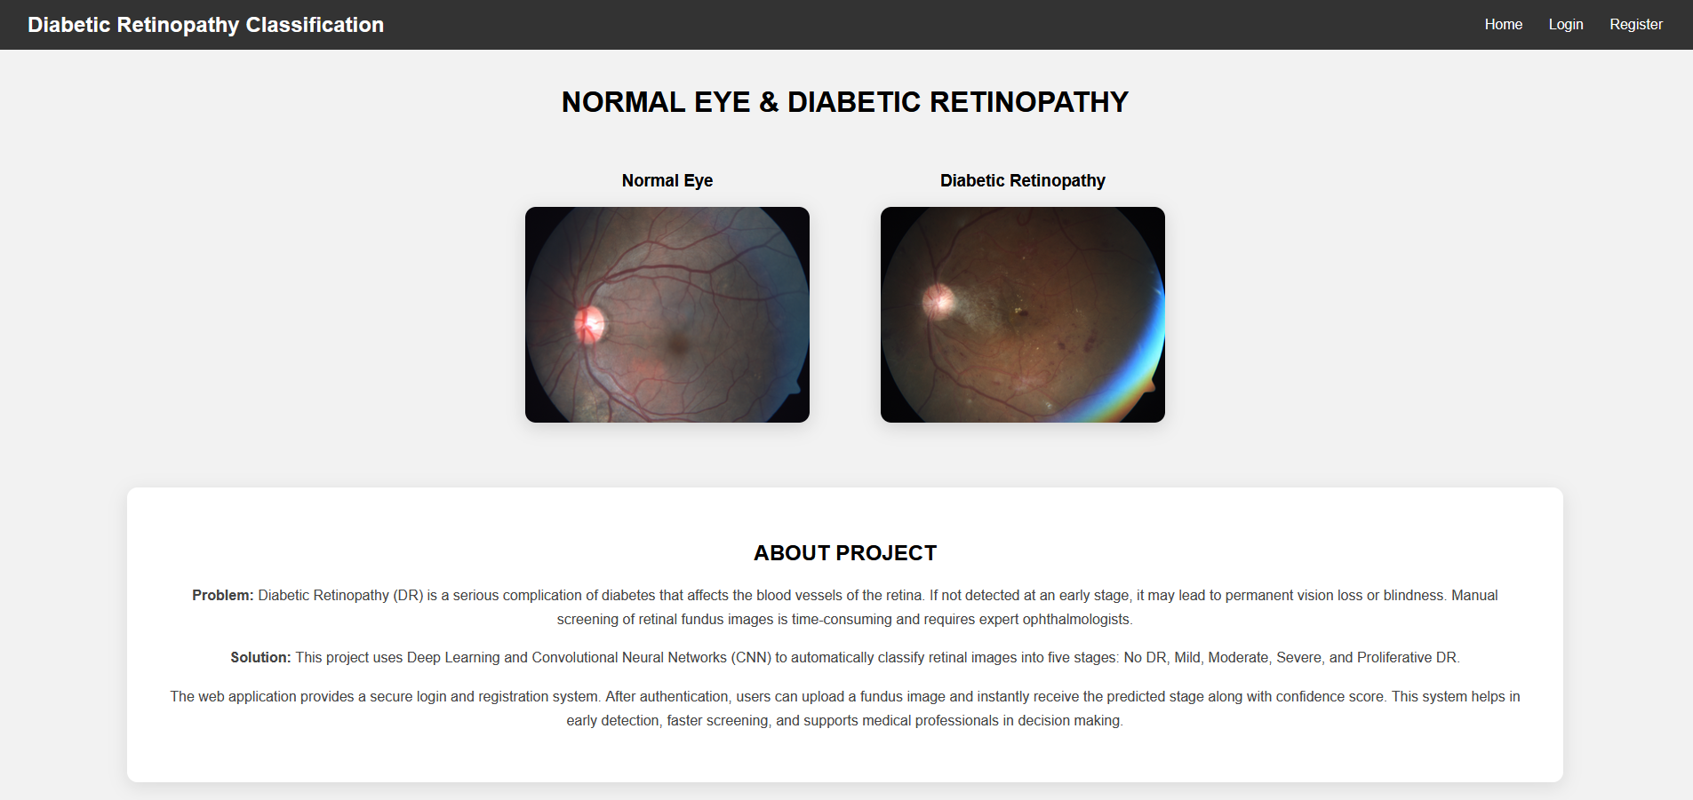
- Login page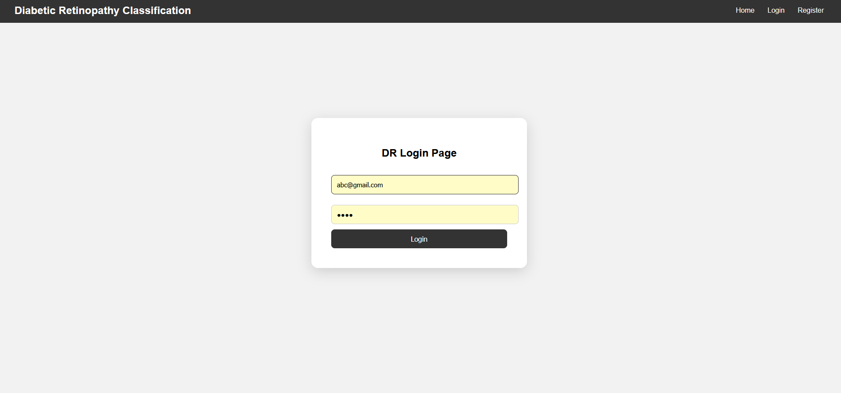

- Registration page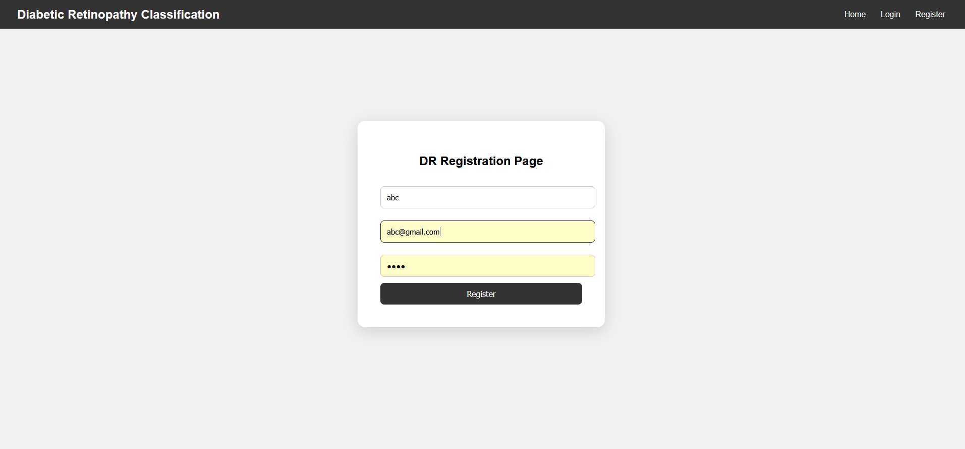
- Prediction page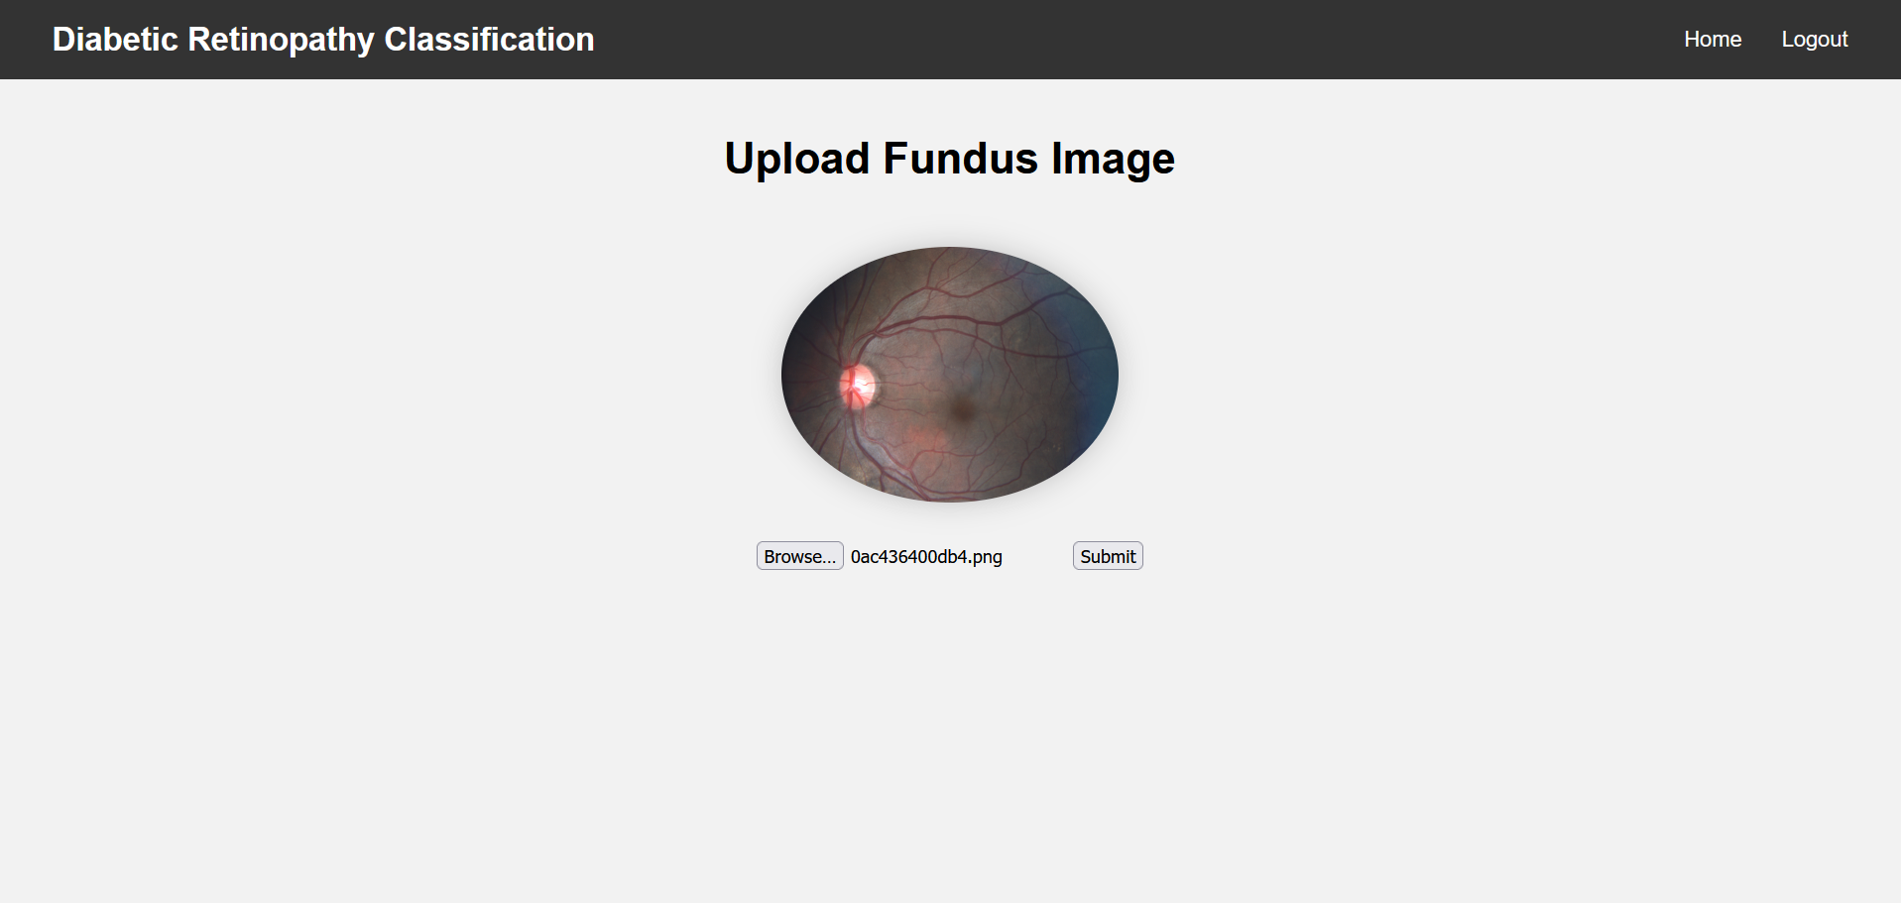

- Result page