PIZZA SALES SQL QUERIES

- KPI’s:-
- Total Revenue:
SELECT SUM(total_price) AS Total_Revenue from pizza_sales

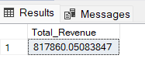

- Average Order Value:
SELECT SUM(total_price) / COUNT(DISTINCT order_id) AS Avg_Order_Value from pizza_sales

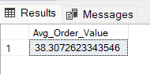

- Total Pizzas Sold:
SELECT SUM(quantity) AS Total_Pizza_Sold from pizza_sales

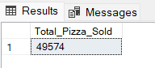

- Total Orders:
SELECT COUNT(DISTINCT order_id) AS Total_orders from pizza_sales

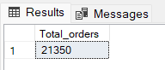

- Average Pizzas Per Order:
SELECT CAST(CAST(SUM(quantity) AS DECIMAL(10,2)) / CAST(COUNT(DISTINCT order_id) AS DECIMAL(10,2)) AS DECIMAL(10,2)) AS Avg_Pizzas_per_order from pizza_sales

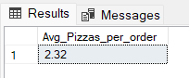

- Daily Trends for Total Orders:-
SELECT DATENAME(DW, order_date) AS order_day, COUNT(DISTINCT order_id) AS Total_orders from pizza_sales GROUP BY DATENAME(DW, order_date)

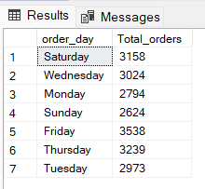

- Hourly Trend for Total Orders:-
SELECT DATEPART(HOUR, order_time) AS order_hours, COUNT(DISTINCT order_id) AS Total_orders from pizza_sales GROUP BY DATEPART(HOUR, order_time) ORDER BY DATEPART(HOUR, order_time)

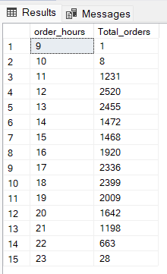
- Percentage of Sales by Pizza Category:-
SELECT pizza_category, SUM(total_price) AS Total_Sales, SUM(total_price) * 100 / (SELECT SUM(total_price) from pizza_sales) AS PCT from pizza_sales GROUP BY pizza_category

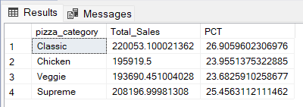

- Percentage of Sales by Pizza Size:-
SELECT pizza_size, SUM(total_price) AS Total_Sales, SUM(total_price) * 100 / (SELECT SUM(total_price) from pizza_sales) AS PCT from pizza_sales GROUP BY pizza_size ORDER BY PCT DESC

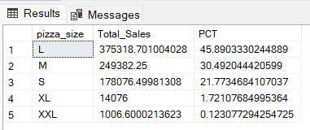

- Total Pizzas Sold by Pizza Category:-
SELECT pizza_category, SUM(quantity) AS Total_Pizzas_Sold from pizza_sales GROUP BY pizza_category

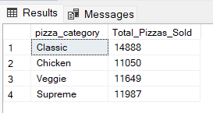

- Top 5 Best Sellers by Total Pizzas Sold:-
SELECT TOP 5 pizza_name, sum(quantity) AS Total_Pizzas_Sold from pizza_sales GROUP BY pizza_name ORDER BY sum(quantity) DESC
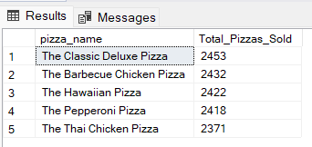

- Bottom 5 Worst Sellers by Pizzas Sold:-
SELECT TOP 5 pizza_name, sum(quantity) AS Total_Pizzas_Sold from pizza_sales GROUP BY pizza_name ORDER BY sum(quantity)

