Homework 8: Running Pinecone Job as an Airflow Pipeline

This report explains the setup and execution of an Apache Airflow pipeline integrated with Pinecone for semantic search operations. The project was performed inside a Dockerized environment with multiple Airflow components (webserver, scheduler, worker, Redis, Postgres). The pipeline successfully automated data ingestion, embedding generation, index creation, and semantic querying within Pinecone.

Environment Setup

The environment was created using Docker Compose to orchestrate Airflow services. Custom Python dependencies such as sentence-transformers and pinecone-client were pre-installed via a Dockerfile.
An .env file handled AIRFLOW_UID and AIRFLOW_GID for permission consistency. Once built, the containers were initialized and brought up using:

docker compose build --no-cache docker compose up airflow-init docker compose up -d
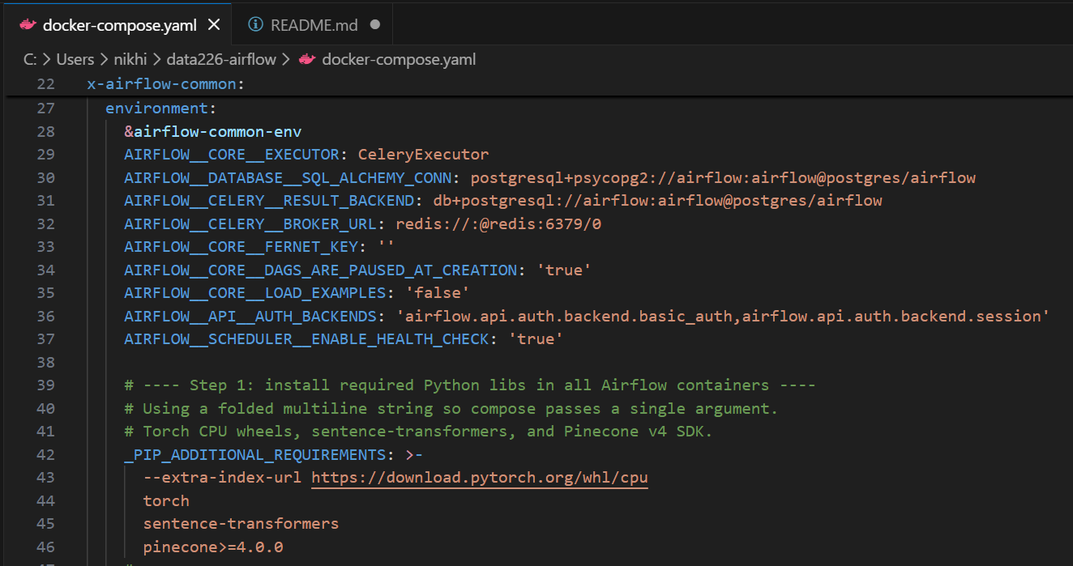
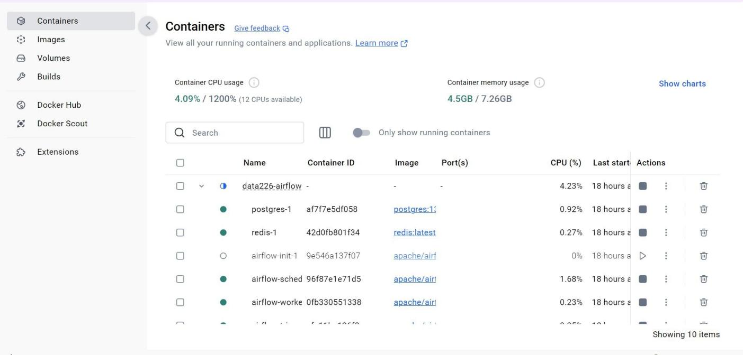

Airflow and Pinecone Configuration

After launching Airflow (http://localhost:8080), Pinecone credentials were stored under Admin → Variables. The variables included API key, index name, cloud, and region.
This allowed each Airflow task to securely access Pinecone configuration via Variable.get().
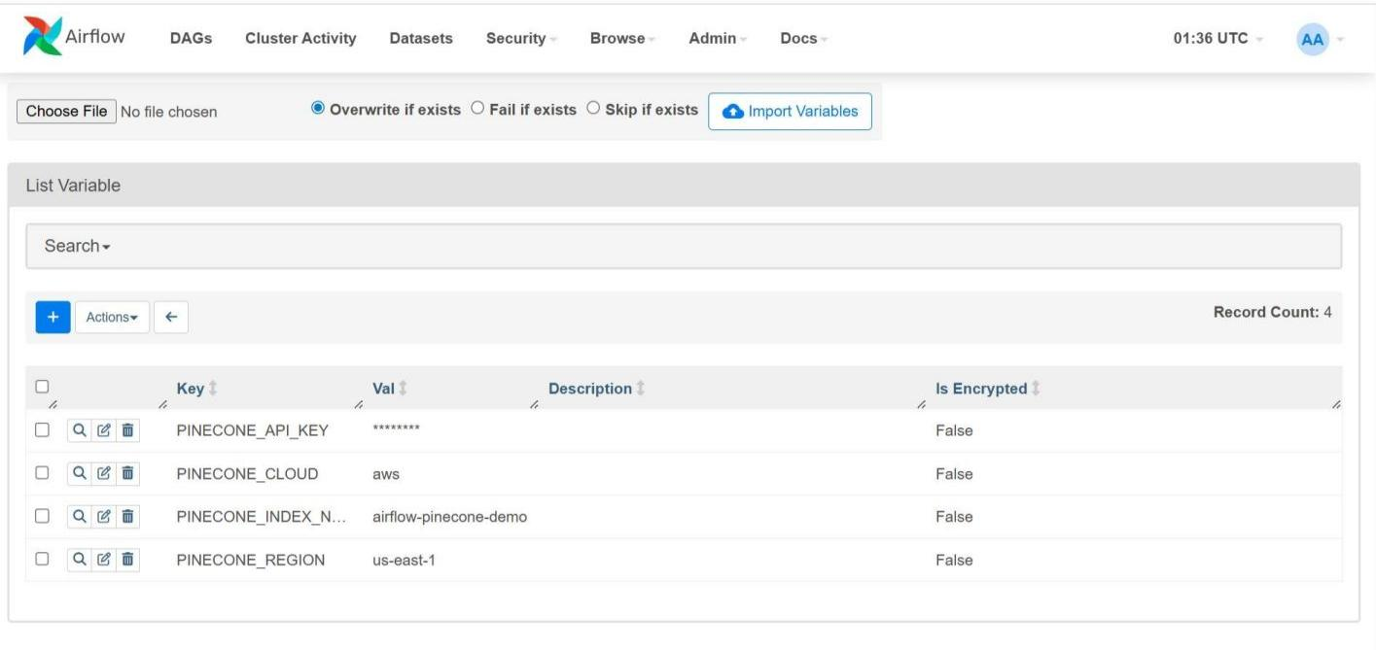

3.Download, Process and Generate an input file to Pinecone
The DAG ‘pinecone_pipeline_demo’ included four PythonOperator tasks:
  - prepare_input – generated an input text file.
  - create_index – created or verified an existing Pinecone index.
  - embed_and_upsert – embedded the text and upserted vectors to Pinecone.
  - query_index – performed semantic query and logged ranked results.
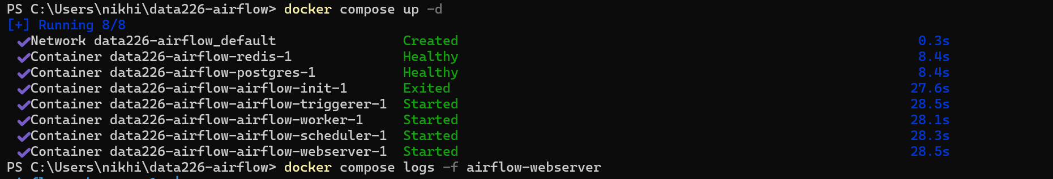
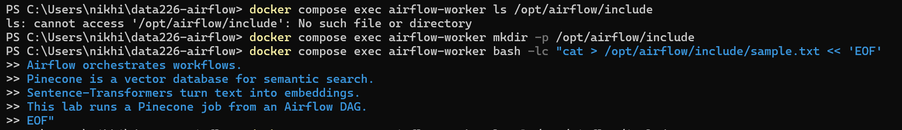

4.Create Pinecone index

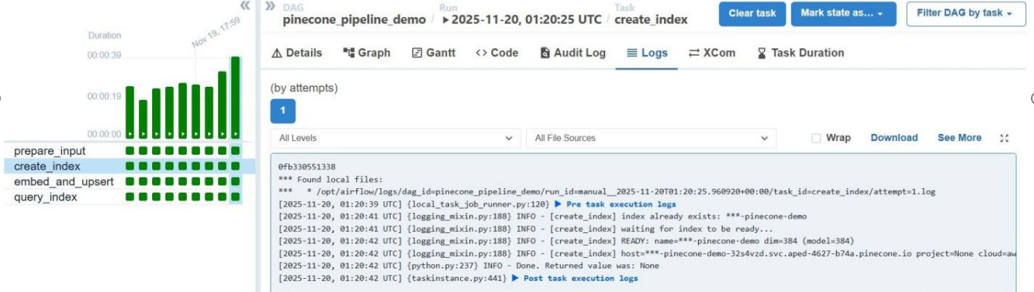

5.Convert the input file into embeddings and ingest them into Pinecone
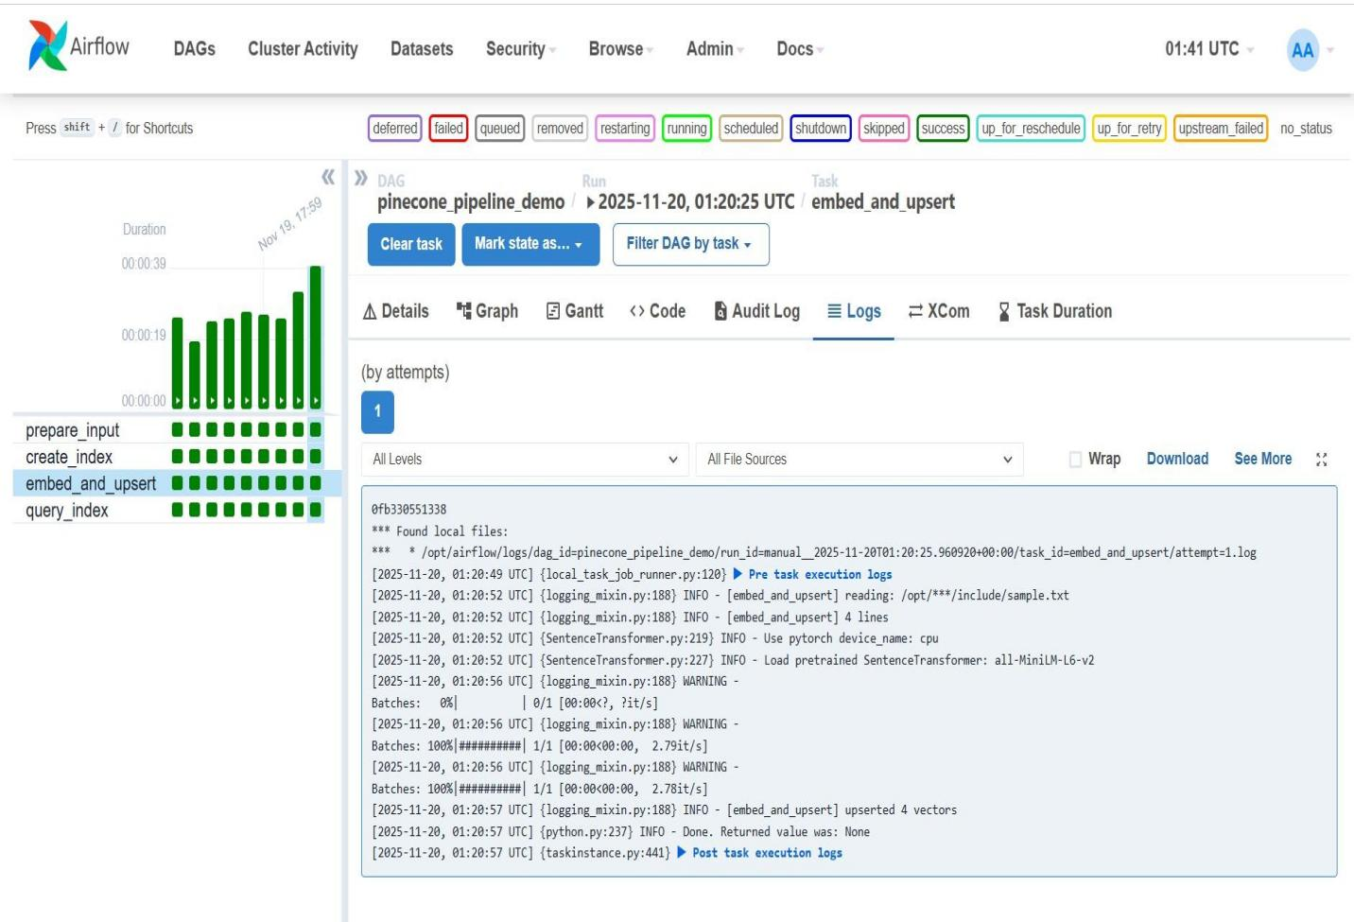

6.Run search against Pinecone
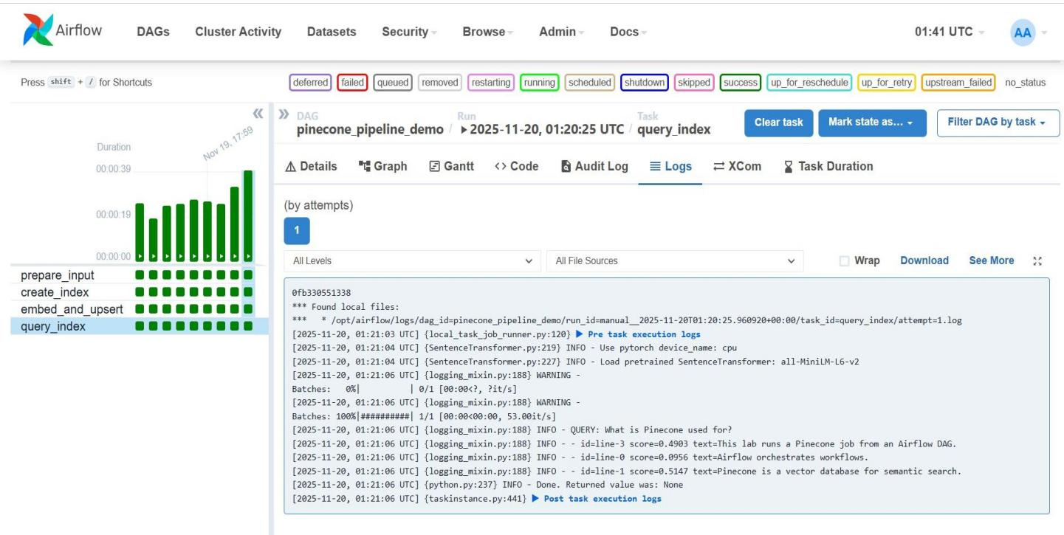
Conclusion

This project successfully demonstrated how to automate an end-to-end semantic search pipeline using Apache Airflow and Pinecone. All steps—from input generation to vector search— ran in Docker containers, ensuring reproducibility. The workflow can be easily extended for larger datasets
or other vector databases.

