INT375 - DATA SCIENCE TOOLBOX :PYTHON PROGRAMMING

**PROJECT REPORT**

(Project Semester January-April 2025)

*TITLE-* CRIME_INCIDENTS_IN_2024

**Submitted by**

Name – Mansi kumari

Registration No – 12311253

Roll No - 52

Section – K23ED

Course Code – INT375

Under the Guidance of

**Dr. Dhiraj Kapila (UID: 23509)**

**Discipline of CSE/IT**

**Lovely School of Computer Science**

**Lovely Professional University, Phagwara**

**CERTIFICATE**

This is to certify that Mansi Kumari bearing Registration no.12311253 has completed INT37 project titled, **“CRIME_INCIDENTS_IN_2024”** under my guidance and supervision. To the best of my knowledge, the present work is the result of his original development, effort and study.

**Signature and Name of the Supervisor Designation of the Supervisor**

**School Of Computer Science**

Lovely Professional University Phagwara, Punjab.

Date: 12/04/2025

1. **INTRODUCTION:**

The year 2024 marked a significant period in the global landscape of law and order, with a noticeable shift in the pattern and nature of crime incidents. Advancements in technology, economic pressures, urban migration, and social unrest played a pivotal role in shaping crime trends across nations. From traditional offenses such as theft, assault, and organized crime to the rapid surge in cybercrime and financial fraud, law enforcement agencies worldwide faced evolving challenges.

**2. Source of dataset:**

Open Government Data (OGD) Platform India

The OGD platform offers a variety of datasets related to crime statistics in India. These datasets are contributed by various state departments and provide detailed insights into different types of crimes.

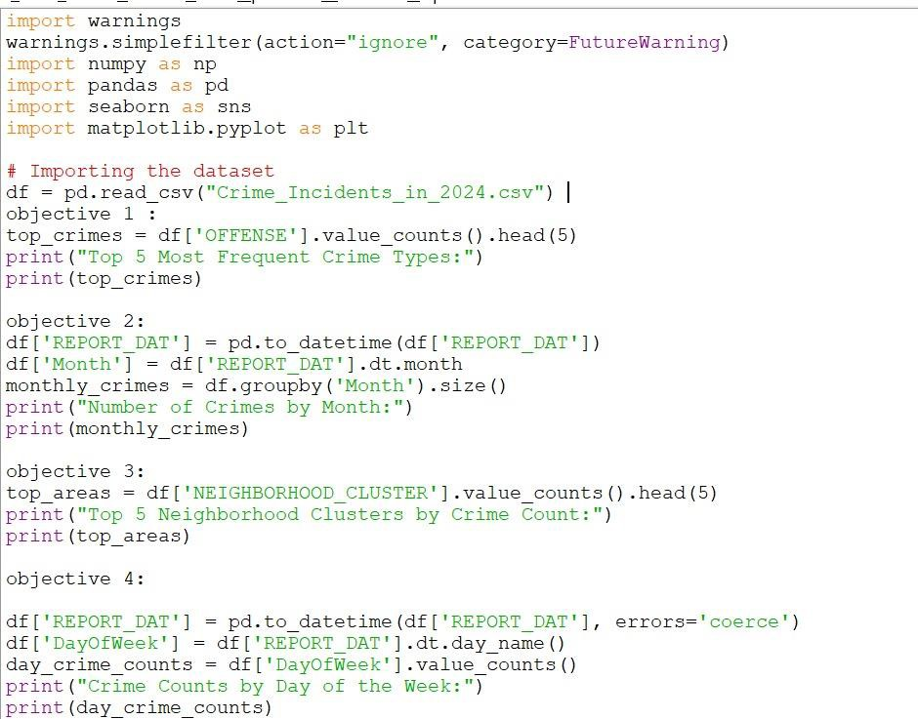

# **Analysis on dataset**

z

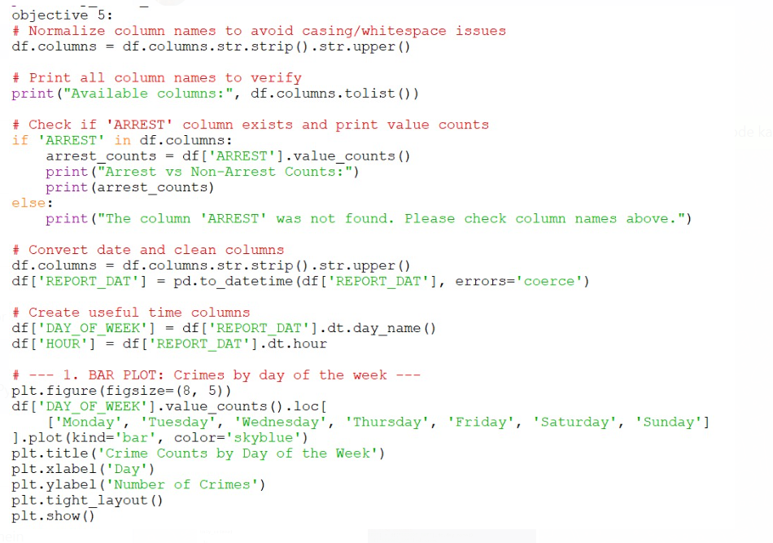

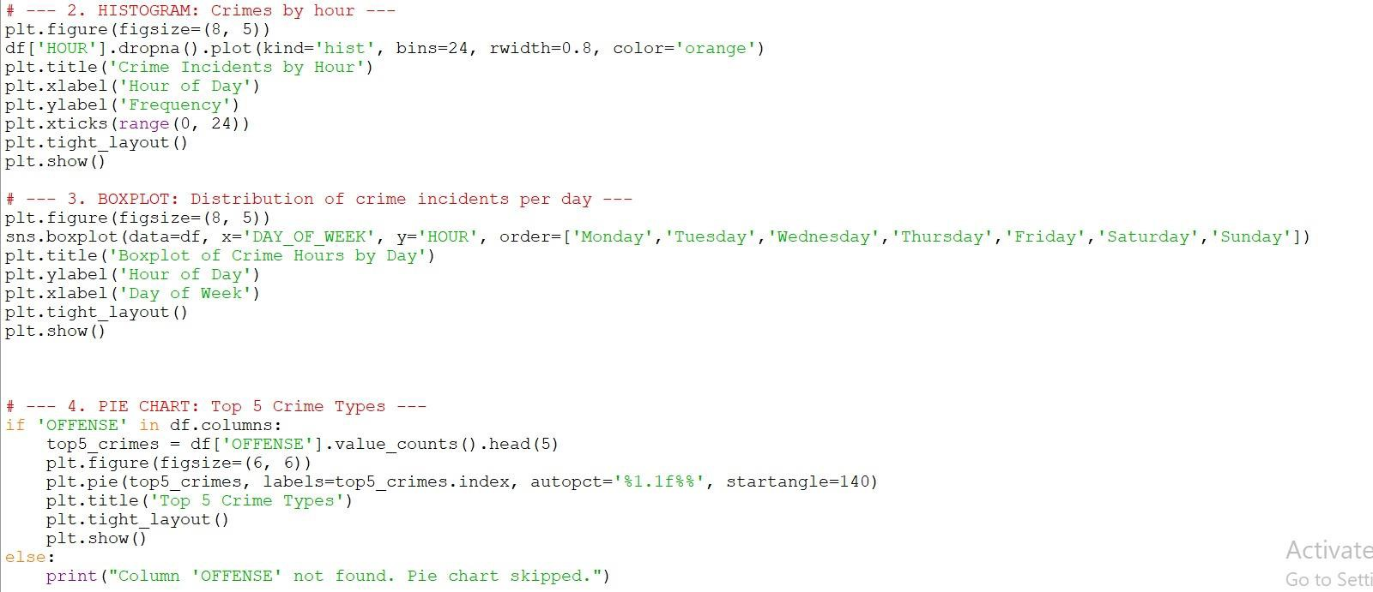

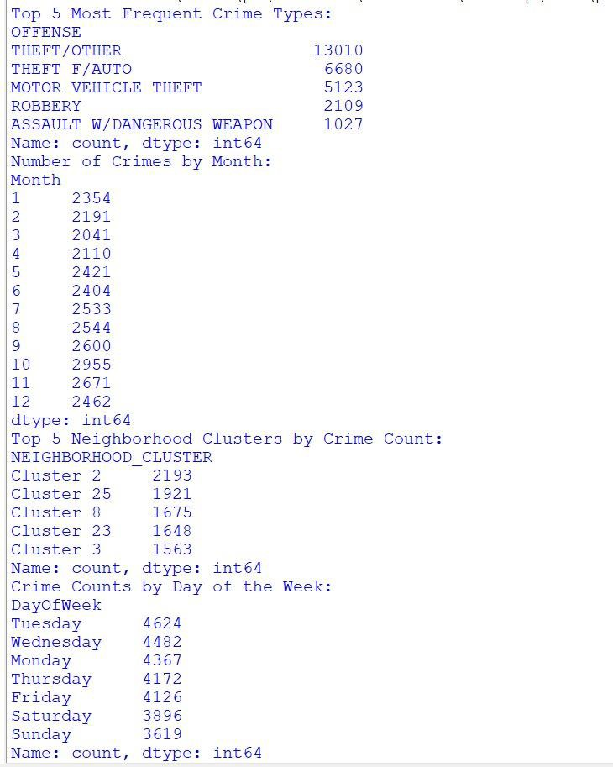

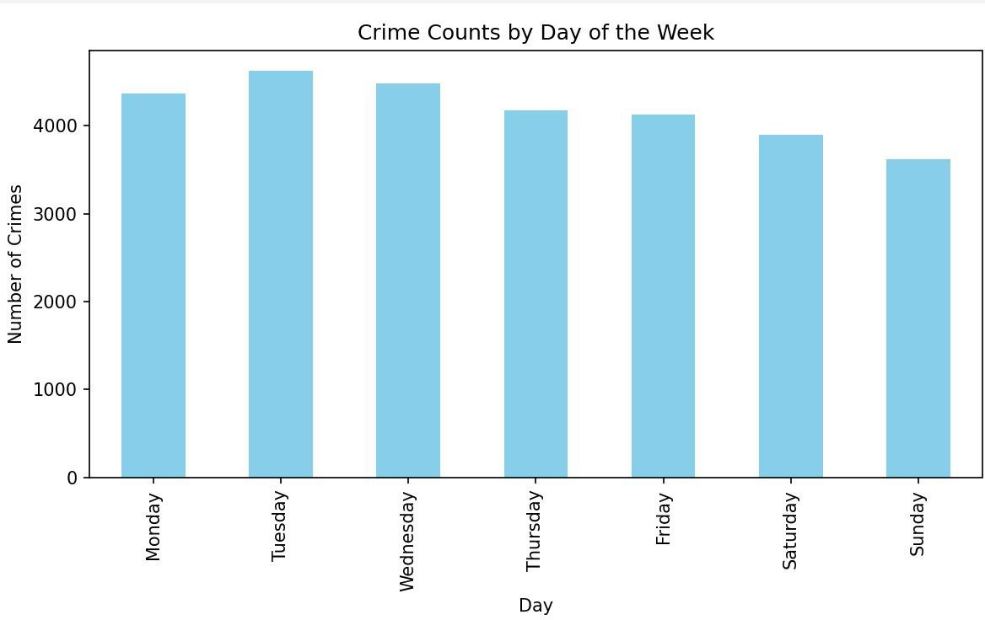

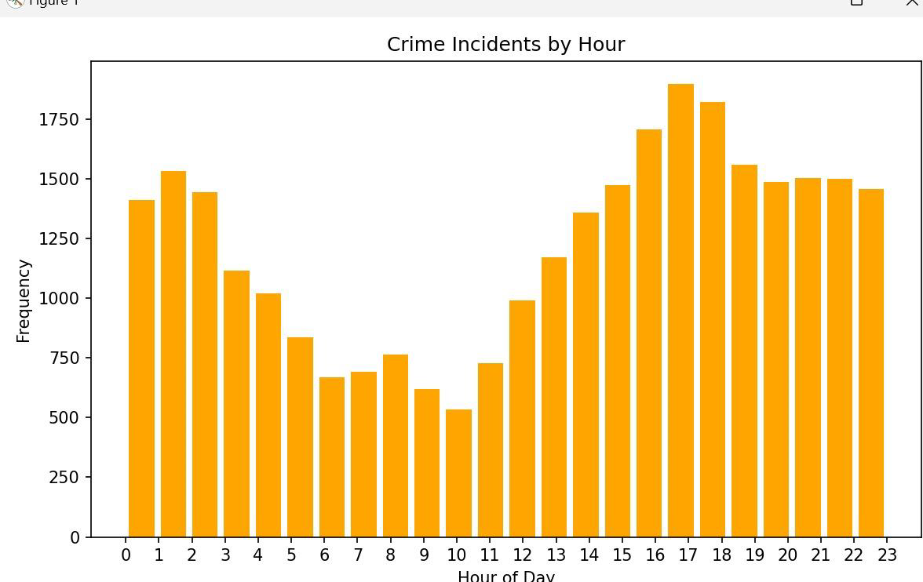

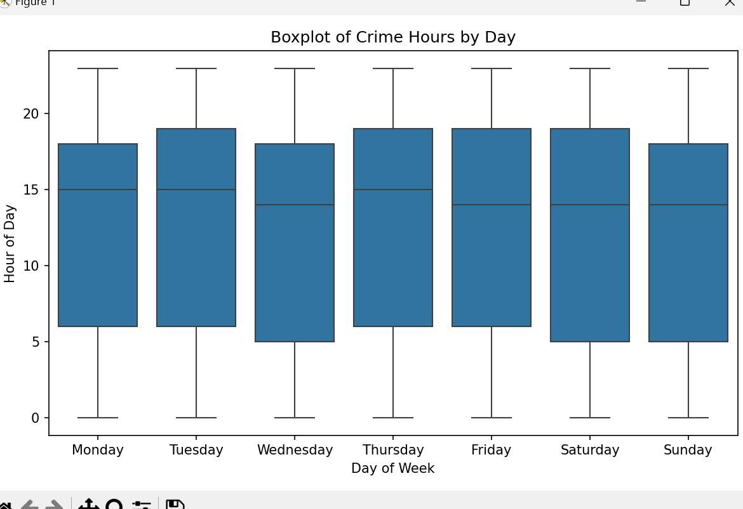

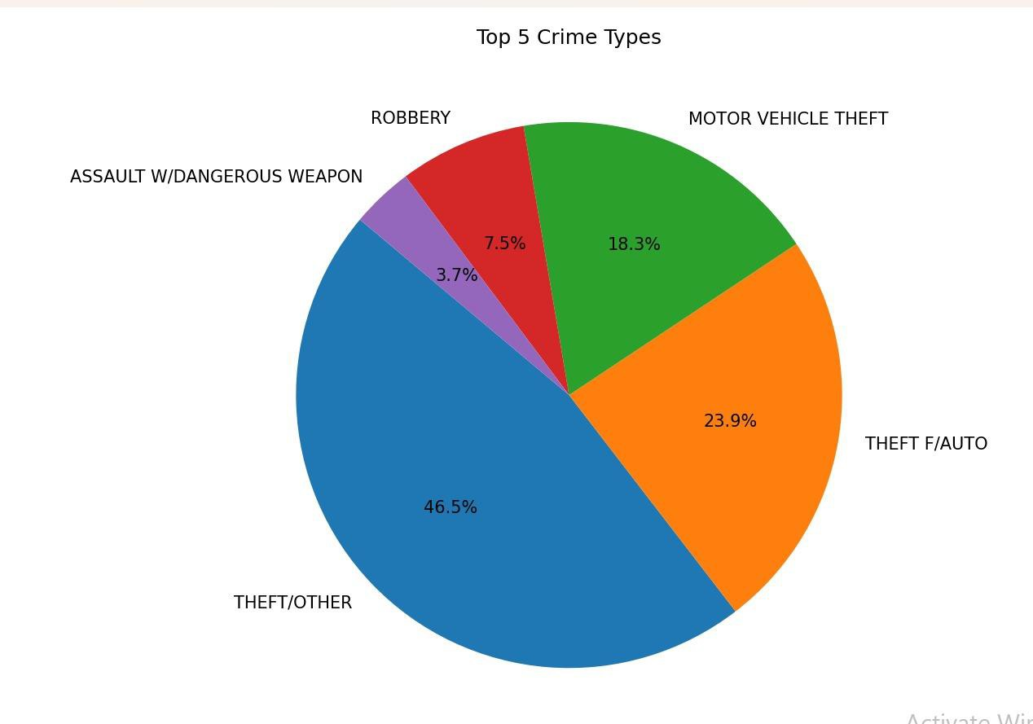

**4. Conclusion**

The crime landscape in 2024 highlighted the dynamic and multifaceted nature of criminal activity in

a rapidly evolving world. While traditional crimes continued to pose threats, the dramatic rise in cybercrime and

tech-enabled offenses underscored the urgent need for modernized law enforcement strategies. Regions with high

population density and socio-economic disparities witnessed increased vulnerability, particularly for women and marginalized groups. Despite these challenges, there were notable efforts by governments, law enforcement

agencies, and civil society to adapt through policy reforms, technological interventions, and public awareness campaigns. Moving forward, a collaborative and proactive approach—combining legal measures, education, digital security, and community engagement—will be crucial to building safer societies and effectively addressing the complex

crime scenarios of the future.

**5. Future Scope**

As crime patterns continue to evolve with advancements in technology and societal changes, the future demands a comprehensive and forward-thinking approach to crime prevention and control. The key areas of focus include:

**Technological Integration**: Leveraging artificial intelligence, big data analytics, and surveillance systems can

enhance real-time crime detection, predictive policing, and faster investigation processes.

**Cybersecurity Frameworks**: With the increasing digitization of financial and personal data, building robust cybersecurity infrastructure and educating citizens on digital safety will be critical.

**6**. **References**

**Dataset link**

**Website:** [**https://catalog.data.gov/dataset/?tags=customer-service**](https://catalog.data.gov/dataset/?tags=customer-service)

**Github**

**URL:**

**Linkedin**

**URL:** [https://www.linkedin.com/posts/mansi-kumari- 10b9b4289_python-datascience-crimeanalytics- activity-7316845703526338560](https://www.linkedin.com/posts/mansi-kumari-%2010b9b4289_python-datascience-crimeanalytics-%20activity-7316845703526338560)