Mahalakshmi Murugan

118A1088

TE CE D

**EXPERIMENT-01**

**Aim:** To identify a case study and design an Entity-Relationship Model.

**Problem Statement:**

Design an ER Diagram for SCHOOL MANAGEMENT SYSTEM which comprises the following entities:

School, Student, Employee, Subjects, Teachers, other staffs, Examination and Class.

Student has an unique Student ID ,Name. School has an address , CST no. and name. Teacher has an unique Teacher ID, mobile number and Address. Teacher takes class which is enrolled by Students. Students takes examinations of particular subject on stipulated date. School has Employee and employee contains an Employee ID, name and Address. Employee are Teachers and other Staffs . Teacher teaches subjects which is read by Students.

**ER Diagram:**

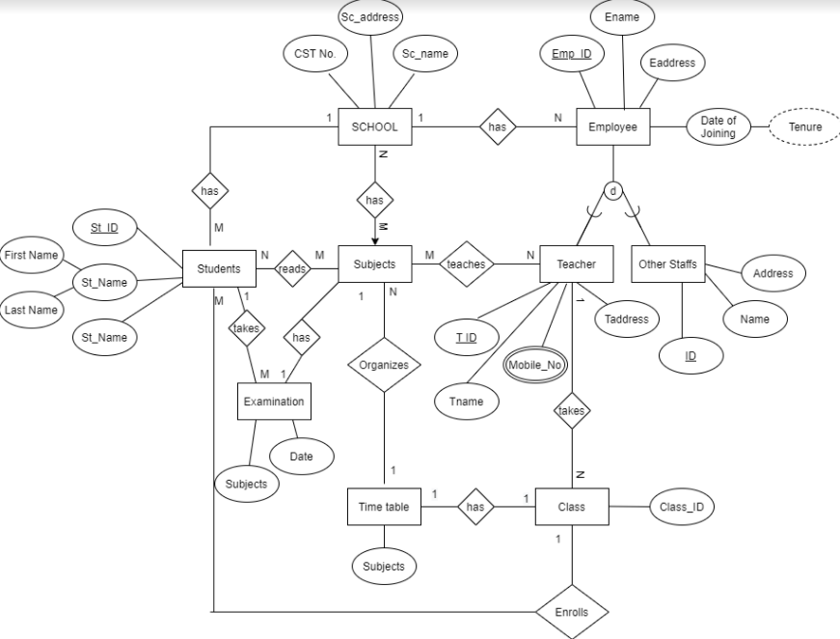

**Conclusion :**

Hence we have successfully identified the case study of School Management System and designed the respective Entity-Relation Model .