Mahalakshmi Murugan

118A1088 TE-CE D2

# EXPERIMENT 5: CISCO PACKET TRACER

**AIM:** To setup a Network and Configure IP addressing, Subnetting, Masking using CISCO packet tracer.

**THEORY:**

Download Cisco Packet Tracer. Once it is downloaded, install it using the default selections. After the installation, you can create a network topology to perform the hands-on lab exercises.

Create a network topology using Cisco Packet Tracer:

### Create a Network Topology

You can easily create a network topology using Cisco Packet Tracer. In the following sections, we are going to explain how to create a network topology that will contain four PCs, two switches, and two routers.

#### Adding PCs in Cisco Packet Tracer

To add PCs in Cisco Packet Tracer, you need to perform the following steps:

1. In the Cisco Packet Tracer console, click on the **PC** icon, click **Generic**, and then click in the logical view area to add a **Generic** PC.
2. Repeat the same step to add three more Generic PCs in the logical view area, as shown in the following figure.

Create a Network Topology in Cisco Packet Tracer

#### Adding Switches in Cisco Packet Tracer

1. To add a switch in Cisco Packet Tracer, click the **Switch** icon, select a switch type, such as **2960**, and then add the selected switch in the logical view area.
2. Repeat the same step to add one more switch.

#### Adding Routers in Cisco Packet Tracer

1. To add a router in Cisco Packet Tracer, click the **Router** icon, select a router type, such as **2811**, and then add the selected router in the logical view area.
2. Repeat the same step to add one more router.

Note: Different types of router series provide different types of [features](https://protechgurus.com/new-features-of-windows-server-2016/) and limitations.

#### Understanding Connection Types in Cisco Packet Tracer

To connect devices in Cisco Packet Tracer, first, you need to understand the various types of cables (connections) used to connect network devices. Some of the common types of cables are:

1. **Straight-through**: Used to connect different types of devices (devices that use different wiring standards), such as Router-to-Switch and Switch-to-PC.
2. **Cross-over**: Used to connect same types of devices, such as router-to-router, PC-to-PC, and switch-to-switch.
3. **Serial DCE**: Used to connect router-to-router in a WAN network.
4. **Console**: Used to take console (using hyper terminal) of a router on a PC.

To see the various types of connections, click the **Connection** icon. Spend some time to understand the connections. Once you are familiar with the types of connections, connect the devices to create the network topology.

The following figure displays the various types of connections used to connect devices:

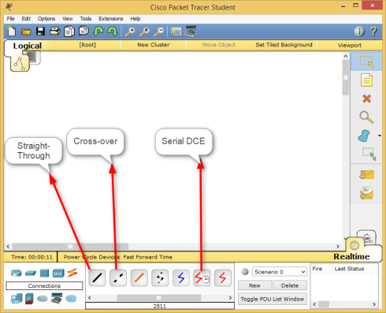

Since we have chosen the modular router (that allows you to modify the number of interfaces), you may need to customize the interfaces before it can be used to connect other network devices. To do this, double-click **Router0**, on the **Router0** properties dialog box, click the **Power** button to power off **Router0**.

The following figure displays how to add a module in a router using Cisco Packet Tracer.

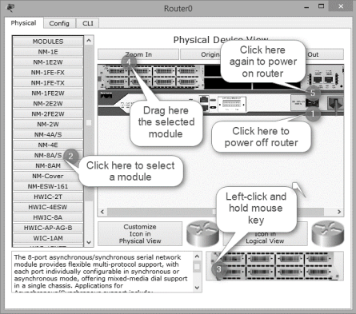

Now, open the **Router1** properties dialog box, add the same module to **Router1** also, and then close the **Router1** properties dialog box.

#### Connecting Devices in Cisco Packet Tracer

1. To connect devices in Cisco Packet Tracer, click the connection type icon, and select an appropriate cable. For example, to connect **PC0** to **Switch0**, select the straight-through cable, click on **PC0**, and select the **FastEthernet0** interface.
2. Next, click on **Switch0**, and then select the **FastEthernet0/1** interface. The following figure displays how to connect a PC to a switch in Cisco Packet Tracer.

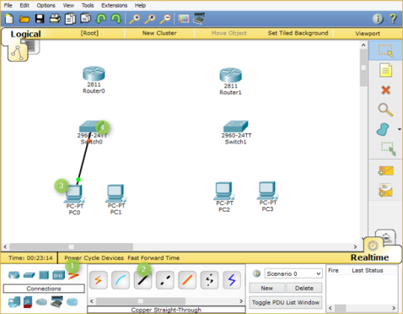

1. Now, add **PC1** to **Switch0** using the **FastEthernet0/2** interface. Also, add **PC2** and **PC3** to the **FastEthernet0/1** and **FastEthernet0/2** interfaces of **Switch1,**respectively.
2. If you have connected a wrong device to a wrong interface, you can use the **Delete**option to delete a connection or device. The following figure displays how to use the **Delete** option to delete a device or connection in Cisco Packet Tracer.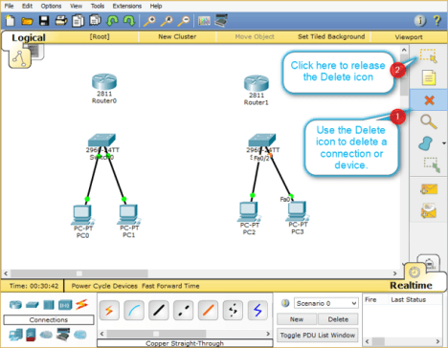
3. Once, you have connected all the PCs to switches, now, connect **Switch0** to **Router0,** and **Switch1** to **Router1** using the straight-through cables.
4. Select the straight-through cable, click on **Switch0**, and then select**FastEthernet0/3** interface.
5. Click **Router0**and select the **FastEthernet0/0** interface.
6. Select again the straight-through cable, click on **Switch1**, and select**FastEthernet0/3** interface.
7. Next, click **Router1** and then select the **FastEthernet0/0** interface.

The following figure displays how to connect routers to switches to create a network topology.

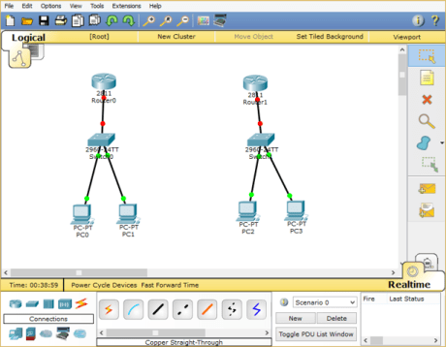

### Interconnecting Routers in Cisco Packet Tracer

Now, connect **Router0** to **Router1** using the serial connection. To do this, you need to perform the following steps:

1. Select the **Serial DCE** cable, click on **Router0,** and select the **Serial1/0** interface.
2. Click on **Router1** and select the **Serial1/0** interface, as shown in the following figure.

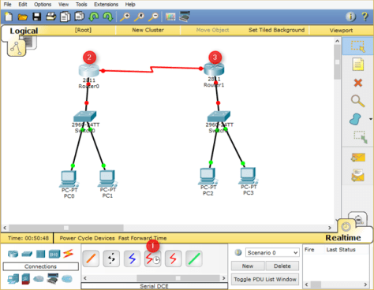

In this post, you have learned how to [create a network topology in Cisco Packet Tracer.](https://protechgurus.com/create-a-network-topology-in-cisco-packet-tracer/) If you wish, you can save the created network topology for the later use. To do this, you need to perform the following steps:

1. In Cisco Packet Tracer, click File, and select **Save** **As**.
2. In the **File name** text box, type a name of the topology, and then click **Save**.
3. **Creation of Network Topology in Cisco Packet Tracer**

**OUTPUT:**

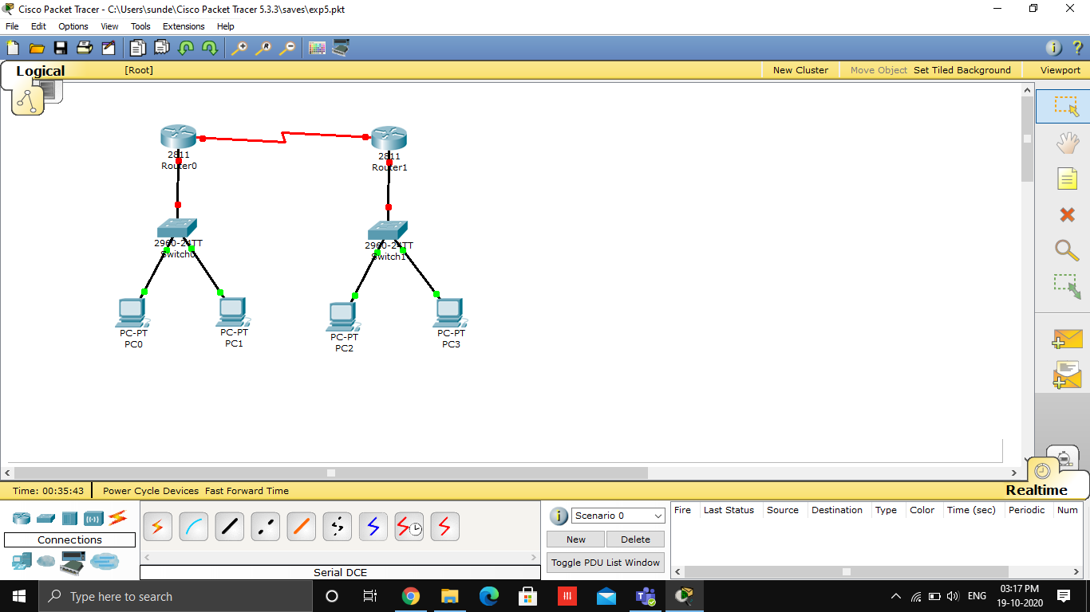

1. **Configure IP addressing, Subnetting, Masking using CISCO packet tracer.**

**PROGRAM and OUTPUT:**

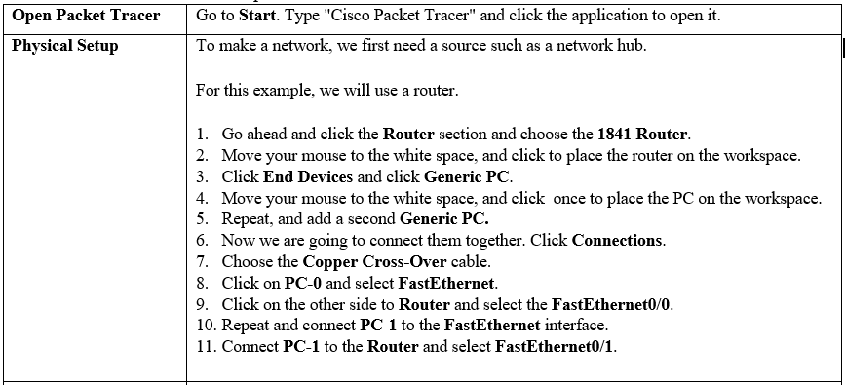

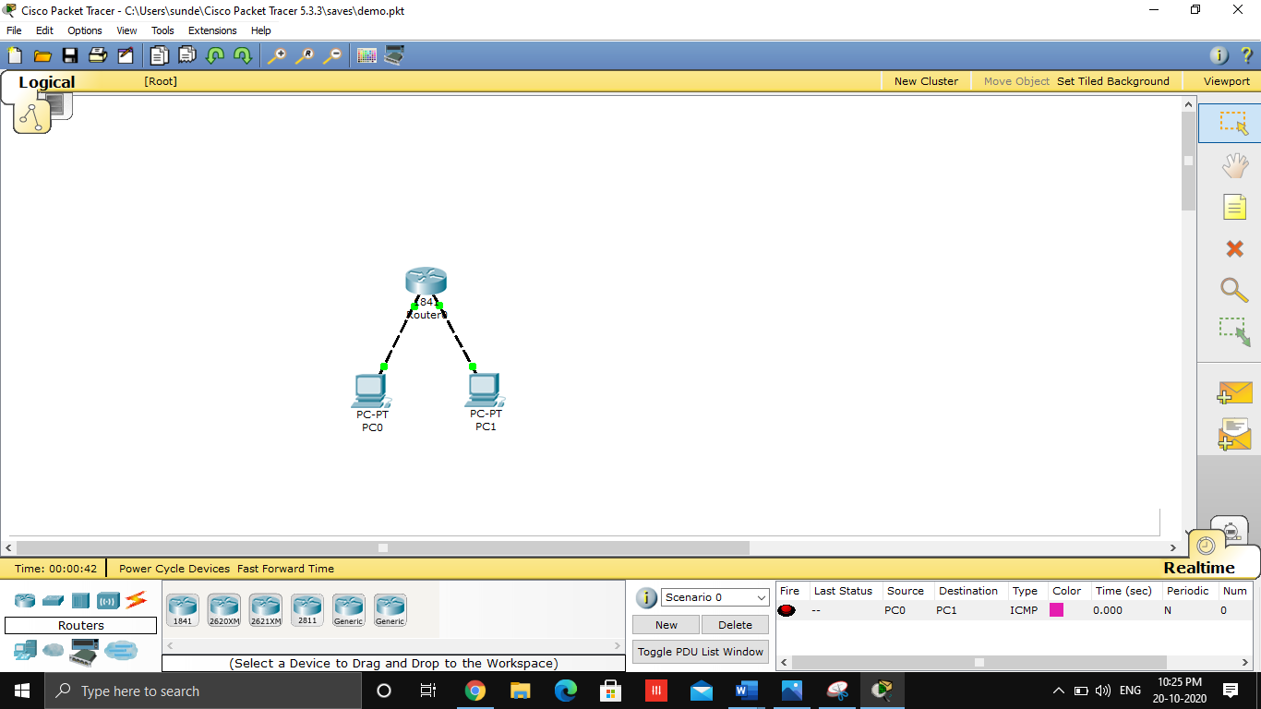

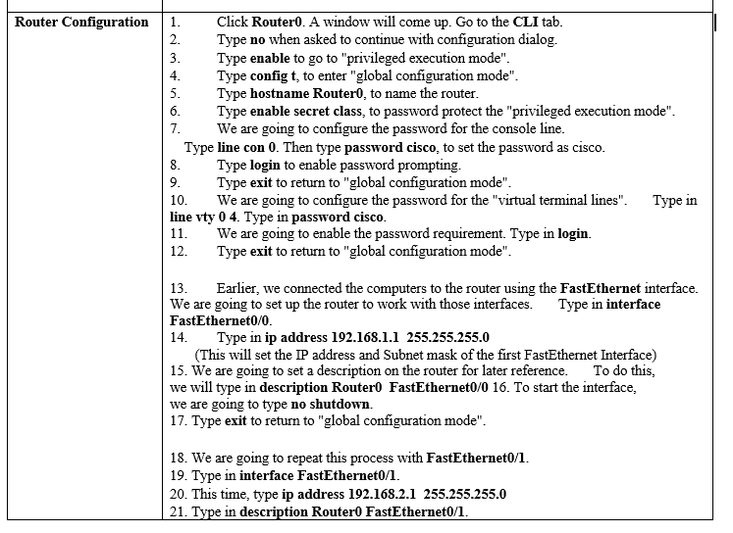

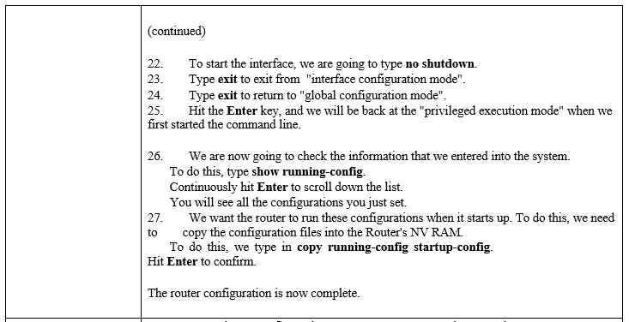

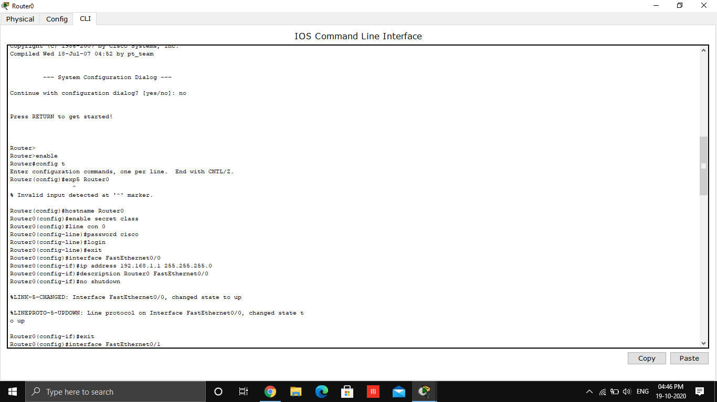

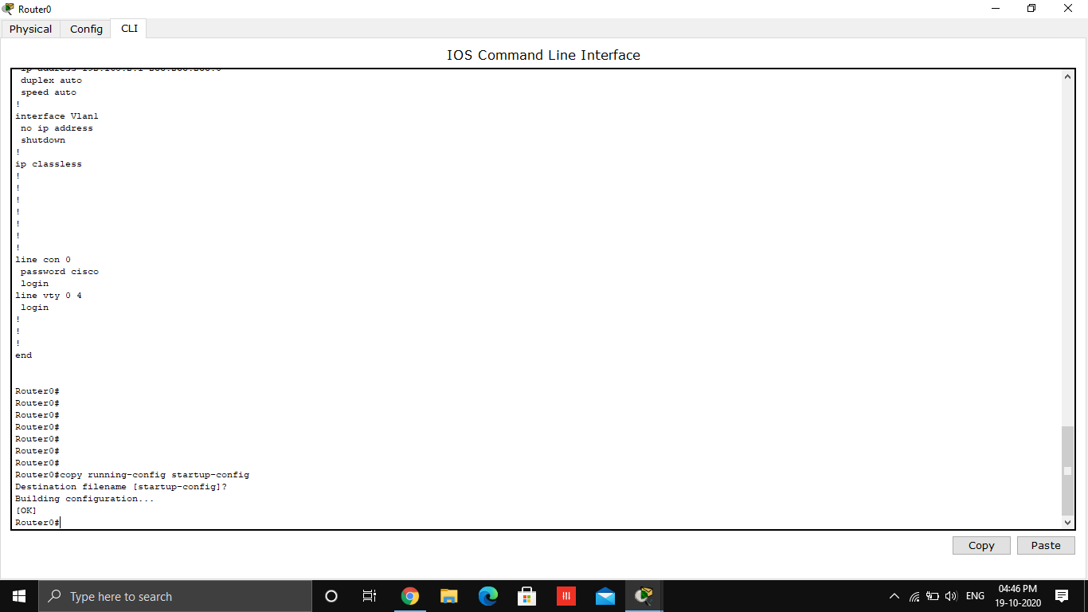

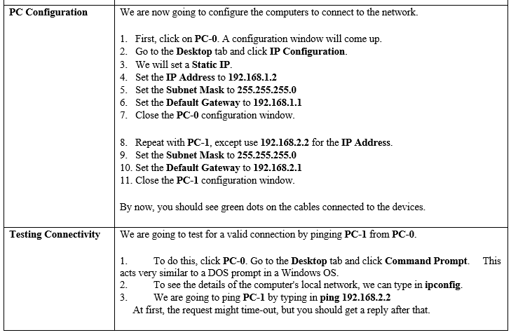

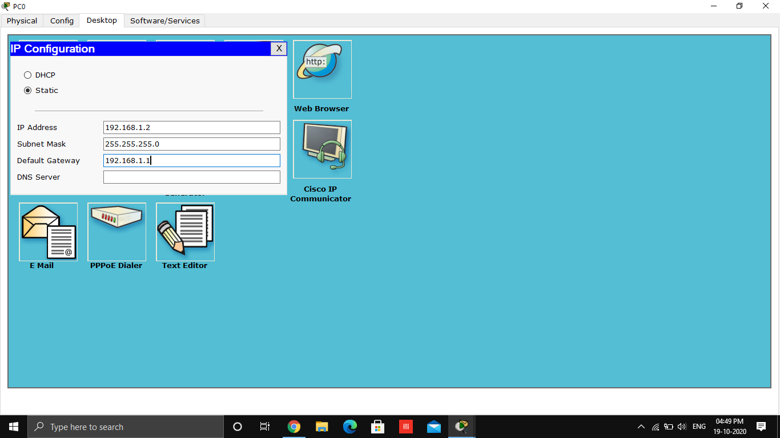

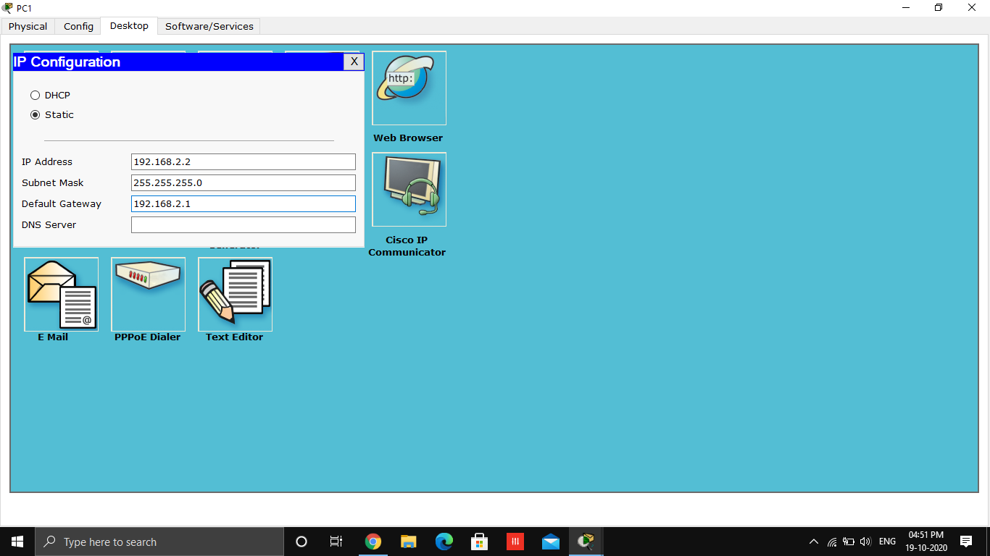

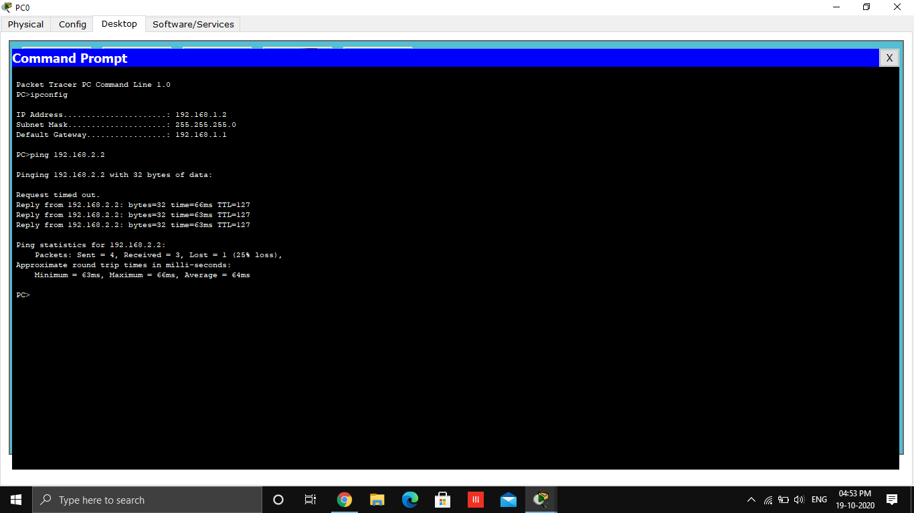

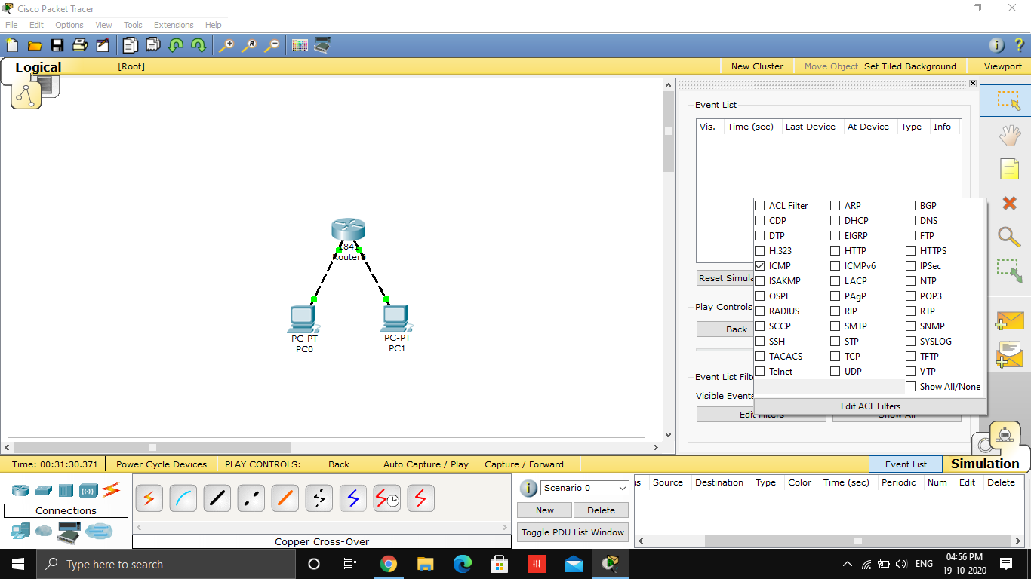

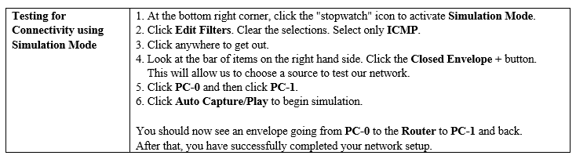

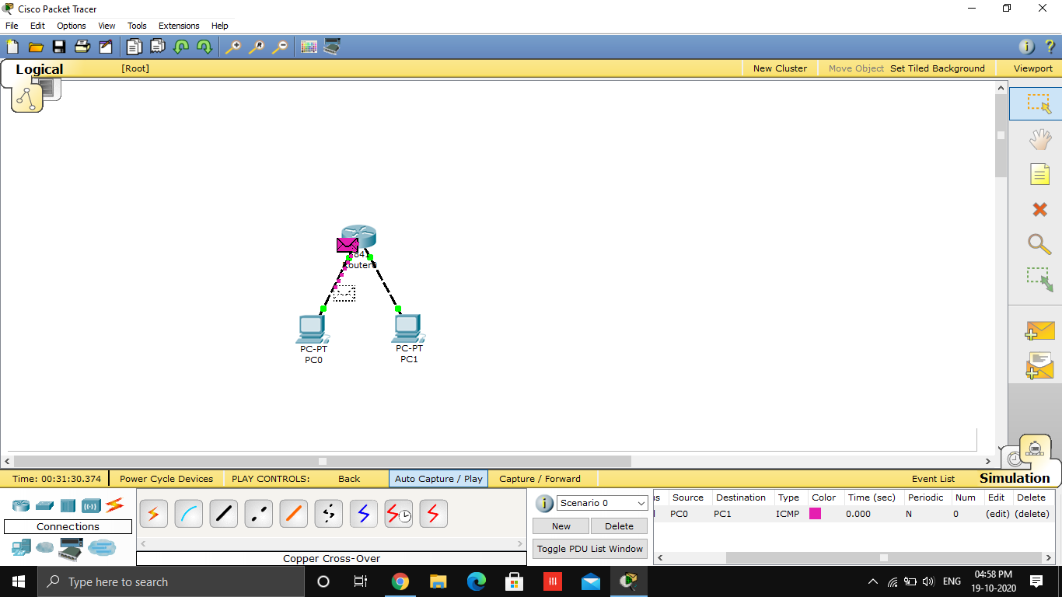

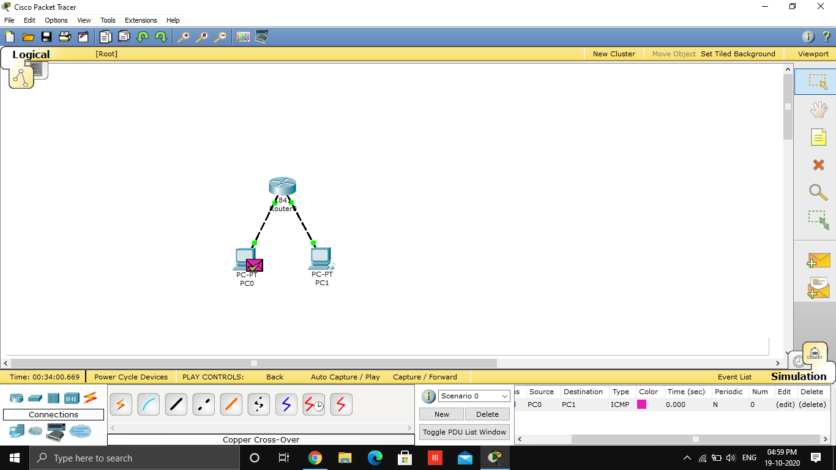

**CONCLUSION:** We have created a Network and Configured IP addressing, Subnetting, Masking using CISCO packet tracer successfully .