**HARSHITHA H MOOLYA**

**118A1048 TE/CE/C3**

**EXPERIMENT NO-5**

**AIM :** Assembly program to find the length of the string

**THEORY :**

String is s series of data byte or word available in memory at consecutive locations. It is either referred as byte string or word string. Their memory is always allocated in a sequential order. Instructions used to manipulate strings are called string manipulation instructions.

|  |  |
| --- | --- |
| **String Instructions used** REP | repeat the given instruction till CX != 0 |
| REPE | repeat the given instruction while CX = 0 |
| MOVSB | moves contents of byte given by DS:SI into ES:DI |
| MOVSW | moves contents of word given by DS:SI into ES:DI |
| CMPSB | compares byte at ES:DI with byte at DS:SI and sets flags |
| CMPSW | compares word at ES:DI with word at DS:SI and sets flags |

**CODE :**

data segment

msg db 'hello$'

len db 0h

data ends

code segment

assume cs:code,ds:data

start:

mov ax,data

mov ds,ax

mov al,'$'

lea si,msg

next:

cmp al,[si]

je done

inc len

inc si

jmp next

done:

mov al,len

add al,30h

mov dl,al

mov ah,2

int 21h

mov ah,4Ch

int 21h

code ends

end start

**OUTPUT :**

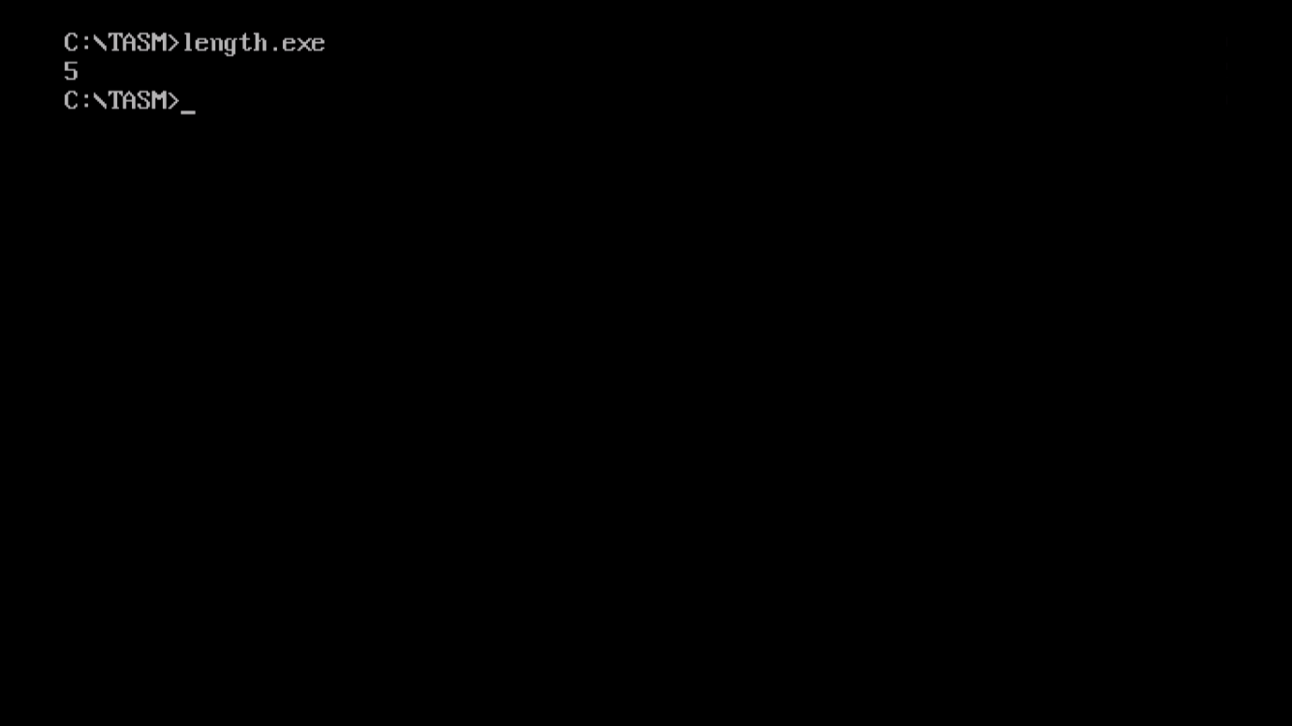

**CONCLUSION :** Length of the string is calculated successfully.