**Installation:**

1. Software needed to be installed are:
2. Python
   * Windows:
     1. <https://www.python.org/downloads/>
     2. Click Download, run the exe, done
   * Linux
     1. Open Terminal
     2. sudo apt-get install python3.6.8
3. pip Installation
   * Windows
     1. Installed with Python package (step not required)
   * Linux
     1. Open Terminal
     2. sudo apt-get install python3-pip
4. OpenCV installation
   * Windows
     1. Open cmd
     2. pip install opencv-python
   * Linux
     1. Open Terminal
     2. pip install opencv-python
5. Text Editor (VS code suggested)

<https://code.visualstudio.com/download>

Refer above link and download the desired version according to your system

1. Pytesseract

* Windows

1. Open cmd
2. pip install pytesseract

* Linux

1. Open cmd
2. sudo apt-get install tesseract-ocr
3. Numpy

* Windows

1. Open cmd
2. pip install numpy

* Linux

1. Open cmd
2. sudo apt install python-numpy
3. PIL
4. For different devices, images maybe stored in different directory.

So in line no. 32 instead of ‘/Users’ you need to put the directory where the image is saved.

initialdir ='/Users'

1. In line 10, you need to copy the location where pytesseract is installed and replace it with ,

C:\Program Files (x86)\Tesseract-OCR\tesseract.exe

**Working of GUI app:**

This application can be used as OCR-Scanner App. Various functions in this application are as follows:

1. Open Image :

It opens the image you want to work with. Just select the desired image and click ‘Open’.

1. Resize Image :

Using this, you can resize the image in whatever size you want. This is more useful when the image is too big to fit in the screen. You will be asked to enter width and height in pixels for the resized image.

1. Auto Crop:

It will detect edges according to large change of colour (contrast) and automatically cropped and wrapped in the size 540 x 700 pixels. It works well, if inputted a paper on a table or dark background.

1. Manual Crop :

You will have to manually select 4 points in clockwise direction in Image window. It will cropped and wrapped in the size 540 x 700 pixels.

1. Scan Effect :

It will bring the scanned ‘Black and white’ effect on the image.

1. Rotate Left :

It will rotate the Image in 90° counter clockwise direction.

1. Rotate Right:

It will rotate the Image in 90° clockwise direction.

1. Blur Image :

It will blur the image.

1. OCR:

It will find English characters and highlighting it by drawing a green box around it.

1. Show Text :

It will show up the text in the textbox which it can identify from the image.

1. Show Original :

It will display original image.

1. Save Image:

It will save the image with last edit.

1. Close Window :

It will close all the windows along with its own. It can be used to close the application

**Snapshots of app:**

Main Screen:

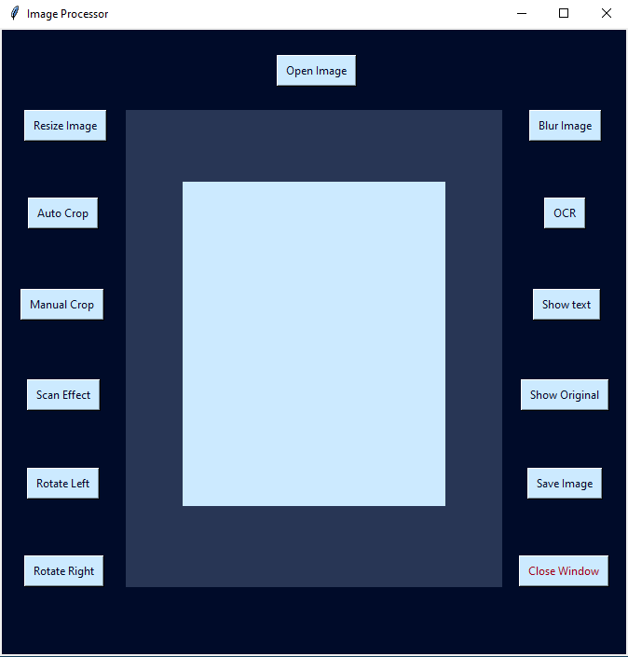

Resize Image :

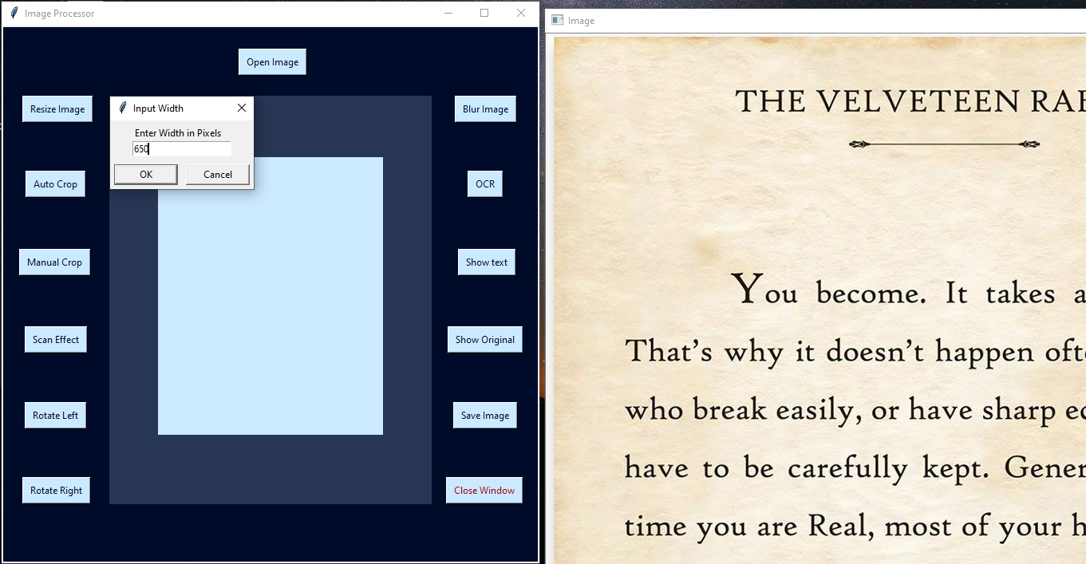

Scan Effect :

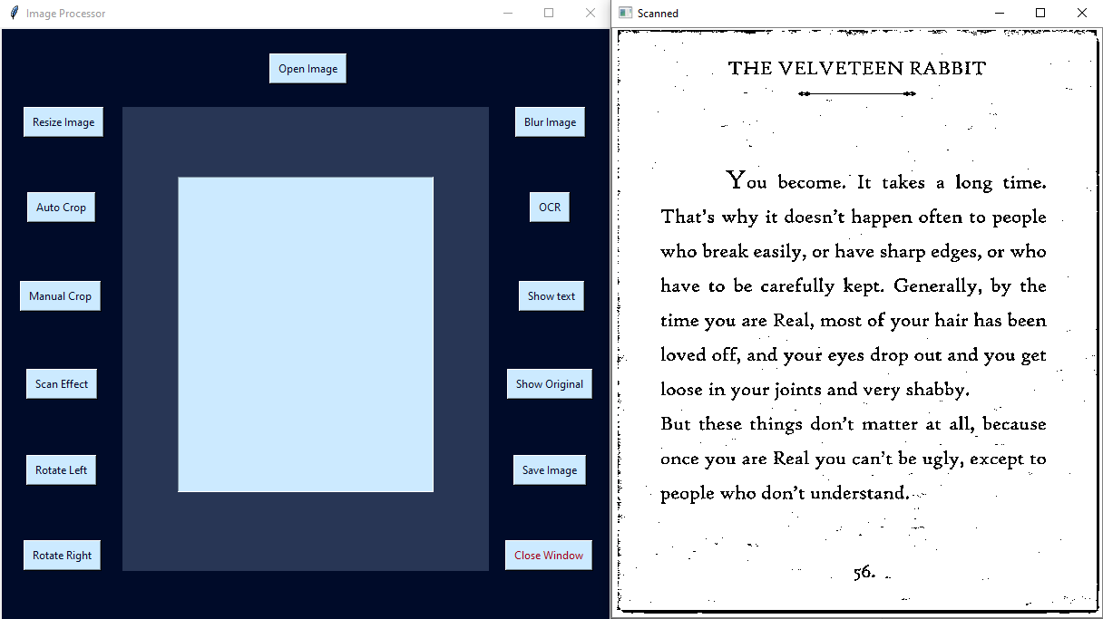

OCR :

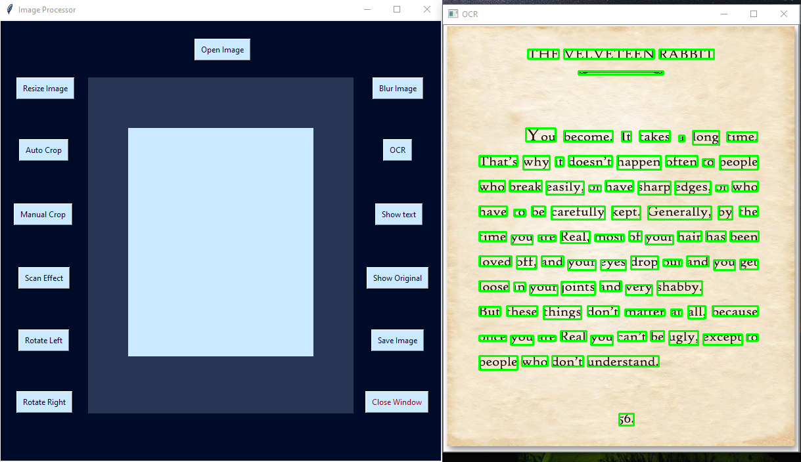

Show Text:

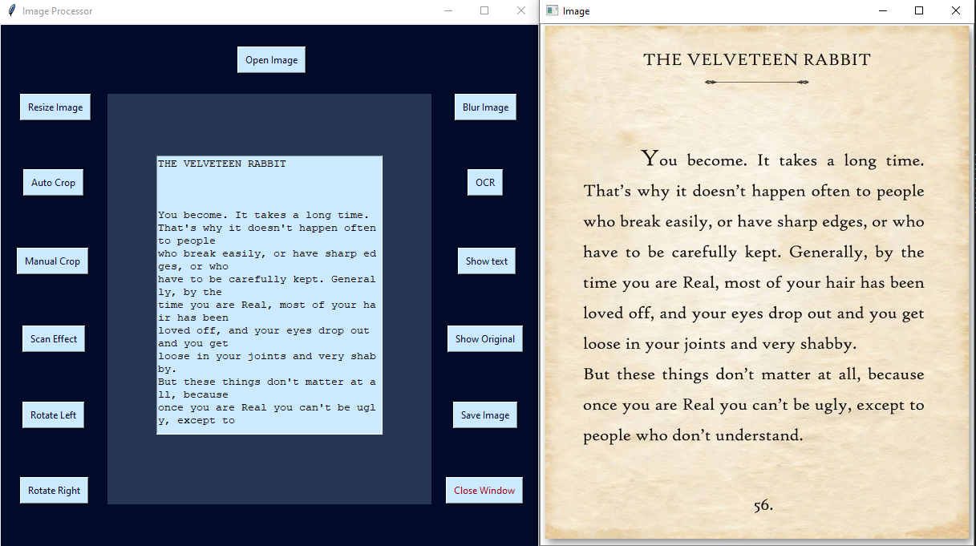

Blur Image:

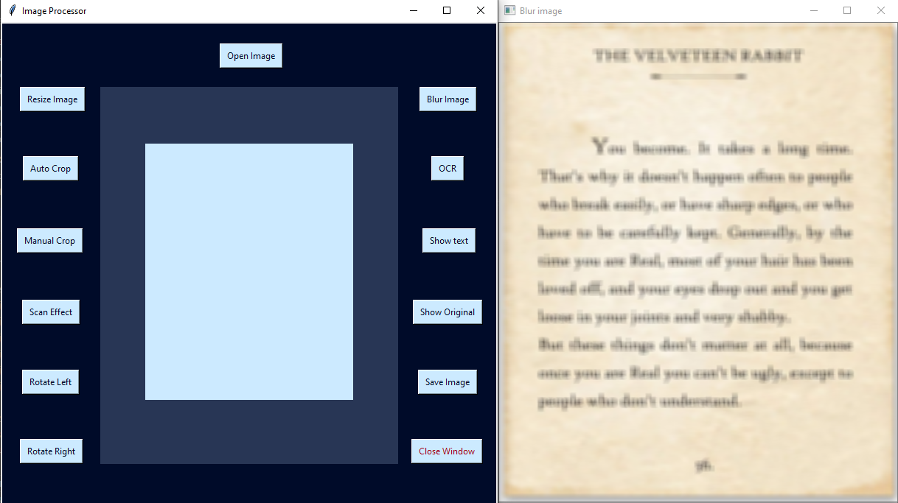

Auto Crop :

Original img:

