IAM
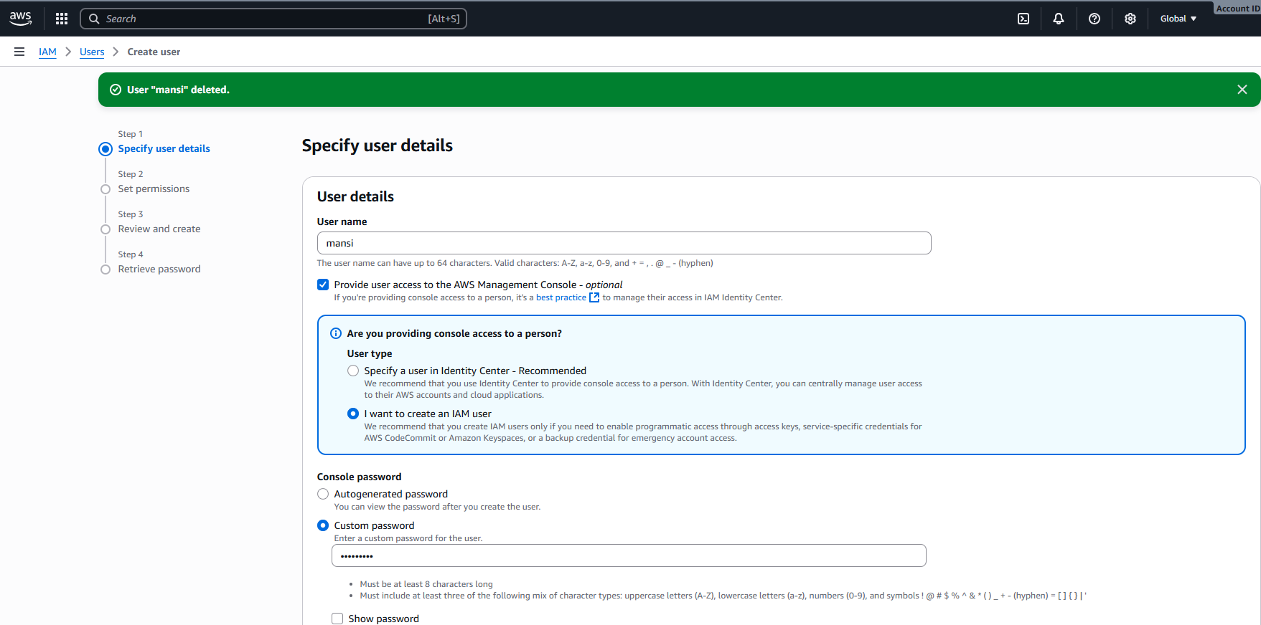
AWS "Create User" – Step 1: Specify User Details
- User Name: Must be 1–64 characters; letters, numbers, and select symbols allowed.
- Access Options:
  - Option to enable AWS Management Console access.
  - Prompt to choose between:
  - Identity Center user (recommended for centralized access management).
  - IAM user (for direct programmatic and console access).
- Password Setup:
  - Choose between autogenerated or custom password (min. 8 characters).
  - Checkbox to force password reset on first sign-in.
- Notification: A previous user named "manut" was deleted.

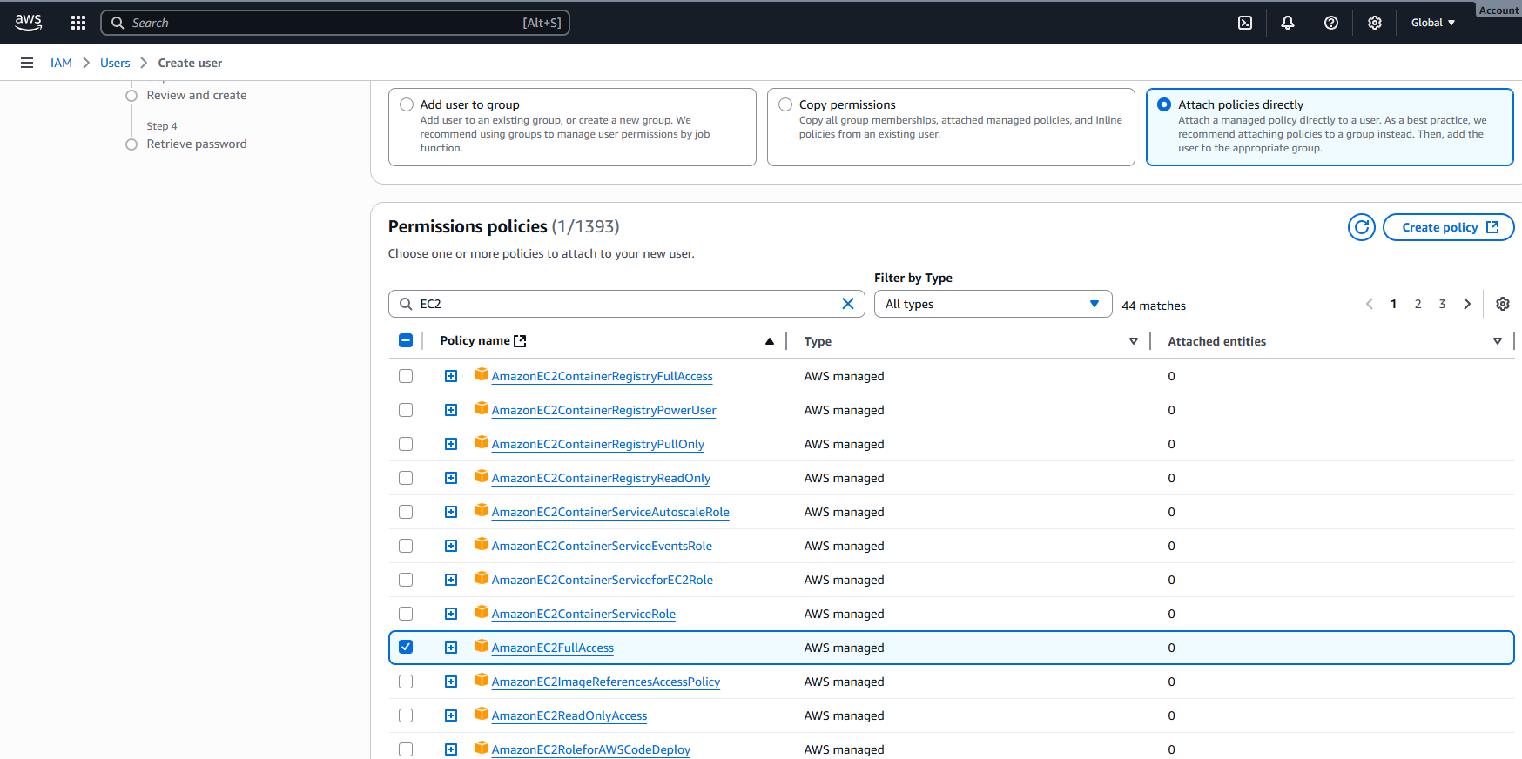
AWS "Create User" – Step 2: Set Permissions (Filtered for EC2)
- Search Filter: "EC2" used to display policies related to Amazon EC2 services.
- Policy List: Shows AWS-managed permission policies like:
  - AmazonEC2FullAccess (highlighted)
  - AmazonEC2ReadOnlyAccess
  - AmazonEC2ContainerRegistryFullAccess, etc.
- Assignment Options:
  - Add user to a group
  - Copy permissions from an existing user
  - Attach policies directly (current method)
- ✅ Highlighted Policy: AmazonEC2FullAccess grants full access to EC2 resources.

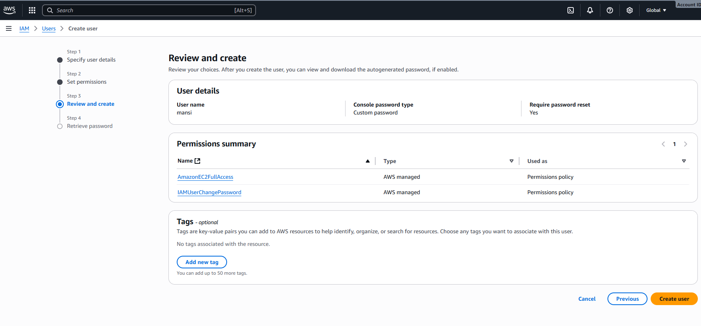
AWS "Create User" – Step 3: Review and Create
- User Details:
  - Username: test
  - Password Type: Custom password
  - Password Reset Required: No
- Permissions Assigned:
  - AmazonEC2FullAccess – Full access to EC2 resources (AWS managed)
  - IAMUserChangePassword – Allows user to change their own password (AWS managed)
- Tags:
  - Optional key-value pairs for organizing resources
  - Button available to Add new tag
- Next Step: Click "Create user" to finalize setup
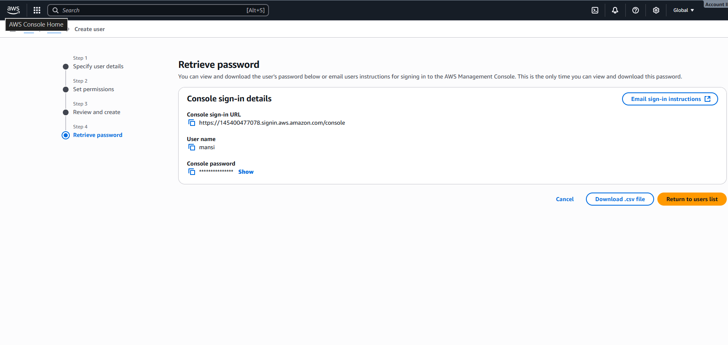
AWS "Create User" – Step 4: Retrieve Password
- User Info:
  - Username: mansi
  - Console Sign-in URL:
https://645347070173.signin.aws.amazon.com/console
  - Password: Hidden (with option to reveal)
- Actions Available:
  - 📧 Email sign-in instructions
  - 📄 Download .csv file with credentials
  - 🔙 Return to users list
- Workflow Navigation:
- This is the final step after specifying details, setting permissions, and reviewing.

