EC2
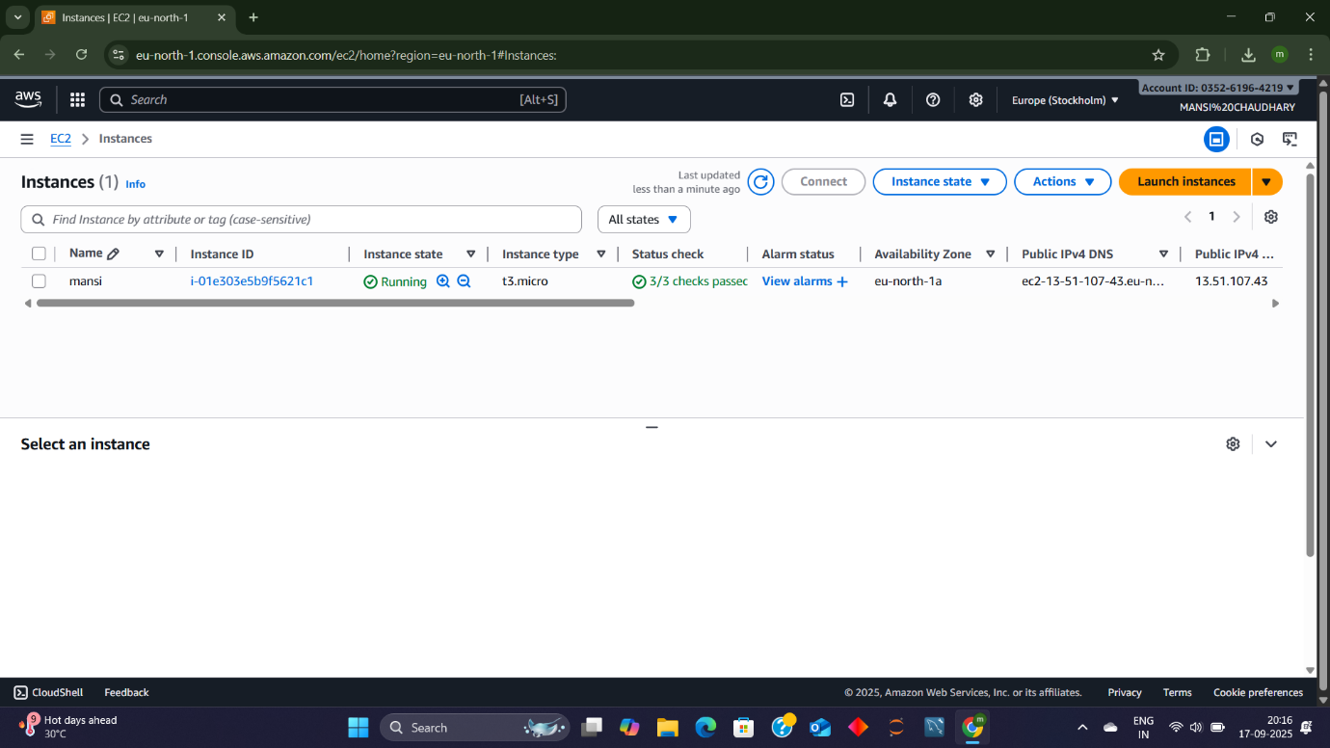
AWS EC2 Instance Summary: MANSI
🔹 Instance Details
- Instance Name: MANSI
- Instance ID: i-0e1d2b5d9695f2c11
- Instance Type: t3.micro
- Availability Zone: eu-north-1a
- State: Running ✅
- Status Checks: 2/2 Passed
🌐 Networking
- Public IPv4 Address: 15.150.107.46
- Public DNS: ec2-15-150-107-46.eu-north-1.compute.amazonaws.com
📊 Monitoring
- Alarm Status: View alarms (no active alerts shown)
- 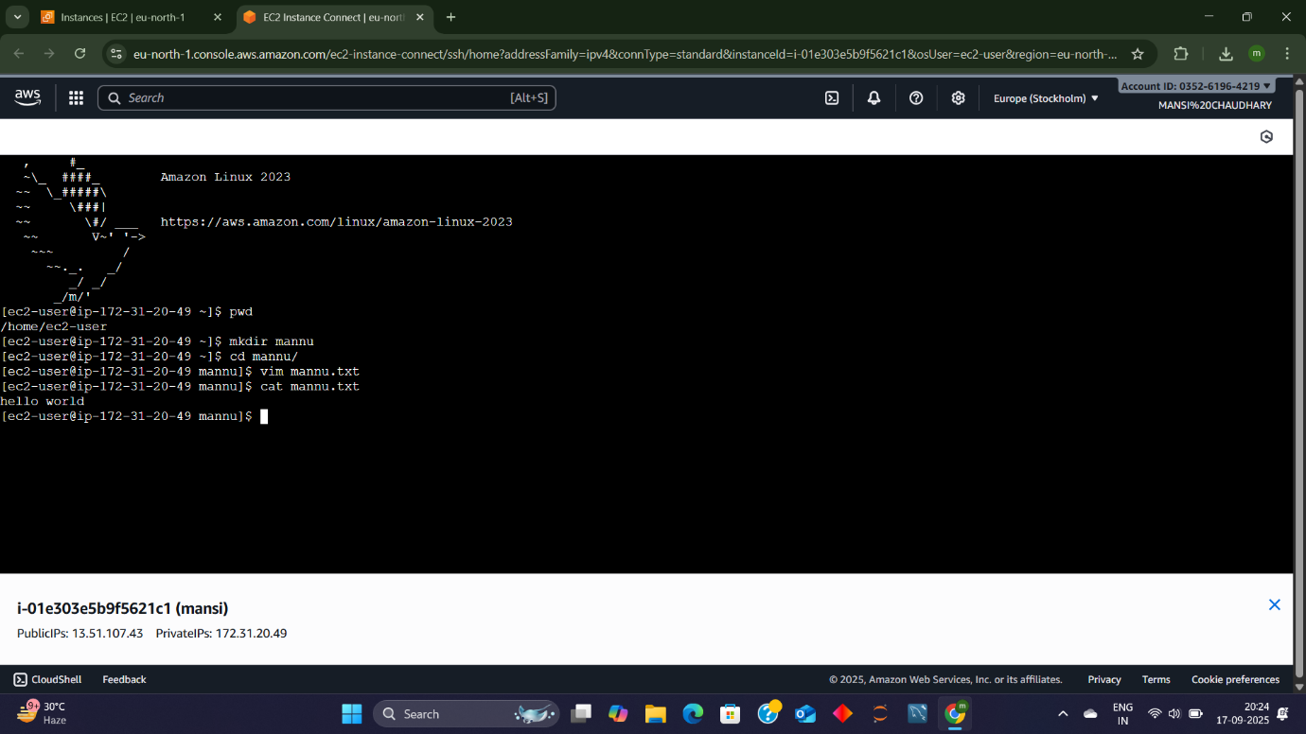
Environment Details
- User: ec2-user
- Operating System: Amazon Linux 2023
- Instance IP (Private): 172.31.0.25
- Current Directory: /home/ec2-user
📂 Command Line Activity
- Navigated to folder: mannu
- Listed contents:
- mannu.txt

