Phase 2 Screenshots for step 5
5a Registartion type spilt
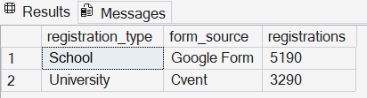
5b Blank or missing values per column

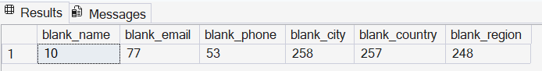

5c Country spellings (shows the USA / US / United States problem)
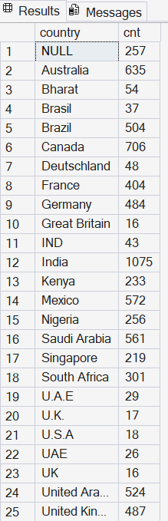
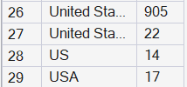
5d Institution fields: both filled, neither filled
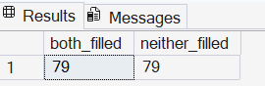

5e Emails that clearly fail a basic pattern
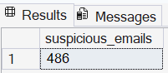

5f Institution names that do not match the reference list exactly
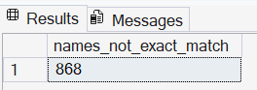

5g Exact duplicate rows ignoring the registration ID
290 rows

Conclusion : about 7% of emails are invalid, about 10% of institution names do not match the official list, and there are duplicate registrations

Power BI Pages Screenshots
Page 1: Overview
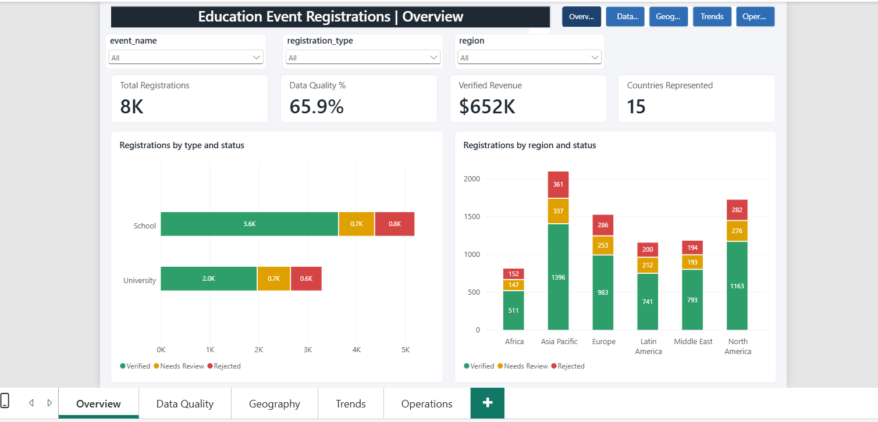

Page 2: Data Quality
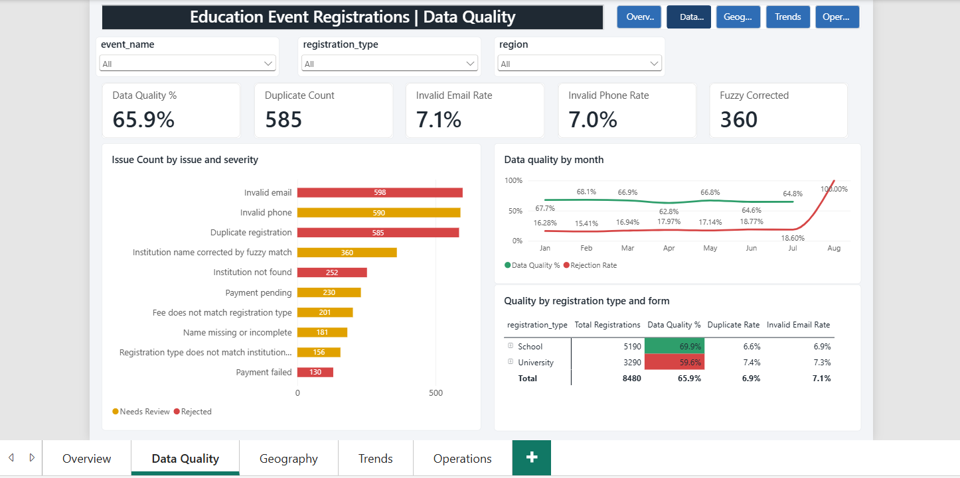

Page 3: Geography
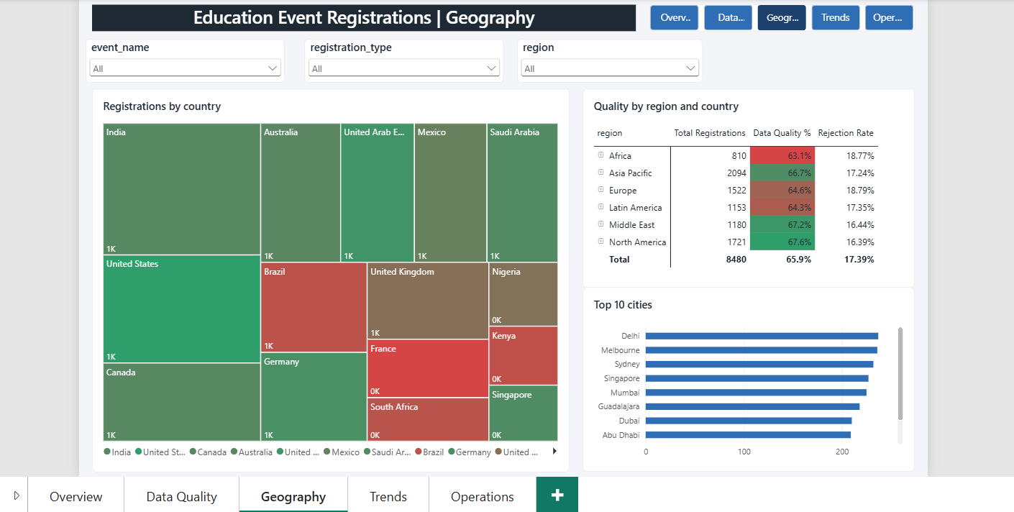

Page 4: Trends
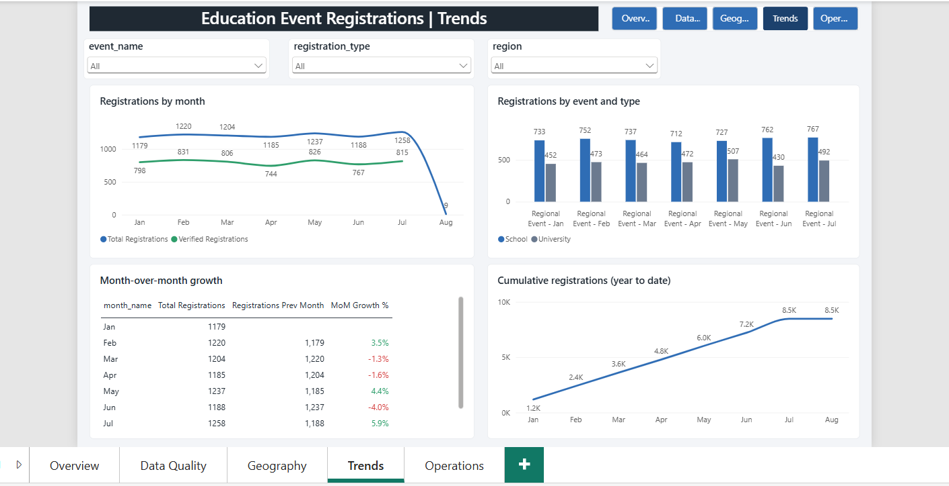

Page 5: Operations
