Team ID : 212
Title : Heart Disease Analysis
Introduction
Heart disease is one of the leading causes of death worldwide and poses a significant challenge to global healthcare systems. Cardiovascular diseases include conditions such as coronary artery disease, heart attack, arrhythmia, and heart failure. According to global health studies, millions of people suffer from heart-related illnesses every year. Many of these cases can be prevented or managed effectively if risk factors are identified early. Factors such as high cholesterol, high blood pressure, smoking habits, lack of physical activity, obesity, diabetes, and age are major contributors to heart disease.
In modern healthcare systems, hospitals and medical organizations collect large volumes of patient data. This data includes demographic information, laboratory test results, diagnostic measurements, and treatment records. Although these datasets contain valuable information, analyzing them in raw format can be difficult. Large datasets with multiple attributes often require analytical tools to interpret patterns and trends effectively.
Data analytics and visualization play an important role in healthcare decision-making. By transforming raw data into visual representations such as charts, graphs, and dashboards, it becomes easier for healthcare professionals, researchers, and analysts to understand complex datasets. Visualization tools allow users to identify patterns, correlations, and anomalies in data that might otherwise remain hidden.
This project focuses on analyzing heart disease data using Tableau, which is a widely used data visualization tool. Tableau enables users to create interactive dashboards and visualizations that help explore large datasets efficiently. The aim of this project is to analyze a heart disease dataset and present the insights using an interactive Tableau dashboard.
The dashboard allows users to explore relationships between different medical parameters such as age, cholesterol level, blood pressure, and heart rate. Through visualizations, the project demonstrates how data analytics can be used to understand health risks and patterns associated with heart disease.

2. Problem Statement
Healthcare organizations generate large amounts of data from patient records, diagnostic tests, and medical research. While this data can be extremely useful for identifying disease patterns and improving treatment strategies, analyzing it manually is challenging.
Heart disease datasets often contain numerous attributes related to patient health conditions. These attributes may include age, sex, blood pressure, cholesterol level, electrocardiographic results, heart rate, and exercise-related measurements. When this information is presented in the form of tables or spreadsheets, it becomes difficult to interpret the relationships between these variables.
Another challenge is identifying patterns that indicate the presence or risk of heart disease. Without appropriate tools, healthcare professionals may find it difficult to quickly analyze trends or correlations in patient data. This may limit the ability to make data-driven decisions in healthcare management.
Therefore, there is a need for an analytical approach that can convert raw medical data into meaningful insights. Data visualization tools provide a solution by transforming numerical data into graphical representations that are easier to understand.
The problem addressed in this project is to analyze heart disease data and develop an interactive dashboard that presents the information in a clear and visually appealing manner. The dashboard will allow users to explore the dataset and understand the impact of different medical parameters on heart disease.
By using Tableau for visualization, the project aims to simplify the interpretation of healthcare data and support better analysis of heart disease patterns.

3. Objectives
The main objective of this project is to analyze heart disease data and present the results through an interactive visualization dashboard. Data visualization helps convert complex numerical datasets into graphical representations that are easier to interpret.
The first objective is to collect and study a heart disease dataset that contains medical attributes related to cardiovascular health. Understanding the dataset is important to identify the key parameters that influence heart disease.
The second objective is to perform data preprocessing and cleaning to ensure that the dataset is accurate and consistent. Data cleaning is a crucial step because incomplete or incorrect data can affect the accuracy of the analysis.
Another objective is to use Tableau to create visualizations that represent relationships between different attributes in the dataset. These visualizations may include bar charts, pie charts, scatter plots, and line graphs. Each type of chart provides insights into different aspects of the dataset.
The project also aims to design an interactive dashboard that combines multiple visualizations into a single interface. The dashboard should allow users to interact with filters and explore the dataset dynamically.
Finally, the project aims to analyze the results obtained from the dashboard and identify patterns related to heart disease risk. By studying these patterns, the project demonstrates how data analytics can support healthcare analysis and decision-making.

4. System Architecture
The system architecture represents the overall structure and workflow followed in the project. It describes how the data moves from the dataset stage to the final visualization dashboard.
The process begins with data collection, where the heart disease dataset is obtained from a reliable source. The dataset contains medical information about patients and their heart health conditions.
The next step is data preprocessing, where the dataset is cleaned and prepared for analysis. During this stage, missing values are handled, duplicate records are removed, and incorrect entries are corrected.
After cleaning the data, the dataset is imported into Tableau. Tableau is used to analyze the dataset and create visual representations of the data.
Once the dataset is loaded, different visualizations are created to represent relationships between variables. These visualizations help in understanding trends and patterns within the dataset.
The visualizations are then combined into an interactive dashboard. The dashboard integrates multiple charts and graphs so that users can explore the data from different perspectives.
Finally, the dashboard is published or deployed online, allowing users to access and interact with the visualizations.
System Flow:
Problem Identification
↓
Data Collection
↓
Data Cleaning
↓
Data Visualization using Tableau
↓
Dashboard Creation
↓
Result Analysis
5. Technology Stack
The technology stack used in this project includes software tools and technologies that support data analysis and visualization.
Tableau is the primary tool used for this project. It is a powerful data visualization software that enables users to create interactive dashboards and charts. Tableau supports various types of visualizations and provides features such as filters, parameters, and calculated fields.
The dataset used in the project is stored in CSV format. CSV (Comma-Separated Values) files are widely used for storing tabular data because they are simple and compatible with many software tools.
Basic data analytics techniques are used to analyze the dataset and identify relationships between variables. These techniques involve studying patterns, distributions, and correlations within the data.
For sharing the results, the dashboard can be published online using Tableau Public or other hosting platforms. This allows users to access the dashboard through a web browser and interact with the visualizations.
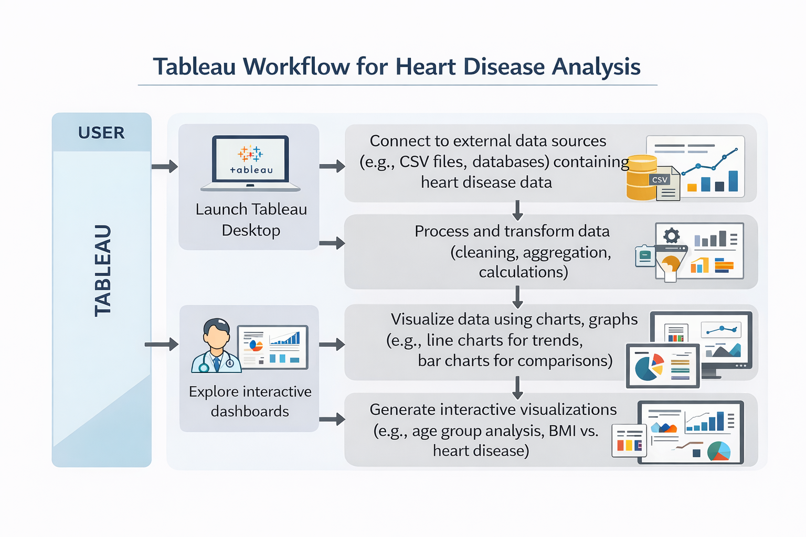

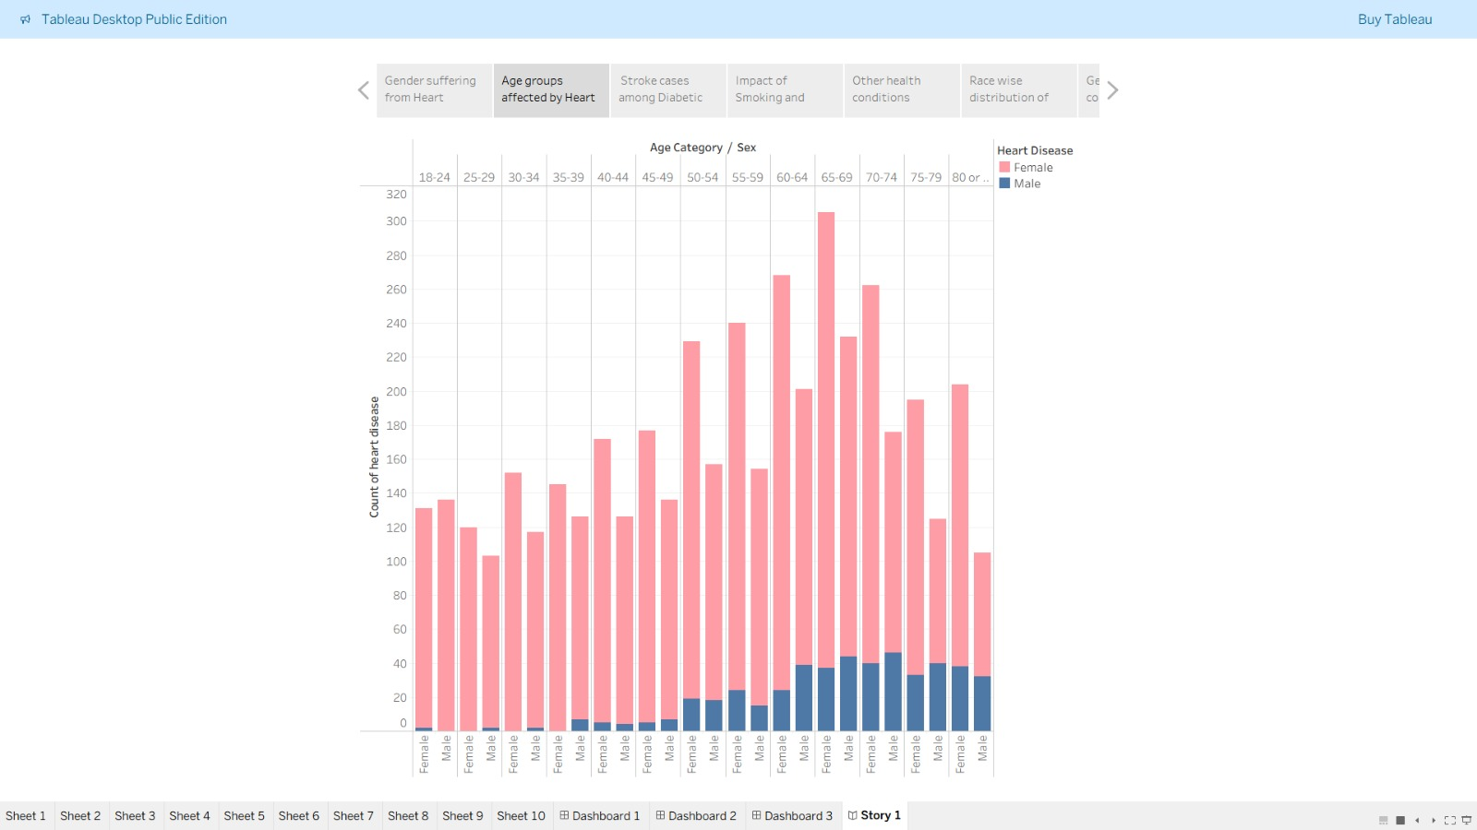
Graph 1.
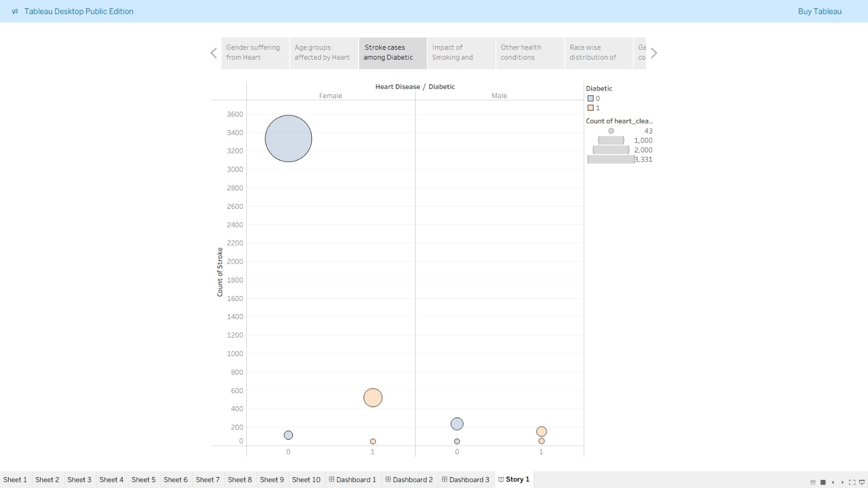
Graph 2.
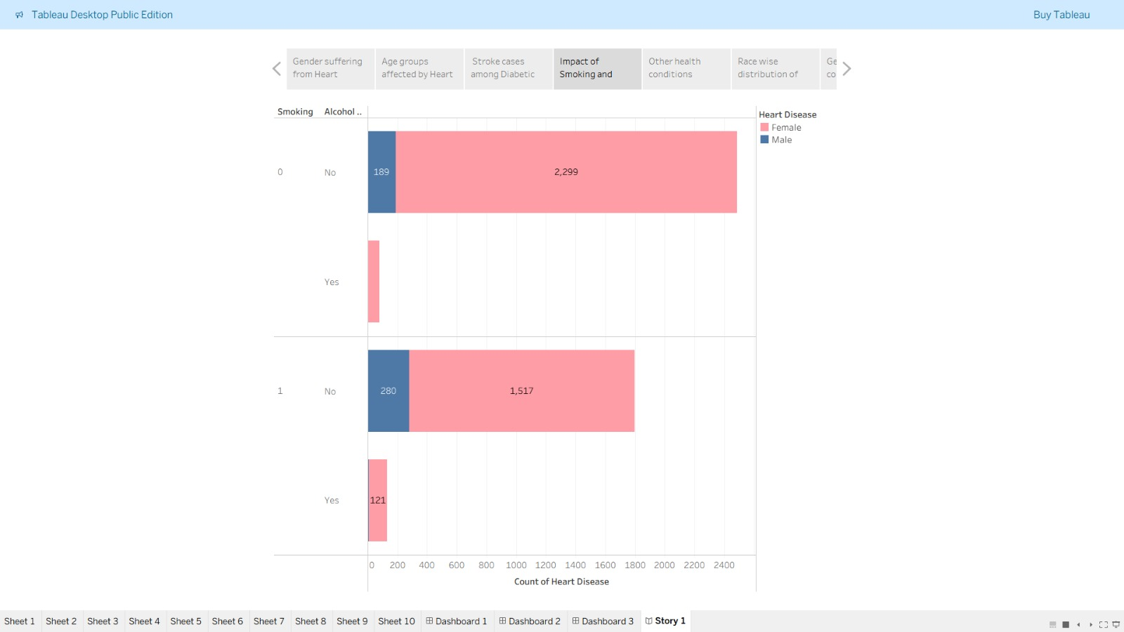
Graph 3.
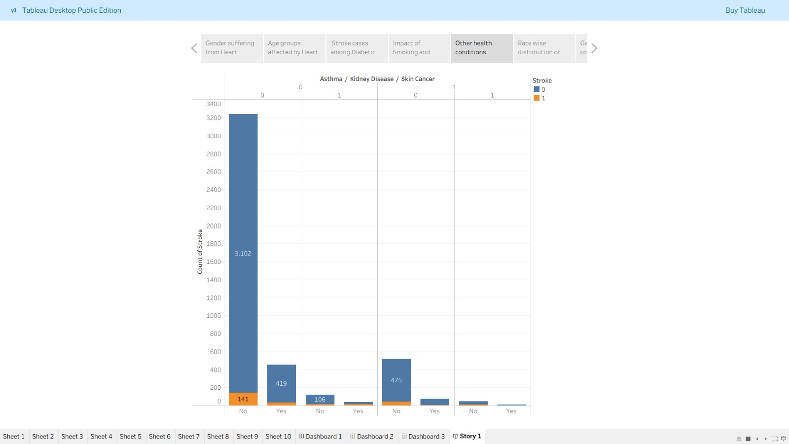
Graph 4.
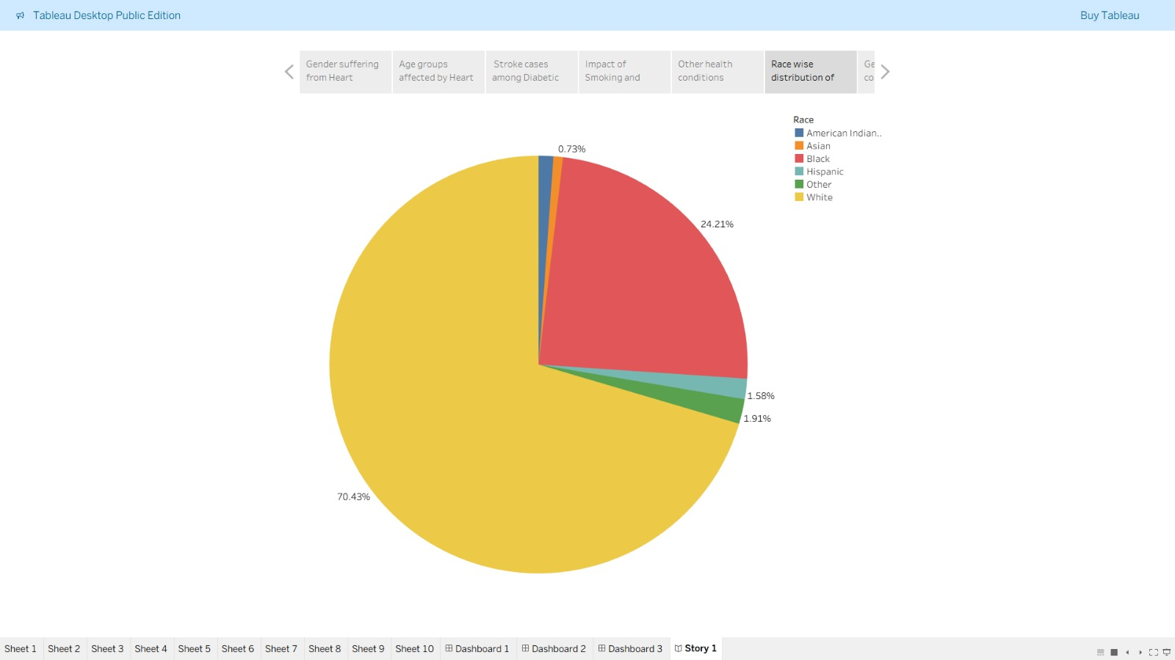
Graph 5.
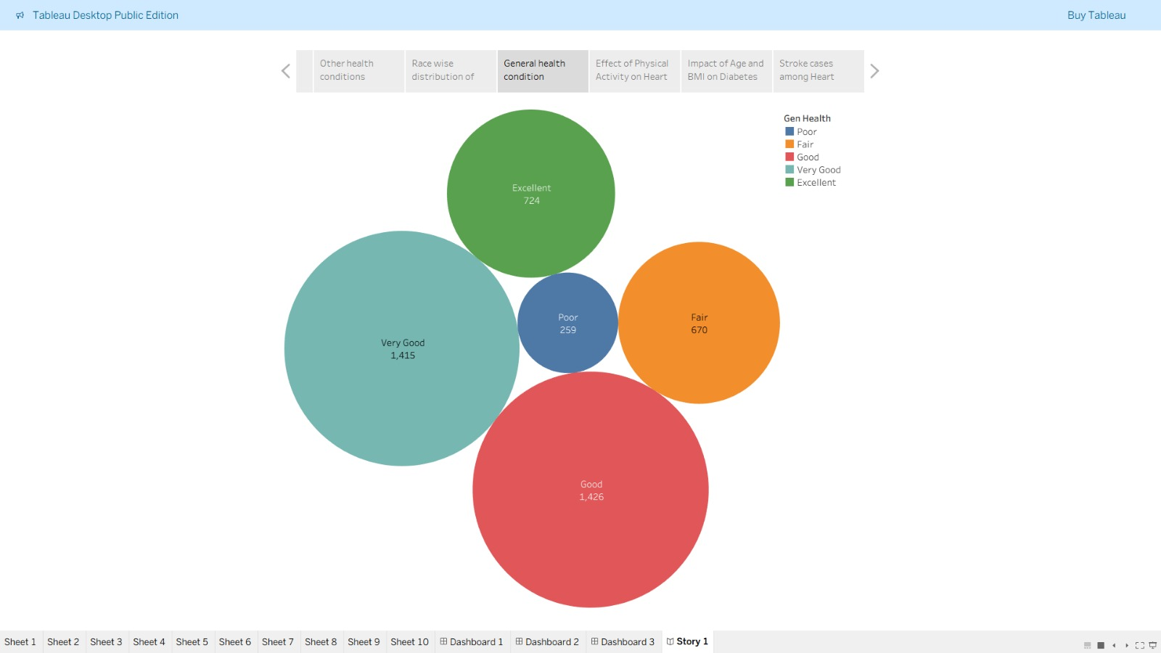
Graph 6.
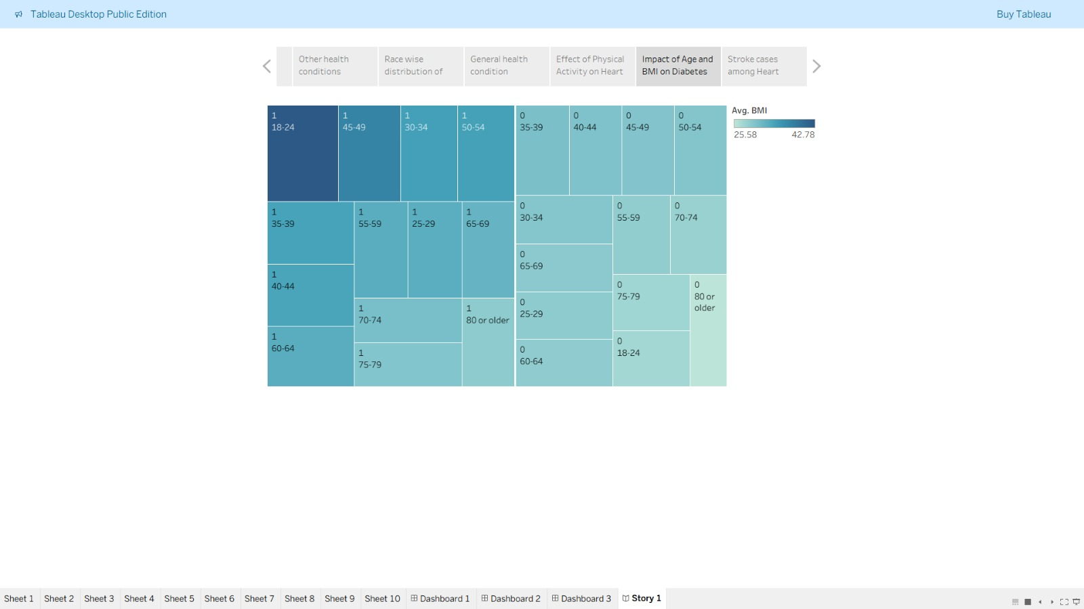
Graph 7.
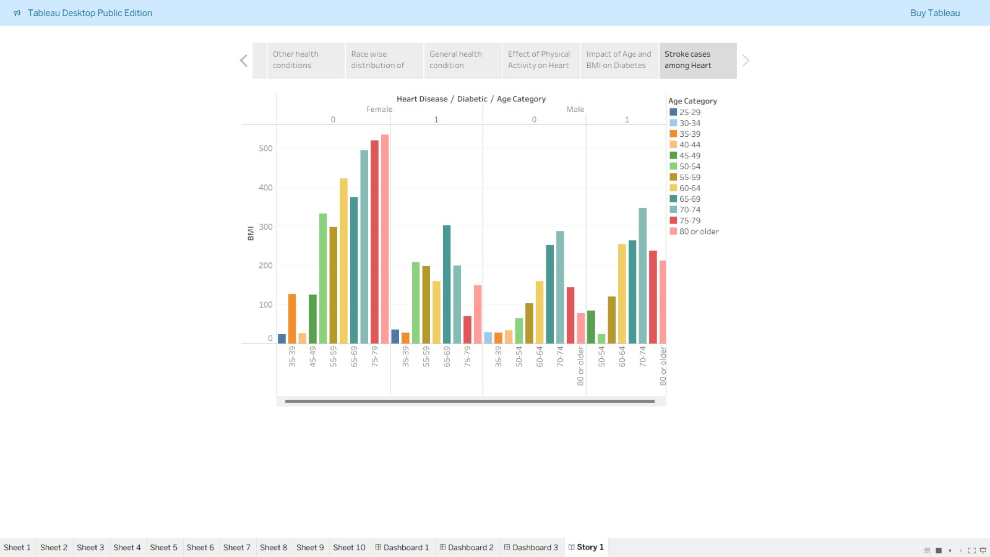
Graph 8.

6. Dataset Description
The dataset used in this project contains information about patients and their heart disease status. It includes several medical attributes that are commonly used to analyze cardiovascular health.
Each record in the dataset represents a patient and contains measurements related to their health condition. These attributes help determine whether a patient has heart disease or not.
Some of the important attributes in the dataset include age, sex, chest pain type, resting blood pressure, cholesterol level, fasting blood sugar, electrocardiographic results, maximum heart rate, and exercise-induced angina.
The dataset also includes a target variable that indicates whether the patient has heart disease. A value of 1 represents the presence of heart disease, while a value of 0 represents the absence of the disease.
This dataset provides valuable information for analyzing how different medical parameters influence the risk of heart disease.
7. Implementation Steps
The implementation of the project follows a systematic process starting from problem identification to dashboard creation.
The first step was identifying the need to analyze heart disease data using visualization techniques. Understanding the problem helped determine the approach for the project.
Next, the heart disease dataset was collected from an online data repository. The dataset contained multiple attributes related to cardiovascular health.
After collecting the dataset, the data cleaning process was performed. This step involved checking for missing values, correcting incorrect entries, and ensuring that the dataset was properly formatted.
Once the data was cleaned, it was imported into Tableau. Tableau automatically detects the structure of the dataset and allows users to create visualizations using drag-and-drop features.
Different types of charts were then created to represent relationships between variables. These charts provided insights into the dataset and helped identify patterns.
Finally, the visualizations were combined into an interactive dashboard that allows users to explore the dataset dynamically.
8. Dashboard Explanation
The dashboard created in this project contains multiple visualizations that help analyze heart disease data.
One of the key visualizations is the age distribution chart, which shows how heart disease cases vary across different age groups.
Another visualization is the gender distribution chart, which compares the number of male and female patients affected by heart disease.
The dashboard also includes a cholesterol analysis chart that shows how cholesterol levels influence heart disease risk.
The chest pain type chart displays the relationship between different chest pain categories and the occurrence of heart disease.
In addition, the dashboard includes a maximum heart rate analysis chart, which helps understand how heart rate is related to heart disease diagnosis.
Filters are included in the dashboard so that users can interact with the data and analyze specific parameters.
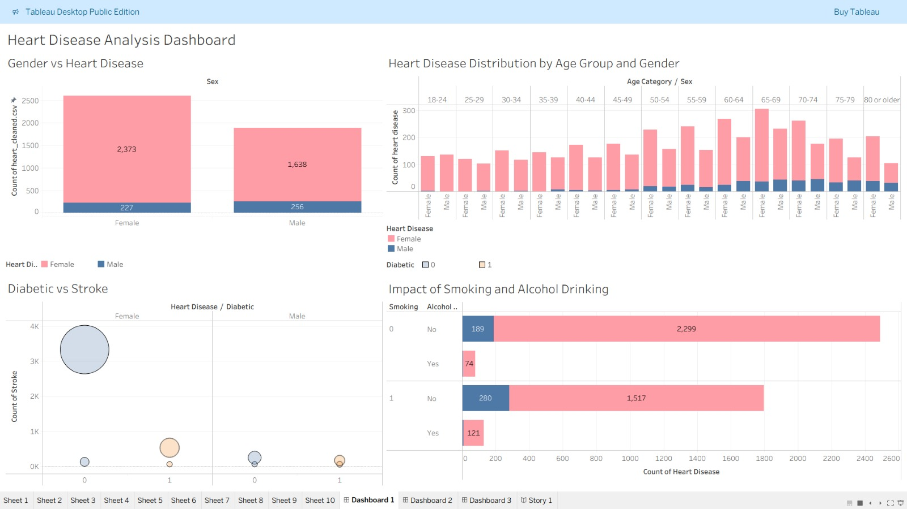
Dashboard 1

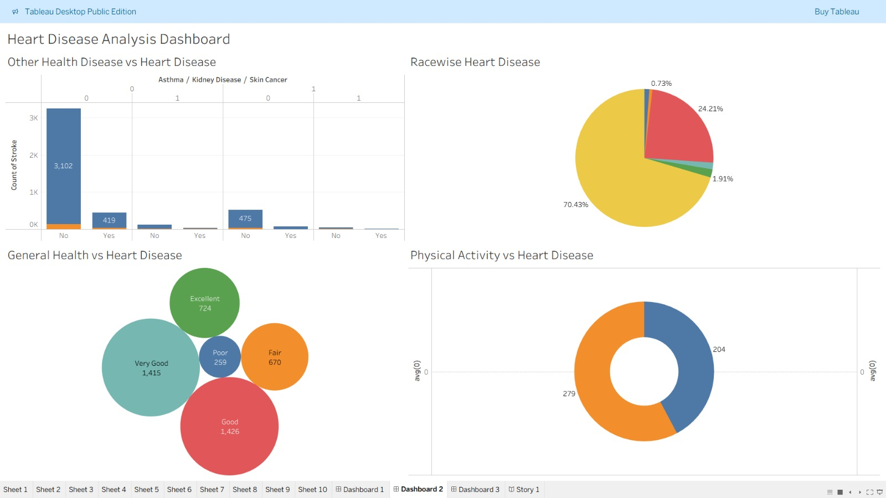
Dashboard 2
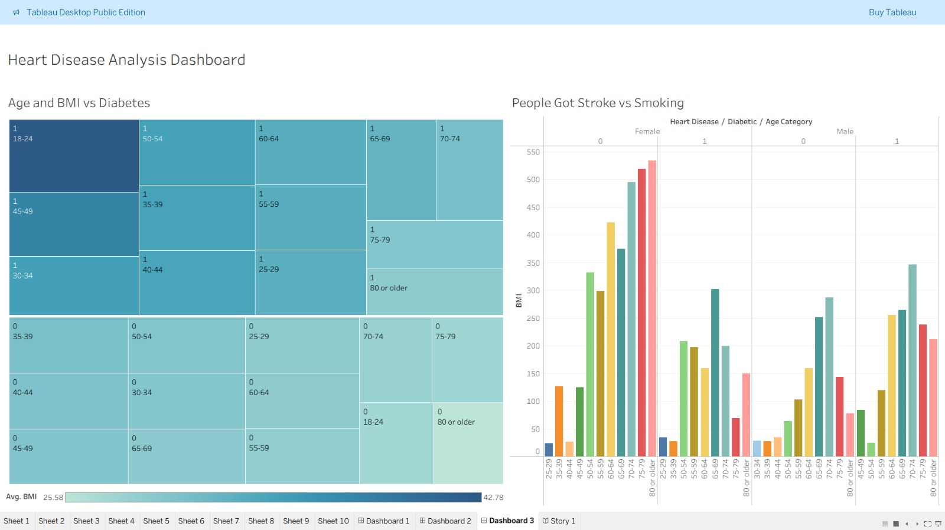
Dashboard 3
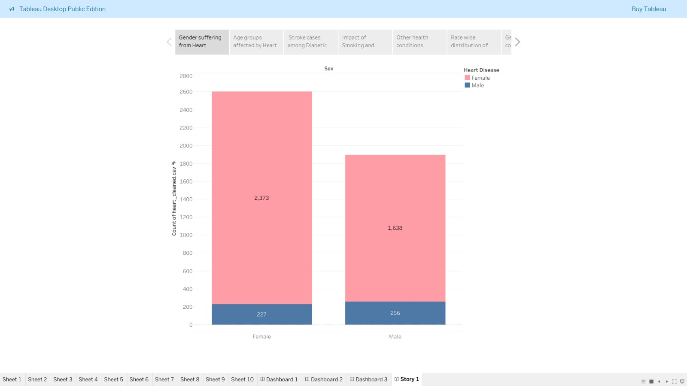
Story
9. Results
The dashboard provides several insights into the heart disease dataset.
The analysis shows that heart disease is more common among middle-aged and older individuals. Age appears to be an important factor influencing cardiovascular health.
Another observation is that higher cholesterol levels are associated with an increased risk of heart disease. Patients with elevated cholesterol values show a higher occurrence of cardiovascular problems.
The gender analysis suggests that male patients are slightly more affected by heart disease compared to female patients.
Certain types of chest pain are strongly related to heart disease diagnosis, indicating that this parameter plays a significant role in identifying cardiovascular issues.
Screenshots of the Tableau dashboard should be included in this section to illustrate the visualizations and support the results obtained from the analysis.
10. Conclusion and Future Scope
The project demonstrates how data visualization tools can be used to analyze healthcare datasets effectively. By using Tableau, complex medical data can be transformed into interactive visualizations that help users understand patterns and trends in the dataset.
The interactive dashboard developed in this project provides insights into heart disease risk factors such as age, cholesterol level, and chest pain type. These insights can help researchers and analysts understand how different medical parameters influence cardiovascular health.
In the future, the project can be expanded by integrating machine learning techniques to predict heart disease risk. Larger and more diverse datasets can also be used to improve the accuracy of the analysis.
Additional features such as real-time healthcare data integration and advanced visualization techniques can further enhance the effectiveness of the dashboard.

References and Links
Tableau: https://public.tableau.com/views/heart_deasease_final/Story1?:language=en-US&publish=yes&:sid=&:redirect=auth&:display_count=n&:origin=viz_share_link
Live Demo:
https://heart-disease-analytics-tableau.onrender.com/
GitHub Repository:
https://github.com/MansiJain-ds/Heart-Disease-Analytics-Tableau

