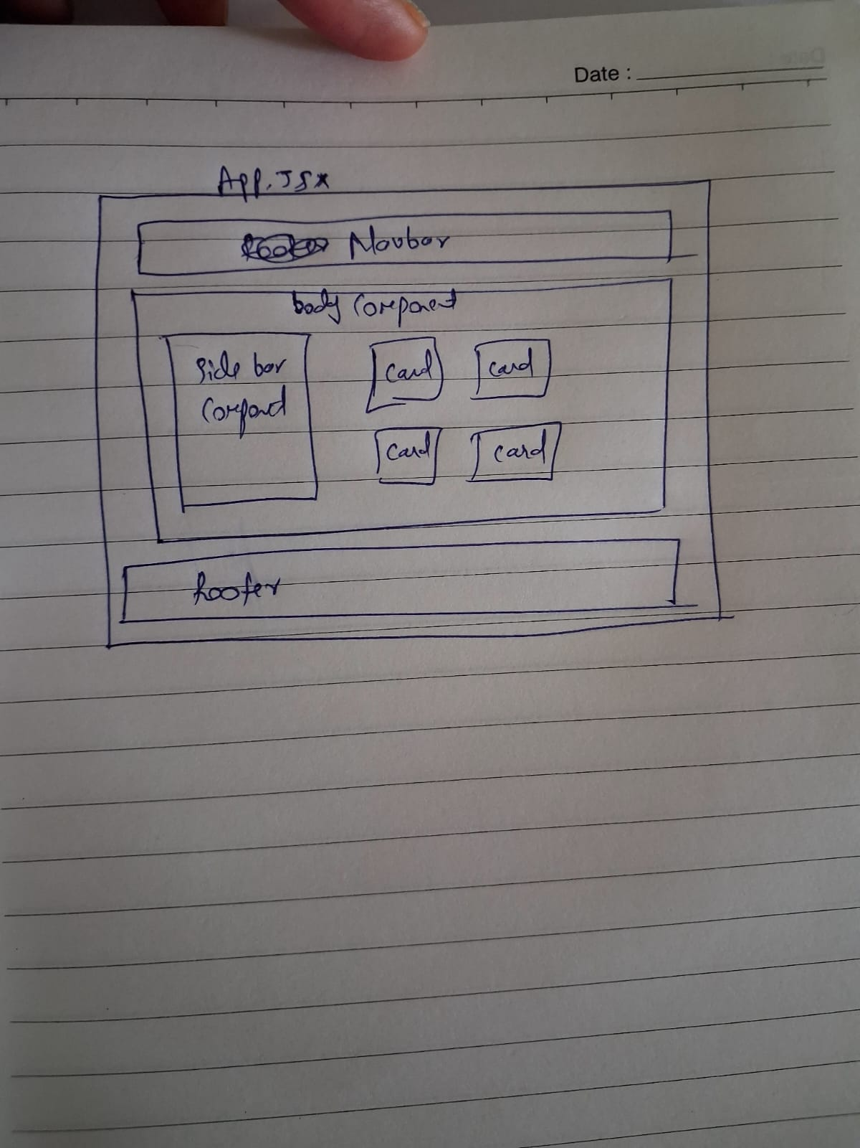

In my app.jsx folder, there is a navbar component. Footer component and boy component
Inside body component there are 2 more components : Sidebar component and cards components.

