AssignmentNo.7

Aim:EvaluationofInterface Problemstatement:

EvaluateanyUI/productusingBenShneiderman’seight goldenrulesforinterfacedesign.

Shneiderman’sEightGoldenRulesofInterfaceDesign

1.StriveforConsistency....

2.EnableFrequentUserstoUseShortcuts....

3.OfferInformativeFeedback....

4.DesignDialogtoYieldClosure....

5.OfferSimpleErrorHandling....

6.PermitEasyReversalofActions....

7.SupportInternalLocusofControl....

8.ReduceShort-TermMemoryLoad.

1.StriveforConsistency.

Example:insert draw design

Explanation :it gives different options of file,home,draw,insert

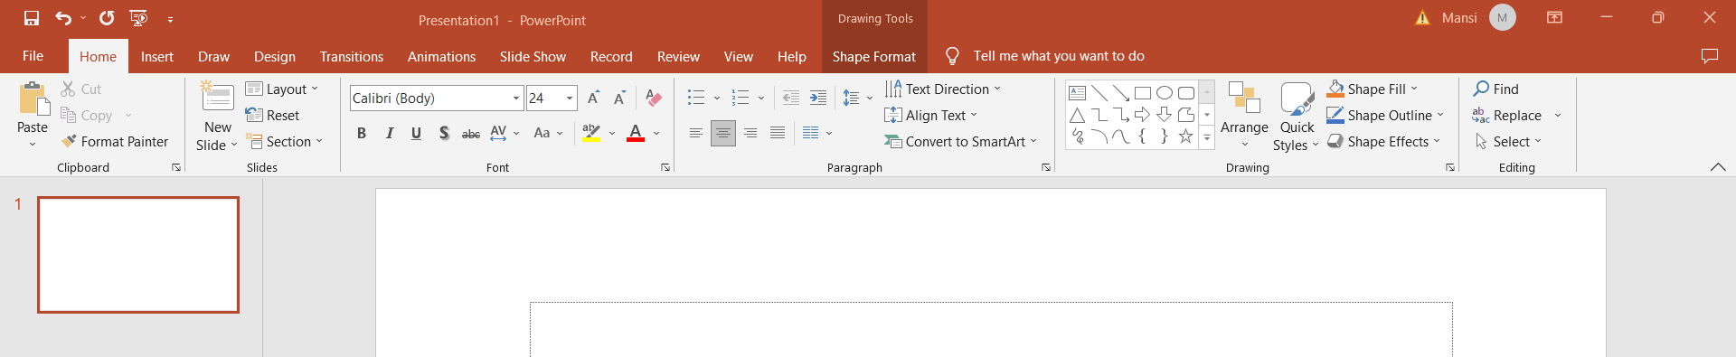

2.EnableFrequentUserstoUseShortcuts.

Example:font size,style

Explanation: power point gives shortcut of font size,style,color



3.OfferInformativeFeedback.

Example: display of font size

Explanation: it gives feedback of what font you have used.



4.DesignDialogtoYieldClosure.

Example:Dialog box for warnings.

Explanation: if you forgot to save and you close that window this warning box will display

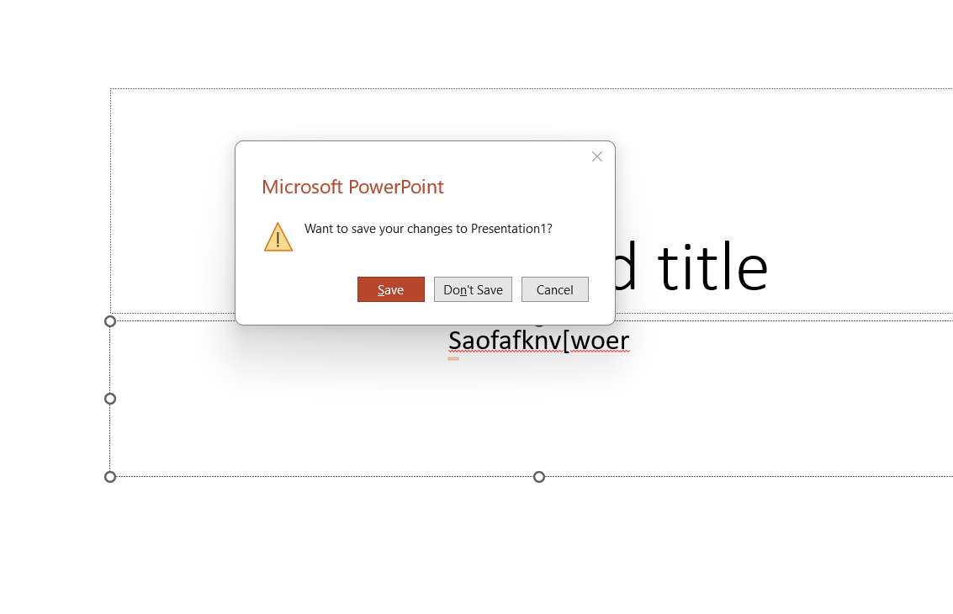

5.OfferSimpleErrorHandling.

Example:incorrect spelling

Explanation: when you type incorrect spelling red underline will displayed.



6.PermitEasyReversalofActions.

Example:any type of mistake

Explanation: you can control+z that mistakes

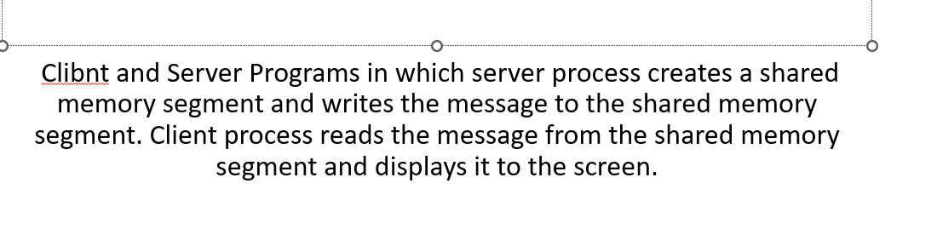

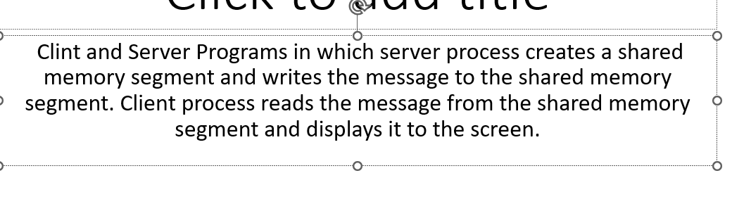

7.SupportInternalLocusofControl.

Example:search

Explanation: if you forgot something you can search

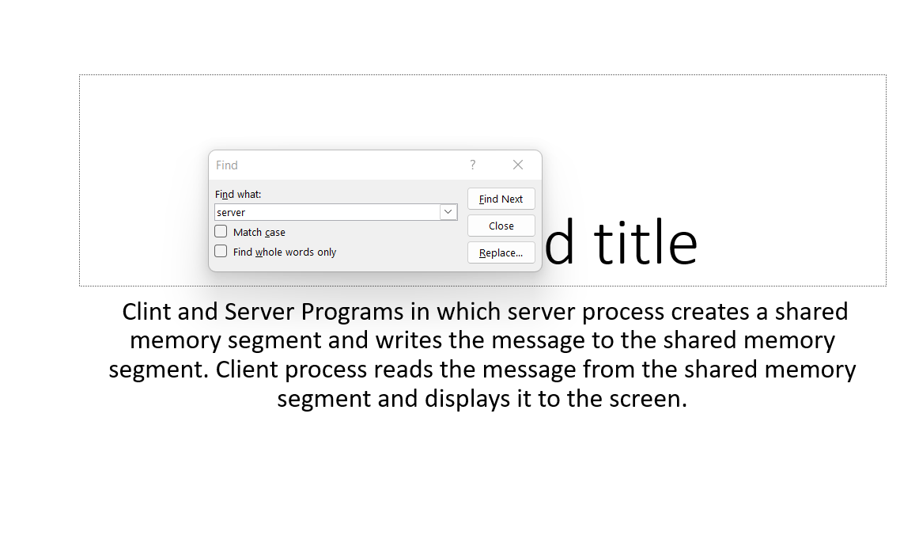

8.ReduceShort-TermMemoryLoad.

Example:file display

Explanation:files are displayed here on which we have workd earlier

