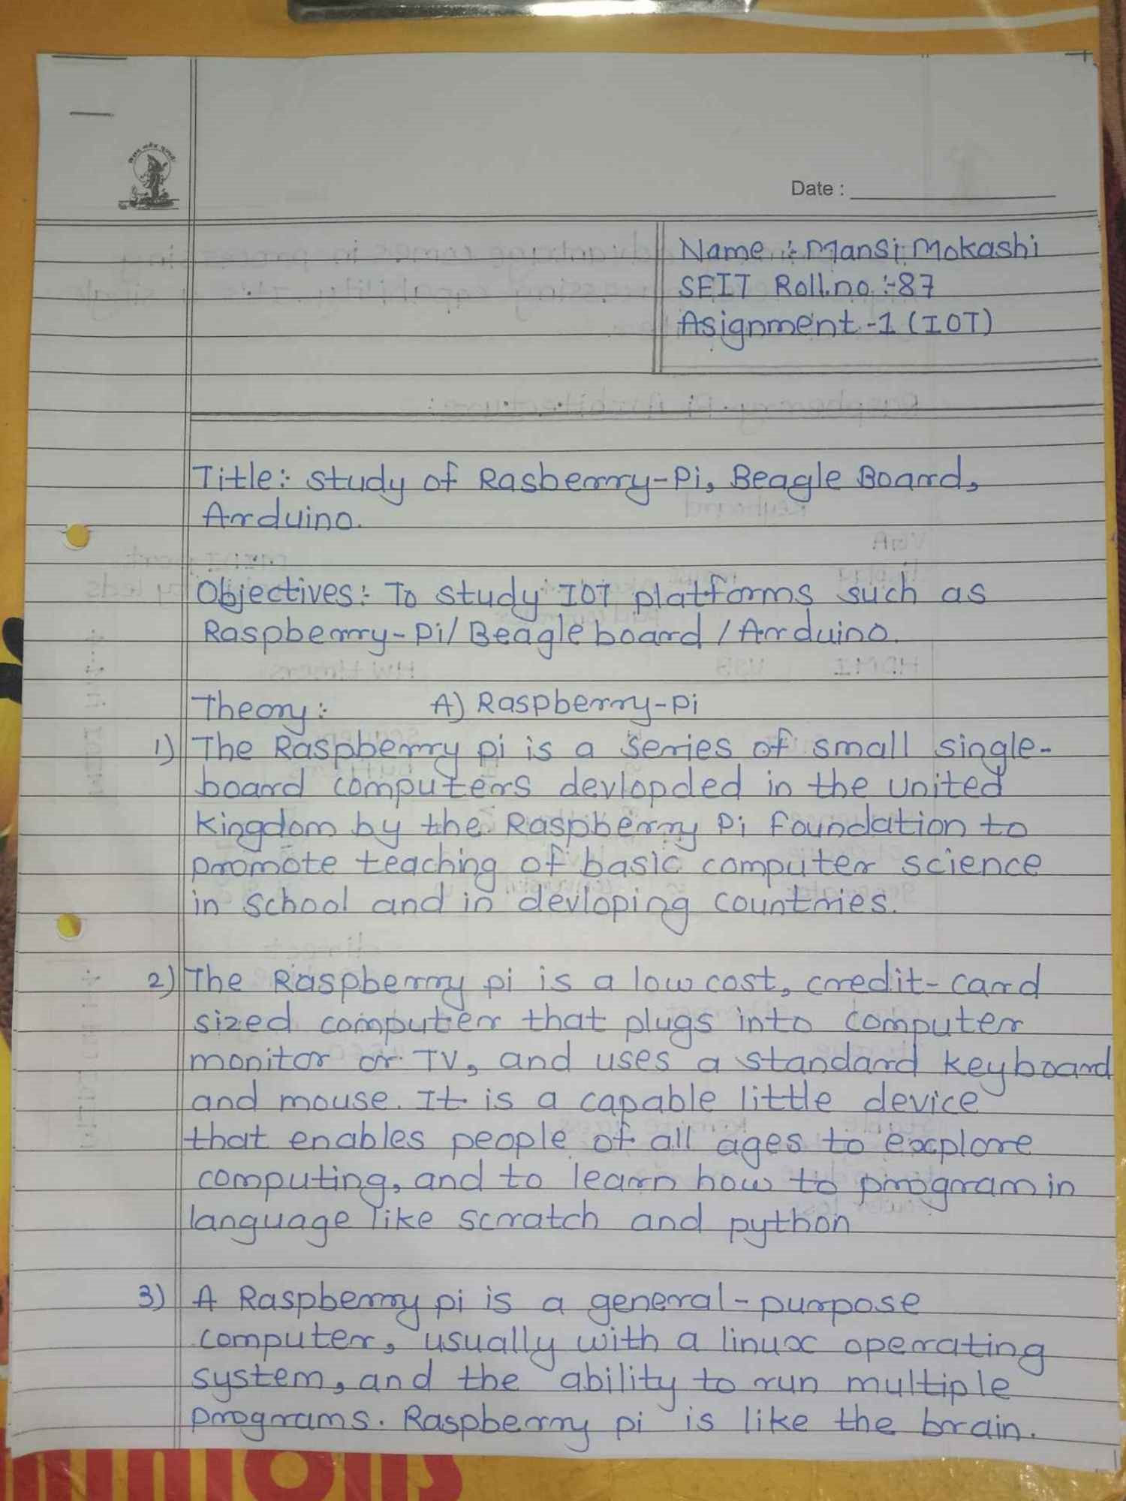

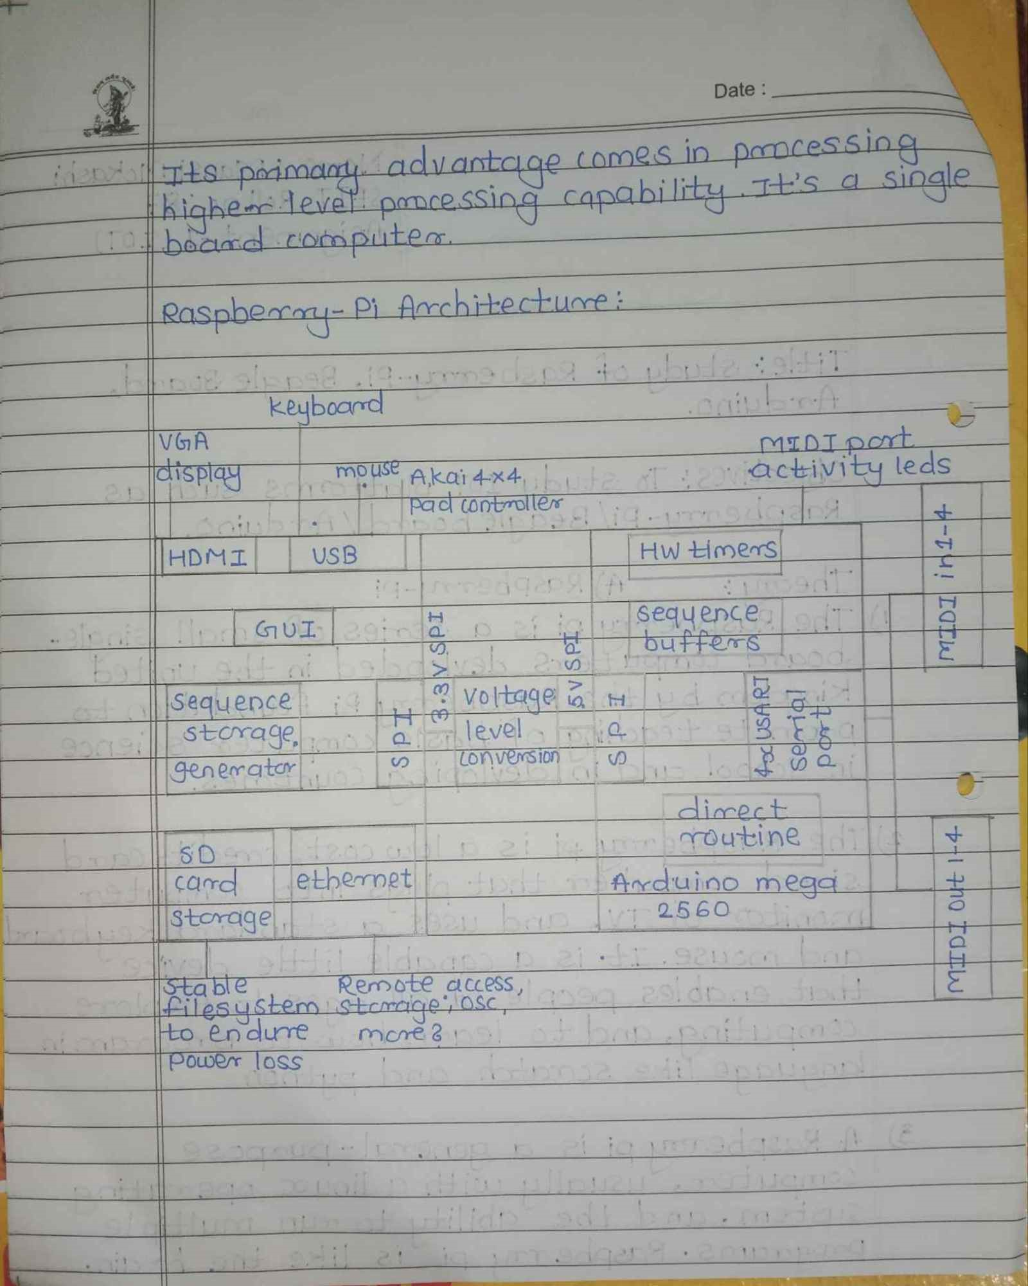

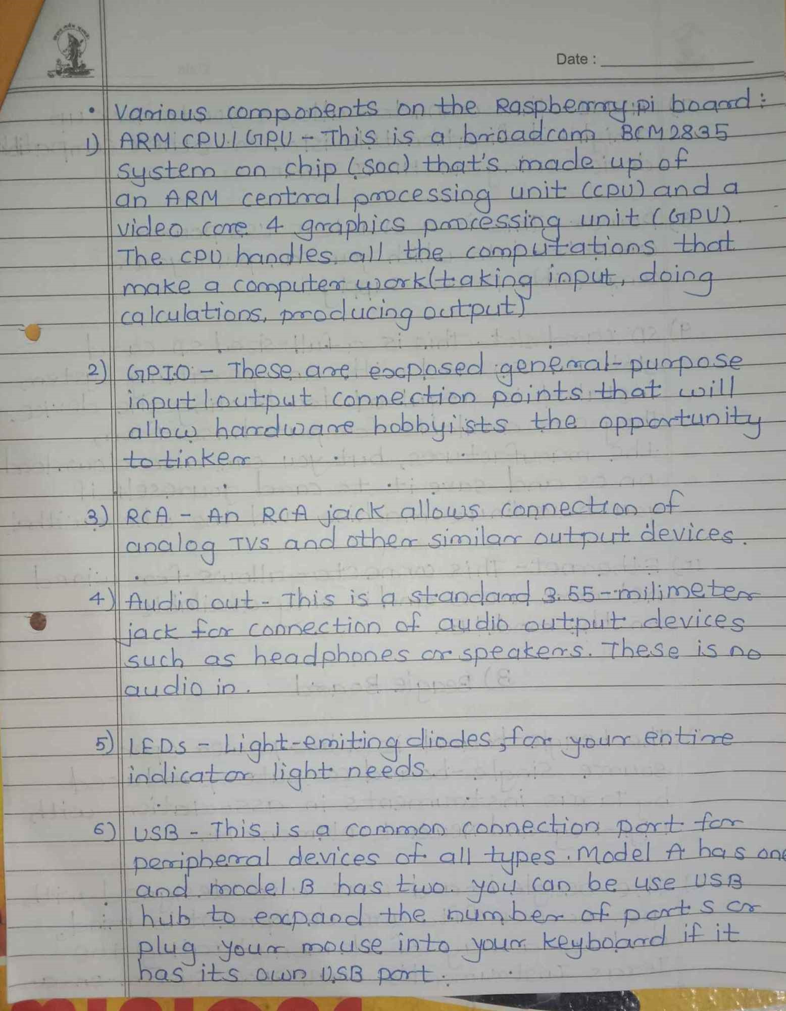

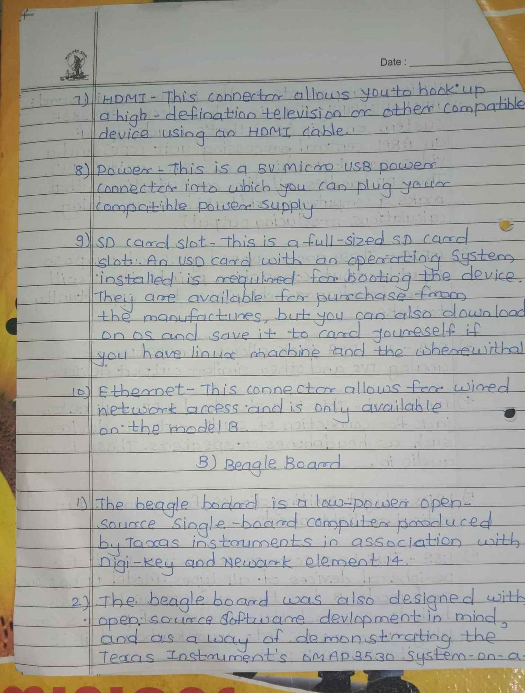

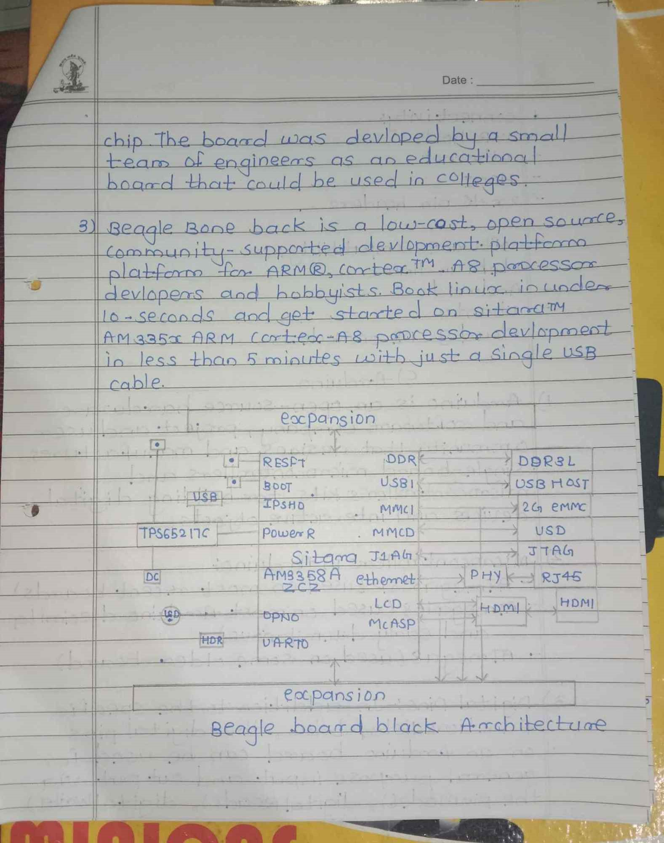

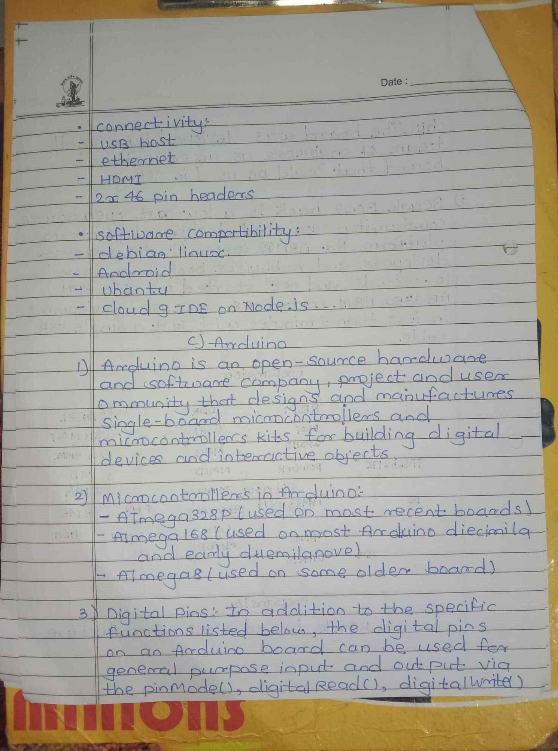

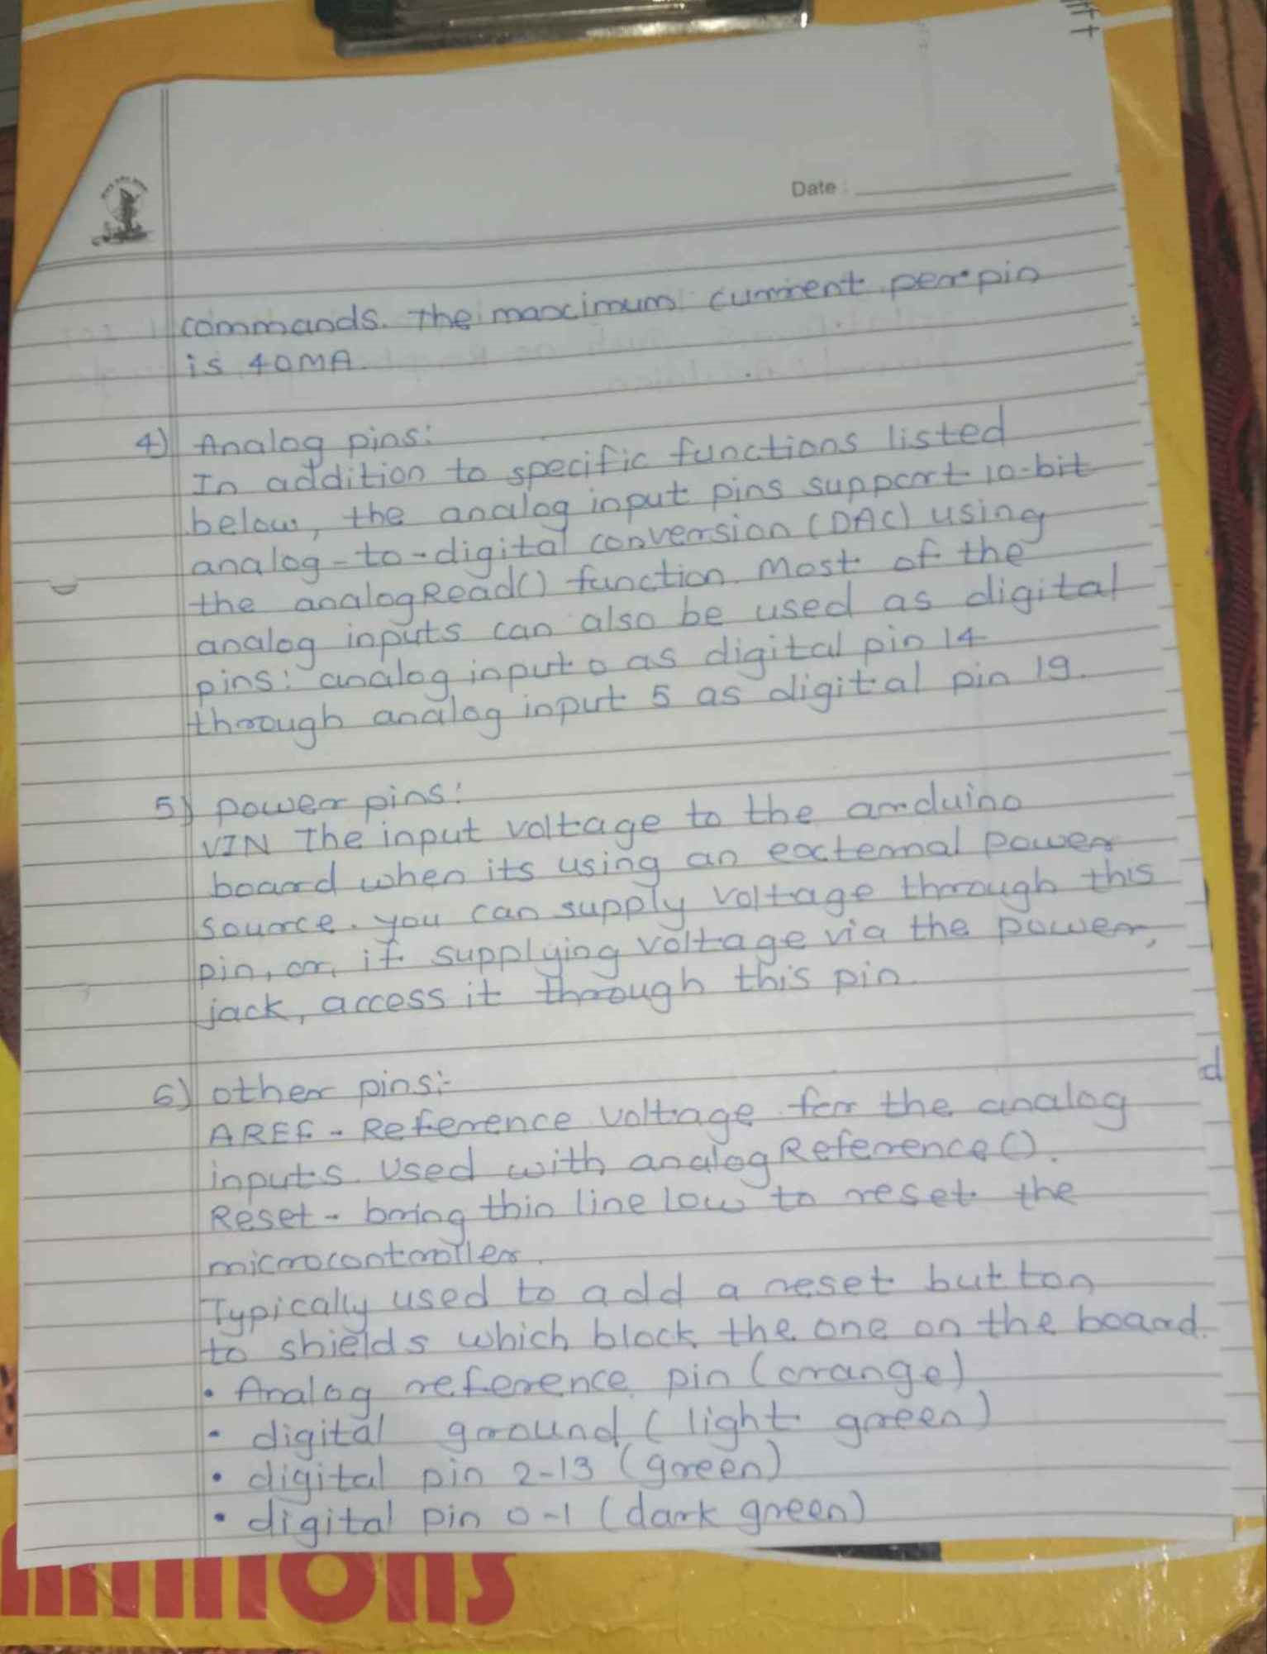

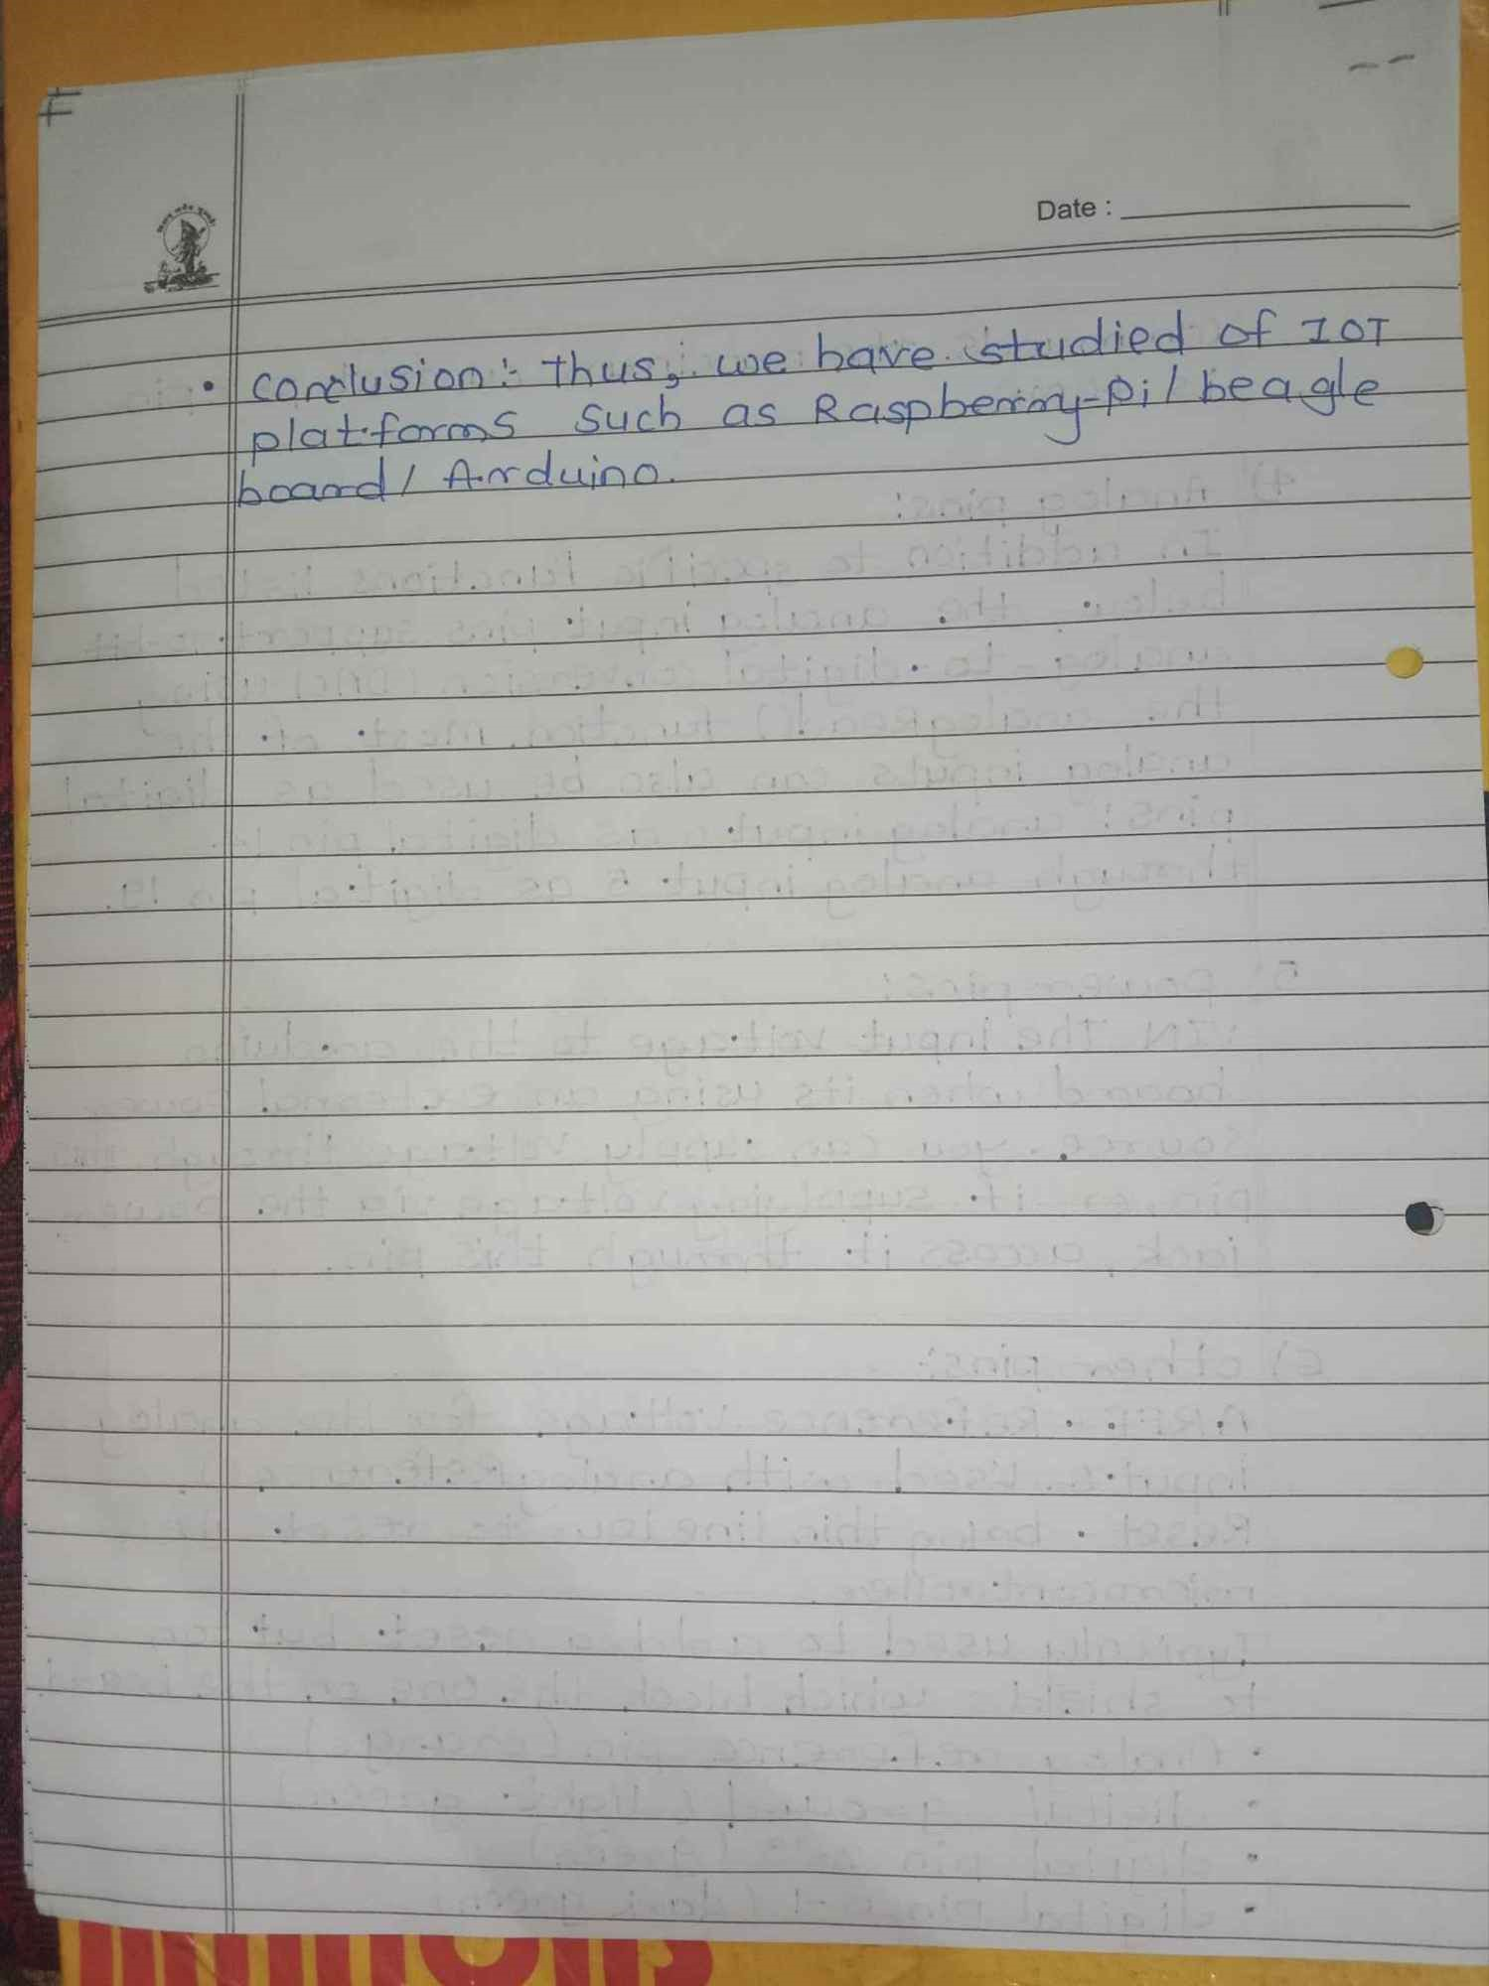

CODE

Import RP1.GPIO as GPIO from time import sleep GPIO.setmode(GPIO.BOARD)

red=29

yellow=31

green 32 GPIO.setup(red, GPIO.OUT)

GPIO.setup(yellow, GPIO.OUT) GPIO.setup(green, GPIO.OUT)

while True:

GPIO.output (red, True)

sleep(1)

GPIO.output (red, False)

GPIO.output (yellow, True)

sleep(1) GPIO.output (yellow, False) GPIO.output (green, True)

sleep(1) GPIO.output (green, False)

GPIO.cleanup()