Connection diagram:

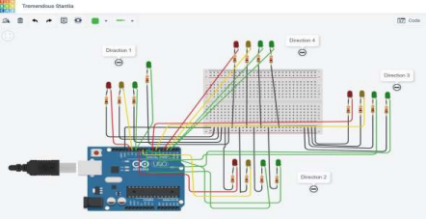

Code:

import RPi.GPIO as GPIO

from time import sleep

GPIO.setmode (GPIO.BOARD)

 red = 7

 yellow = 11

 green = 12

GPIO.setup (red, GPIO.OUT)

GPIO.setup (yellow, GPIO.OUT)

GPIO.setup (green, GPIO.OUT)

while True:

GPIO.output (red, True)

sleep (3)

GPIO.output (red, False)

GPIO.output (yellow, True)

sleep (1)

GPIO.output (yellow, False)

GPIO.output (green, True)

sleep (3)

GPIO.output(green, False)

GPIO.cleanup ()