**IoT ASSIGNMENT 6**

**Code:** **Ultrasonic sensor:**

#define echoPin 2  
#define trigPin 3  
  
long duration;  
int distance;  
  
void setup()  
{  
  pinMode(trigPin,OUTPUT);  
  pinMode(echoPin,INPUT);  
  Serial.begin(9600);  
}  
  
void loop()  
{  
  digitalWrite(trigPin,LOW);  
  delayMicroseconds(2);   
   
  digitalWrite(trigPin,HIGH);  
  delayMicroseconds(10);   
  digitalWrite(trigPin,LOW);  
   
  duration = pulseIn(echoPin,HIGH);  
  distance = duration * 0.034/2;  
   
  Serial.print("Distance :");  
  Serial.print(distance);  
  Serial.println(" cm");

}

**Output:**

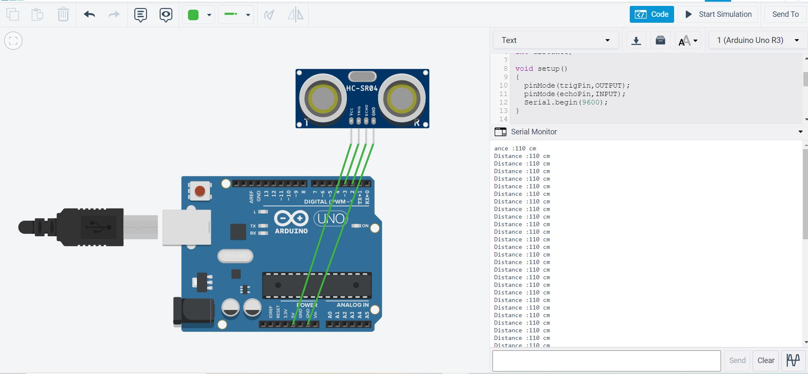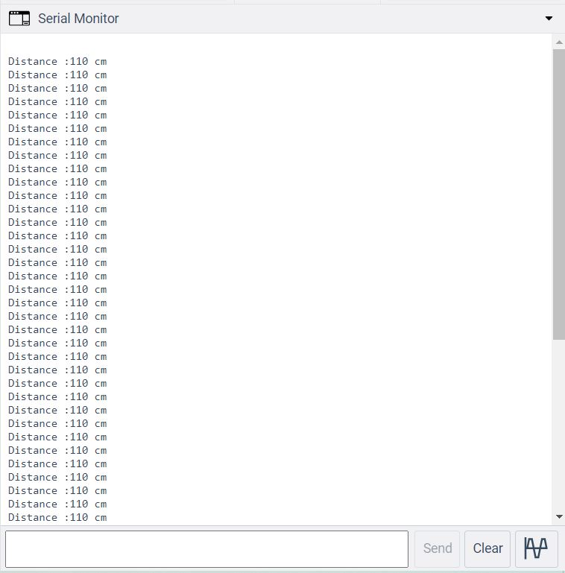

**Code: Ultrasonic sensor and servo motor:**

#define echopin 2

#define triggerpin 3

#include<Servo.h>

long duration;

int distance;

Servo servo1;

int pos=0;

void setup()

{

pinMode(triggerpin, OUTPUT);

pinMode(echopin, INPUT);

Serial.begin(9600);

servo1.attach(3);

}

void loop()

{

digitalWrite(triggerpin, LOW);

delayMicroseconds(2);

digitalWrite(triggerpin, HIGH);

delayMicroseconds(10);

digitalWrite(triggerpin, LOW);

duration = pulseIn(echopin,HIGH);

distance = duration*0.034/2;

Serial.print("Distance : ");

Serial.print(distance);

Serial.println(" cm");

if(distance>50 && distance<300)

{

//rotate from 0 to 180

for(pos=0;pos<=180;pos++)

{

servo1.write(pos);

delay(15);

}

delay(1000);

for(pos=180;pos>=0;pos--)

{

servo1.write(pos);

delay(15);

}

delay(1000);

}

Serial.println("Rotating between 0 to 180");

}

**Output:**

