**Introduction**

In this lab, you will use an EC2 instance to test IAM access from the command-line.

In this lab step, you will connect to an EC2 instance using EC2 Instance Connect and access a shell.

**Instructions**

1. Navigate to [EC2 Instances by clicking here](https://us-west-2.console.aws.amazon.com/ec2/v2/home?region=us-west-2#Instances:):

The instances list page will open:

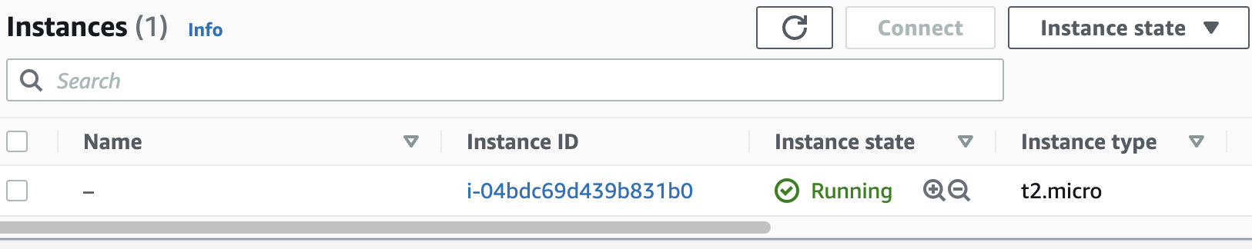

If you don't see a running instance then the lab environment is still loading. Wait until the **Instance state** is **Running**.

2. Right-click theinstance you created, and click **Connect**:

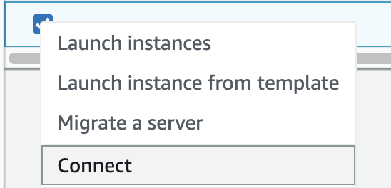

The **Connect to your instance** form will load.

3. In the form, ensure the **EC2 Instance Connect** tab is selected:



You will see the instance's **Instance ID** and **Public IP address** displayed.

4. In the **User name** textbox, enter :

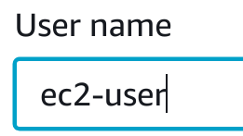

5. To open a browser-based shell, click **Connect**:



If you see an error it's likely that the environment hasn't finished setting up. Check for **Setup completed** at the top-left corner of the lab and try connecting again:

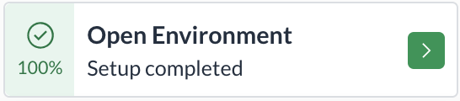

A browser-based shell will open in a new window ready for you to use.

Keep this window open, you will use it in later lab steps.

You can also connect to the instance using your preferred SSH client and the PPK (Windows) or PEM (Mac/Linux) key files in the **Credentials** section of this lab.