**Introduction**

In AWS, you can designate an IAM role to attach to an EC2 instance when launching the instance, or any time after. Attaching an IAM role to an instance allows you to manage permissions for instances centrally with IAM. In this Lab Step, you'll practice launching an EC2 instance with an IAM role attached.

**Instructions**

1. In the AWS Management Console search bar, enter *EC2*, and click the **EC2** result under **Services**:

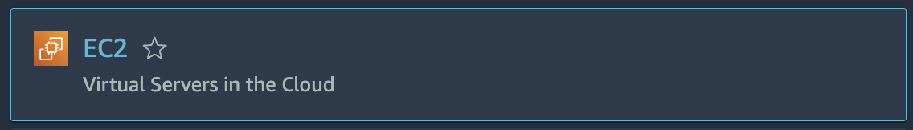

2. From the **EC2** dashboard, click **Launch instance**> **Launch instance**:

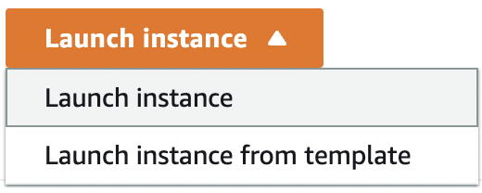

3. In the **Application and OS Images** section, select the **Amazon Linux** option under **Quick Start**:

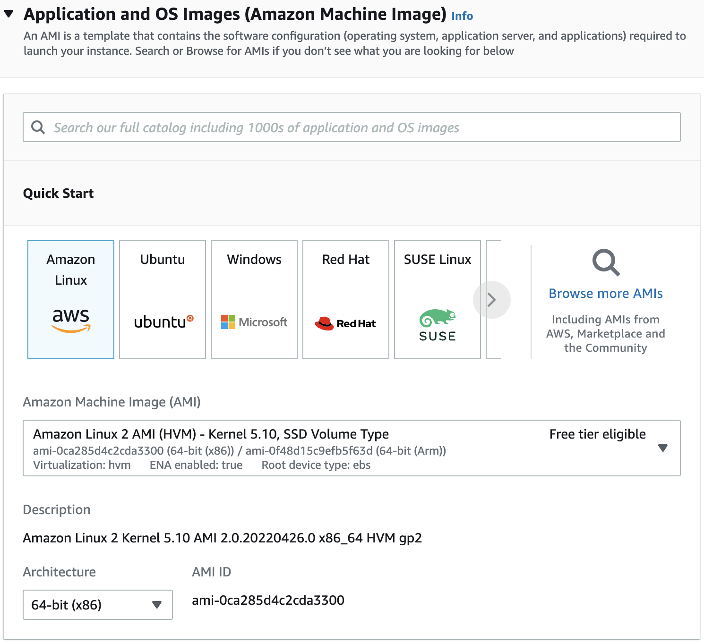

4. In the **Instance Type** section, you should not change any options. Simply make sure the default **t2.micro**is selected:

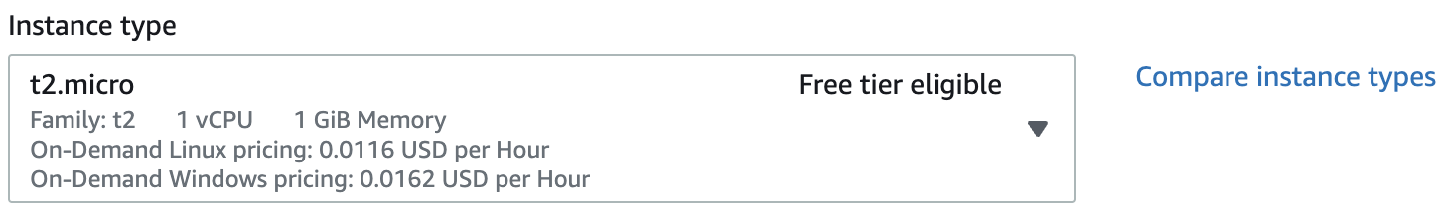

5. In the **Key pair** section, select the **314719318991**keypair:  
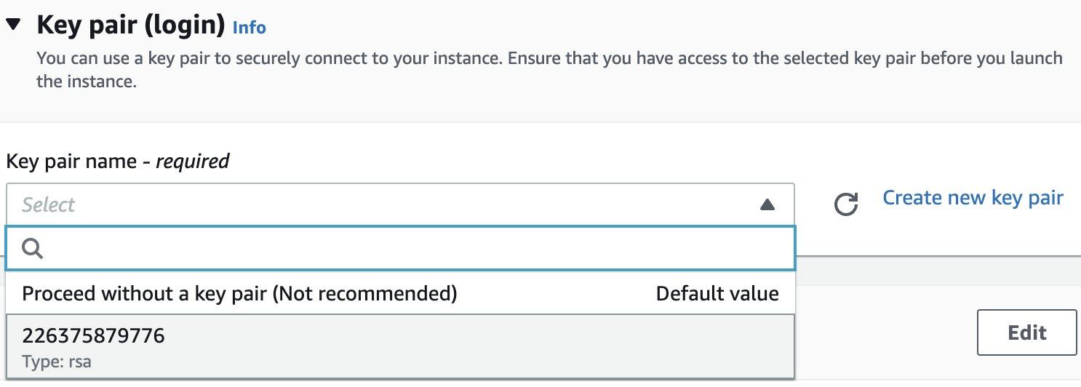  
*Note*: Your keypair may differ from the screenshot.   
*Reminder*: The PEM or PPK formatted key pair can be downloaded directly from the **Your lab data** section of the Cloud Academy Lab page at any time.

6. Expand the Advanced details section, and select **lab-role** for the **IAM instance profile**:

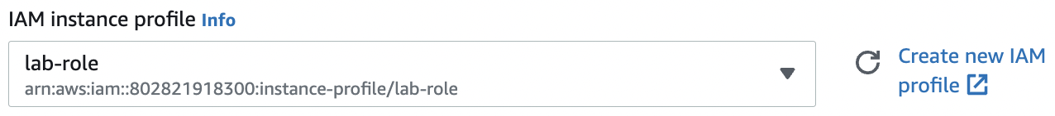

7. In the **Summary** section, click **Launch instance**:



A confirmation page will let you know that your instance is launching:  
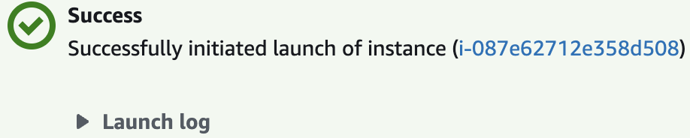

8. Click **View all instances** to return to the **EC2** dashboard:



**Summary**

In this Lab Step, you used the **EC2**Dashboard to create an EC2 instance with an IAM role attached.

VALIDATION CHECKS

**1Checks**

Check again

**Created EC2 Instance with IAM Role Attached**

Check that the EC2 instance exists and has the specified IAM role attached

AWS Identity and Access Management (IAM)Amazon EC2