**Introduction**

AWS Identity and Access Management (IAM) enables you to securely control access to AWS services for your IAM users with IAM policies.

In this Lab Step, you'll practice using policies to manage access to AWS resources for a user named Jeff.

**Instructions**

1. On the **Identity & Access Management** dashboard, click **Policies** on the left:



2. Type *AmazonS3ReadOnlyAccess* into the search box then select the only available policy:

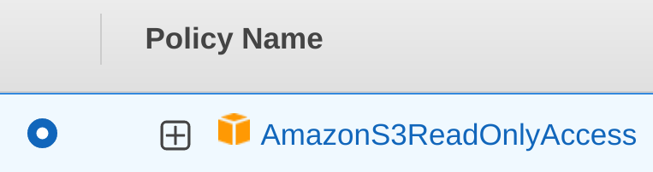

3. Click **Actions**and then choose **Attach**:

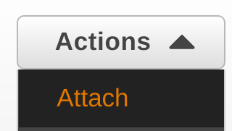

4. Select the **Jeff** User to attach the policy:

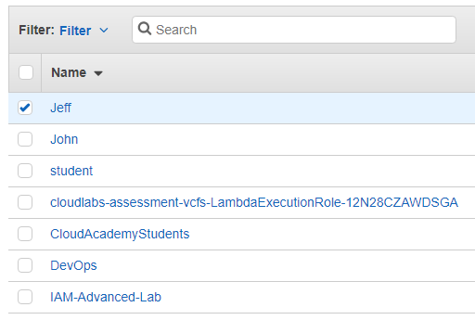

5. Click **Attach Policy**:

alt

**Summary**

In this Lab Step, you used the **IAM Management Console** to attach an AWS policy to an IAM user.

VALIDATION CHECKS

**1Checks**

Check again

**Attached IAM Policy to IAM User**

Check that only the specified policy was attached to the IAM User

AWS Identity and Access Management (IAM)