**Introduction**

After you have created IAM users and created passwords for them, users can sign in to the AWS Management Console by using a special URL, which has this format: https://*AWS-account-ID*.signin.aws.amazon.com/console. In this lab step, you will get the opportunity to use a similar log-in link to log in to the newly-created IAM User.

**Instructions**

1. From the **Identity & Access Management** console, click on **Users** in the sidebar menu.

2. Click **John** on the **IAM User** page:

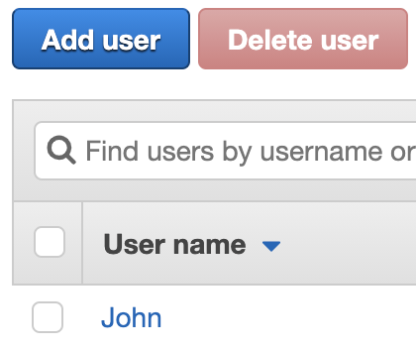

3. Click **Security Credentials** and then navigate to the **Console sign-in link** listed in the tab:

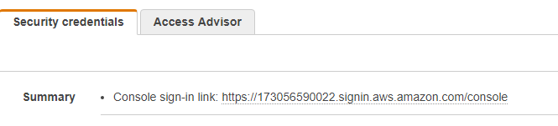

4. Use the credentials in the CSV file you downloaded to log in as John.

The downloaded credentials will be similar to this:

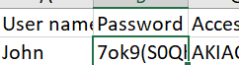

In the Console enter:

Username: Enter *John*

Password: Enter the password from the spreadsheet you downloaded earlier

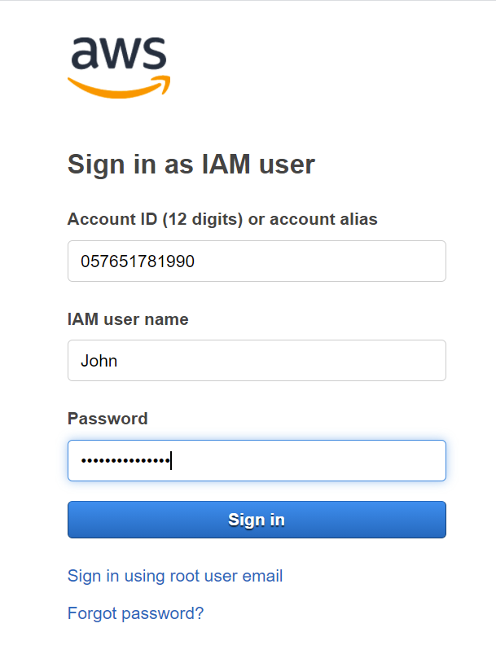

5. From the AWS Management Console, click on **Services** at the top of the page and type *S3* into the text box. Select the **S3** option:

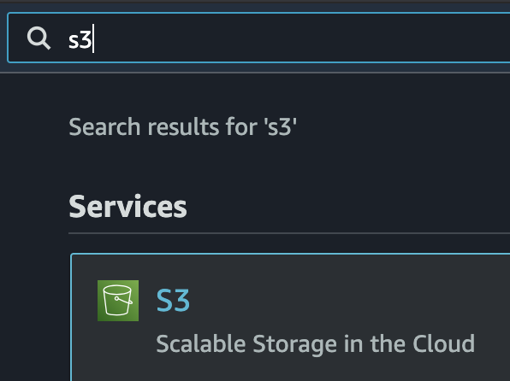

6. Notice that due to the restrictive permissions you placed on the IAM user "John", you receive an **Access Denied** message when attempting to access S3 resources:

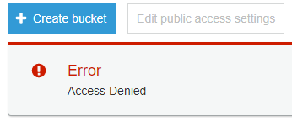

**Summary**

In this Lab Step, you logged in as your newly-created IAM user. You also confirmed that your restrictive IAM permissions worked and that your new user didn't have access to unnecessary AWS resources.

VALIDATION CHECKS

**1Checks**

Check again

**IAM User Logged in to the AWS Management Console**

Check that the IAM User logged in to the AWS Management Console

AWS Identity and Access Management (IAM)