HOTEL BOOKINGS

Business Problem

In the recent years, City Hotels and Resort Hotels have seen High Cancellation Rates. Each Hotel is now dealing with several issues, as a result, including fewer revenues and less than ideal hotel room use. Consequently, lowering Cancellation Rates is both the Hotel’s primary goal to increase their efficiency in generating revenue, and for us to offer thorough Business Advice to address this Problem.

The Analysis of Hotel Booking Cancellations as well as the other factors that have no bearing on their business and yearly revenue generation are the main topics of this Report.



Assumptions

1. No unusual occurrences between 2015 and 2017 will have a Substantial Impact on the data used.
2. The Information is still current and can be used to analyze a hotel’s possible plans in an Efficient manner.
3. There are no Unanticipated Negatives to the Hotel employing any advised techniques.
4. The Hotels are currently not using any of the suggested solutions.
5. The Biggest Factor affecting the Effectiveness of Earning Income is booking Cancellations.
6. Cancellations results in the Vacant Rooms for the booked Length of Time.
7. Clients make Hotel Reservation the same year they make the Cancellations.

Research Questions

1. What are the variables that affect the Hotel Reservation Cancellations?
2. How can we make Hotel Reservation Cancellations better?
3. How will Hotels be assisted in making Pricing and Promotional decisions?

Hypothesis

1. More Cancellations occur when the Prices are Higher.
2. When there is a longer waiting list, Customers tend to cancel more frequently.
3. Most of the clients are coming from Offline Travel Agents to make their Reservations.

Analysis and Findings

The accompanying Bar Graph shows the Percentage of the Reservations that are Cancelled and those that are not.

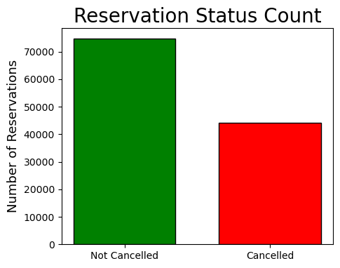

We observe that there are significant number of Reservations that have not been Cancelled. But there are still 37% of Clients who have cancelled their Reservations, which has made a remarkable impact on the Hotels’ Earnings.

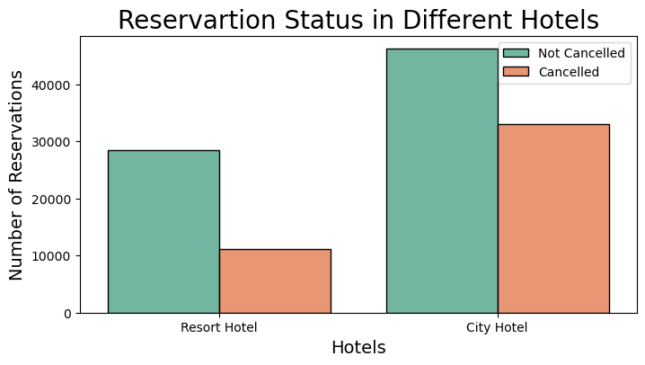

In comparison to the Resort Hotels, City Hotels have more Bookings. This is possible because, maybe the Resort Hotels are more Expensive than the City Hotels.

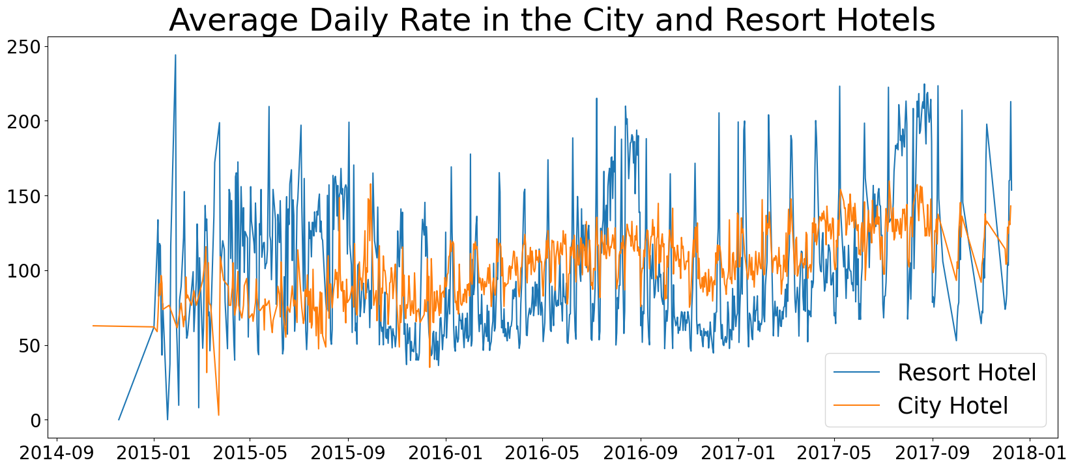

The above Line Graph shows that on certain days, the Average Daily Rate for a City Hotel is lesser than that of a Resort Hotel and on other days, it is even lesser. So, it goes without saying that the Weekends and Holidays may see a rise in Resort Hotel Rates.

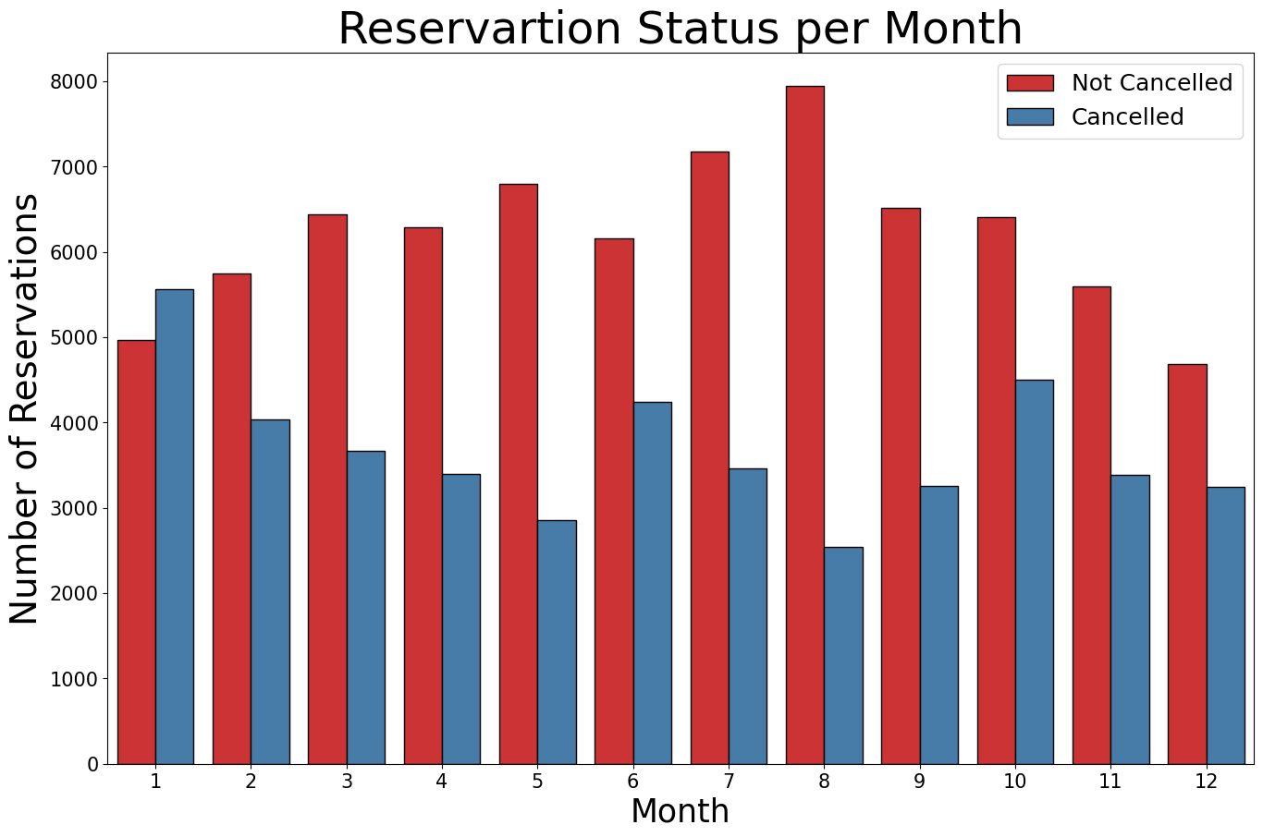

We have developed the Bar graph to analyze which months have the Highest and the Lowest Reservation levels, according to the Reservation Status.

As we observe, both the number of Confirmed Reservations and the number of Cancelled Reservations is largest in the month of August. Whereas, January is the month with the most Cancelled Reservations.

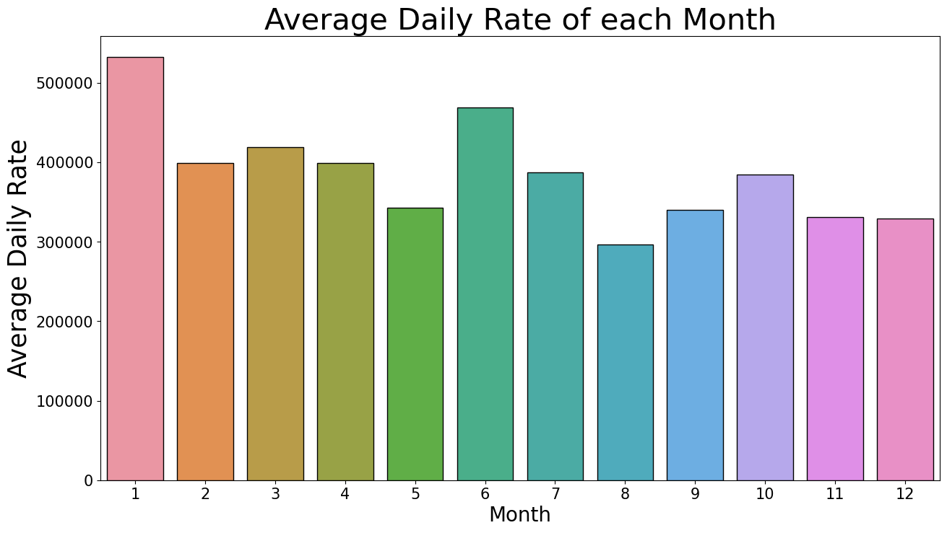

This Bar Graph demonstrates that the Cancellations are most common when the prices are Higher and are least common when they are Lower. Therefore, the Cost of Accommodation is solely Responsible for the Cancellations.

Now, let us see which Country has the Highest number of Reservations Cancelled.

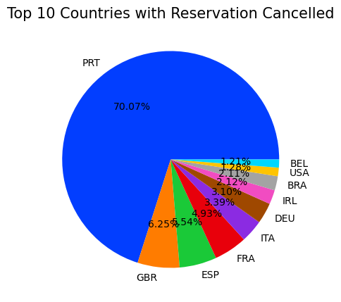

The Top Country is Portugal with Highest number of Cancellations.

Let us now check the areas from where the Guests are visiting the Hotels and making the Reservations. Is it coming from Direct or Groups, Online or Offline Travel Agents?

Around 45% of the Clients are coming from Online Travel Agencies, whereas, 27% of them come from Groups. Only 4% of the Clients make Hotels Reservations directly by visiting them.

Around 47% of the Clients who are come from Online Travel Agencies are Cancelling the Reservations, whereas, 27% of them are from the Group Category.

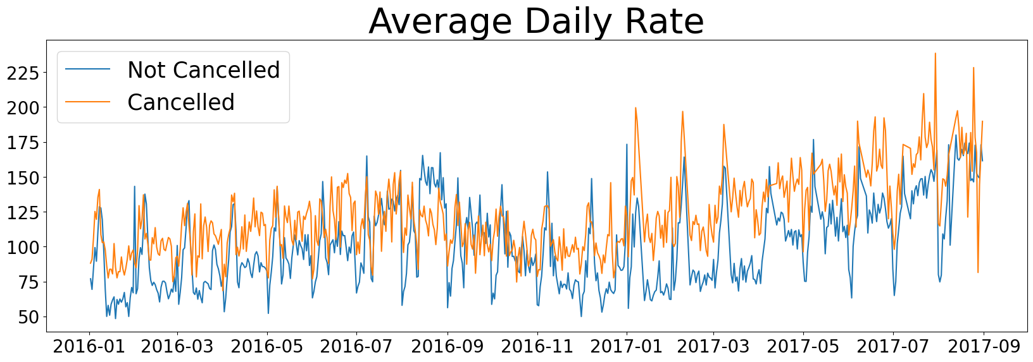

As we see in the graph, the Reservations are Cancelled when the Average Daily Rate is higher than it is in other time, which clearly proves that the Higher Price leads to Higher Cancellations.

Suggestions

1. Cancellations Rates increases with the Price and to prevent this, Hotels should work on their Pricing Strategies and try to Lower the Rates based on the Locations. They can also give some Discounts to the Costumers.
2. Hotels can start some Campaigns and Marketing with a reasonable amount in the month of January to increase their Revenue as the Cancellations are higher in this month.
3. As the ratio of Cancellations is higher in the City Hotels than in the Resort Hotels, they should provide some Reasonable Discounts on the Room Prices in the Weekends and in the Holidays.
4. They can also Increase the Quality of their Hotels especially in Portugal to reduce the Cancellation Rates.