Mansi Patel
Mdp86
Final project proposal
Citations:
Tan CH, Wang TY, Park H, Lomenick B, Chou TF, Sternberg PW. Single-tissue proteomics in Caenorhabditis elegansreveals proteins resident in intestinal lysosome-related organelles. Proc Natl Acad Sci U S A. 2024 Jun 18;121(25):e2322588121. doi: 10.1073/pnas.2322588121. Epub 2024 Jun 11. PMID: 38861598; PMCID: PMC11194598.
DOI:
https://doi.org/10.1073/pnas.2322588121
Figure:
I plan to replicate figure 3 (attached on next page).
Data:
https://authors.library.caltech.edu/records/zks5d-wkw57
the data for fig 3 is in the file titled “pnas.2322588121.sd02.xlsx”.
Description:
The figure shows analysis from single tissue proteomics data from gonad and intestine of C. elegans. This figure focuses on showing that their method of performing MS based proteomic allows for high coverage, reproducibility across animals, and tissue specificity for gonad and intestine.
Steps
- Different sheets in the excel file will need to be split into individual datasets
- First few rows in each dataset contains descriptions that will need to be removed
- the column names and potentially other description might need to be cleaned
- Some of the datasets will need to be converted to long format to be compatible with ggplot
- I will need to generate some count values for the venn diagrams and stacked bar plots
- geom_tile for heatmap, geom_bar for stacked bar plot, geom_point for volcano plot and PCA (I will first need to compute PCA) and geom_venn for venn diagram
- I will also need color code based on tissue for the all the panel
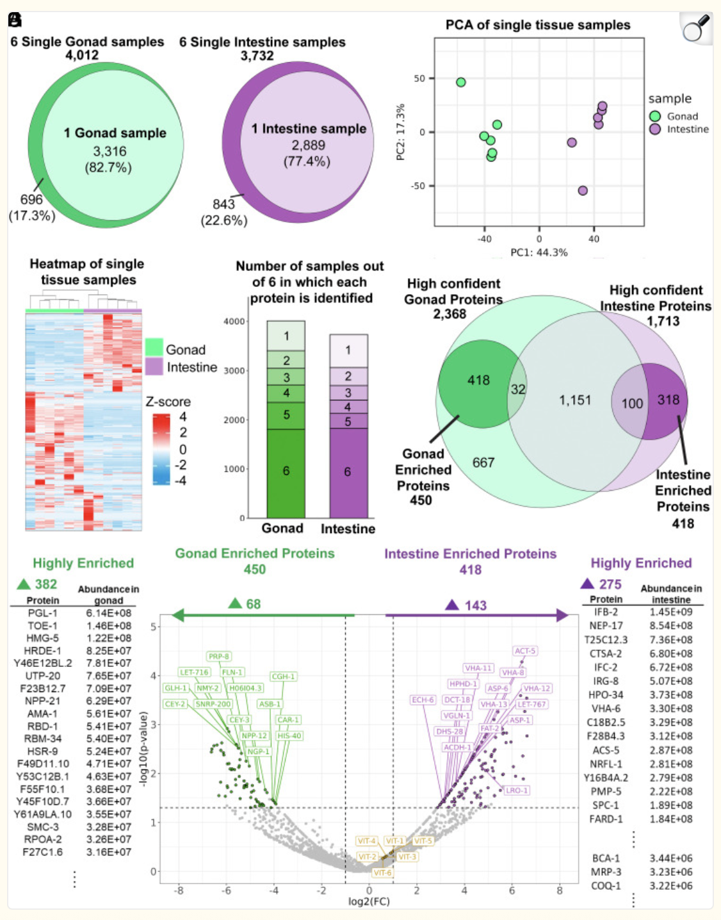

Figure legend:
Single-tissue proteomic analysis. (A) A total of 4,012 proteins were identified from six samples of gonadal tissue, each isolated from a single animal, with up to 3,316 (82.7%) identified in a single gonad sample. (B) A total of 3,732 proteins were identified from six samples of intestinal tissue each extracted from a single animal, with up to 2,889 (77.4%) identified in a single intestinal tissue sample. (C and D) The single-tissue samples of the same type show a high degree of similarity and were clearly distinctive from that of the other tissue type. (C) PCA of the single-tissue samples. Samples were divided into two distinct groups separated on the PC1. (D) Heatmap of the single-tissue samples. The Z-score, representing the distance in SDs from the mean within each row, was computed by subtracting the mean protein abundance from each individual abundance and then dividing by the SD across all samples in that row. (E) The vast majority of the identified proteins were repeatedly identified in tissues isolated from different animals, with nearly half of them identified in every animal. (F) A high-confidence set of proteins present in each tissue, 2,368 in the gonad and 1,713 in the intestine, were identified based on consistent identification of the proteins across different animals and experimental sets. Of these proteins, 450 and 418 were consistently enriched in the gonad and intestine, respectively. (G) Center: A volcano plot showing the relative abundance of the proteins between the gonad and the intestine. Points representing proteins in the high-confidence sets found to be enriched in the gonad (68) and intestine (143) are highlighted with the corresponding colors (green and purple, respectively), and some of the most abundant proteins are labeled. The vitellogenins, which are highly abundant in both tissues, are also labeled in yellow. Flanking the volcano plot on either side are lists of highly abundant proteins selected from those highly enriched (maxed out fold-change) in either the gonad (382) or the intestine (275) and cannot be placed in the plot. Two intestinal-enriched proteins, LRO-1 (plot) and MRP-3 (side), are also labeled and will be discussed more in later sections. The values used in this panel were based on one of the two experimental sets, but the highlighted (colored) proteins were those that were consistently enriched in the respective tissue. Green: gonad; purple: intestine; Yellow: vitellogenins. The Euler diagrams are area-proportional. Lists of proteins described in this figure can be found in Dataset S2.

