##1. importing libraries

import numpy as np

import pandas as pd

import matplotlib. pyplot as plt

import matplotlib. pyplot as plt

import seaborn as sns

import scipy

from sklearn.metrics import classification_report,accuracy_score

from sklearn.ensemble import IsolationForest

from sklearn.neighbors import LocalOutlierFactor

from sklearn.svm import OneClassSVM

from pylab import rcParams

rcParams['figure.figsize'] = 14, 8

RANDOM_SEED = 42

LABELS = ["Normal", "Fraud"]

##2.loading the data

data = pd.read_csv(r"C:\Users\Admin\Downloads\creditcard.csv.zip")

data.head()

data.tail()

data.info()

data.isnull().sum()

##3.Analysis of class distribution

data['Class'].value_counts()

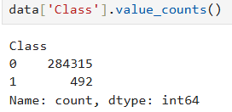

count_classes = pd.value_counts(data['Class'], sort = True)

count_classes.plot(kind = 'bar', rot=0)

plt.title("Transaction Class Distribution")

plt.xticks(range(2), LABELS)

plt.xlabel("Class")

plt.ylabel("Frequency")

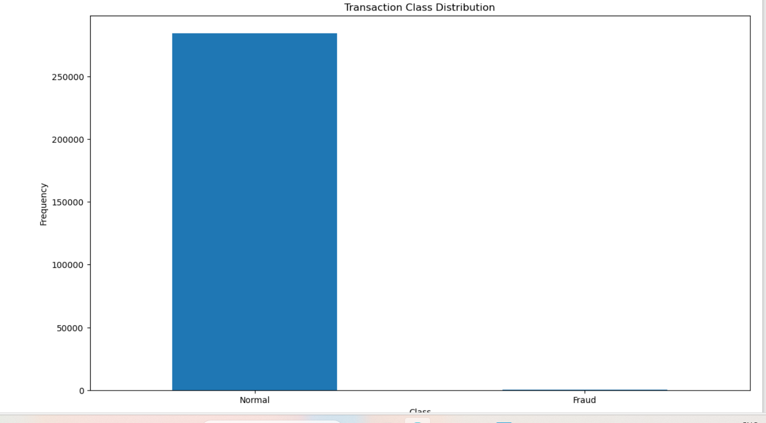

## Normal and Fraud Transaction

fraud = data[data['Class']==1]

normal = data[data['Class']==0]

print(fraud.shape)



print(normal.shape)



fraud.Amount.describe()

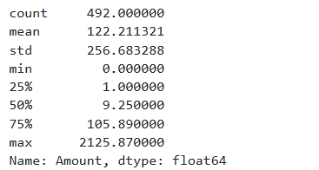

normal.Amount.describe()

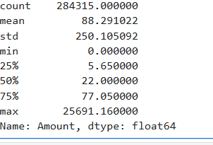

f, (ax1, ax2) = plt.subplots(2, 1, sharex=True)

f.suptitle('Amount per transaction by class')

bins = 50

ax1.hist(fraud.Amount, bins = bins)

ax1.set_title('fraud')

ax2.hist(normal.Amount, bins = bins)

ax2.set_title('normal')

plt.xlabel('Amount ($)')

plt.ylabel('Number of Transactions')

plt.xlim((0, 20000))

plt.yscale('log')

plt.show();

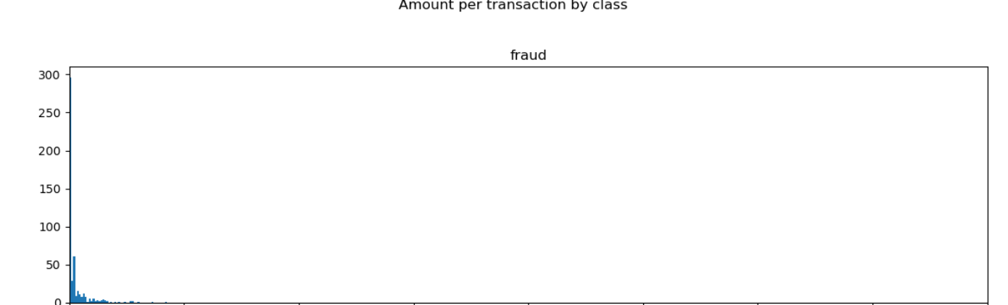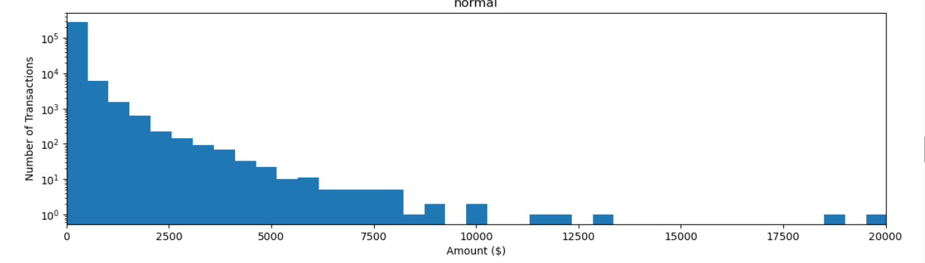

f, (ax1, ax2) = plt.subplots(2, 1, sharex=True)

f.suptitle('Time of transaction vs Amount by class')

ax1.scatter(fraud.Time, fraud.Amount)

ax1.set_title('fraud')

ax2.scatter(normal.Time, normal.Amount)

ax2.set_title('normal')

plt.xlabel('Time (in Seconds)')

plt.ylabel('Amount')

plt.show()

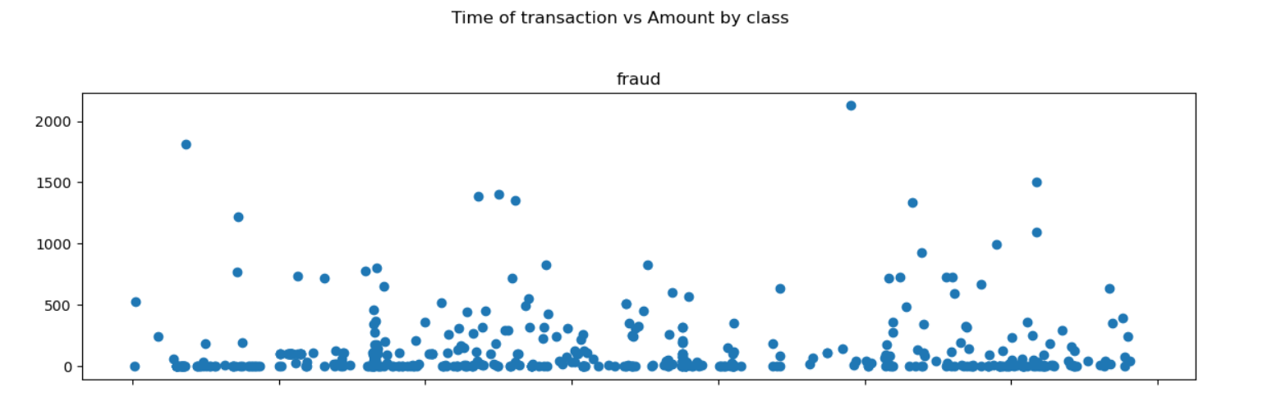

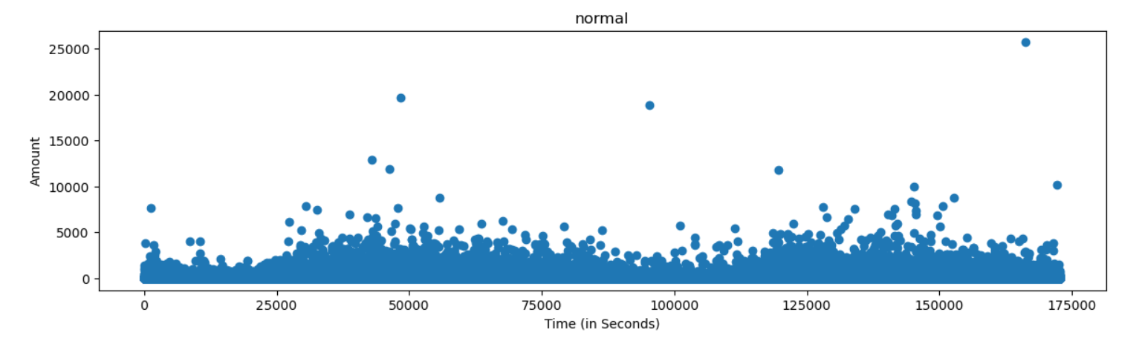

data1= data.sample(frac = 0.1,random_state=1)

data1.shape

data.shape



Fraud = data1[data1['Class']==1]

Valid = data1[data1['Class']==0]

outlier_fraction = len(Fraud)/float(len(Valid))

print(outlier_fraction)

print("Fraud Cases : {}".format(len(Fraud)))

print("Valid Cases : {}".format(len(Valid)))

import seaborn as sns

#get correlations of each features in dataset

corrmat = data1.corr()

top_corr_features = corrmat.index

plt.figure(figsize=(20,20))

#plot heat map

g=sns.heatmap(data[top_corr_features].corr(),annot=True,cmap="RdYlGn")

#Create independent and Dependent Features

columns = data1.columns.tolist()

# Filter the columns to remove data we do not want

columns = [c for c in columns if c not in ["Class"]]

# Store the variable we are predicting

target = "Class"

# Define a random state

state = np.random.RandomState(42)

X = data1[columns]

Y = data1[target]

X_outliers = state.uniform(low=0, high=1, size=(X.shape[0], X.shape[1]))

# Print the shapes of X & Y

print(X.shape)

print(Y.shape)

classifiers = {

"Isolation Forest":IsolationForest(n_estimators=100, max_samples=len(X),

contamination=outlier_fraction,random_state=state, verbose=0),

"Local Outlier Factor":LocalOutlierFactor(n_neighbors=20, algorithm='auto',

leaf_size=30, metric='minkowski',

p=2, metric_params=None, contamination=outlier_fraction),

"Support Vector Machine":OneClassSVM(kernel='rbf', degree=3, gamma=0.1,nu=0.05,

max_iter=-1)

}

type(classifiers)

n_outliers = len(Fraud)

for i, (clf_name,clf) in enumerate(classifiers.items()):

#Fit the data and tag outliers

if clf_name == "Local Outlier Factor":

y_pred = clf.fit_predict(X)

scores_prediction = clf.negative_outlier_factor_

elif clf_name == "Support Vector Machine":

clf.fit(X)

y_pred = clf.predict(X)

else:

clf.fit(X)

scores_prediction = clf.decision_function(X)

y_pred = clf.predict(X)

#Reshape the prediction values to 0 for Valid transactions , 1 for Fraud transactions

y_pred[y_pred == 1] = 0

y_pred[y_pred == -1] = 1

n_errors = (y_pred != Y).sum()

# Run Classification Metrics

print("{}: {}".format(clf_name,n_errors))

print("Accuracy Score :")

print(accuracy_score(Y,y_pred))

print("Classification Report :")

print(classification_report(Y,y_pred))

