**Django Task-2**

1. **Task Description**  
   Build a Python program that returns the number of paragraphs, count of words, count of sentences, and the document size of a .txt file.
2. **Task Output Screenshot**

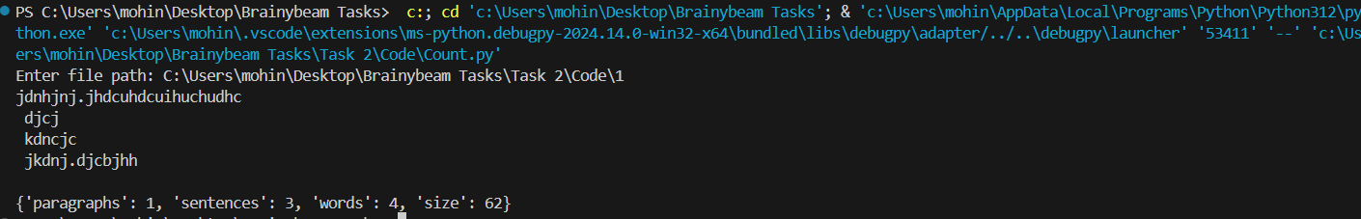

1. **Widget/Algorithm Used In Task**  
   **Algorithm Description**:

* **File Handling**: Read the .txt file using the built-in open() function.
* **Text Processing**: Use string methods to split and count paragraphs, words, and sentences.
  1. Count paragraphs by splitting the content using \n\n as a delimiter.
  2. Count words by splitting the content using whitespace.
  3. Count sentences by splitting the content using . as a delimiter.
* **File Size Calculation**: Use the os module to get the file size in bytes.