**Django Task-3**

1. **Task Description**Use JWT token authentication for login and signup functionality.
2. **Task Output Screenshot**

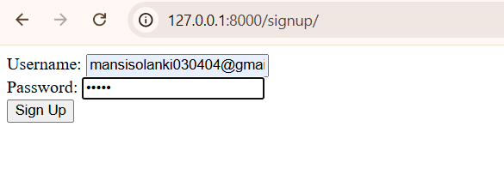

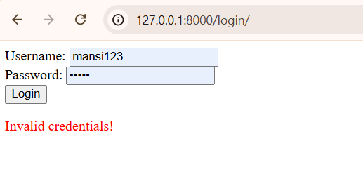

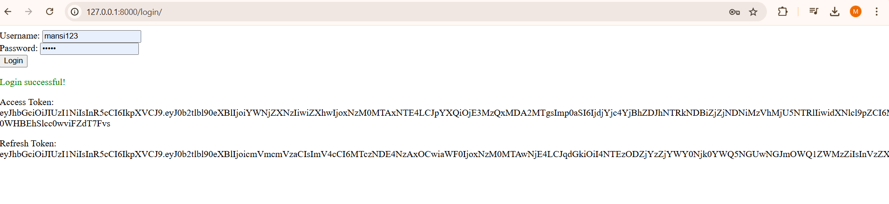

1. **Widget/Algorithm Used In Task  
   Algorithm Description:**

* **User Signup:**
  1. Create a Django view (signup_view) that accepts a username and password to create a new user.
  2. Use Django's built-in User model to save the user to the database.
  3. Check if the username already exists before creating a new user.
* **User Login:**
  1. Create a Django view (login_view) that accepts a username and password to authenticate the user.
  2. Use Django's authenticate method to verify credentials.
  3. Generate a JWT token for the user using the rest_framework_simplejwt package.
* **JWT Workflow:**
  1. Use RefreshToken.for_user(user) to create tokens (access and refresh).
  2. Return the tokens to the user upon successful login.