**Django Task-5**

1. **Task Description**  
   Build a function that returns the YouTube links when any search string is given.
2. **Task Output Screenshot**

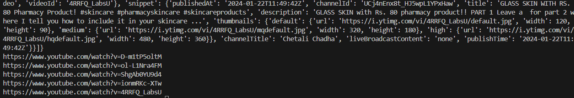

1. **Widget/Algorithm Used In Task**  
   **Algorithm Description**:

* **YouTube API**: Use the YouTube Data API to fetch video details.
* **Steps**:
  1. Send a GET request to the YouTube Data API endpoint (youtube/v3/search) with the search query and API key.
  2. Parse the API response to extract video IDs.
  3. Construct the video URLs using the format https://www.youtube.com/watch?v=<video_id>.
  4. Return the list of video URLs.