Software Requirements Specification (SRS)
AI Travel Booking System
A Multi-Agent AI Travel Planning and Booking Assistance Platform

Project Repository | https://github.com/MansiTiwary/AI-Travel-Booking-System
Prepared By | Mansi Tiwary and Yash Gupta
Version | 1.0 Approved
Date Created | 30 June 2026
Document Type | Software Requirements Specification
Project Status | Beta Version - Under Active Development

Revision History
Version | Date | Author | Description
1.0 | 30 June 2026 | Mansi Tiwary | Initial SRS

Table of Contents
- 1. Introduction
- 2. Overall Description
- 3. External Interface Requirements
- 4. System Features / Functional Requirements
- 5. Other Non-Functional Requirements
- 6. Database Requirements
- 7. System Architecture and Design
- 8. Use Case Model
- 9. Test Cases
- 10. Assumptions, Dependencies and Constraints
- 11. Future Enhancements
- 12. References
- 1. Introduction
- 2. Overall Description
- 3. External Interface Requirements
- 4. System Features / Functional Requirements
- 5. Non-Functional Requirements
- 6. Database Requirements
- 7. System Architecture and Design
- 8. Use Case Model
- 9. Test Cases
- 10. Assumptions, Dependencies and Constraints
- 11. Future Enhancements
- 12. References

1. Introduction

1.1 Purpose
The purpose of this SRS is to define the functional and non-functional requirements of the AI Travel Booking System. The system is designed to automate end-to-end travel planning by using collaborative AI agents for destination research, flight search, hotel recommendation, itinerary generation, budget estimation and final travel plan creation.

1.2 Scope
The system accepts a natural language travel request from the user and produces a complete travel plan. It reduces the need to visit multiple platforms by coordinating specialized agents through a supervisor workflow. The current version focuses on travel planning assistance, recommendation generation and API-based information retrieval. Direct payment and confirmed booking are considered future enhancements.

1.3 Definitions, Acronyms and Abbreviations
Term | Meaning
SRS | Software Requirements Specification
AI | Artificial Intelligence
LLM | Large Language Model
API | Application Programming Interface
Agent | A specialized AI component responsible for a specific task
LangGraph | Framework used for multi-agent workflow orchestration
PostgreSQL | Relational database used for storing requests, users and plans
Tavily | Search API used for destination and web research
AviationStack | API used for flight-related information

1.4 Technologies Used
AI and agent framework: LangGraph, Groq, LLaMA 3.3 70B. Backend: Python and FastAPI. Database: PostgreSQL. External APIs: Tavily Search API and AviationStack API. Development tools: Git, GitHub and Python virtual environment. Frontend technologies in the repository include HTML, CSS and JavaScript.

1.5 Intended Audience
This SRS is intended for developers, testers, project evaluators, academic reviewers, maintainers and future contributors who need to understand the expected behavior and design of the AI Travel Booking System.

2. Overall Description

2.1 Product Perspective
The AI Travel Booking System is a standalone AI-based travel planning assistant. It integrates a backend application, external travel/search APIs, a PostgreSQL data layer and multiple AI agents. The system works as a planning assistant rather than a final commercial ticketing system in the current version.

2.2 Product Functions
- Accept natural language travel requests from users.
- Extract destination, duration, budget, travel origin and preference information.
- Delegate sub-tasks to Flight Agent, Hotel Agent and Itinerary Agent.
- Fetch travel information from external services and web search APIs.
- Generate day-wise itinerary and activity suggestions.
- Recommend flight and hotel options based on cost and preferences.
- Aggregate all agent outputs into one final travel plan.
- Estimate total trip cost and present a structured response.

2.3 User Classes and Characteristics

2.4 Operating Environment
The system is expected to run on a Windows or Linux environment with Python installed. It requires internet access for external APIs and LLM calls. PostgreSQL must be available for database storage/checkpointing. The backend can be served through FastAPI and deployed on cloud platforms that support Python applications.

2.5 Design and Implementation Constraints
- The system depends on availability of external APIs and valid API keys.
- Output quality depends on the LLM response and search data quality.
- Real booking confirmation and payment processing are not included in the current scope.
- Sensitive keys must be stored in environment variables, not directly in source code.
- Internet access is required for real-time search and flight information.

2.6 User Documentation
User documentation should include setup steps, environment variable configuration, API key configuration, database setup, command-line run instructions, backend API run instructions and example travel queries.

2.7 Assumptions and Dependencies
It is assumed that users provide enough travel details such as destination, budget, duration or travel purpose. The system depends on Groq/LLaMA model access, Tavily Search API, AviationStack API and PostgreSQL connectivity.

3. External Interface Requirements
The External Interface Requirements define how the AI Travel Booking System interacts with users, hardware, software, and external communication systems.

3.1 User Interface
The system shall provide a simple, responsive, and user-friendly interface that allows users to interact using natural language.

Features
- User-friendly travel request form
- Natural language query input
- Display of flight recommendations
- Hotel recommendation dashboard
- Day-wise itinerary display
- Total trip cost estimation
- Responsive design for desktop and mobile devices

3.2 Hardware Interface
The system does not require any specialized hardware.

Client Side
- Desktop/Laptop
- Mobile Device
- Internet Connection
- Minimum 4 GB RAM

Server Side
- Cloud Server or Local Server
- PostgreSQL Database Server
- Python Runtime Environment

3.3 Software Interface
The system integrates with multiple software components.

Frontend
- HTML5
- CSS3
- JavaScript

Backend
- Python
- FastAPI
- LangGraph

Database
- PostgreSQL

AI Services
- Groq LLaMA 3.3 70B
- Tavily Search API
- AviationStack API

Version Control
- Git
- GitHub

3.4 Communication Interface
Communication between system components is performed using secure protocols.
- HTTPS Protocol
- REST APIs
- JSON Data Exchange
- PostgreSQL Database Connection
- API Authentication using Secret Keys

4. System Features / Functional Requirements

ID | Functional Requirement | Description
FR-01 | Submit Travel Request | Users can enter travel requests using natural language.
FR-02 | Intent Recognition | The Supervisor Agent extracts destination, duration, budget, and preferences.
FR-03 | Flight Recommendation | Flight Agent recommends suitable and cost-effective flights.
FR-04 | Hotel Recommendation | Hotel Agent recommends hotels according to budget and location.
FR-05 | Itinerary Generation | Generates a day-wise travel itinerary with attractions and activities.
FR-06 | Cost Estimation | Calculates estimated travel expenses.
FR-07 | Final Travel Plan | Combines outputs from all AI agents into a complete travel plan.
FR-08 | API Integration | Retrieves travel information using Tavily Search API and AviationStack API.
FR-09 | Database Storage | Stores travel requests, plans, and logs in PostgreSQL.
FR-10 | Error Handling | Handles invalid inputs, API failures, and database errors gracefully.

5. Non-Functional Requirements

5.1 Performance Requirements
- Generate travel plans within a few seconds.
- Handle multiple user requests simultaneously.
- Optimize API response time.
- Efficient database queries.

5.2 Reliability Requirements
- Maintain high system availability.
- Continue operation despite temporary API failures.
- Ensure consistent AI-generated recommendations.
- Provide meaningful error messages.

6. Database Requirements
The project uses PostgreSQL for storing structured data and supporting the workflow. The database design may include the following logical entities:

7. System Architecture and Design
The system follows a multi-agent architecture. A supervisor agent receives the user request and assigns specific tasks to specialized agents. Each agent completes its responsibility and sends the output to the final agent, which creates the complete travel plan.
User Request
↓
Supervisor Agent
↓
Flight Agent + Hotel Agent + Itinerary Agent
↓
Final Planning Agent
↓
Complete Travel Plan

7.1 Module Description
Module | Description
User Interface Module | Provides a user-friendly interface where users enter travel requests in natural language and view personalised travel recommendations.
Supervisor Agent | Acts as the central coordinator of the system. It analyses the user's travel request, extracts relevant information such as destination, budget, duration, and delegates tasks to specialised AI agents.
Flight Agent | Searches for suitable flight options using external APIs and recommends cost-effective routes based on user preferences and budget.
Hotel Agent | Retrieves hotel information and recommends accommodations considering location, ratings, price, and user preferences.
Itinerary Agent | Generates a structured day-wise travel itinerary, including tourist attractions, activities, transportation, and estimated timings.
Final Response Agent | Collects outputs from all specialised agents, combines them into a complete travel plan, and presents a well-structured final response to the user.
API Integration Module | Connects the application with external services such as Tavily Search API, AviationStack API, and Groq LLM API to retrieve real-time travel information.
Database Module | Stores travel requests, generated itineraries, agent responses, logs, and user-related information using PostgreSQL.
Backend Module | Implements business logic, API endpoints, workflow management, and communication between AI agents using Python, FastAPI, and LangGraph.

8. Use Case Model

8.1 Actors
- Traveller (Primary Actor)
- Administrator
- Developer

8.2 Use Case Description

Use Case | Actor | Description
Submit Travel Request | Traveller | User enters destination, budget, duration, and travel preferences in natural language.
Generate Travel Plan | Traveller | System generates a personalized travel plan using multiple AI agents.
Find Flights | Traveller | Flight Agent recommends suitable flight options.
Find Hotels | Traveller | Hotel Agent recommends hotels based on budget and preferences.
Generate Itinerary | Traveller | Itinerary Agent creates a day-wise travel schedule.
View Final Recommendation | Traveller | User views the combined travel plan including flights, hotels, itinerary, and estimated cost.
Manage APIs | Developer | Configures API keys, updates integrations, and monitors external services.
Maintain Database | Administrator | Manages PostgreSQL database, backups, and application logs.

8.3 Use Case Diagram
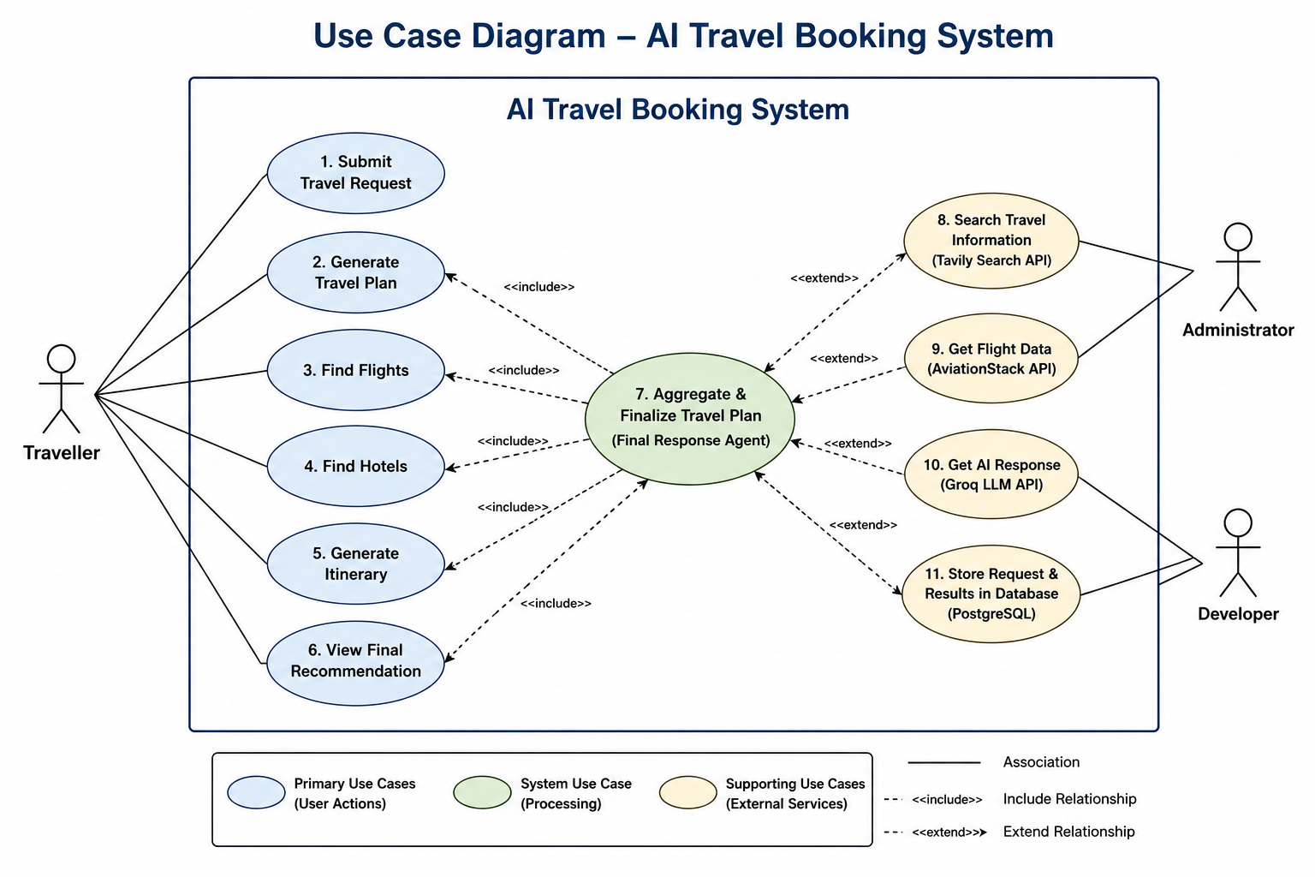

9. Test Cases
Test Case ID | Test Scenario | Input | Expected Output | Status
TC-01 | Generate travel plan | Plan a 5-day trip to Goa under ₹30,000 | Complete travel itinerary generated | Pass
TC-02 | Flight recommendation | Cheapest flight from Mumbai to Dubai | Flight options displayed | Pass
TC-03 | Hotel recommendation | Hotels near Marina Bay Sands | Hotel recommendations displayed | Pass
TC-04 | Itinerary generation | 7-day Japan itinerary | Day-wise itinerary generated | Pass
TC-05 | Budget estimation | Trip to Manali under ₹15,000 | Estimated total cost displayed | Pass
TC-06 | Invalid destination | Plan trip to UnknownCity | Appropriate error message displayed | Pass
TC-07 | Missing budget | Plan a trip to Kerala | System asks for missing budget or generates a general recommendation | Pass
TC-08 | API failure | Disable AviationStack API | Error handled gracefully with user-friendly message | Pass
TC-09 | Database connectivity | PostgreSQL unavailable | Connection error handled and logged | Pass
TC-10 | Complete AI workflow | Plan a 6-day trip to Singapore under ₹80,000 | Supervisor coordinates all agents and returns a complete travel plan | Pass

10. Assumptions, Dependencies and Constraints

10.1 Assumptions
- User provides at least basic travel information.
- External APIs return usable results.
- The LLM can understand and process travel planning instructions.
- The database server is available when persistence is required.

10.2 Dependencies
- Groq API / LLaMA 3.3 70B model access
- Tavily Search API
- AviationStack API
- PostgreSQL database
- Python packages and environment variables

10.3 Constraints
- Actual ticket booking and payment are outside the current system scope.
- Flight and hotel data accuracy depends on external service providers.
- API rate limits may affect repeated usage.
- System recommendations should be verified before real travel booking.

11. Future Enhancements
- Flight booking integration
- Hotel booking integration
- Visa requirement assistant
- Travel expense tracker
- Voice-based travel assistant
- Multi-language support
- Travel recommendation engine
- AI travel concierge dashboard

12. References
- GitHub Repository: https://github.com/MansiTiwary/AI-Travel-Booking-System
- Project README and repository documentation
- Project demo and benchmark summary reports available in repository
- IEEE-style SRS structure and standard academic SRS format

