

BIRLA INSTITUTE OF TECHNOLOGY AND SCIENCE, PILANI

FIRST Semester 2021-2025
“END-TO-END HYBRID INFRASTRUCTURE SETUP ON AZURE WITH RDS AND SCCM INTEGRATION”
CSIWZG628T DISSERTATION

by
Mansi Vashishth
2021wa86114

Dissertation Work carried out at Wipro Technologies, PUNE

BIRLA INSTITUTE OF TECHNOLOGY AND SCIENCE
Pilani (Rajasthan) India
October 2025

CSIWZG628T DISSERTATION

“END-TO-END HYBRID INFRASTRUCTURE SETUP ON AZURE WITH RDS AND SCCM INTEGRATION”

Submitted in partial fulfilment of the requirements of

M. Tech Computing Systems & Infrastructure Degree Program

by
Mansi Vashishth
2021wa86114

Under the supervision of

Rishav Raj (Lead Administrator L2)

Dissertation work carried out at Wipro Technologies, Pune

BIRLA INSTITUTE OF TECHNOLOGY AND SCIENCE PILANI (RAJASTHAN)
October 2025

BIRLA INSTITUTE OF TECHNOLOGY AND SCIENCE PILANI

Certificate

This is to clarify that the entitled Creating End-to-End Hybrid Infrastructure Setup on Azure with RDS and SCCM Integration submitted by Mansi Vashishth Bits-ID 2021wa86114 in partial fulfilment of the requirements of CSIWZG628T Dissertation, embodies the work done by her under my supervision.

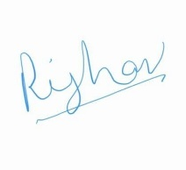

Date: 31-October-2025 Signature of the supervisor Rishav Raj
Designation Lead Administrator
S.No | Content | Page No.
1. | Abstract | 8
2. | Objective and scope of the plan | 9
3. | Create and Azure Subscription | 10
4. | Resource group, Virtual Network and Virtual Machine | 11- 12
5. | Tools used in this project | 12
6. | Steps and Process to create VM setup using Terraform | 13-15
7. | Verify the VM created | 16
8. | Connect VM via RDP | 17-18
9. | Install ADDS and promote the server as Domain Controller | 19-21
10. | Create a DNS server | 22
11. | Create OU & Users | 23
12. | SQL server Setup | 24-26
13. | Script to perform SQL and SSMS setup | 27
14. | Terraform Script to Create 3 Virtual Machines | 28-34
15. | Windows Server Update Services (WSUS) | 35
16. | What is SCCM / MECM? | 36
17. | SCCM setup installation | 37-44
18. | SCCM Configuration After Installation | 45-50
19. | RDS Farm | 51
20. | Components of RDS farm | 52-53
21. | Step by step commands performed to setup RDS Farm | 54-55
22. | Creating Authorization policy for RD Gateway | 56-58
23. | Testing RDP connection through RD Gateway | 59-62
24. | Conclusion | 63
25. | Detailed Plan of the work | 64
26. | Reference Links | 65
27. | Check list of items for report | 66

Abstract

In this project we demonstrate the deployment of 3 windows server infrastructure in Microsoft Azure with the help of tools like Terraform and PowerShell for automate the process. This infrastructure included three Windows Server VMs, Resource group, virtual network, subnet, public Ips all these were provisioned through Terraform.

After deployment, the first VM was promoted to a Domain Controller with roles such as AD DS and DNS. The remaining VMs were joined to the domain and configured with their respective roles using automated PowerShell scripts. The second VM was set up with SQL Server, while the third VM was added as a domain member server for SCCM. SCCM was installed and configured on mansivm-1 to centrally manage client updates. Remote Desktop Services (RDS) roles were deployed on mansivm-2, with mansivm-0 and mansivm-1 functioning as Session Hosts. PowerShell scripts were used to automate the entire RDS setup, including role installation, certificate binding, session collection creation, load balancing, and RD Gateway configuration.
This project demonstrates the approach in which Terraform provisions infrastructure and automated server role configuration using PowerShell that enables a scalable and production ready setup. The use of Azure ensures flexibility, security, and cost-effective scalability across the environment.

ACKNOWLEDGEMENTS

I would like to thank my project Supervisor Rishav Raj for his guidance effort, guidance and patience. He has been extremely supportive and cooperative in this whole effort. His valuable comments and suggestions have been very helpful in enhancing the quality of work.
I would like to express my sincere gratitude towards my examiners Augustin Jabaraz and Preethi Manian for examining my progress despite their business schedule.
I am also thankful to WIPRO TECHNOLOGIES for giving me such opportunity for training in M. Tech Computing System and Infrastructure Degree Program and providing all the resources required for this dissertation.

Objective and scope of the plan

Objective:
Main Objective is to bring all the infrastructure of an existing organization under a single domain using windows technologies based on cloud computing using Terraform and PowerShell maintain the infrastructure in compliance all the time.

Scope of the plan:

The scope of the plan is to create a windows domain with various windows technologies that are required for an organization using Cloud Computing.

- Get an Azure subscription
- The automation and deployment of three virtual machines on Azure using Terraform.
- Deploy the Windows Machines
- Create Domain
- Promote the VM0 to domain controller.
- Deploy all the applications/ roles using PowerShell.

This project can be used to train my team on Azure and automation which can be show cased to the client and get the contract of cloud-based projects that are the handled by client.

Create an Azure Account

Creating an Azure account is as easy as you create outlook account. Organizations will buy subscriptions to maintain the resources and secure the environment.

Here in this project, I have used Azure free subscription also called as Student trail.
Create an Outlook account, and then use the outlook account to create azure free subscriptions by signing up at https://portal.azure.com/#home

Below is the home screen of Azure after sign-up

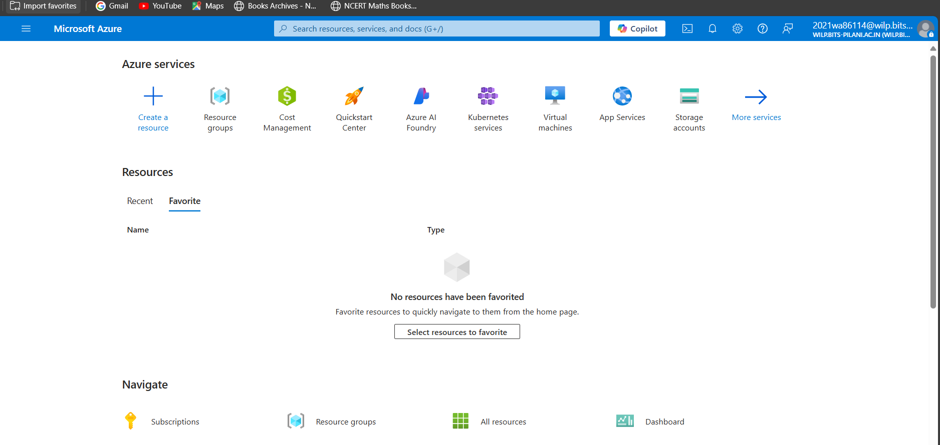

Resource group:

A Resource Group in Azure is like a folder where you keep all your Azure resources together.
It helps you organize and manage everything in one place — for example, virtual machines, networks, or storage accounts.
Even though the resource group itself is created in a specific region, it can still hold resources from other regions. There’s no limitation on that.
You can think of it as the main container where all your Azure resources live and are managed
In my case name of resource is MTECH.

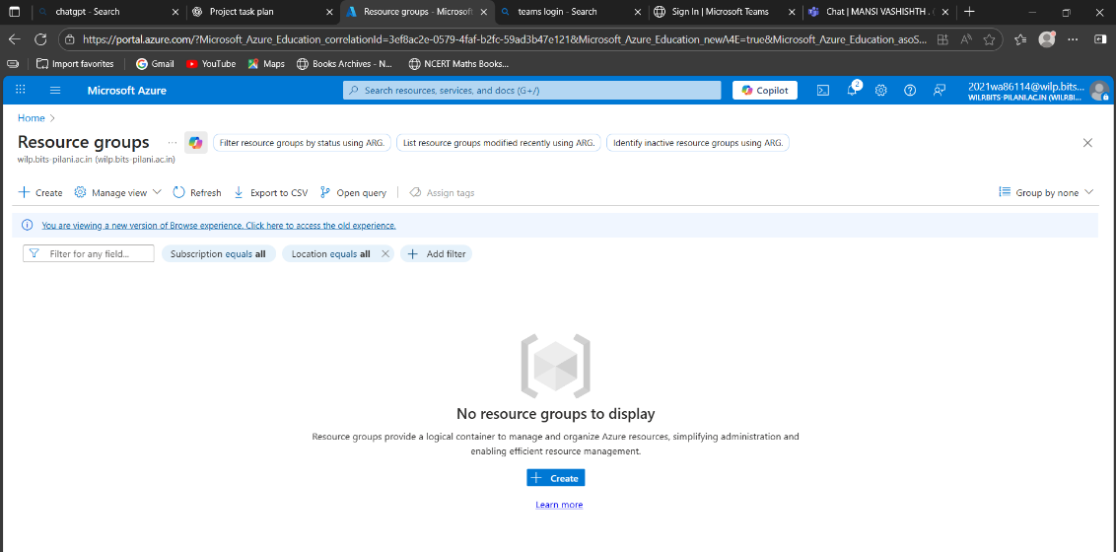

Virtual Network:

Azure (VNet) is the core blocks for creating private networks inside Azure. It allows different resources—like (VMs)—to talk to each other securely, as well as connect to the internet or you’re on-premises environment.

You can think of a VNet as similar to the networks we use in traditional data centers, but it also comes with Azure’s advantages like easy scaling, high availability, and strong isolation.

By default, everything inside a VNet can connect out to the internet. If you want the internet or outside users to reach a resource inside the VNet, you need to give it a public IP address or put it behind a load balancer. You can also manage outgoing connections using public IPs or load balancers.

I have named the VNet as MTech_Network.

Virtual Machine:

Azure Virtual Machines (VMs) are a type of cloud-based computer that you can create and use whenever you need. Unlike other ready-made Azure services, VMs give you more freedom and control over the system because you decide how it is set up, which software to install, and how it is maintained.
The main advantage of using a VM in Azure is that you don’t need to buy or manage the physical servers yourself. Azure takes care of the underlying hardware, and you just focus on using the machine. However, you are still responsible for things like updating the operating system, installing applications, and keeping it secure.
There are different situations where Azure VMs are useful:
- Development and Testing – Developers can quickly spin up VMs with the exact settings they need to build and test their applications.
- Running Applications – If your app has changing demand, you can add more VMs when traffic is high and remove them when it’s low. This way, you only pay for what you actually use.
- Extending Your Datacenter – VMs in Azure can connect with your company’s on-premises network, making it easy to expand your IT infrastructure without buying new physical servers.

Here, I have created 3 VM’s named as: mansivm-0, mansivm-1, mansivm-2.

Tools Used in This Project
- Terraform – This is a tool that helps us create servers and networks in Azure automatically, instead of doing everything by hand.
- Microsoft Azure Portal – The website where we can see, manage, and monitor all the resources we create in Azure.
- Azure Virtual Machines (VMs) – These are like computers running in the cloud. We used them for Domain Controller and SQL Server.
- PowerShell – A scripting tool we used to run commands for setting up the Domain Controller, joining other VMs to the domain, and installing SQL.
- Remote Desktop (RDP) – This allows us to log in to our virtual machines and work on them as if they were normal computers.

Steps and Process to Create the setup now using Terraform

  - Created Infrastructure with Terraform – Used Terraform to automatically create 3 virtual machines inside an Azure Virtual Network:
- Prework: a. Install and setup Terraform in local machine.
b. Download Azure CLI.
c. If using VS Code, then install extension – HashiCorp Terraform for smooth setup.

- Created a folder name: F:\2021wa86114\azure-3vm-project to store script and terraform scripts.
- Open Command Prompt as admin and navigate to the folder path where you have stored the scripts and .tf code.
- Login Azure using: az login
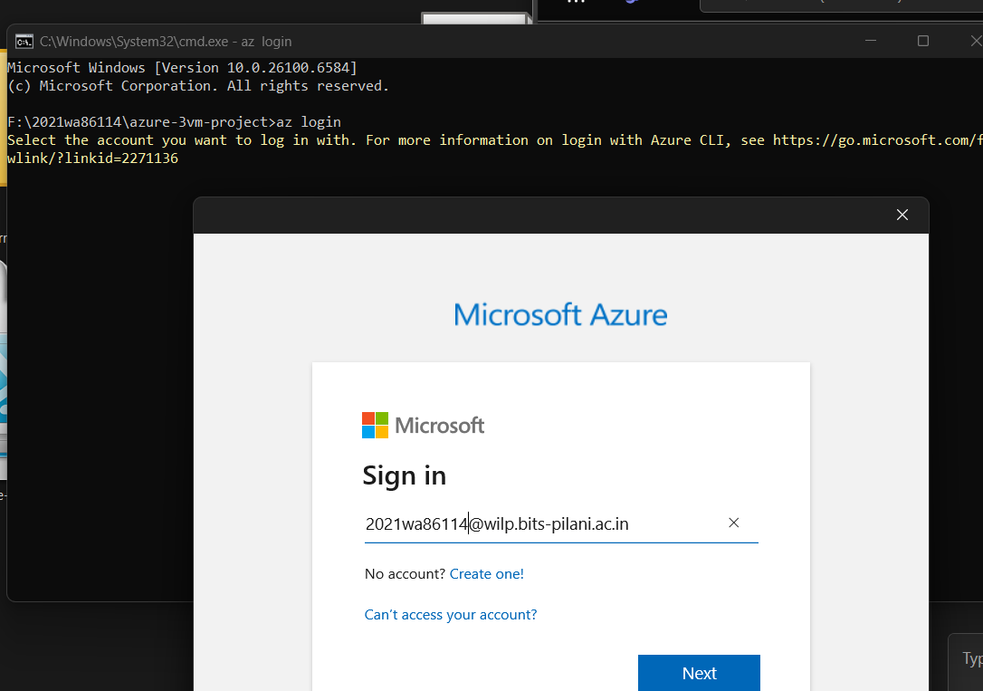

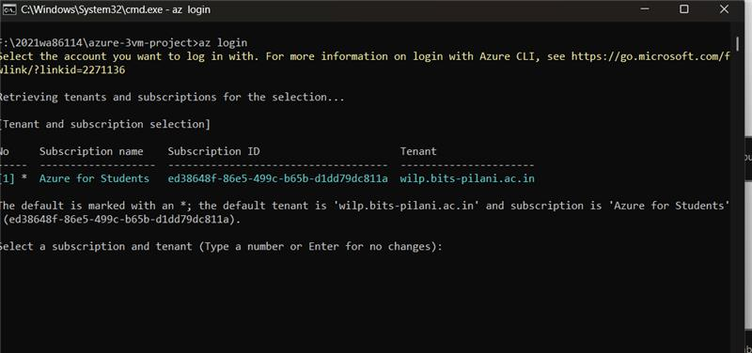

***I have given below names in configuration setup:

- Resource group name: MTECH
- Azure region for resources: Central India
- VNet Name: MTech_Network
- Subnet Name: subnet-project
- Number of Virtual Machines to create: 3
- Domain name: bits.com
***** I have documented the terraform code for this process on page no 28

- Initialize Terraform: Run terraform init
First, I ran terraform init to set up Terraform and download the required Azure provider. 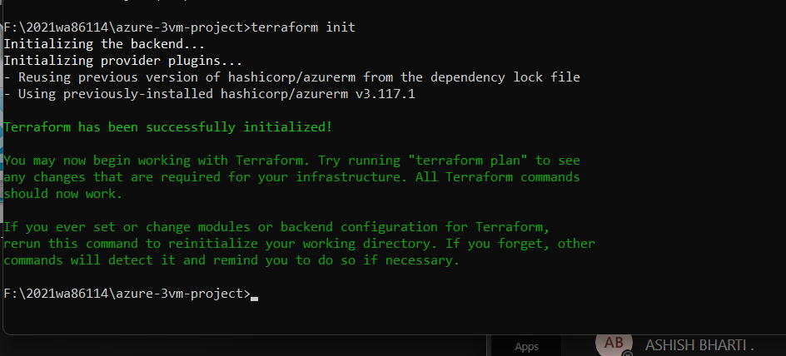

- Terraform Plan: Run terraform plan
Then, I used terraform plan to check what resources Terraform would create in Azure. This step helps to make sure everything is correct before actually creating the resources.
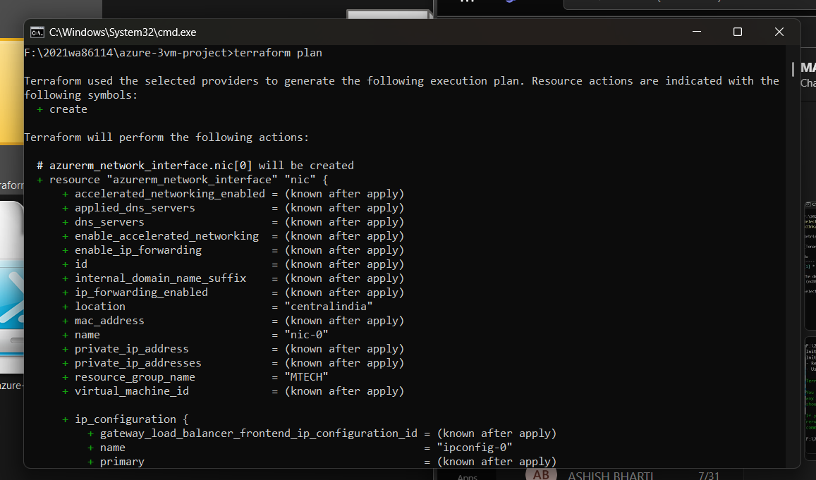
- Terraform Apply: terraform apply -auto-approve
Next, I ran terraform apply to actually create the resources. Terraform created a resource group, virtual network, subnet, network security groups, public IPs, network interfaces, and three virtual machines.
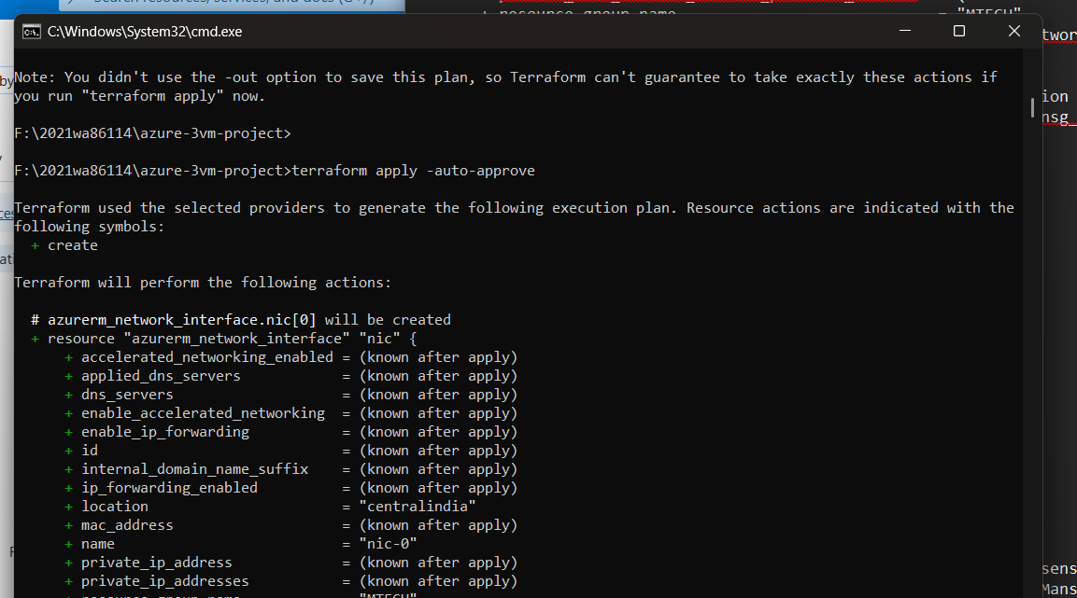

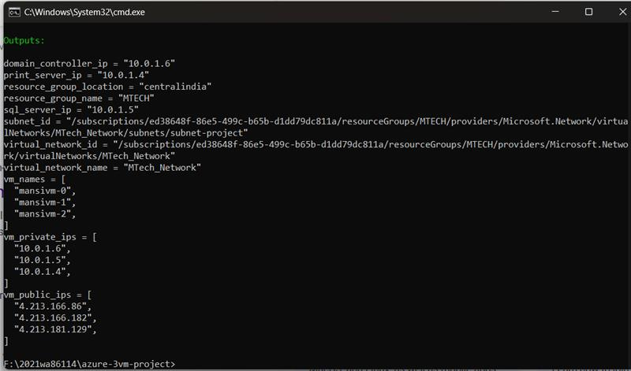

Post terraform apply: Verify Resources

After running the Terraform script, I went to the Azure portal to confirm that all three virtual machines and the related network resources were created correctly.
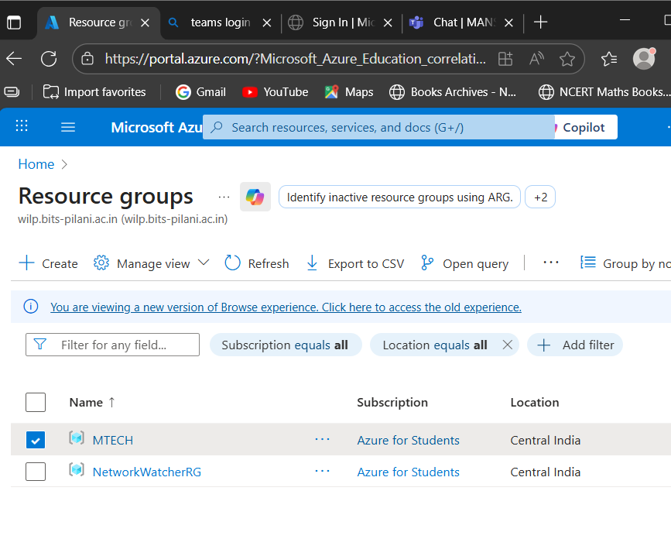

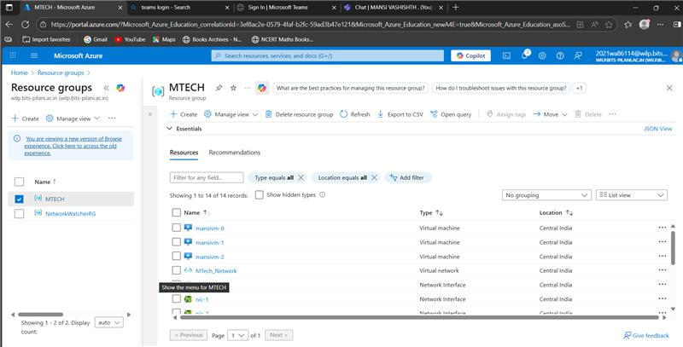

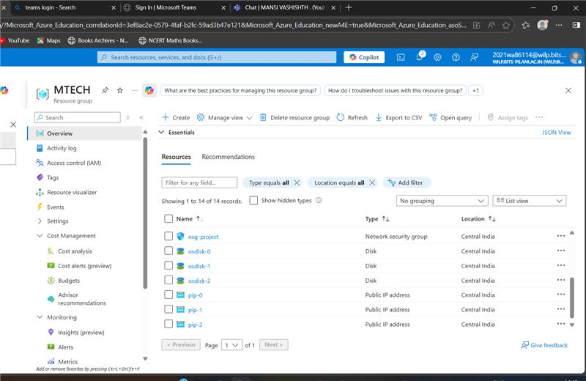
Promote Mansivm-0 to act as Domain Controller

Each operating system uses its own way (protocol) to connect to a virtual machine. In this project, the VMs are running Windows Server 2019 Datacenter. Windows servers use Remote Desktop Protocol (RDP), which works on port 3389, to connect.
To log in, we can simply download the RDP file from the portal and connect by entering the admin username and password that were set while creating the VM.

- Step 1: Connect Virtual machine – mansivm-0 via rdp
Click on server name -> connect -> Download RDP file - connect

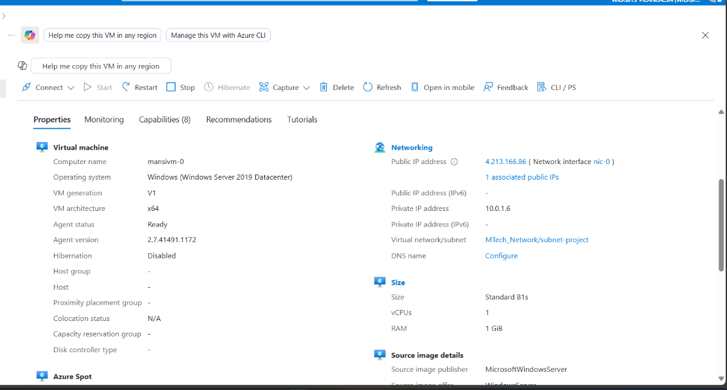

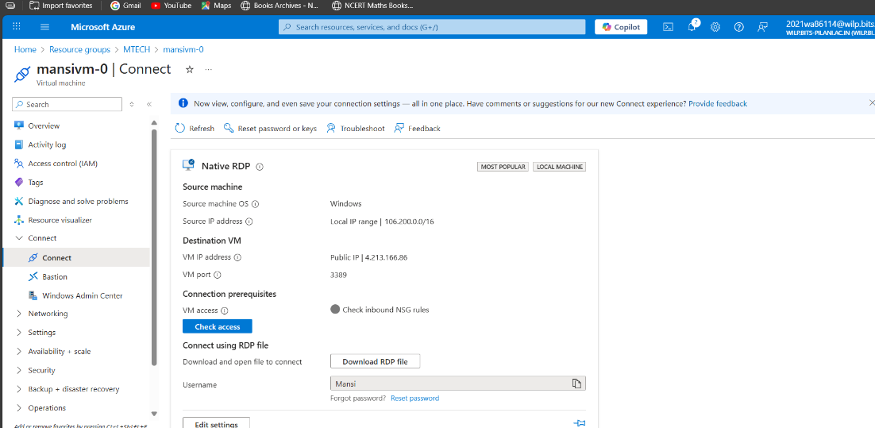

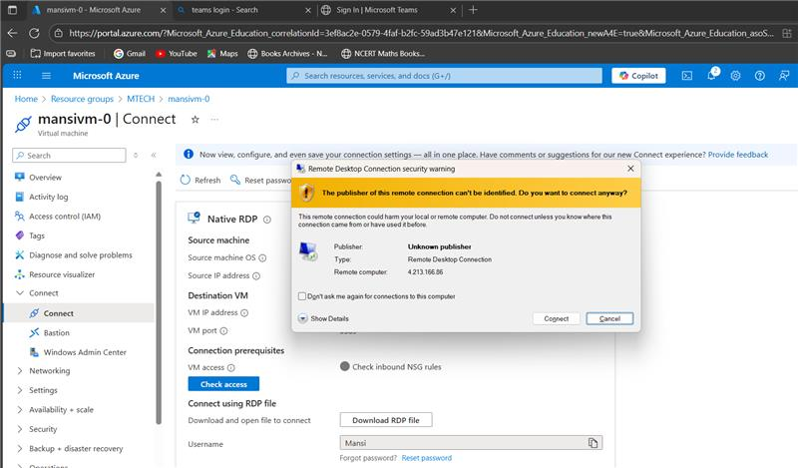

I am able to get into the server successfully. Since its free trail account the firewalls are already configured by Azure and Microsoft Defender is the antivirus tool installed in the server.

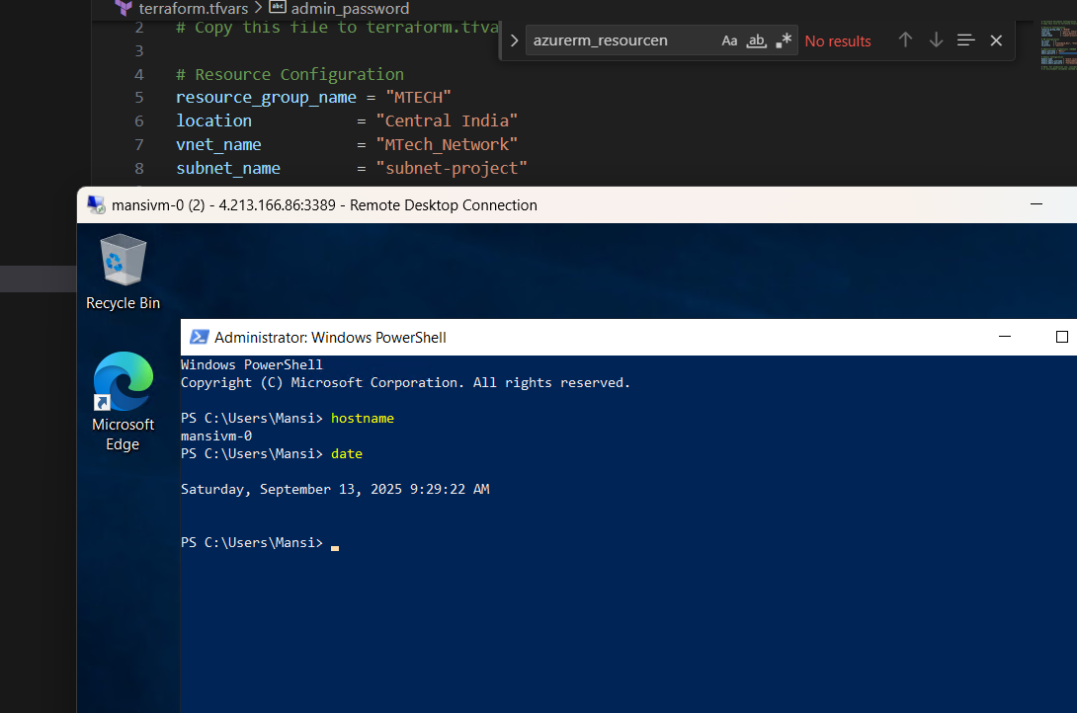

Install ADDS and promote the server as Domain Controller
A Domain Controller (DC) is a special server in a network that manages security and user access. It checks login requests, stores user accounts, and makes sure security rules are followed. In Windows environments, the Domain Controller works with Active Directory, which is the main service used to organize and control users and resources in a domain.

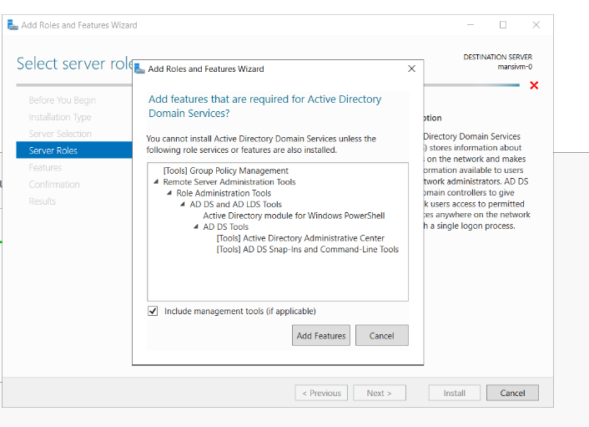

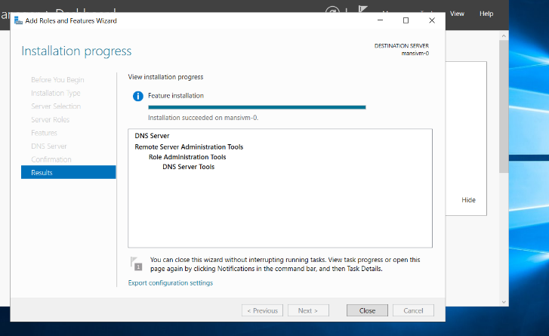

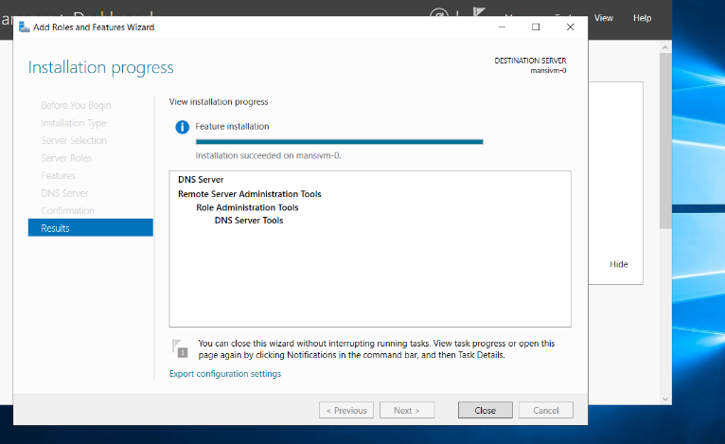

Post installation of the AD DS role, the server can be promoted to a domain controller.
Since I was creating a new domain, I chose the option “Add a new forest” and named my domain bits.com

Next, I set a password for Active Directory recovery and continued with the default settings. Once the installation finished, the server rebooted, and after restart, a new domain called bits.com was successfully created, managed by the forest root domain controller (DC).

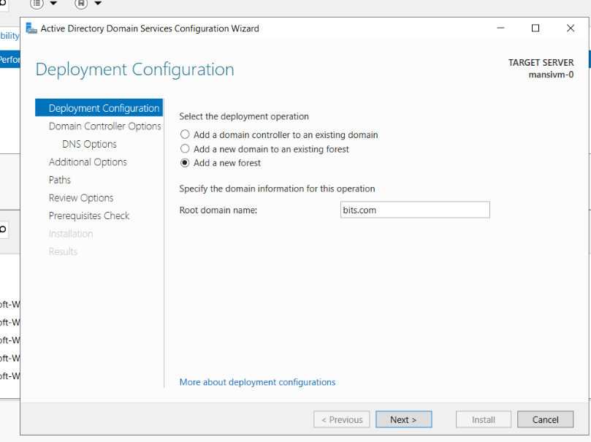

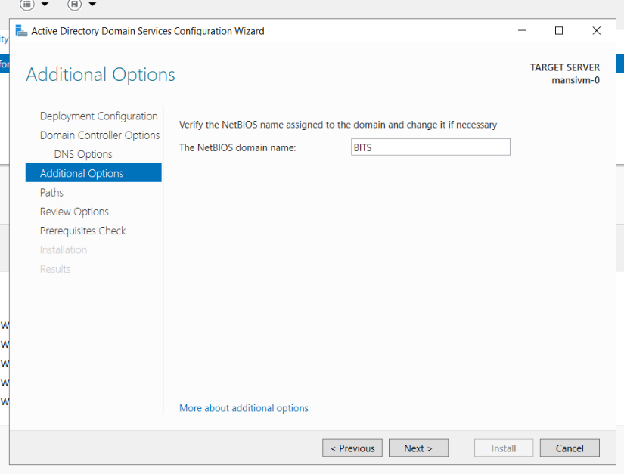

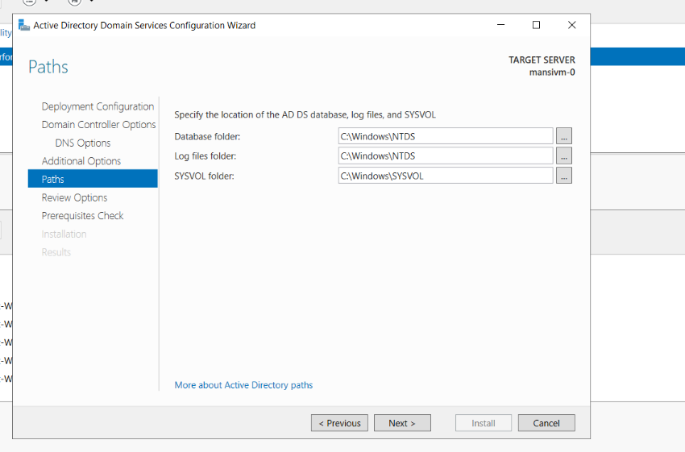

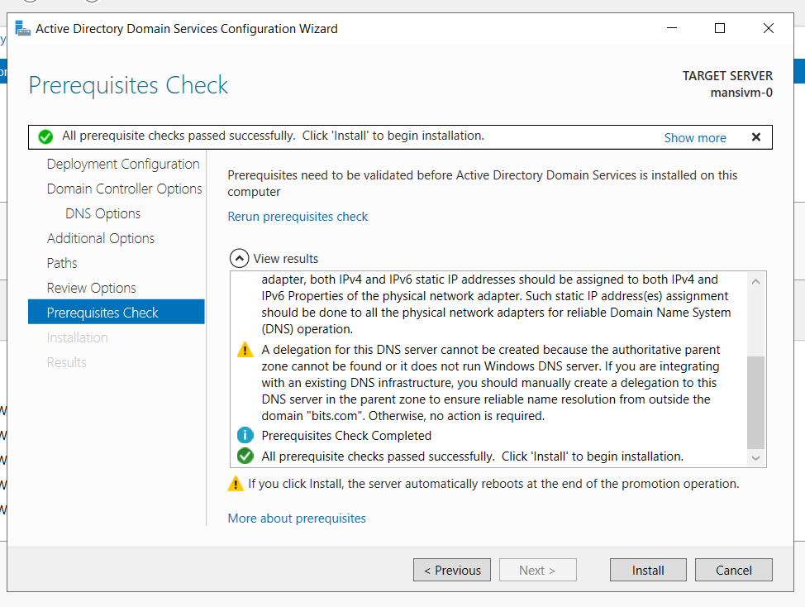
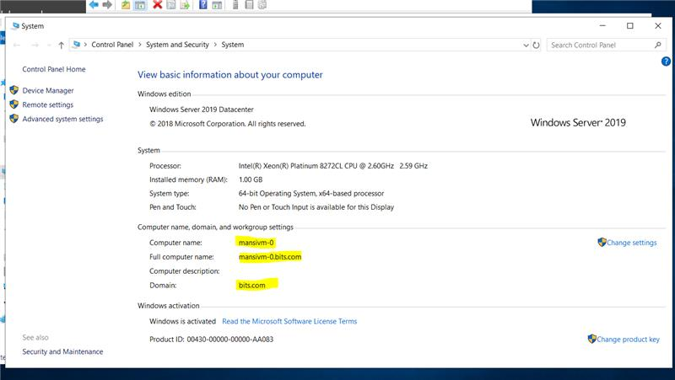

Create a DNS server:
The Domain Name System (DNS) is like a naming service for computers and servers. It makes it possible to use simple names instead of remembering long numbers (IP addresses). For example, instead of typing an IP, we just use a name like server1 or google.com.
When we install DNS, the server can match names to the right IP addresses. This way, users can easily find and connect to other systems without needing to know the actual numbers.
The process of installing DNS is almost the same as installing ADDS, but here we just select DNS. After the server restarts, the same domain controller also works as a DNS server.
In small setups, one server can handle both ADDS and DNS. But in bigger companies, there are usually separate servers dedicated just for DNS management.
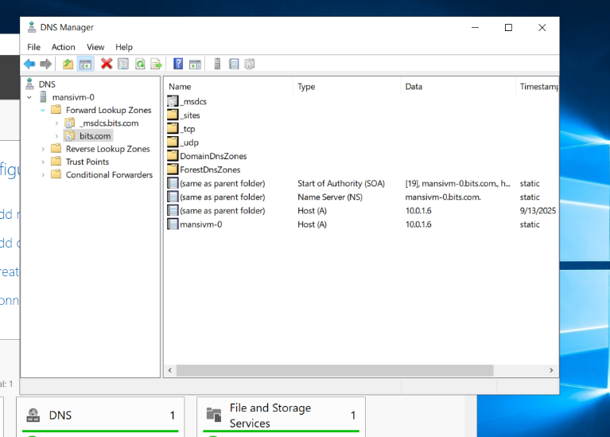

An OU is like a folder inside Active Directory where you can keep users, groups, and computers of an organization. It helps in keeping everything organized.
The main use of an OU is that administrators can apply policies (rules) or permissions to it. For example, you can create an OU for each department like HR, IT, or Finance, and then apply specific rules only to that department.

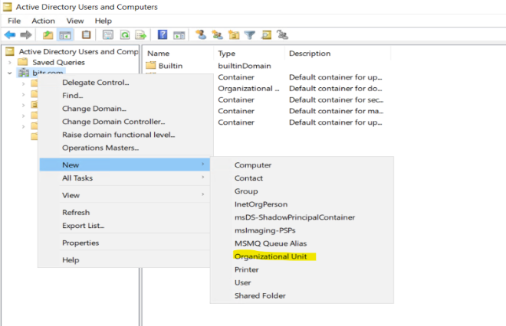
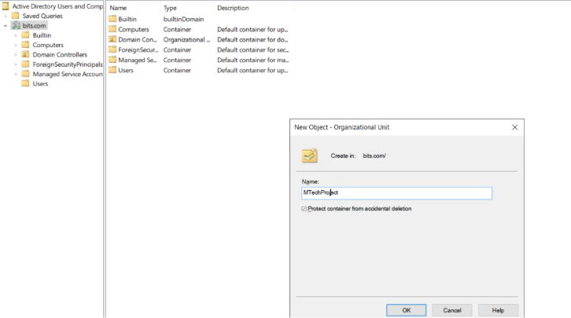

Once the OU is ready, create users to manage the environment, services and applications. Below are the users that I have created in this OU.
- Mansi Vashishth
- SCCMAdmin
- sqladmin

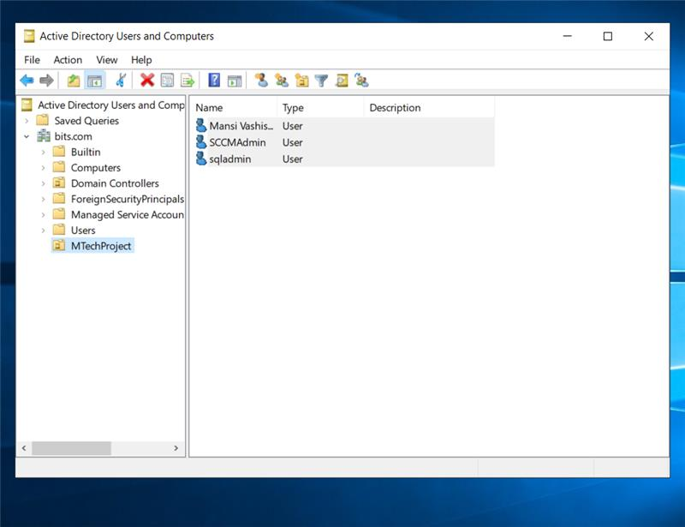
I have added all the users to Domain Admins so that they will have admin access over the Domain.

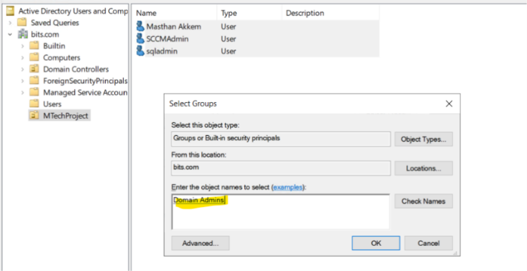

As server is successfully promoted as domain controller. Now I have joined the rest two vms to domain -bits.com and configure the roles as planned.
Provided Admin access to the servers for the accounts that which we created.
- Mansi Vashishth has full control over Domain Controller (DC).
- SCCMAdmin has the full control over SCCM server.
- Sqladmin has full control over SQL server.
Configure SQL Server setup on mansivm-1

- Login to server via rdp.
- Now, to join server to domain bits.com we need to configure VM 0 ip as DNS server in rest of the servers by using cli.
$DomainName = "bits"
$DC_IP = "10.0.1.6"
# Set DNS to point to the domain controller
Set-DnsClientServerAddress -InterfaceAlias "Ethernet" -ServerAddresses $DC_IP
- Once, DNS configured successfully. Run below command on vm to join to the domain.
# Join domain
Add-Computer -DomainName "bits.com" -Credential(Get-Credential) -Restart
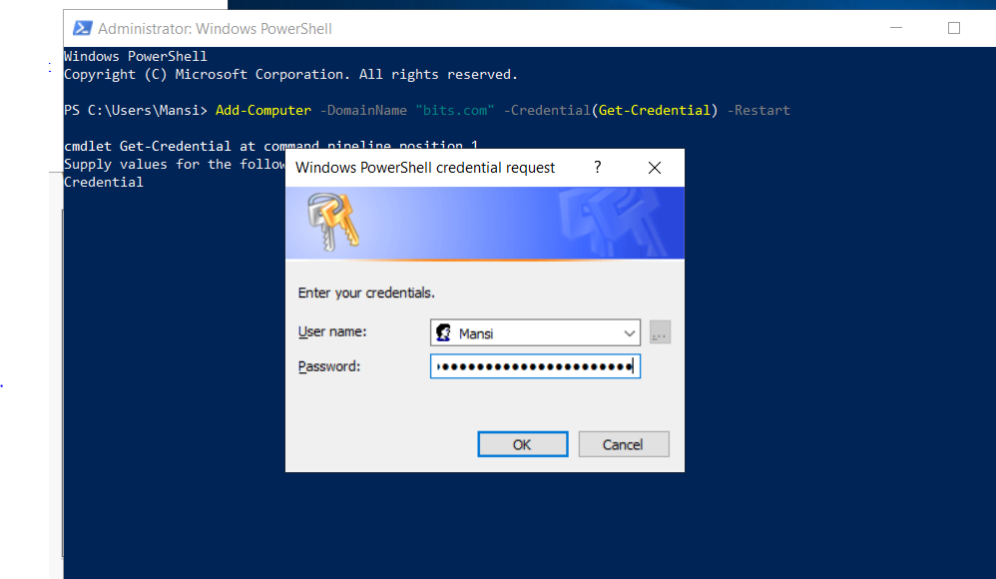
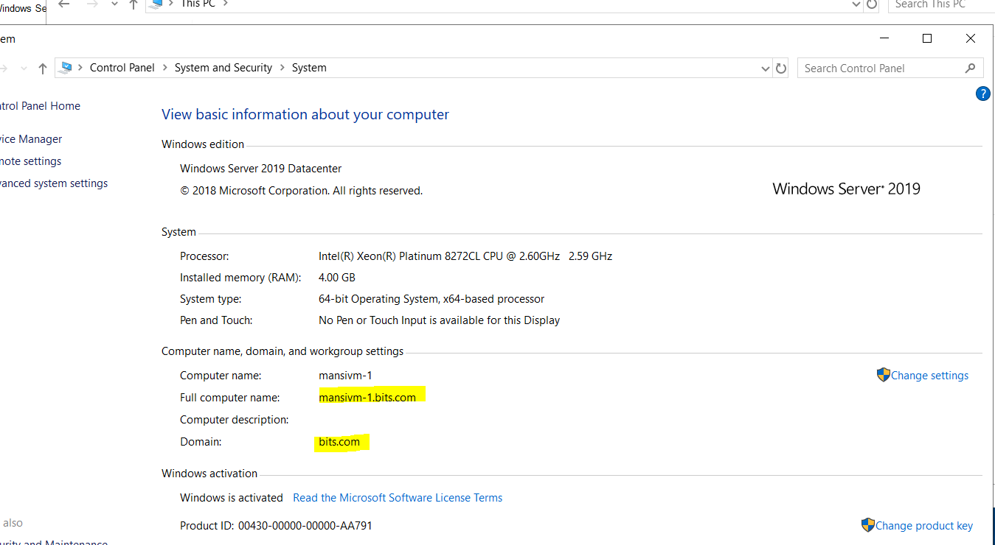

SQL Server 2019

SQL Server 2019 is Microsoft’s database software. It is used to store, manage, and organize data so that applications can use it. For example, if you have an application that keeps records of students, employees, or sales, SQL Server is the place where all that data is saved.
It is reliable, secure, and can handle large amounts of information. SQL Server 2019 also comes with many features to make searching, analysing, and protecting data easier.

SQL Server Management Studio (SSMS)
This is a free that is provided by Microsoft to work with SQL Server. It gives you simple window where you can:
- Connect to your SQL Server,
- Create or manage databases,
- Run queries (ask questions from the database),
- Backup or restore data, and
- Monitor the server.

In this project, I installed SQL Server 2019 Express
Instead of doing the setup manually, I used a PowerShell script to make the process faster and easier.

The script performed the following steps automatically:
- Downloaded the SQL Server 2019 Express installer.
- Installed SQL Server with the required configuration.
- Opened the firewall port (1433) so that SQL Server can be accessed.
- Downloaded and installed SQL Server Management Studio (SSMS).
- Cleaned up the temporary setup files after installation.

By using the script, the installation became more reliable and repeatable. I didn’t need to click through the installer manually; everything was done in one go.

I have created the script and paster under C:\Scripts of VM1
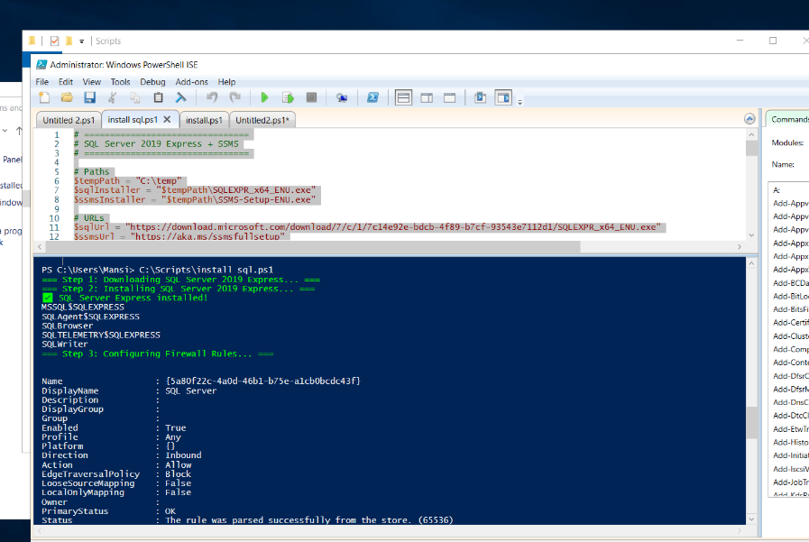

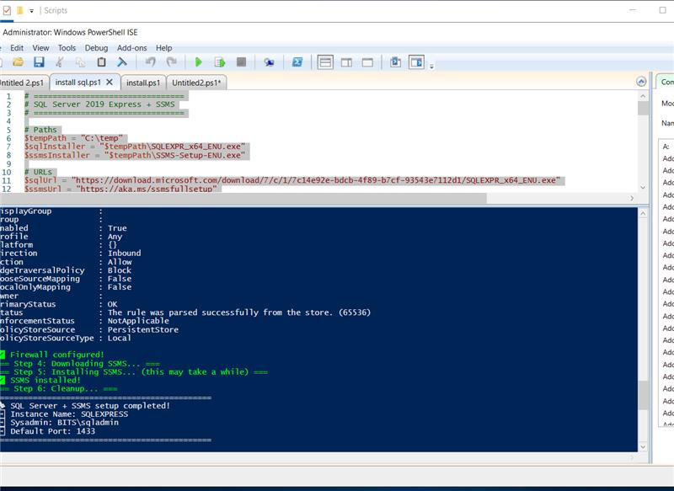

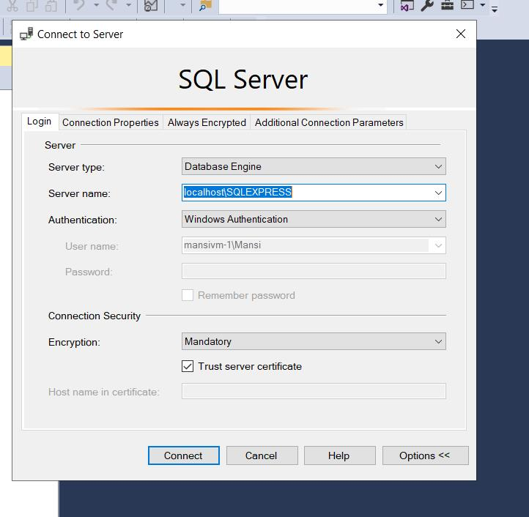

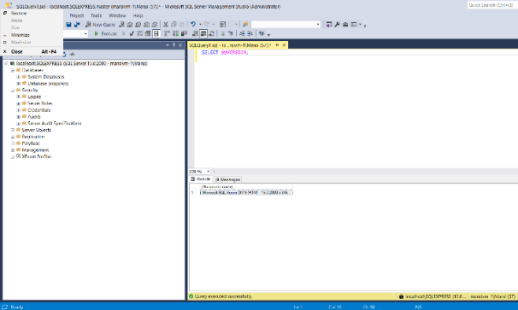
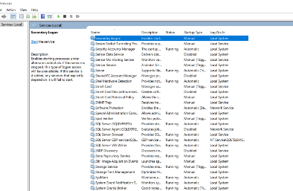

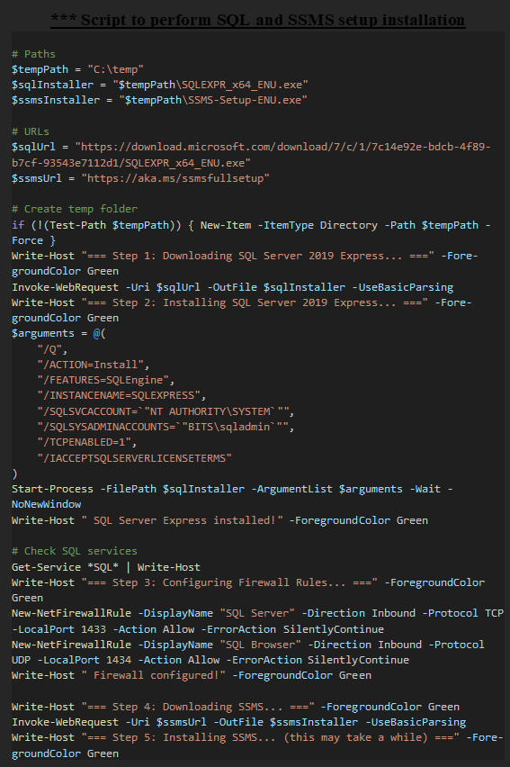
***** Terraform Script to Create 3 Virtual Machines

Below is the Terraform script that was used in this project to create:
- A resource group
- A virtual network and subnet
- A network security group with rules
- Public IPs and Network Interfaces
- Three Virtual Machines (VM0 as Domain Controller, VM1 as SQL Server, and VM2 as RDS)

Main.tf:

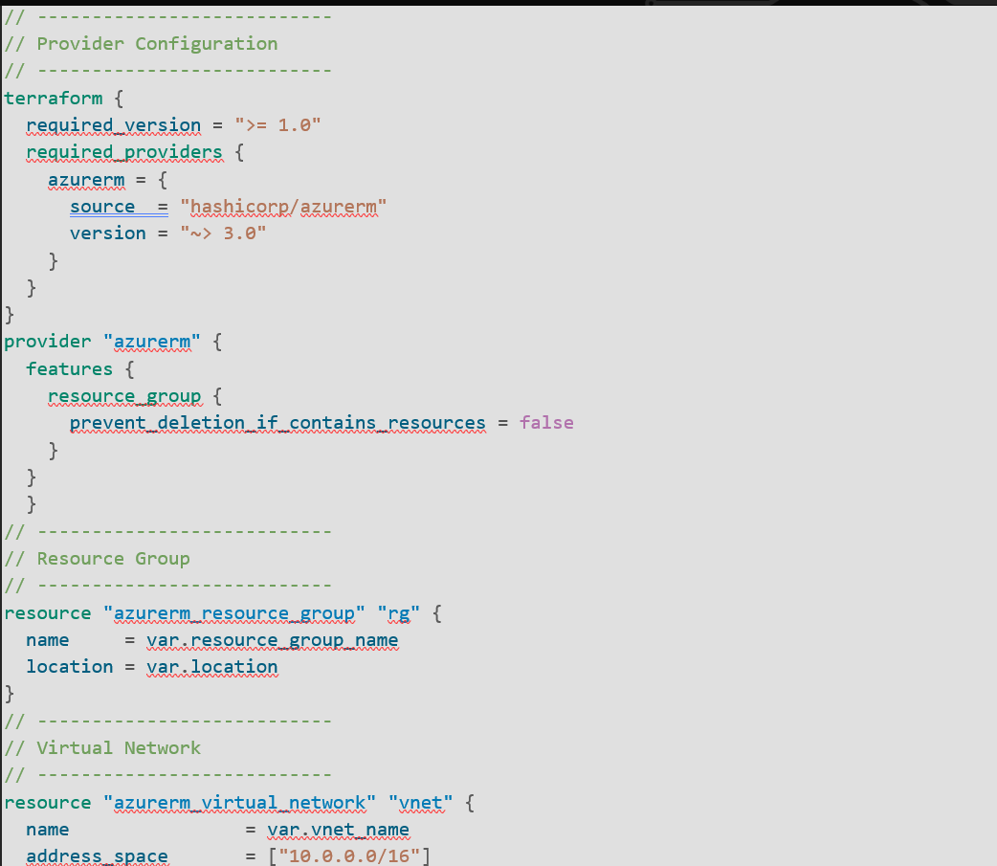

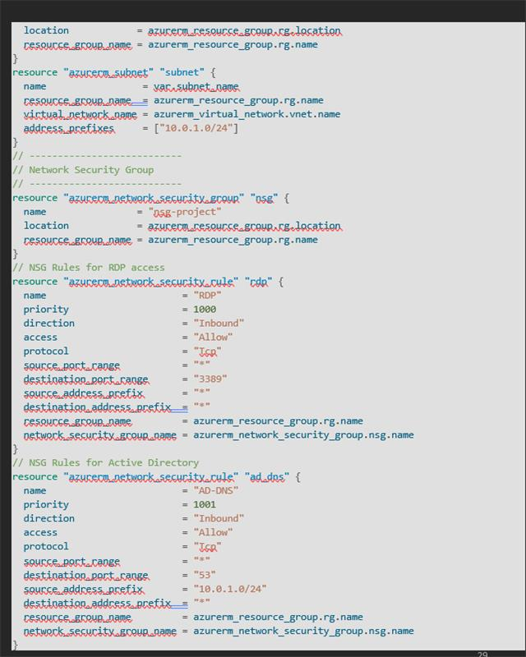

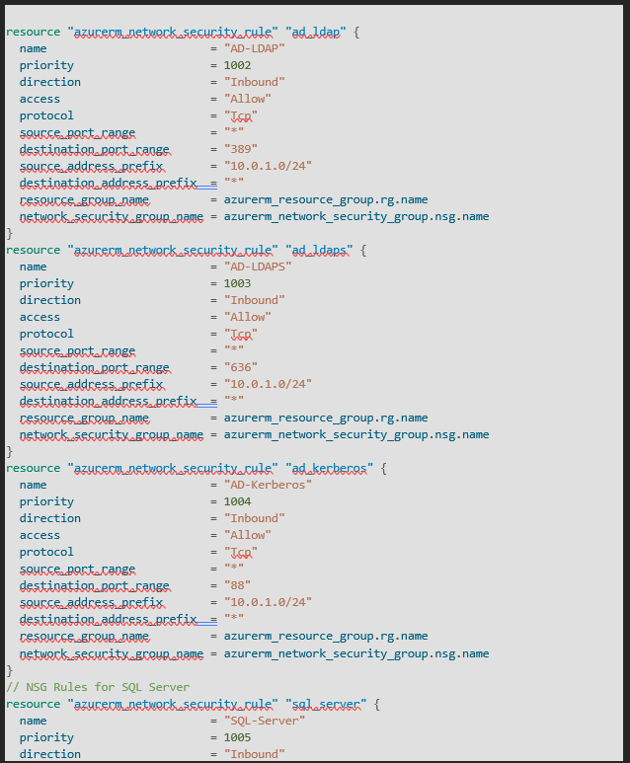
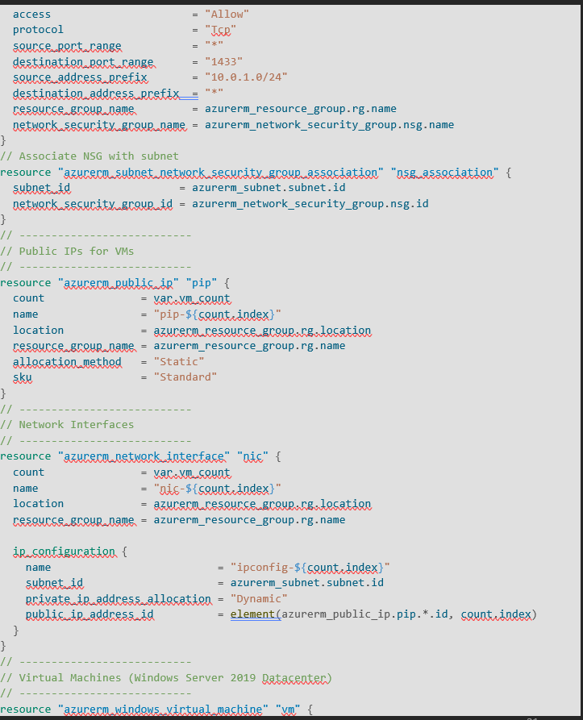

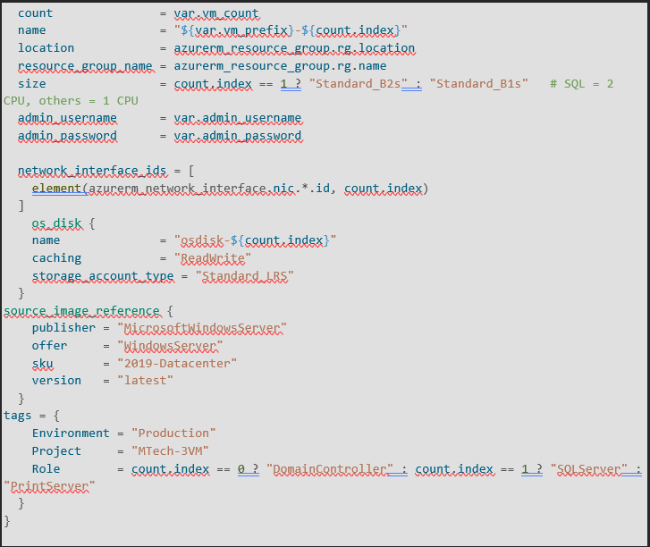

** Varibles.tf:

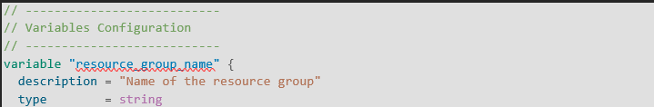

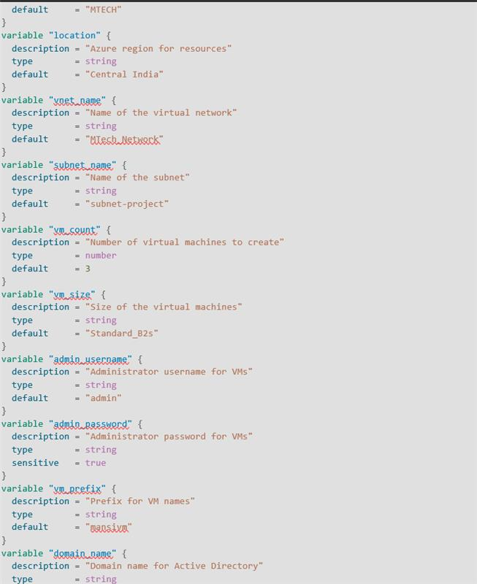

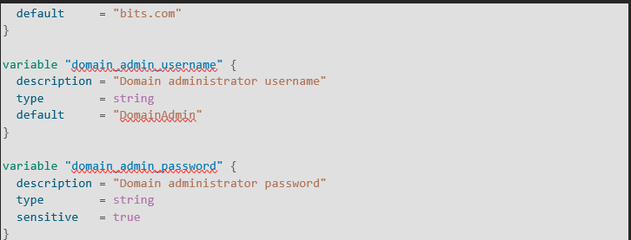

Windows Server Update Services (WSUS):

To deploy software updates through Configuration Manager, we first need to install the WSUS (Windows Server Update Services) role. Later, WSUS will be connected with the Software Update Point (SUP) role in Configuration Manager.
WSUS works as a central tool that manages Microsoft updates for the organization. It downloads updates from Microsoft and helps distribute them to different computers across the network. This way, administrators can control which updates are installed and when, instead of every system downloading them individually.

After installing the WSUS role, we must configure where update files will be stored. This is done using the post-install command, which sets the content directory — the folder where WSUS will save downloaded updates.

Without this step, WSUS won’t know where to store updates, and SCCM won’t be able to deploy patches. It’s like assigning a download folder before downloading anything — essential for proper operation.

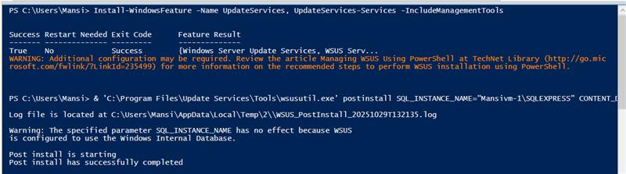

What is SCCM / MECM?

Microsoft Endpoint Configuration Manager (MECM) — previously known as SCCM or SMS — is a powerful tool from Microsoft used to manage large numbers of computers. It helps IT teams with:
It helps organizations:
- Automatically deploy Windows updates and patches
- Install software remotely across hundreds or thousands of machines
- Roll out operating systems with zero-touch deployment
- Collect detailed hardware and software inventory
- Monitor compliance and system health

SCCM reduces manual effort, improves security, and ensures consistency across all managed devices. It’s widely used in enterprises to maintain control over their IT infrastructure.

SCCM Installation Made Easy

The below screenshots will be help for easy installation of SCCM in the server. Anyone can install by following the screenshots.

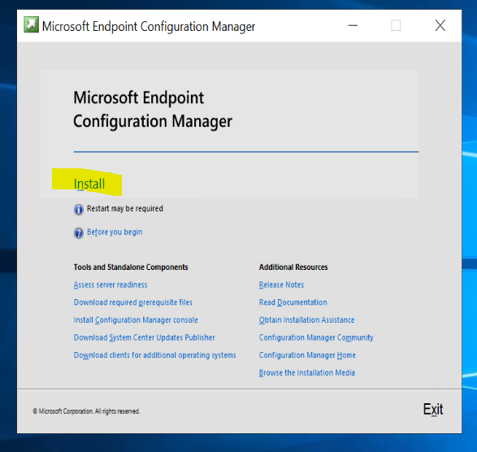

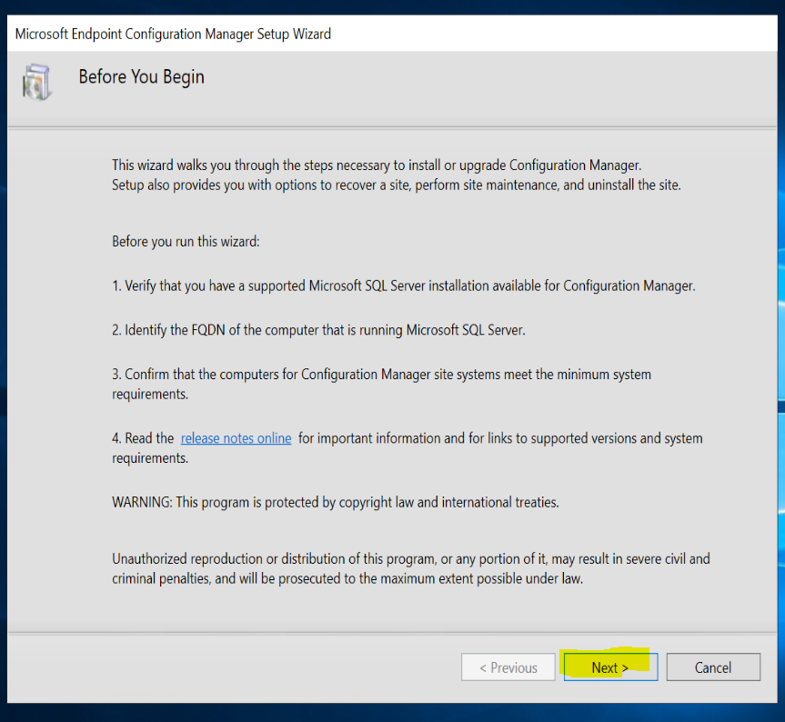
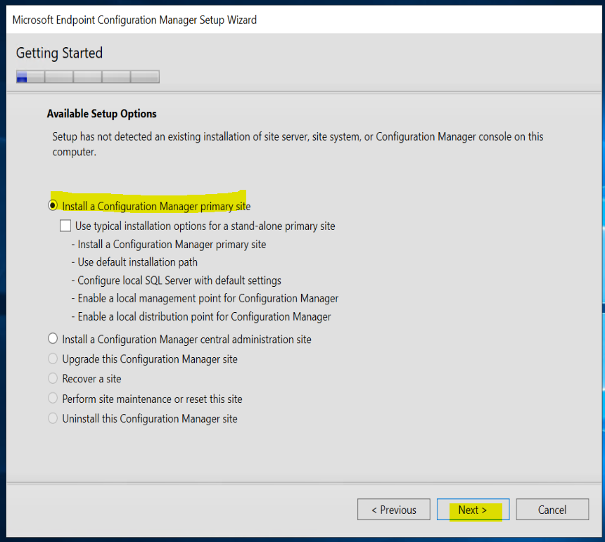

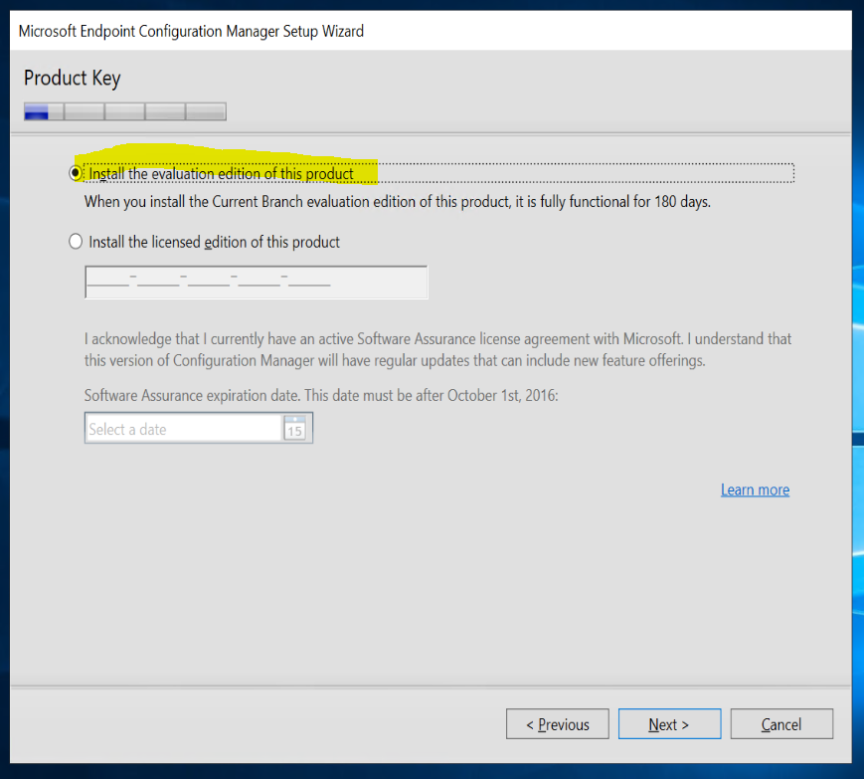
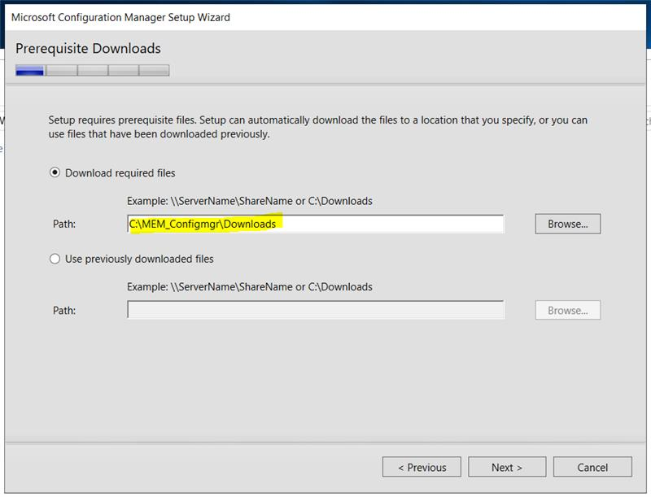

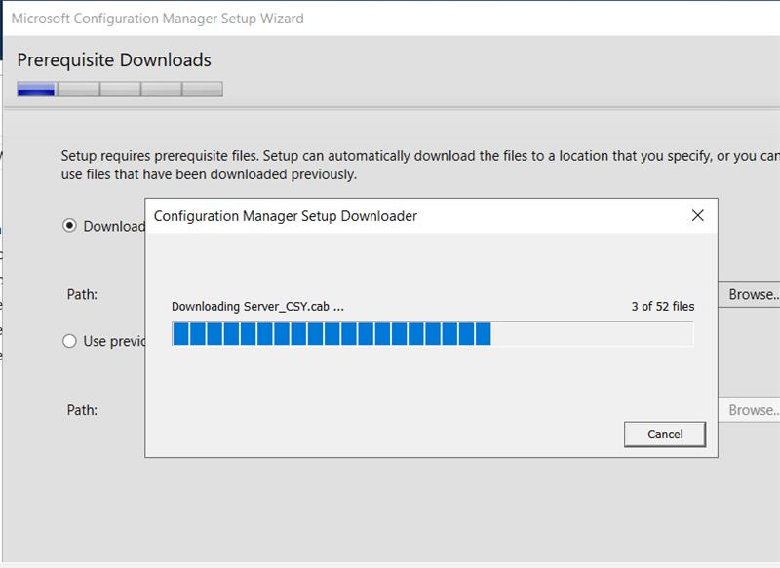

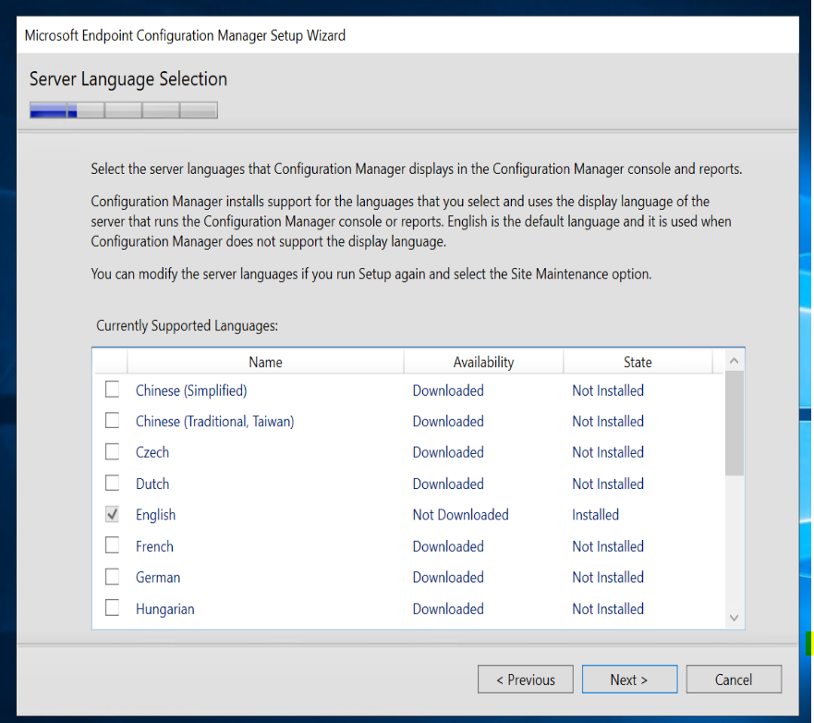

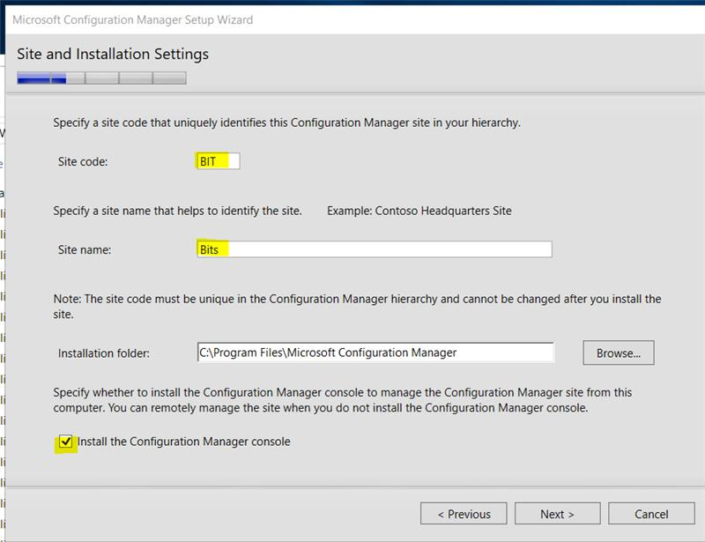

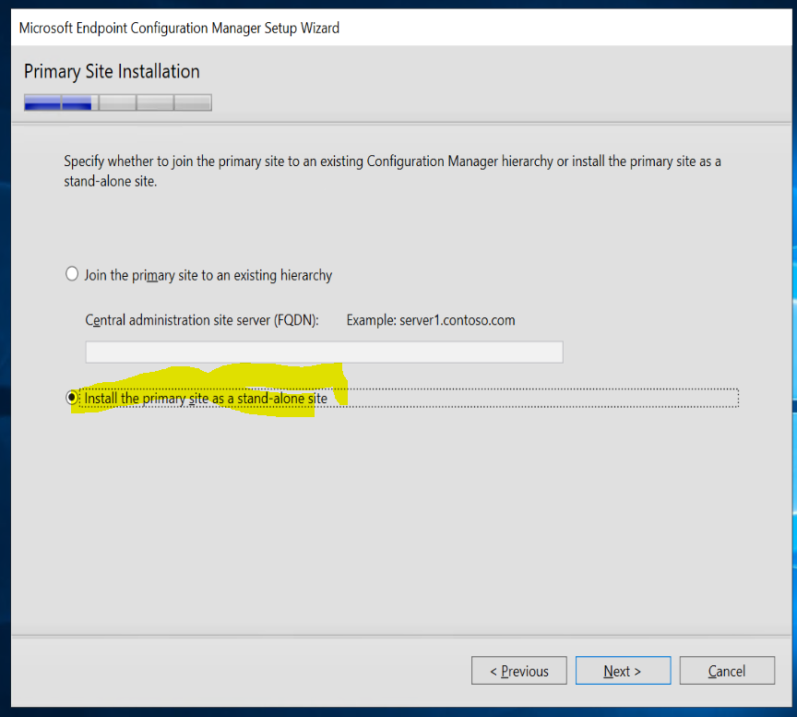

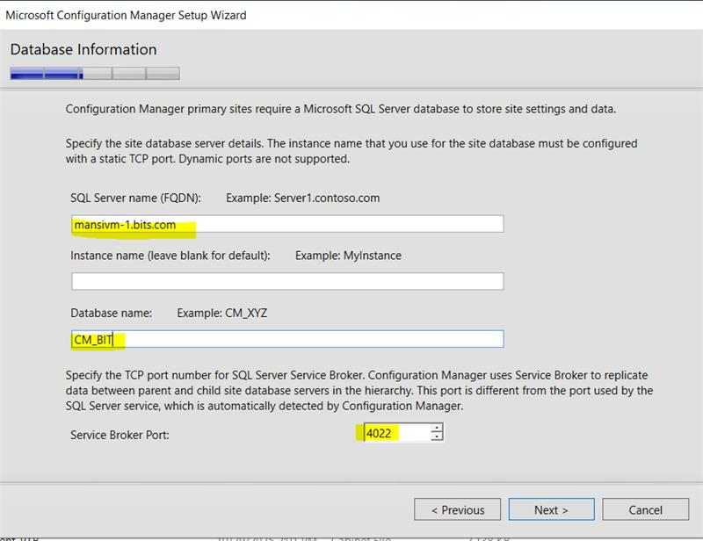

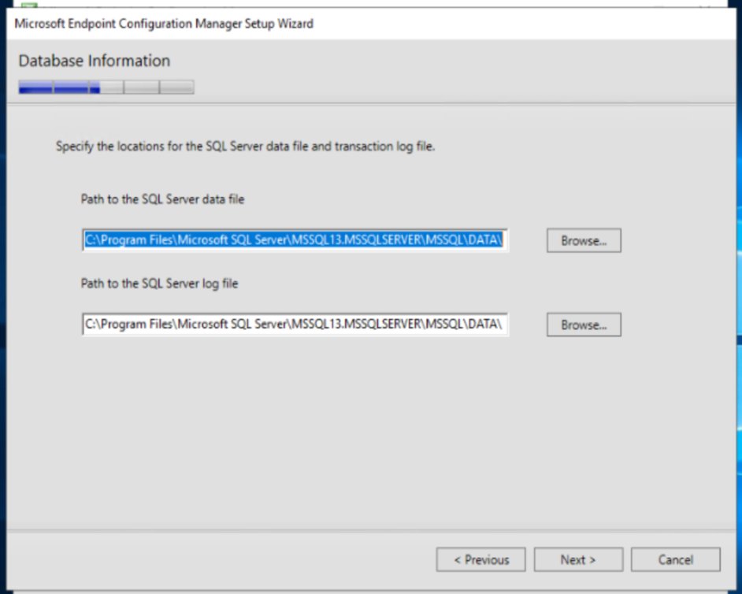

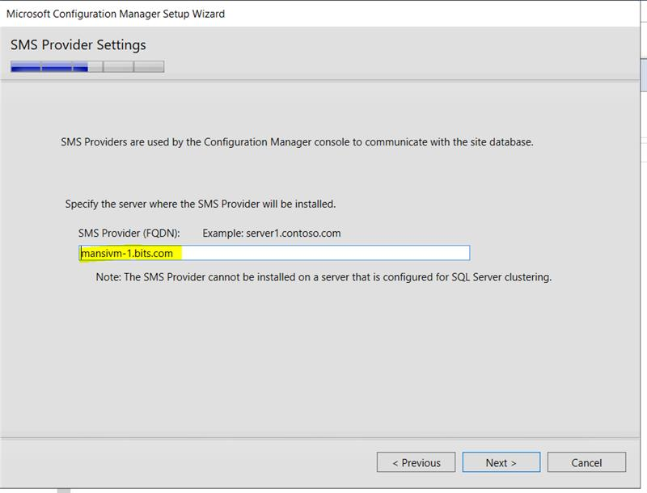

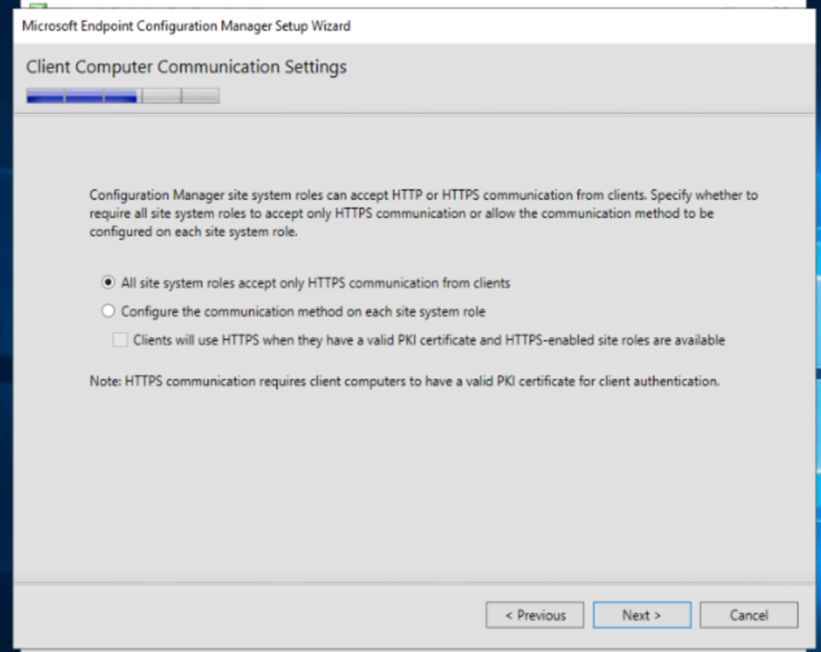



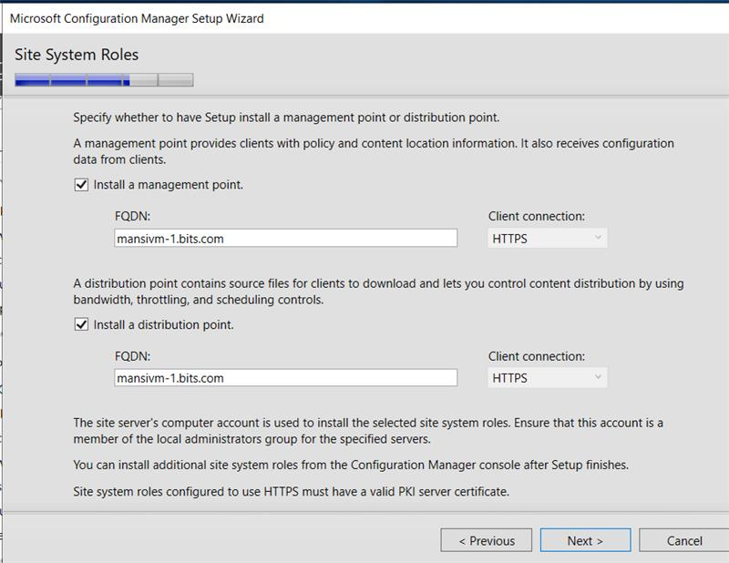
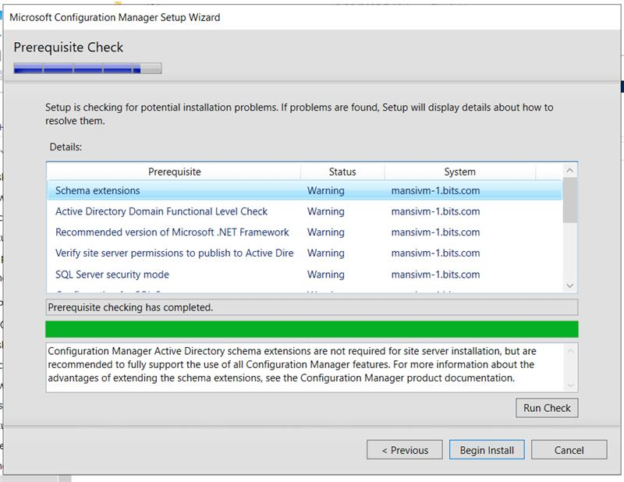

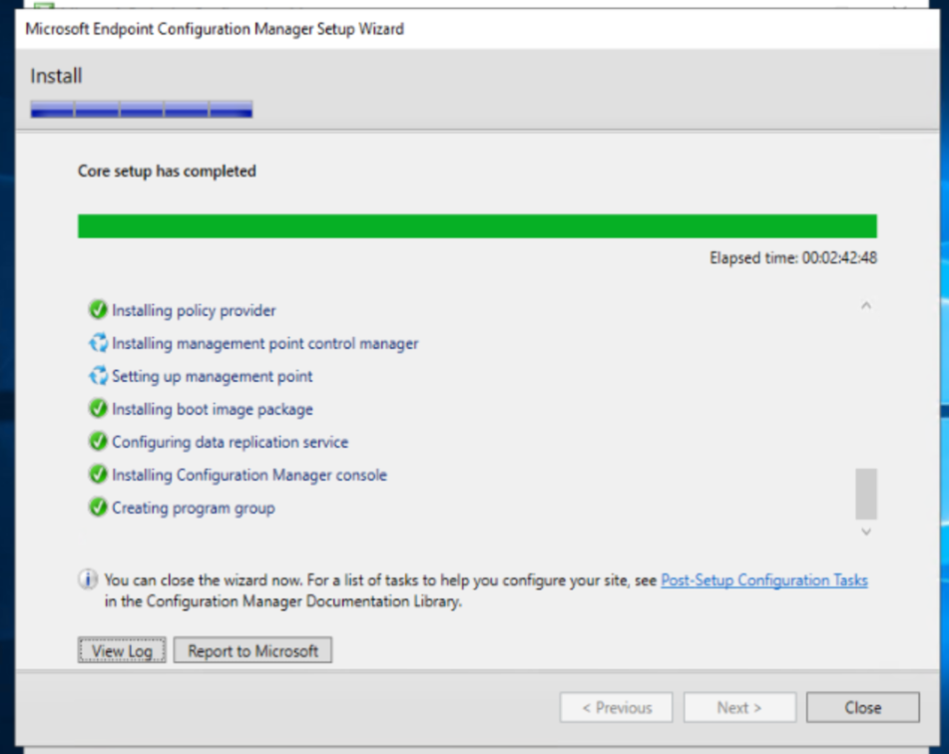

- SCCM Configuration After Installation

After successfully installing SCCM, I proceeded to configure the environment by integrating it with Active Directory. This allowed SCCM to discover and manage users, computers, and groups within the domain.
🔹 Primary Site Setup
I configured the SCCM primary site using the following details:
- Site Code: BIT
- Site Name: Bits
This site now serves as the central management point for all SCCM operations including deployments, patching, and inventory.

Active Directory Integration:

To enable SCCM to fetch data from AD, I activated the following discovery methods:
- Active Directory System Discovery – to detect computers
- Active Directory User Discovery – to detect user accounts
- Active Directory Group Discovery – optional, for AD groups
Each method was configured with the appropriate LDAP path, and a full discovery was initiated to ensure complete synchronization.

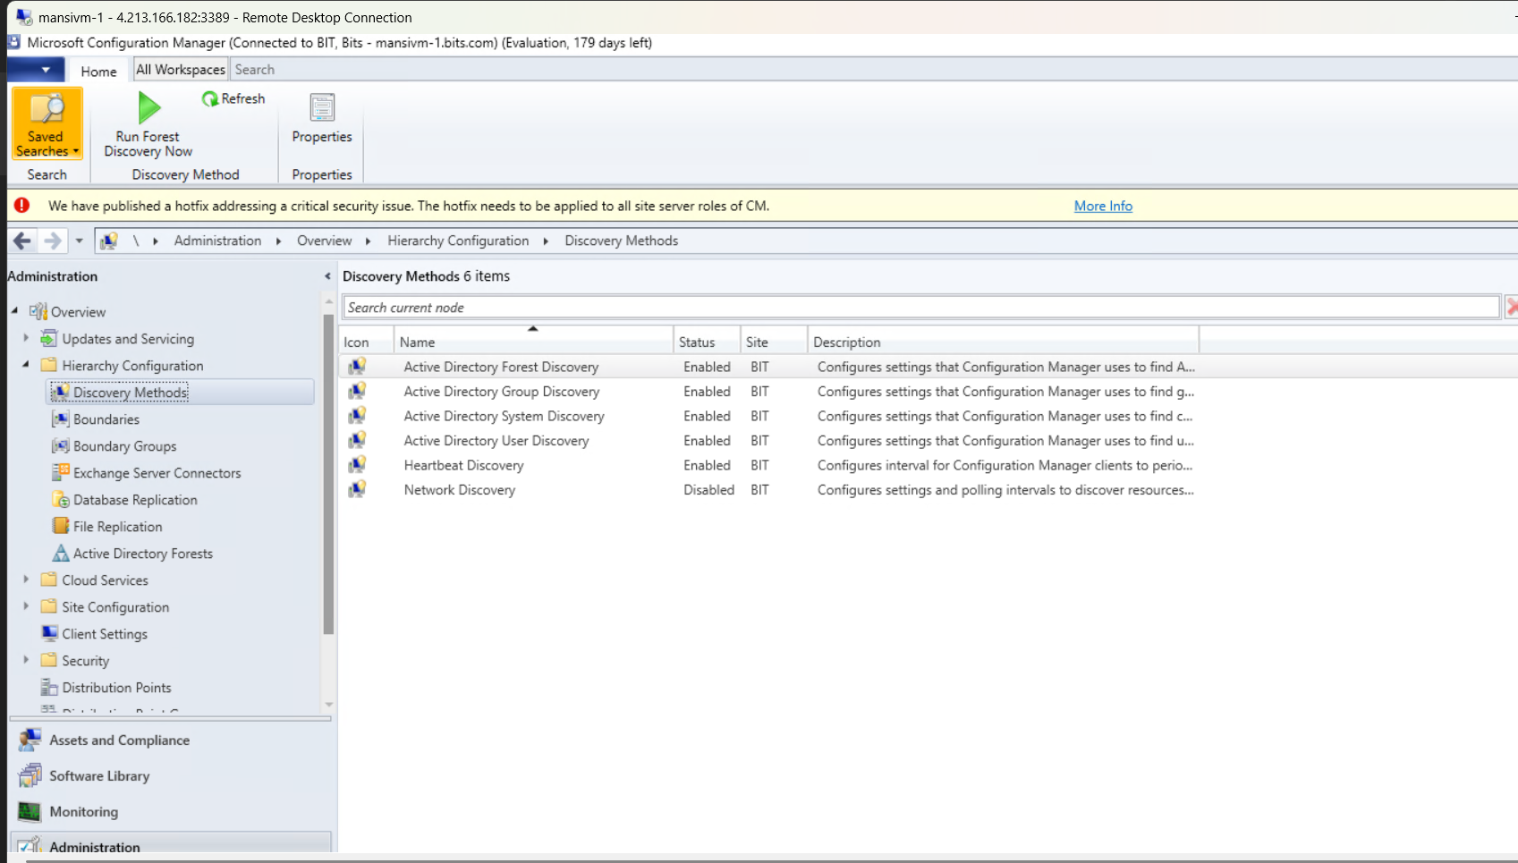

Verification:

Post-discovery, I verified that:
- Devices and users appeared under Assets and Compliance
- SCCM was successfully communicating with AD
This confirmed that the SCCM environment was fully integrated and ready for client management and software deployment.

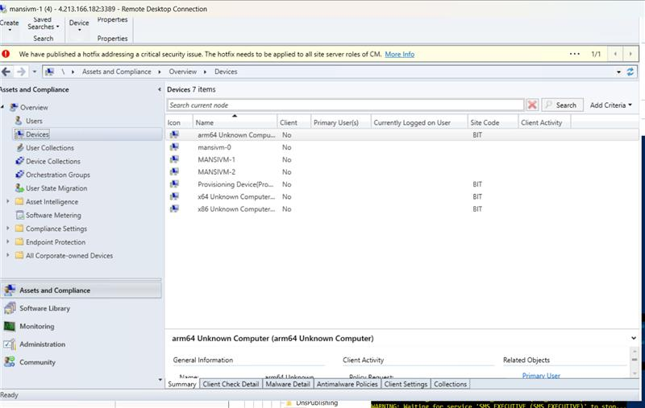

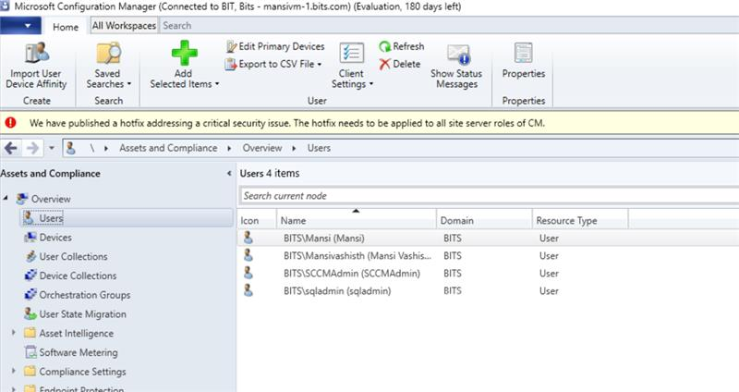
Boundary Group Configuration and Client Installation

After configuring the SCCM site and integrating Active Directory, I proceeded to set up boundary groups to ensure proper site assignment and content distribution.
🔹 Boundary Group Setup
- Created a boundary group and added the relevant subnet to define the network location.
- Linked the boundary group to the primary site (BIT) under the References tab.
- Verified that the site system hosting the Management Point and Distribution Point was added.
- Enabled options for site assignment and content location to ensure clients could receive updates and applications.

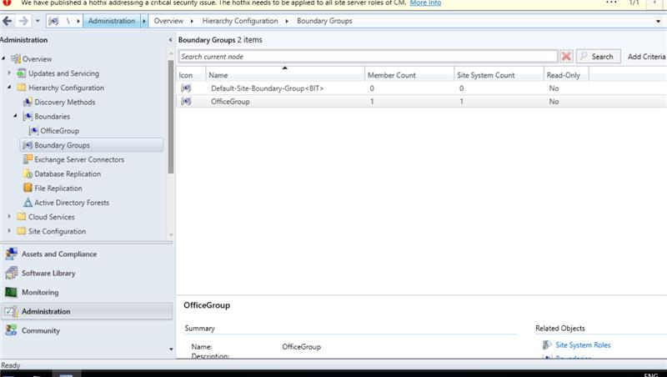

Client Push Installation
Once discovery was complete and boundary groups were properly configured:
- Initiated client push installation for three servers listed under Assets and Compliance → Devices.
- 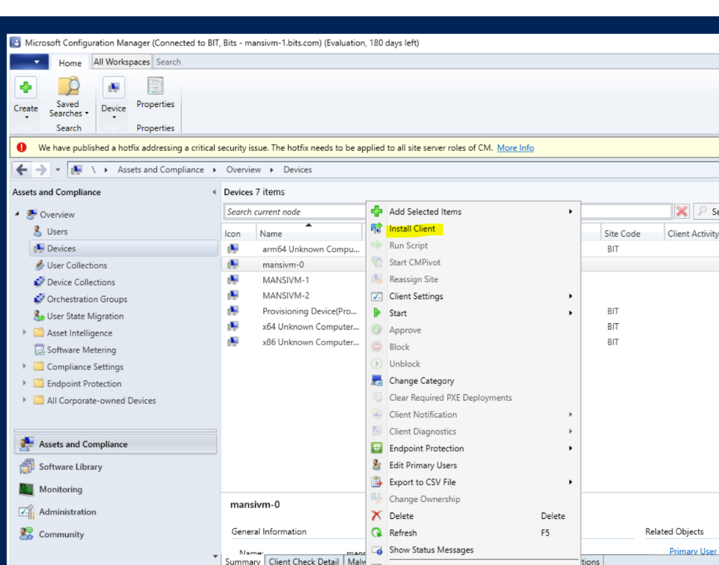

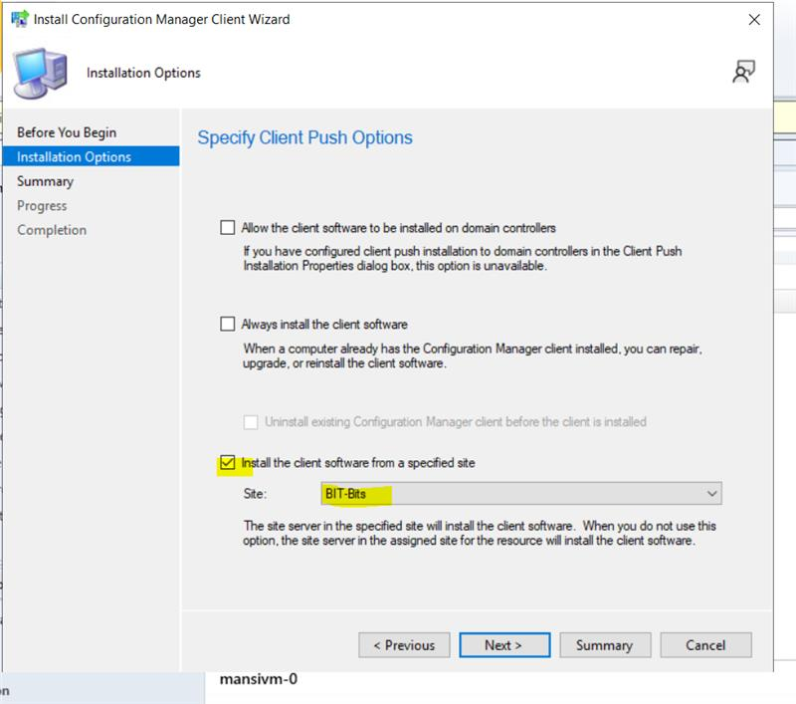
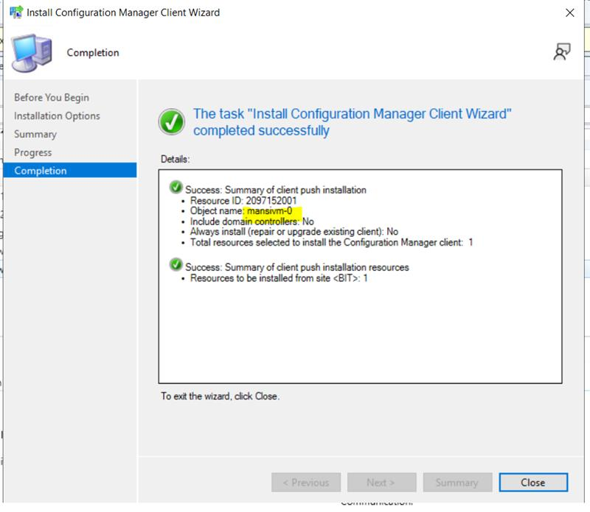

Synchronizing and importing updates from Microsoft site:

- Added the Software Update Point role to the SCCM site server

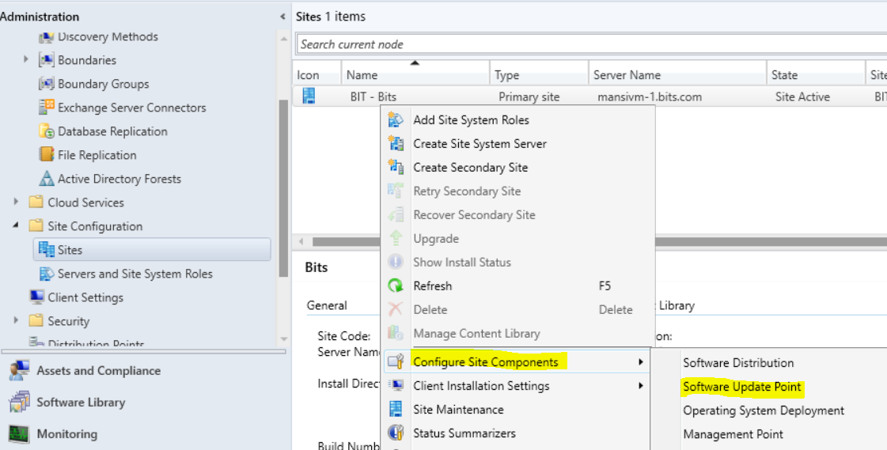

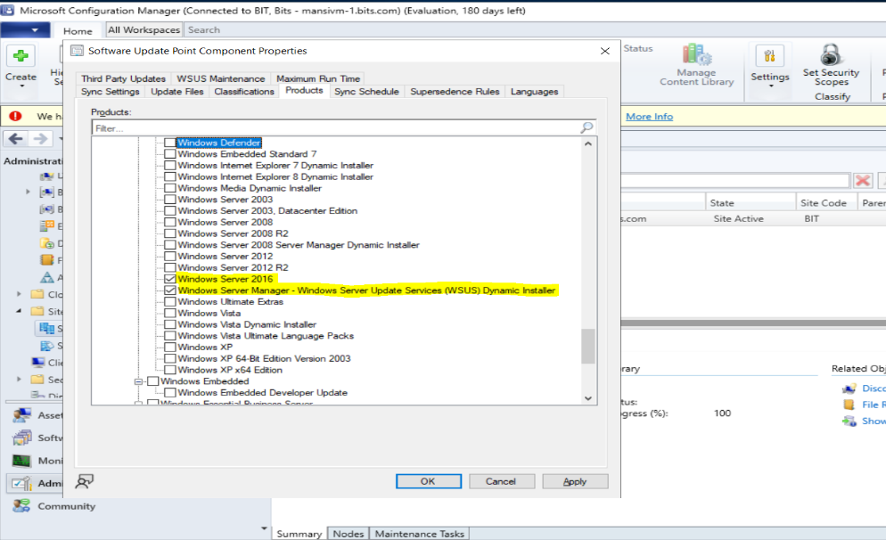

- Synchronization and Verification:

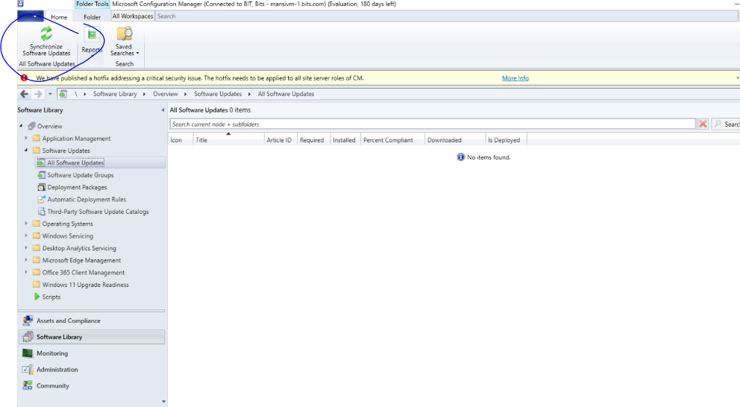

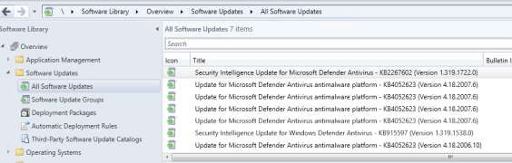

***RDS FARM***

An RDS farm is a scalable setup of Remote Desktop Services where multiple servers work together to provide secure, load-balanced remote access to users. It includes roles like RD Gateway, Connection Broker, Session Hosts, and Web Access — each with a specific job.

RDS is a role, which is found in windows server applications which gives
RD sessions, apps, VMs and is managed by the central server. RDS Farm is a
group of session host servers and a connection broker which helps users to
connect to the session on the servers. In an azure environment we have more
advantage of cost effectiveness, hardware independence, reliability, scalability
and secure remote access.
It uses RDP(Remote desktop Protocol) which uses port 3389 for connection to
session host servers. A client can connect to the machine from their PC using
RDP and can do their daily tasks.
Reasons for RDP
➔It's independent of Hardware’s.
➔No issues of incompatibility of applications.
➔Reduces cost of Hardware as it does not require separate hardware setup
for each user. Users can connect from their devices.
➔Incompatible OS architecture

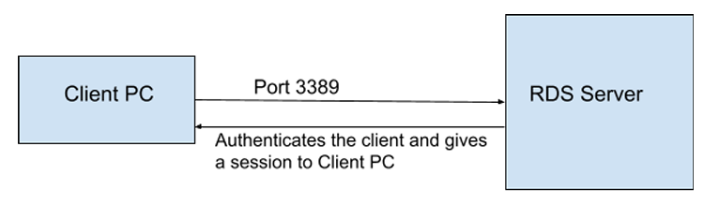 Components of an RDS Farm

Component | What It Does
RD Session Host | Hosts the actual desktop sessions or Remote Apps. Users connect here.
RD Connection Broker | Manages user sessions and redirects users to available Session Hosts.
RD Gateway | Allows secure access from outside the network using HTTPS (port 443).
RD Web Access | Provides a web portal for users to launch RemoteApps or desktops.
RD Licensing | Manages RDS licenses (optional if using Per User mode for small setups).

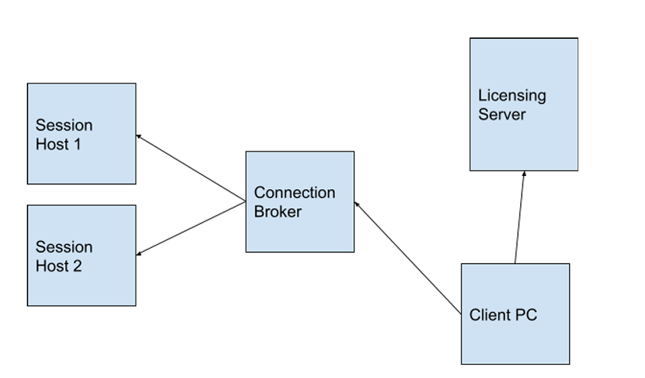

- RD Session Host :
This is the server where users actually work. It runs the remote desktop or RemoteApp session. You can have multiple Session Hosts in a farm to balance the load and avoid performance issues. In my case, mansivm-0 and mansivm-1 are session host.

- RD Connection Broker:
This is the brain of the RDS farm. It tracks all active sessions and decides which Session Host a user should connect to. If a user disconnects and reconnects, the broker ensures they return to the same session. It also handles load balancing and redirection.

- RD Gateway:
This role allows users to connect securely from outside the network using HTTPS (port 443). It wraps the RDP traffic inside SSL, so users don’t need a VPN. It’s perfect for remote access from home or client locations. In my case, Mansivm-2 is RD Gateway.

- RD Web Access
This is the web-based portal where users can log in and launch RemoteApps or full desktops. It’s useful for non-technical users who prefer clicking icons instead of using mstsc. In Short, pprovides a browser-based portal where users can launch RemoteApps or full desktops. It’s the user-friendly front end.

- RD Licensing
This role manages RDS license usage. In small setups, you can use Per User mode without buying CALs. For larger environments, you need to install and activate the RD Licensing Server.

- Session Collection
A Session Collection is a group of Session Hosts that serve a specific set of users or applications. You can create multiple collections for different departments or use cases. It helps organize and isolate workloads. In my case I have named my collection - RDSCollection

Step by step commands performed to setup RDS Farm:

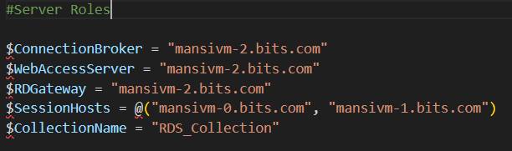

- Step 1: Login to all three VM and run below commands to enable PowerShell remoting and enable firewall rules”

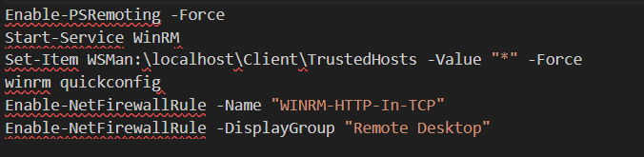

- Step 2: Login to Mansivm-0 and Mansivm-1 to install session host:

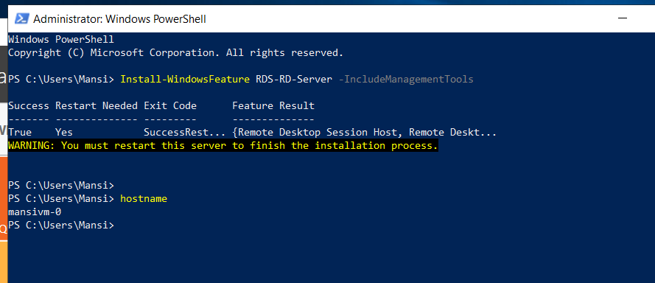
- Step 3: Login to Mansivm-2 to proceed futher and setup farm:

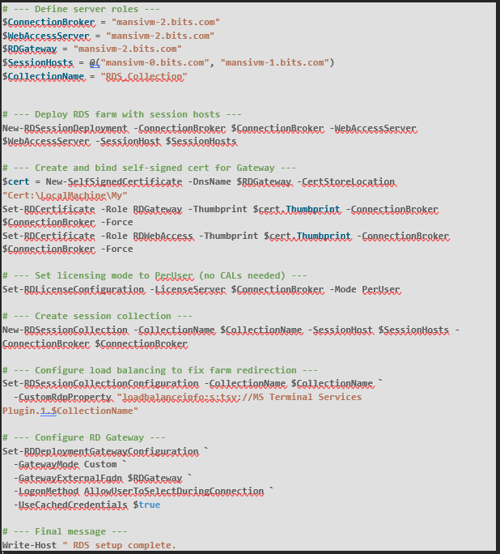
**Validate RDS Collection group status and members:

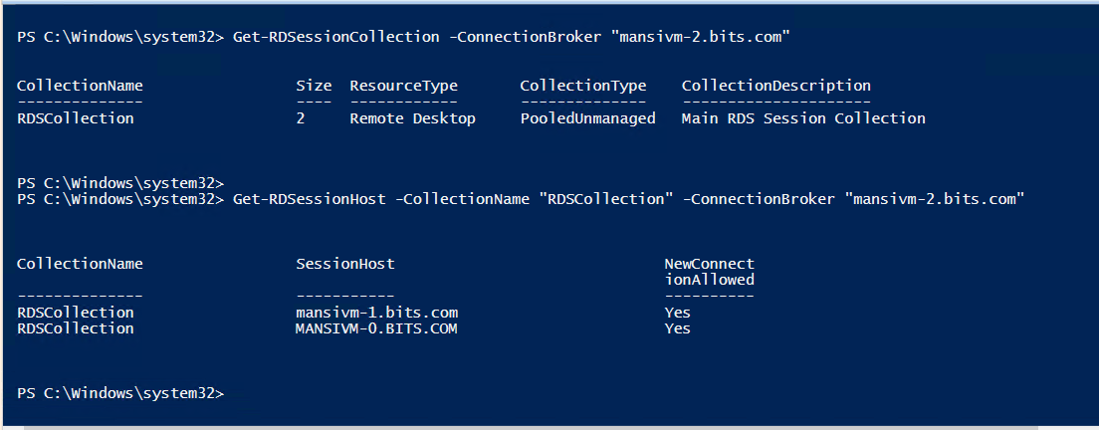

** Creating Authorization policy for RD Gateway**

a. We will open Remote Desktop Gateway and the click on creating Authorization policy.

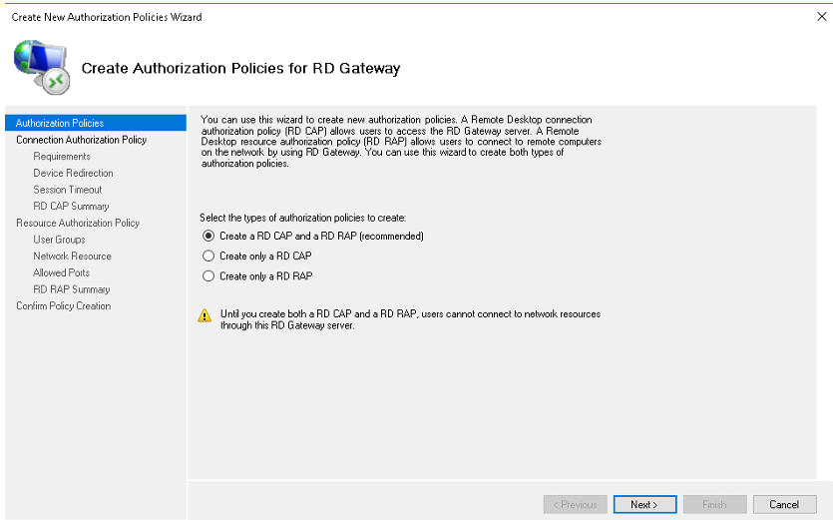

b. We will create both Connection Authorization Policy(CAP) and Resource Authorization Policy(RAP). First RD CAP will be created.

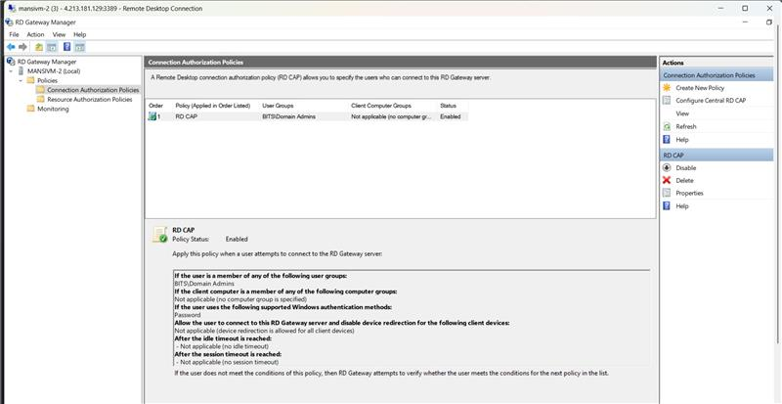



c. Once both policy will be created our RDGateway setup will be completed.

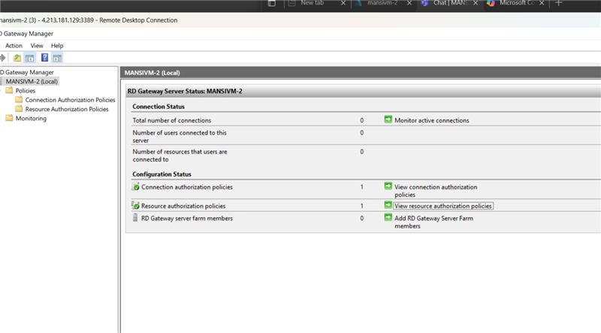

**Validating SSL self-signed certificate:
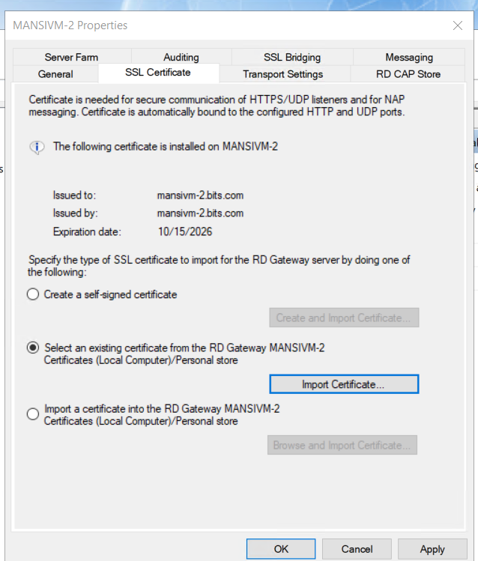

- Validating RD Web Access: https://mansivm-2.bits.com/RDWeb
This is the web-based portal where users can log in and launch RemoteApps or full desktops. It’s useful for non-technical users who prefer clicking icons instead of using mstsc. In Short, pprovides a browser-based portal where users can launch RemoteApps or full desktops. It’s the user-friendly front end.

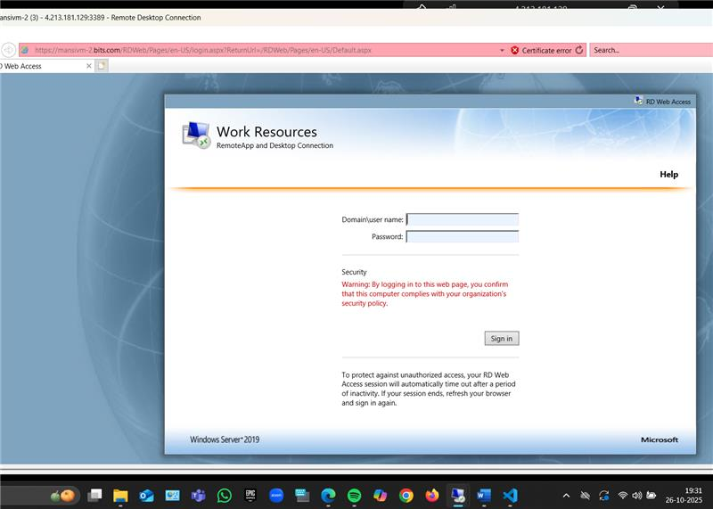

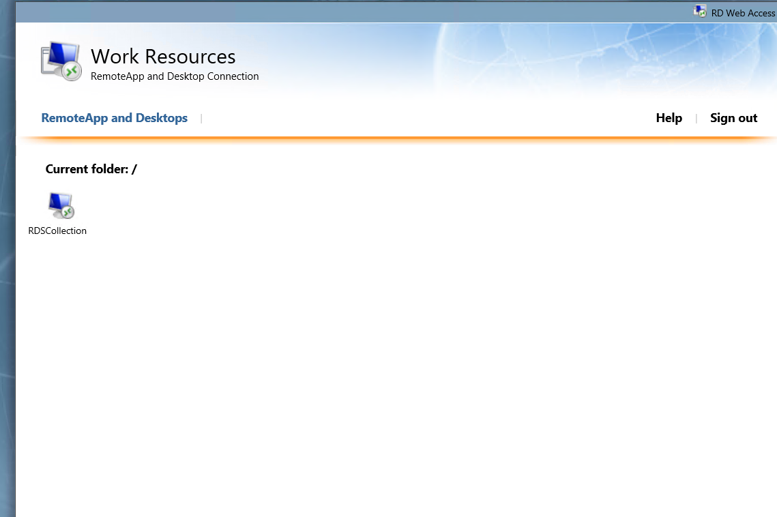

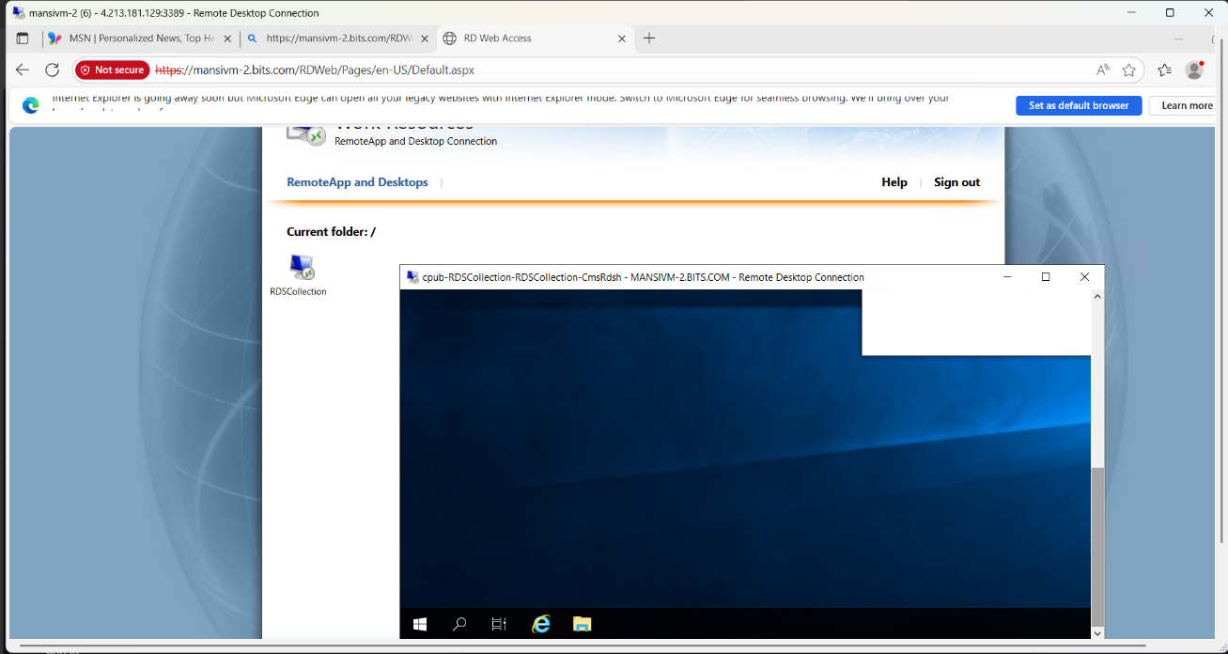

*Testing server’s remote connectivity through gateway:

We will try to do a remote desktop to one of our Session host servers. We will add rdsgateway server as Gateway server for it.

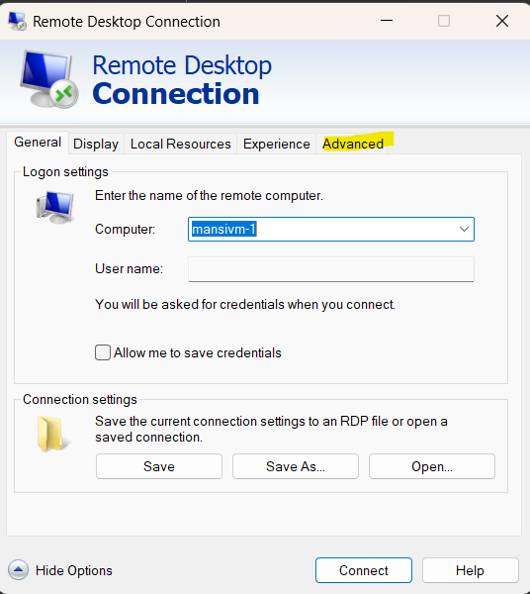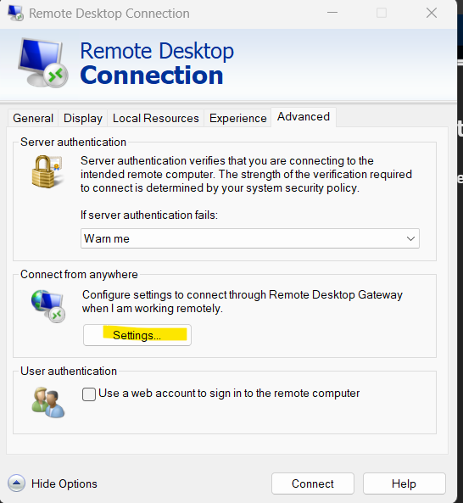

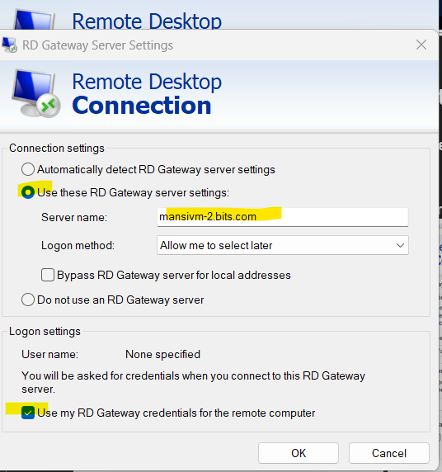

Now we will give the required credentials for both gateway server and Session host server

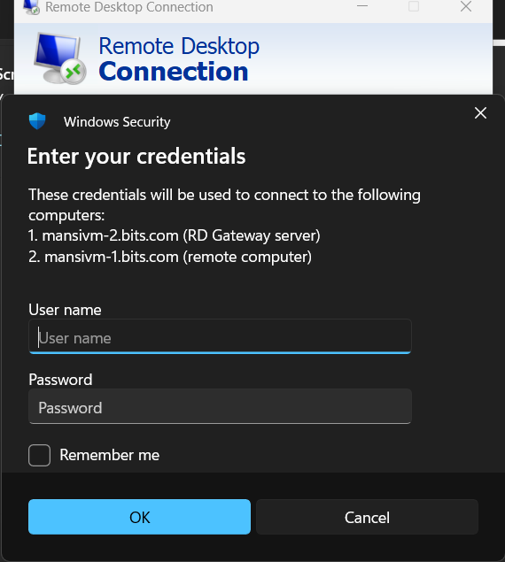

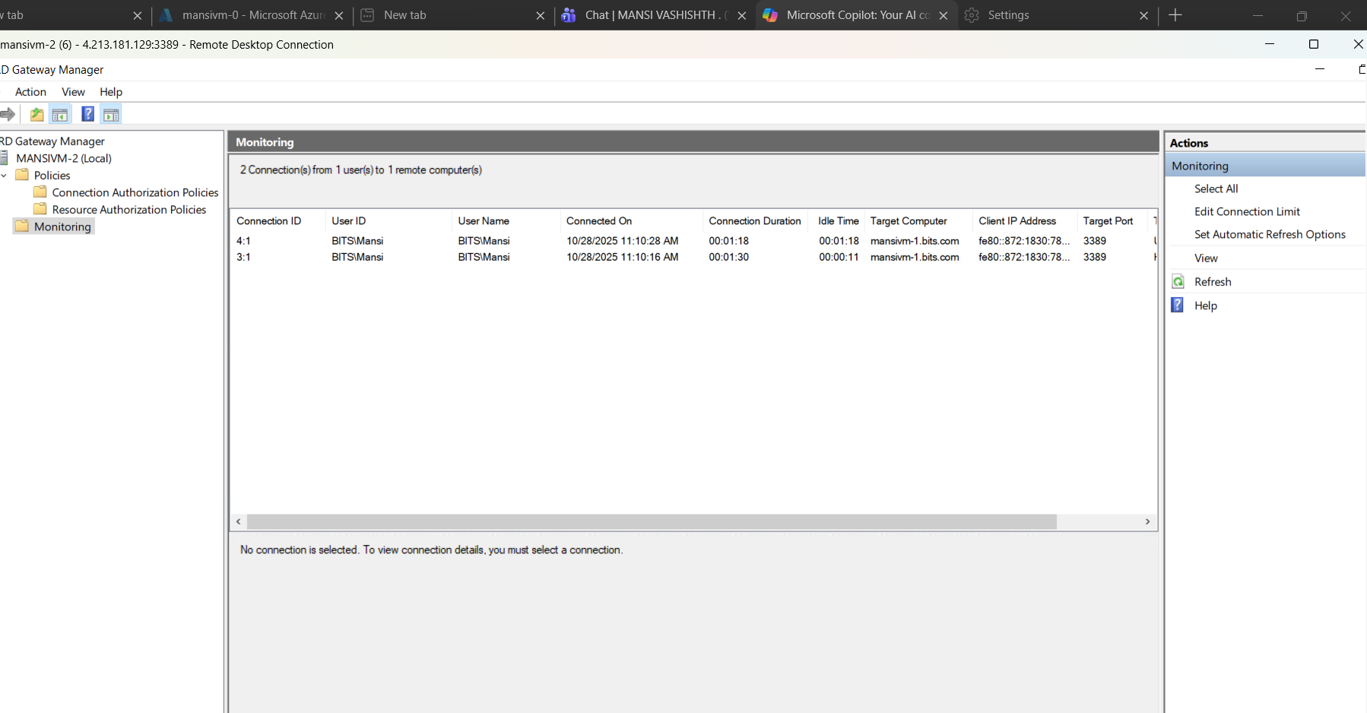

Conclusion

- First, I took an Azure subscription and prepared the cloud environment.
- I analysed the requirements and wrote the Terraform code for infrastructure.
- Using terraform apply, I created 3 virtual machines (VMs) in Azure.
- I configured the first VM as a Domain Controller by installing AD DS and DNS.
- I joined the 2nd and 3rd VMs to the created domain.
- On the second VM, I installed SQL Server using PowerShell script.
- The third VM was successfully joined to the domain and kept for extra roles (like SCCM)
- Installed and configured SCCM on mansivm-1, with SQL and all prerequisites handled on the same server.
- SCCM will sync with Microsoft update website with the help of Webserver, download the updates, store them in SQL server and push them to all the client servers.
- Deployed RDS roles on mansivm-2, with mansivm-0 and mansivm-1 as Session Hosts for remote desktop access.
- Used PowerShell to automate the entire RDS setup, including role installation, farm deployment, certificate binding, session collection creation, load balancing, and RD Gateway configuration.
- We are using Azure in setting up this infra which is very useful in cost optimization, efficiency, availability, backup and security.

Detailed Plan Of The Work

S.no: | Tasks to be done | Duration | Plan deliverable
1 | Requirement Gathering and analysis | Week 1 | Gather all the requirements and make a blueprint of the project
2 | Infrastructure Setup with Terraform and azure subscription | Week 2,3 & 4 | Started with creating an active Azure subscription and Wrote Terraform code to automatically create the required resources.
3 | Virtual Machines Creation | Week 5 | Deployed 3 Windows Server 2019 VMs in Azure using Terraform.
4 | Create Domain Controller Setup | Week 6 | Promote one of the VM as a Domain Controller (AD DS + DNS)
5 | Domain Join | Week 7 | Join other VMs to domain.
6 | Create a Database to store organization data | Week 8 &9 | Installed and configured SQL Server 2019 on one of the VM using PowerShell scripts
7 | Make device compliance | Week 10 to 11 | Deploy an SCCM server and install required updates and applications to make the devices compliance
8 | Will set up a Remote Desktop connection broker server | Week 12 to 13 | Remote desktop connection broker server will be set up.
9 | Will create a Remote Desktop Gateway server and its required roles and Configure and Deploy RDS Farm for DS Domain in Azure environment. | Week 14 to 15 | Remote Desktop Gateway server will be created and RDS Farm will be configured and deployed.
10 | Testing and validation of the server and setup security | Week 16 | Testing and validating the virtual machine and setup security to the machine to protect the VM from unauthorized access

