Name : Manasi Hire

Roll no: 331070

PRN NO: 22320015

1.Create persona for an app or website *using AI for Mental Health Support in Women in STEM.*

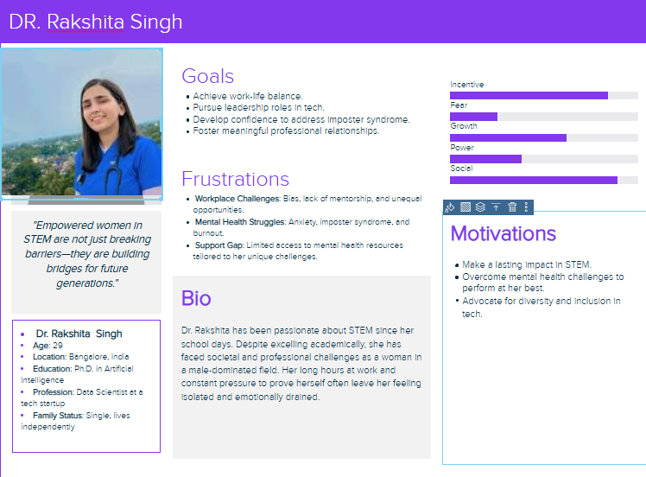

#### **2. Perform Contextual Inquiries:**

**Objective**: To understand the mental health challenges faced by women in STEM and identify how an AI-powered solution can help.

**Interviewees**:

* Dr. Ananya Sharma (Senior Research Scientist).
* Riya Patel (Software Engineer, early career professional).
* Emily Harper (Data Analyst, mid-level professional).

#### **Key Questions and Responses:**

1. **What are the primary stressors in your professional life?**
   * **Ananya**: "Balancing high-stakes projects and family life is overwhelming."
   * **Riya**: "I often feel I have to overperform to be taken seriously in meetings."
   * **Emily**: "There’s constant pressure to stay updated with new tools and skills."
2. **How do you currently manage stress?**
   * **Ananya**: "I occasionally meditate, but consistency is a challenge."
   * **Riya**: "Talking to friends helps, but they don’t always understand the specifics of my field."
   * **Emily**: "I rely on journaling, but it doesn’t address my deeper concerns."
3. **What features would you like in a mental health app?**
   * **Ananya**: "A resource library on handling workplace challenges would be useful."
   * **Riya**: "I’d love a mentorship platform to connect with experienced women."
   * **Emily**: "A personalized, AI-driven chatbot that feels non-judgmental."
4. **How often would you use such a platform?**
   * **Consensus**: Weekly for resources, daily for quick stress relief or check-ins.

#### **Findings:**

* **Common Challenges**:
  + Work-life balance.
  + Lack of tailored mental health resources.
  + Difficulty finding supportive professional communities.
* **Desired Features**:
  + AI-driven personalization (e.g., chatbots, insights).
  + Community forums and mentorship.
  + Tools for mindfulness and stress tracking.

### **3. Requirement Analysis and Proposed Solution**

#### **Requirement Analysis:**

1. **User Needs**:
   * Easy-to-use mental health support.
   * Tools tailored to women in STEM (e.g., managing imposter syndrome, workplace bias).
   * Privacy and security.
2. **Technical Features**:
   * AI-powered chatbot for 24/7 support.
   * Data visualization for mental health trends.
   * Interactive content (e.g., videos, articles, quizzes).
3. **Challenges**:
   * Encouraging user engagement without overwhelming them.
   * Ensuring inclusivity across diverse STEM fields.

#### **Proposed Solution:**

**AI-Driven Mental Health Platform for Women in STEM:**

1. **Features**:
   * **AI Chatbot**: Offers real-time mental health guidance, coping exercises, and resources.
   * **Community Space**: Anonymized forums for women to share experiences and advice.
   * **Mentorship Hub**: Connect users with experienced mentors in STEM fields.
   * **Personalized Insights**: Track mood, stress levels, and provide actionable recommendations.
   * **Skill-Building Resources**: Tutorials on stress management, time management, and overcoming bias.
2. **Design Principles**:
   * **User-Centric**: Intuitive interface with minimal navigation complexity.
   * **Anonymity**: Optional anonymity for sensitive topics.
   * **Accessibility**: Support for multiple languages and assistive technologies.
3. **Implementation Roadmap**:
   * **Phase 1**: Develop core features (AI chatbot, resource library, basic analytics).
   * **Phase 2**: Integrate community forums and mentorship hub.
   * **Phase 3**: Enhance personalization with machine learning algorithms for adaptive recommendations.

### **Conclusion**

This solution addresses the mental health challenges of women in STEM by combining AI-driven personalization, community support, and practical tools. It ensures accessibility, scalability, and a positive user experience to empower women to thrive in their careers and personal lives.