Day 1:

Nodejs cmd:

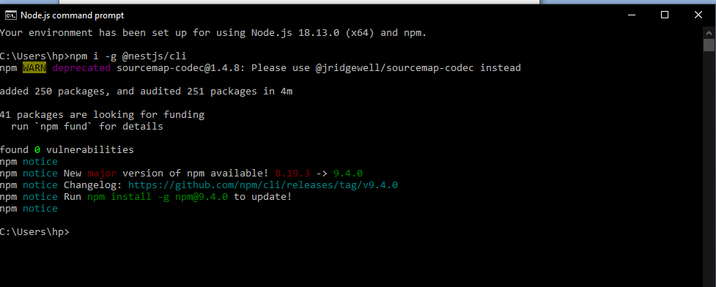

Bash:

hp@Mansij MINGW64 ~
$ cd ..

hp@Mansij MINGW64 /c/Users
$ cd ..

hp@Mansij MINGW64 /c
$ cd e:

hp@Mansij MINGW64 /e
$ cd NestJS\ Workspace/

hp@Mansij MINGW64 /e/NestJS Workspace
$ cd backend/

hp@Mansij MINGW64 /e/NestJS Workspace/backend
$ nest new myapp

⚡ We will scaffold your app in a few seconds..

? Which package manager would you ❤️ to use? (Use arrow keys)
? Which package manager would you ❤️ to use? npm
CREATE myapp/.eslintrc.js (663 bytes)
CREATE myapp/.prettierrc (51 bytes)
CREATE myapp/nest-cli.json (171 bytes)
CREATE myapp/package.json (1936 bytes)
CREATE myapp/README.md (3340 bytes)
CREATE myapp/tsconfig.build.json (97 bytes)
CREATE myapp/tsconfig.json (546 bytes)
CREATE myapp/src/app.controller.spec.ts (617 bytes)
CREATE myapp/src/app.controller.ts (274 bytes)
CREATE myapp/src/app.module.ts (249 bytes)
CREATE myapp/src/app.service.ts (142 bytes)
CREATE myapp/src/main.ts (208 bytes)
CREATE myapp/test/app.e2e-spec.ts (630 bytes)
CREATE myapp/test/jest-e2e.json (183 bytes)

- Installation in progress... ☕
√ Installation in progress... ☕

Successfully created project myapp
Get started with the following commands:

$ cd myapp
$ npm run start

Thanks for installing Nest 🙏
Please consider donating to our open collective
to help us maintain this package.

Donate: https://opencollective.com/nest

In terminal of vs code:
->npm run start:dev
Open browser and run localhost:3000
should see Helo World
edit app.service.ts for new message

=================== Please have the following prepared before class [Day 1 summary]
0. NodeJs and VSCode installed and working
1. NestJS CLI installed npm i -g @nestjs/cli
2. make a directory at your E drive as workspace inside workspace make another folder as backend, inside which you should have _documentation folder
3. in backend folder run terminal and create a new project named myapp by running code nest new myapp and open this project in VS Code
4. run the project with npm run start:dev and see your localhost at port 3000

=================

Day 2 [setting up packages manually]

hp@Mansij MINGW64 /e/NestJS Workspace/backend
$ mkdir scratch

hp@Mansij MINGW64 /e/NestJS Workspace/backend
$ ls
_documentation/ myapp/ scratch/

hp@Mansij MINGW64 /e/NestJS Workspace/backend
$ cd scratch

hp@Mansij MINGW64 /e/NestJS Workspace/backend/scratch
$ ls

hp@Mansij MINGW64 /e/NestJS Workspace/backend/scratch
$ npm init -y
Wrote to E:\NestJS Workspace\backend\scratch\package.json:

{
"name": "scratch",
"version": "1.0.0",
"description": "",
"main": "index.js",
"scripts": {
"test": "echo \"Error: no test specified\" && exit 1"
},
"keywords": [],
"author": "",
"license": "ISC"
}

hp@Mansij MINGW64 /e/NestJS Workspace/backend/scratch
$ ls
package.json

hp@Mansij MINGW64 /e/NestJS Workspace/backend/scratch
$code .

In terminal of vs code:
========================================
npm install @nestjs/common@9.0.0
npm install @nestjs/core@9.0.0
npm install @nestjs/platform-express@9.0.0
npm install reflect-metadata@0.1.13
npm install typescript@4.7.4

E:\NestJS Workspace\backend\scratch>npm install @nestjs/common@9.0.0

added 6 packages, and audited 7 packages in 12s

1 package is looking for funding
run `npm fund` for details

found 0 vulnerabilities

E:\NestJS Workspace\backend\scratch>npm install @nestjs/core@9.0.0 @nestjs/platform-express@9.0.0

added 94 packages, and audited 101 packages in 25s

13 packages are looking for funding
run `npm fund` for details

found 0 vulnerabilities

E:\NestJS Workspace\backend\scratch>npm install reflect-metadata@0.1.13

up to date, audited 101 packages in 909ms

13 packages are looking for funding
run `npm fund` for details

found 0 vulnerabilities

E:\NestJS Workspace\backend\scratch>npm install typescript@4.7.4

added 1 package, and audited 102 packages in 3s

13 packages are looking for funding
run `npm fund` for details

found 0 vulnerabilities

In root folder i.e. scratch, add tsconfig.json file and add the following contents :
{
"compilerOptions":{
"module":"commonjs",
"target": "es2017",
"experimentalDecorators": true,
"emitDecoratorMetadata": true
}
}

In root folder i.e. scratch, add src folder and create main.ts file inside it. Finally add the following contents in main.ts :
import { Controller, Get, Module } from "@nestjs/common";
import { NestFactory } from "@nestjs/core";

@Controller() //decorator
class AppController {
//controller ko euta function

@Get() //decorator
getRootRoute() {
return {
name: "Mansij Ranjit",
dob: "31/7/2001",
contact: "9840253456",
address: {
province: "Bagmati",
street: "Kalanki",
},
};
}

@Get("/food")
getMyFavouriteFood() {
return {
food: ["pizza", "momo"],
};
}
}

//newspaper class wrapping a jerry
//controller is exposed through module
@Module({
controllers: [AppController], //creates instance of appcontroller
})
class AppModule {
//nothing
}

async function bootstrap() {
const app = await NestFactory.create(AppModule);
await app.listen(3000);
}

bootstrap();

In terminal of vs code run the following:
E:\NestJS Workspace\backend\scratch>npx ts-node-dev src/main.ts
Need to install the following packages:
ts-node-dev@2.0.0
Ok to proceed? (y) y
[INFO] 14:30:06 ts-node-dev ver. 2.0.0 (using ts-node ver. 10.9.1, typescript ver. 4.9.4)
[Nest] 11604 - 01/28/2023, 2:30:13 PM LOG [NestFactory] Starting Nest application...
[Nest] 11604 - 01/28/2023, 2:30:13 PM LOG [InstanceLoader] AppModule dependencies initialized +347ms
[Nest] 11604 - 01/28/2023, 2:30:13 PM LOG [RoutesResolver] AppController {/}: +36ms
[Nest] 11604 - 01/28/2023, 2:30:13 PM LOG [RouterExplorer] Mapped {/, GET} route +4ms
[Nest] 11604 - 01/28/2023, 2:30:13 PM LOG [NestApplication] Nest application successfully started +2ms

Run Postman and run base url in get request:
