

**Project Team Members:**

1. Mansi Kumar
2. Nirmal Songa
3. Apurva Sirskar

1. **Documentation Purpose:**

Payroll management software is the need and necessity of every organization. With payroll management the employee information and their salary details are efficiently managed to satisfy the needs of both the employees and administrators.

The services provided by the proposed payroll management system are payroll checks and reports (salary report and leave report), time sheet, and tax reports. It processes monthly payroll in shortest time frame and keeps employees updated on their statutory obligation. It has an easy to use interface which makes it easy to analyze different aspects included in employees’ salary.

This system itself updates based on whatever is required or requested from the user-end. In existing traditional and manual system the chances of error occurrence would be very high, but this being an online computerized application, gives users alert messages, helps, and warnings on whatever required or requested.

**Technology Used:**

* Coding Language: C#.NET
* Front-end Design: ASP.NET
* Back-end Database: SQL Server

1. **Modules:**

It consists of following modules such as,

1. Login
2. Forgot password
3. New Employee Registration
4. Employee
5. Administrator

**Login:**

In this module the Employee or Administrator enters the system by using different user names. The Employee has to access the website. If Employee hasn’t registered, he/she will go to register page to create a new account by providing the required detail. After registering, the user will Login to the webpage.

**Forget Password:**

By using this Employee can retrieve the password

**New Employee Registration:**

If the Employee is new to the organization then he/she has to register in the new Employee registration form.

**Administrator:**

Under this we have five sub titles

**Employee:**

Under this we have seven sub titles

1. Update Employee
2. Apply Leave
3. View Salary Report
4. Work Sheet

**Update Employee:**

If the Employee want to update his profile then he has to update in the update employee form.

**Apply Leave:**

If the Employee wants to apply for a Leave then he will apply in the Apply leave form.

It contains the leave date, apply date, no of days and reason fields.

**View Salary Report:**

If the Employee wants to see his salary report then he or she can see it in view salary form

**Work Sheet:**

In work sheet Employee can enter the work of the day

**Administration**

1. Employee Report
2. Salary Report
3. Leave Report
4. Search Work Sheet.

**Salary Report:**

In this administrator generate a salary report for the employee.

**Leave Report:**

In this administrator see the leaves applied by employees and he manages the leaves.

**Search work Sheet:**

By using this administrator can see the employee work sheets.

1. **Design and Implementation Constraints:**

Database**:** The system shall use the SQL Server Database, which is open source and free.

Operating System: The Development environment shall be Windows10

Web-Based**:** The system shall be a Web-based application ASP.Net.

1. **Functionality and Analysis:**

In existing payroll system the services provided by it are payroll checks and reports, tax reporting, timesheet. Administrator will maintain the employee information and timesheet.

In this system the administrator will issue a specific ID to the employee. The employee duty is to get registered in the system and submit his particulars.

1. **Schema Diagram:**

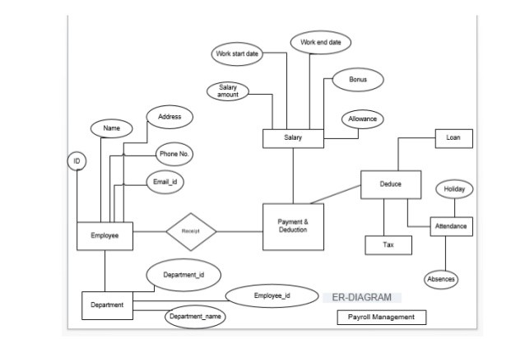

1. **Case Diagram:**

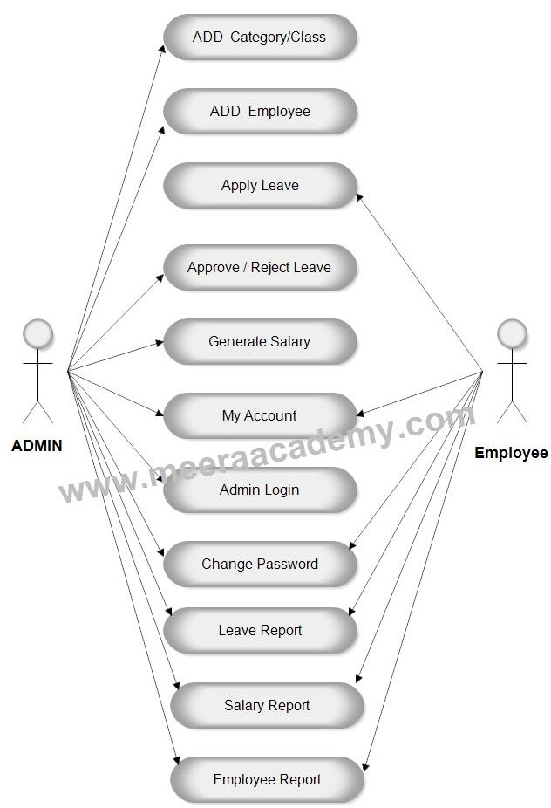

1. **Flow Diagram:**

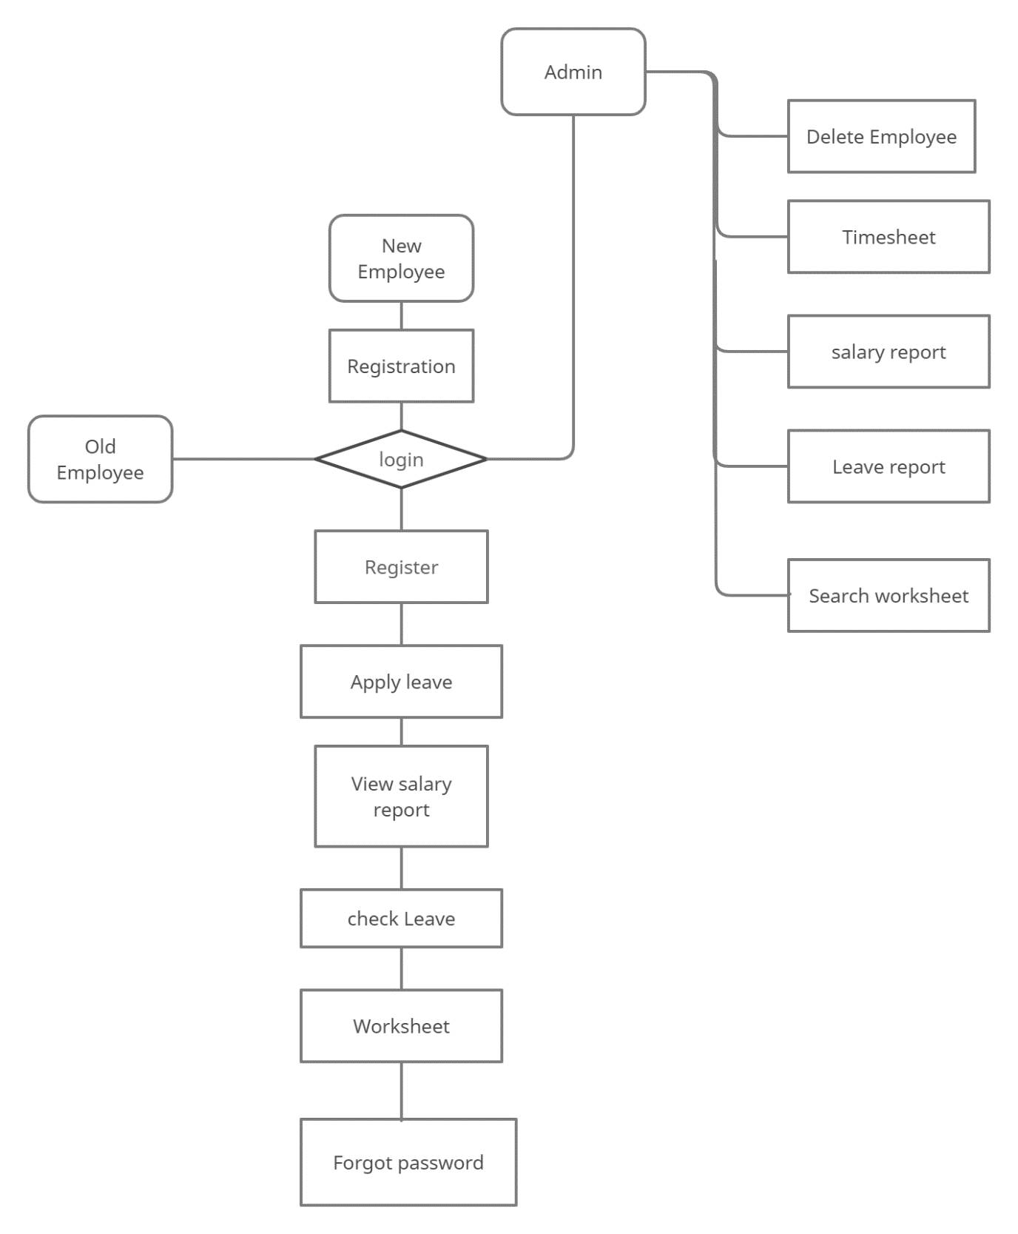

**8.0 Database Diagram:**

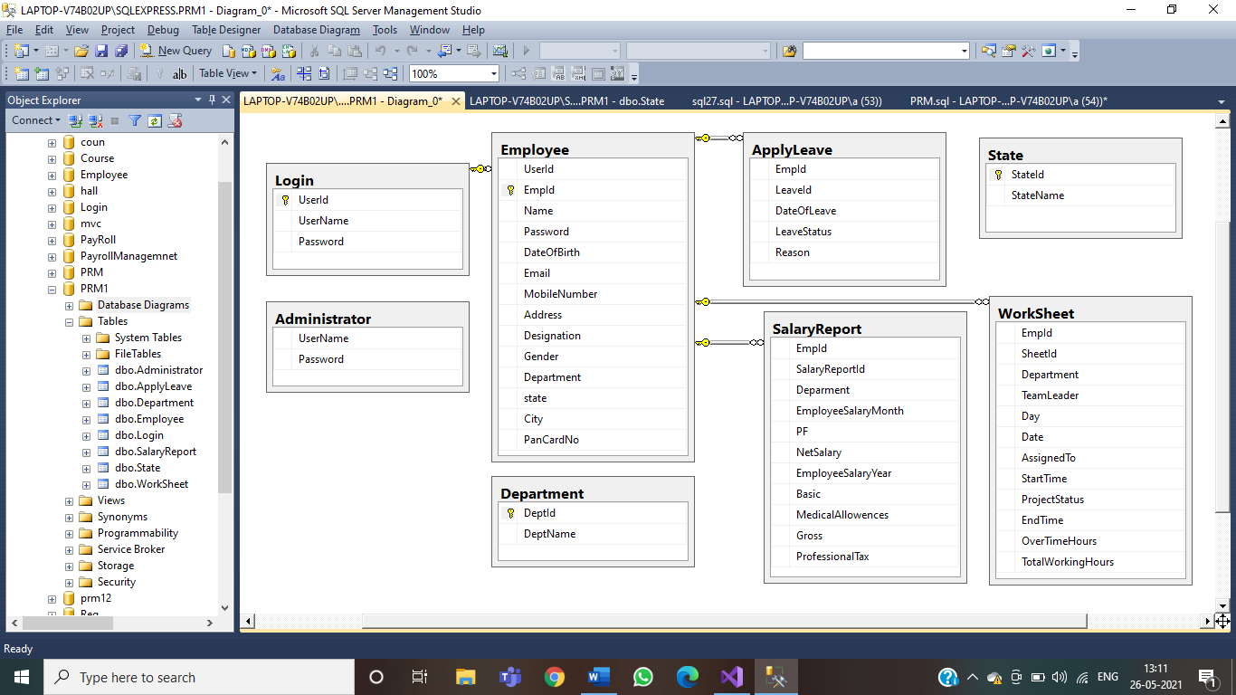

**9.0 Conclusion:**

The application Payroll System developing by us will made the best possible efforts to satisfy the needs of Employee and Administrator.

The details can be accessed and the salary calculation is done according to the rules and regulations of particular company in shortest time frame and keep Employers up to date on his statutory obligations.

Efficiently manage employee information with easy to use interfacing and process monthly payroll along with satisfying features like leave reports, time sheet and work sheet. So that it promotes clear, transparent, accountable and user friendly administration.

**10.0 Test cases:**

**Login Page**

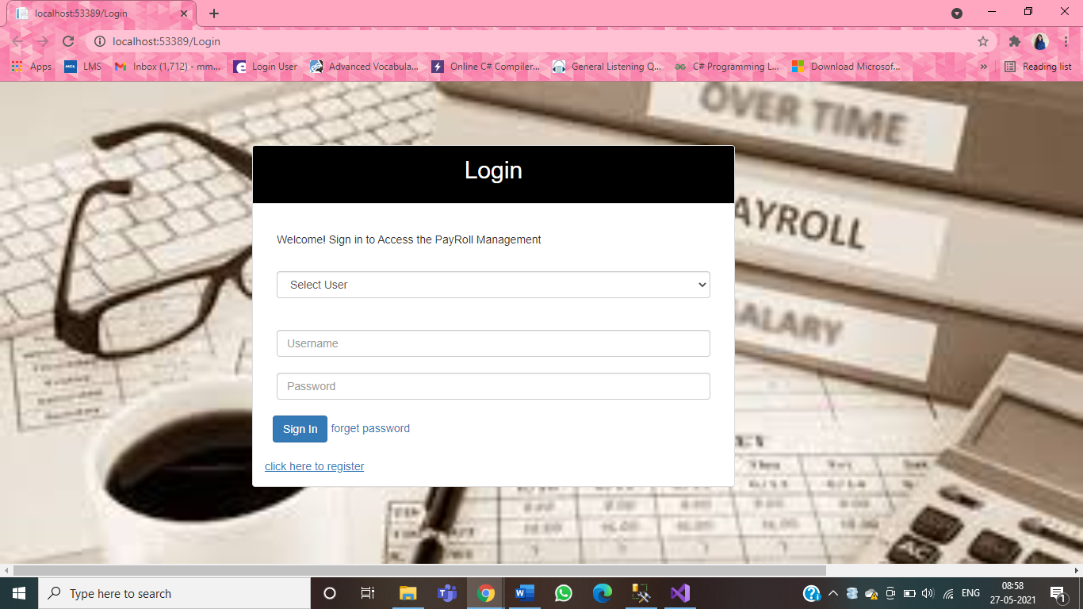

**Registration Page:**

