**E-COMMERCE WEBSITE DATABASE MANAGEMENT SYSTEM**

**By:**

|  |  |
| --- | --- |
| SHASHANK GUTGUTIA | 16BCE0256 |
| MANSIMRAN SINGH ANAND | 16BCE0643 |

**Submitted to: Prof. GEETHA MARY A**

**Slot: D1**

**CSE2004**

**DATABASE MANAGEMENT SYSTEM**



**ACKNOWLEDGEMENTS**

We are very grateful to **GEETHA MARY** ma’am , our project guide, without whose guidance we would not able to complete this project.

We would also like to thank VIT University management for giving us this opportunity to undergo this course and providing us facilities to do this project.

**Sign:**

16BCE0256 SHASHANK GUTGUTIA

16BCE0643 MANSIMRAN SINGH ANAND

TABLE OF CONTENTS

1. TOPIC……………………………………………………………………….1
2. ACKNOWLEDGEMENTS…………………………………………………2
3. ABSTRACT…………………………………………………………………4
4. INTRODUCTION…………………………………………………………...5
5. LITERATURE REVIEW ………………………………………………...…6
6. REQUIREMENTS……………………………………………………….…..7
7. CONCLUSION AND FUTURE WORK ……………………………………9
8. REFERENCES…….………………………………………………………..10

**Abstract:**

The business-to-consumer aspect of electronic commerce (e-commerce) is the most visible business use of the World Wide Web. The primary goal of an e-commerce site is to sell goods and services online.

Creating a E-Commerce Website Database Management System is one of the most interesting and satisfying experience in terms of learning. The primary purpose is to create a user friendly E-Commerce Website which provides the basic functionality of creating an account, placing an order and generating a bill for the same, without losing on the key aspect of simplicity and ease of access for the common man.

We took up this project with the aim of creating a very basic Front-End using HTML,CSS and JAVASCRIPT, thereby connecting it with the backend Database using PHP. Processing and managing the queries helped us understand the concepts taught in class clearly. We have successfully created a website which allows customers to choose a product from a range of options and place an order. However due to certain limitations a key aspect of E-Commerce websites i.e. processing transactions through a secure online payment portal could not be incorporated in our project. Thus it is not a general purpose shopping website but a rather basic implementation of whatever we understood in class.

We hope that we can take it even further after this semester in terms of complexity and functionality.

**INTRODUCTION**

E-commerce is fast gaining ground as an accepted and used business paradigm. More and more business houses are implementing web sites providing functionality for performing commercial transactions over the web.

It is reasonable to say that the process of shopping on the web is becoming commonplace. The objective of this project is to develop a general purpose e-commerce store where any product can be bought from the comfort of home through the Internet.

The customer will be asked to fill his details and will be provided with a Customer ID .Next he will be prompted to choose his product and place an order for the same using the Product ID provided.

**LITERATURE REVIEW**

The increasing importance of e-commerce is apparent in the study conducted by researches at the GVU (Graphics, Visualization, and Usability) Center at the Georgia Institute of Technology. In their summary of the findings from the eighth survey, the researchers report that “e-commerce is taking off both in terms of the number of users shopping as well as the total amount people are spending via Internet based transactions”.

Over three quarters of the 10,000 respondents report having purchased items online. The most cited reason for using the web for personal shopping was convenience (65%), followed by availability of vendor information (60%), no pressure form sales person (55%) and saving time (53%).

A good e-commerce site should present the following factors to the customers for better usability :

* Easy scanning and selecting items in a list.
* Effective categorical organization of products.
* Simple navigation from home page to information and order links for specific products.
* Minimal and effective security notifications or messages.
* Consistent layout of product information.

Finally, completed orders should be acknowledged quickly. This may be done with an acknowledgment or fulfilment page.

**CODE**

**FIRST PAGE**

<!DOCTYPE html>

<html>

<head>

<title> sign up page </title>

<style>

body {

background-color:white;

}

a:link, a:visited {

background-color:purple;

background-image: url("backgroundgif.gif");

color: white;

padding: 14px 25px;

text-align: center;

text-decoration: none;

display: inline-block;

text-align:center;

}

a:hover, a:active {

background-color:grey;

text-align:center;

}

</style>

</head>

<body>

<h1 style="text-align:center"> E-COMMERCE DATABASE MANAGEMENT</h1>

<form action="dbms_review.php" method="post">

<br><br>

<table style="background-color:#901B9A" border="7" width="350" height="400" align="center">

<tr> <td>Name</td>

<td><input type="text" name="name"></td>

</tr>

<tr><td>Email ID</td>

<td><input type="text" name="email"></td>

</tr>

<tr><td>Address</td>

<td><input type="text" name="address"></td>

</tr>

<tr><td>Country</td>

<td><input type="text" name="country"></td>

</tr>

<tr> <td colspan="5" align="center"><input type="submit" name="signup" value="submit"></tr></td>

</table>

<br>

&nbsp;&nbsp;&nbsp;&nbsp;&nbsp;&nbsp;&nbsp;&nbsp;&nbsp;&nbsp;&nbsp;&nbsp;&nbsp;&nbsp;&nbsp;&nbsp;&nbsp;&nbsp;&nbsp;&nbsp;&nbsp;&nbsp;&nbsp;&nbsp;&nbsp;&nbsp;&nbsp;&nbsp;&nbsp;&nbsp;&nbsp;&nbsp;&nbsp;&nbsp;&nbsp;&nbsp;&nbsp;&nbsp;&nbsp;&nbsp;&nbsp;&nbsp;&nbsp;&nbsp;&nbsp;&nbsp;&nbsp;&nbsp;&nbsp;&nbsp;&nbsp;&nbsp;&nbsp;&nbsp;&nbsp;&nbsp;&nbsp;&nbsp;&nbsp;&nbsp;&nbsp;&nbsp;&nbsp;&nbsp;&nbsp;&nbsp;&nbsp;&nbsp;&nbsp;&nbsp;&nbsp;&nbsp;&nbsp;&nbsp;&nbsp;&nbsp;&nbsp;&nbsp;&nbsp;&nbsp;&nbsp;&nbsp;&nbsp;&nbsp;&nbsp;&nbsp;&nbsp;&nbsp;&nbsp;&nbsp;&nbsp;&nbsp;&nbsp;&nbsp;&nbsp;&nbsp;&nbsp;&nbsp;&nbsp;&nbsp;&nbsp;&nbsp;&nbsp;&nbsp;&nbsp;&nbsp;&nbsp;&nbsp;&nbsp;&nbsp;&nbsp;&nbsp;&nbsp;&nbsp;&nbsp;&nbsp;&nbsp;&nbsp;&nbsp;&nbsp;&nbsp;&nbsp;&nbsp;&nbsp;&nbsp;&nbsp;&nbsp;&nbsp;&nbsp;&nbsp;&nbsp;&nbsp;&nbsp;&nbsp;&nbsp;&nbsp;&nbsp;&nbsp;&nbsp;&nbsp;&nbsp;&nbsp;&nbsp;&nbsp;&nbsp;&nbsp;&nbsp;&nbsp;&nbsp;&nbsp;&nbsp;&nbsp;&nbsp;&nbsp;&nbsp;&nbsp;&nbsp;&nbsp;&nbsp;&nbsp;&nbsp;&nbsp;&nbsp;&nbsp;&nbsp;&nbsp;&nbsp;&nbsp;&nbsp;&nbsp;&nbsp;&nbsp;&nbsp;&nbsp;&nbsp;&nbsp;&nbsp;&nbsp;&nbsp;&nbsp;<a style="text-align:center" href="http://localhost/dbms/customer_id.php">NEXT</a>

<br>

<br>

</body>

</html>

<?php

$conn = mysqli_connect('localhost','root','');

if(!$conn)

{

echo 'not connected to server';

}

if(!mysqli_select_db($conn,'e-commerce'))

{ echo ' e-commerce database not selected';

}

if(isset($_POST['signup']))

{ $name=$_POST['name'];

$customer_ID=(floor((rand() * 1000)+1));

$email=$_POST['email'];

$address=$_POST['address'];

$country=$_POST['country'];

$query= " INSERT INTO customer (customer_ID,name,email,address,country) values('$customer_ID','$name','$email','$address','$country')";

if (mysqli_query($conn, $query))

{ echo "New record created successfully";

}

else

{

echo "Error: " . $query . "<br>" . mysqli_error($conn);}

}

?>

**SECOND PAGE**

<?php

if(isset($_POST['signup']))

{$valuetosearch = $_POST['name'];

$query = "SELECT * FROM `customer` WHERE CONCAT (`customer_id`, `name`, `email`, `address`, `country` ) LIKE '%".$valuetosearch."%';";

$search_result = filtertable($query);

}else

{$query = "SELECT * from `customer`";

$search_result = filtertable($query); }

function filtertable($query1)

{$connect = mysqli_connect("localhost","root","","e-commerce");

$filter_result = mysqli_query($connect,$query1);

return $filter_result;}

?>

<!DOCTYPE html>

<html>

<head>

<link rel="stylesheet" href="https://cdnjs.cloudflare.com/ajax/libs/materialize/0.100.2/css/materialize.min.css">

<script type="text/javascript" src="https://code.jquery.com/jquery-3.2.1.min.js"></script>

<script src="https://cdnjs.cloudflare.com/ajax/libs/materialize/0.100.0/js/materialize.min.js"></script>

<title> sign up page </title><style>

body {background-color:white;

background-image: url(background.gif);

}

a:link, a:visited {background-color:purple;

color: white;

padding: 14px 25px;

text-align: center;

text-decoration: none;

display: inline-block;

text-align:center;

}

a:hover, a:active { background-color:grey;

text-align:center; }

.header {background-color: #f1f1f1;

padding: 5px;

font-size: 45px;

text-align: center; }

</style>

</head>

<body>

<div class="header">

<h1>E-commerce data base management</h1></div>

<h1 style="text-align:center;font-size:40px;"> Enter you name below to get you customer id</h1>

<form method="post">

<br><br><div class="row">

<div class="col s4"></div>

<div class="col s4"><tr> <td><input type="text" name="name"></td>

</tr><br><br>

<div class="row"><div class="col s1"></div>

<div class="col s10"> <tr> <td colspan="5" align="center">&nbsp;&nbsp;&nbsp;&nbsp;&nbsp;&nbsp;&nbsp;&nbsp;&nbsp;&nbsp;&nbsp;&nbsp;&nbsp;&nbsp;&nbsp;&nbsp;&nbsp;&nbsp;&nbsp;&nbsp;&nbsp;&nbsp;&nbsp;&nbsp;&nbsp;&nbsp;&nbsp;&nbsp;&nbsp;&nbsp;&nbsp;&nbsp;&nbsp;&nbsp;&nbsp;&nbsp;&nbsp;&nbsp;&nbsp;&nbsp;&nbsp;&nbsp;&nbsp;&nbsp;&nbsp;<input type="submit" name="signup" value="submit"></tr></td>

<br><br><br>

<br><br. <br><br>

&nbsp;&nbsp;&nbsp;&nbsp;&nbsp;&nbsp;&nbsp;&nbsp;&nbsp;&nbsp;&nbsp;&nbsp;&nbsp;&nbsp;&nbsp;&nbsp;&nbsp;&nbsp;&nbsp;&nbsp;&nbsp;&nbsp;&nbsp;&nbsp;&nbsp;&nbsp;&nbsp;&nbsp;&nbsp;&nbsp;&nbsp;&nbsp;<a style="text-align:center" href="http://localhost/dbms/product.php#test1">PRODUCT PAGE</a>

<br><br><br><br>

<br><br><br><br>

<br><br><br>

<?php while($row = mysqli_fetch_array($search_result)) : ?>

<?php echo "the customer id of " ; ?> <?php echo $row['name'] ; ?>

<?php echo "is";?> <?php echo $row['customer_id'] ; ?>

<?php endwhile;?>

</div> <div class="col s1"></div>

</div> </div>

<div class="col s4"></div> </div>

</body></html>

**THIRD PAGE**

<!DOCTYPE html>

<html>

<head>

<title> product page </title>

<link rel="stylesheet" href="https://cdnjs.cloudflare.com/ajax/libs/materialize/0.100.2/css/materialize.min.css">

<script type="text/javascript" src="https://code.jquery.com/jquery-3.2.1.min.js"></script>

<script src="https://cdnjs.cloudflare.com/ajax/libs/materialize/0.100.0/js/materialize.min.js"></script>

<style>

a:link, a:visited {

color: white;

padding: 14px 25px;

text-align: center;

text-decoration: none;

display: inline-block;

text-align:center;}

a:hover, a:active {

background-color:grey;

text-align:center;}

</style></head>

<body> <div class="row"><div class="col s12">

<ul class="tabs"> <li class="tab col s4"><a href="#test1">ELECTRONICS <br> <br> </a></li><li class="tab col s4"><a href="#test2">STATIONERY <br> <br></a></li>

<li class="tab col s4"><a href="#test3">SPORTS <br> <br></a></li></ul>

</div><div id="test1" class="col s12"> <ul class="collapsible popout" data-collapsible="accordion"> <li>

<div class="collapsible-header"><i class="material-icons"></i>Samsung Galaxy S8</div><div class="collapsible-body"><span>PRODUCT DESCRIPTION : <br><br> 4 GB RAM, 64 GB ROM <br> Expandable Upto 256 GB <br> 5.8 inch Quad HD+ Display <br> 12MP Rear Camera, 8MP Front Camera <br> 3000 mAh Battery <br> Exynos 8895 Processor <br><br> PRODUCT ID - 1 <br><br> PRICE - 67000 </span></div></li> <li>

<div class="collapsible-header"><i class="material-icons"></i>Apple I-pad Mini</div> <div class="collapsible-body"><span> PRODUCT DESCRIPTION : <br><br> 8MP primary camera with auto focus, panorama, HDR, exposure control, burst mode, tap to focus, timer mode, f/2.4 aperture, five-element lens, hybrid IR flter, backside illumination, auto image stabilisation, face detection, photo geotagging, video image stabilisation, slow motion (120 fps), 3X video zoom, video geotagging and 1.2MP front facing camera. 32.4-watt-hour lithium-polymer battery1 year manufacturer warranty for device and 6 months manufacturer warranty <br><br> PRODUCT ID - 2 <br><br> PRICE - 25000 </span></div></li>

<li> <div class="collapsible-header"><i class="material-icons"></i>Fast Tract Digital Watch</div> <div class="collapsible-body"><span> PRODUCT DESCRIPTION : <br><br> Dial Colour : Blue, Case Colour : Black Strap Colour : Denim Blue <br> Strap Material : Faux Leather Water Resistant/Shock Resistant <br> Display Type : Analogue, Movement Type : Quartz <br> 6 Months Manufacturer Warranty <br><br> PRODUCT ID - 3 <br><br> PRICE - 3000 </span></div> </li><li>

<div class="collapsible-header"><i class="material-icons"></i>Electric Iron</div>

<div class="collapsible-body"><span> PRODUCT DESCRIPTION : <br><br> German grade non-stick coated sole plate <br> Cast In Sole Plate Technology For Faster And Uniform Heating <br> Thermostat For Variable Temperature Control Thermal Fuse For Over Heat Safety Protection <br> rgonomic design and Light weight with instant heating <br><br> PRODUCT ID - 4 <br><br> PRICE - 2000 </span></div></li> <li>

<div class="collapsible-header"><i class="material-icons"></i>Electric Kettle</div>

<div class="collapsible-body"><span> PRODUCT DESCRIPTION : <br><br> 1.8 Liter Capacity, Elegant Handles with Single- Touch Lid Locking, Automatic Cut-Off When Water Has Boiled, Concealed Element, Power Indicator, 360 Degree Swivel Base. 1500 W 1 year warranty <br><br> PRODUCT ID - 5 <br><br> PRICE - 1000 </span></div> </li> </ul> <script>

$(document).ready(function(){

$('.collapsible').collapsible(); }); </script> </div>

<div id="test2" class="col s12"><ul class="collapsible popout" data-collapsible="accordion">

<li><div class="collapsible-header"><i class="material-icons"></i>Unibal Gel Pen (set of 10)</div> <div class="collapsible-body"><span> PRODUCT DESCRIPTION : <br><br> 100% made in Japan by Mitsubishi Pencil Co.Ltd <br> Stainless-steel tip with tungsten carbide ball <br> Only blue colour is available temporary <br> The see through ink barrel lets you see how much ink is left <br> High-quality and reliable rollerball featuring waterproof <br> User friendly,safe and comfortable to use <br> A favourite for over 10 years <br><br> PRODUCT ID - 6 <br><br> PRICE - 500 </span></div> </li> <li><div class="collapsible-header"><i class="material-icons"></i>Spiral Sticky Notepad</div> <div class="collapsible-body"><span> PRODUCT DESCRIPTION : <br><br>A pocket size mini sticky note pad with different sizess of sticky notes <br> Small sticky notes Size : 5 cm Length, 1.5 cm Width, Full size sticky note Size : 7.5 cm Length, 5 cm Width <br><br> PRODUCT ID - 7 <br><br> PRICE - 100 </span></div><li><li>

<div class="collapsible-header"><i class=" -icons"></i>Highlighters (set of 5)</div><div class="collapsible-body"><span> PRODUCT DESCRIPTION : <br><br> Chisel tip for underlining and Highlighting <br> Water based fluorescent ink for better visibility <br> Available 5 Fluorescent colours ( Yellow, Pink, Orange, Green, Blue)<br>Non-Toxic <br><br> PRODUCT ID - 8 <br><br> PRICE - 200 </span></div>

</li> <li> <div class="collapsible-header"><i class="material-icons"></i>Nataraj erasers(set of 20)</div> <div class="collapsible-body"><span> PRODUCT DESCRIPTION : <br><br> Made up of soft high quality material <br> Erases Graphite gently without damaging paper <br> Smooth on paper <br><br> PRODUCT ID - 9 <br><br> PRICE - 500 </span></div> </li><li>

<div class="collapsible-header"><i class="material-icons"></i>Apsara Pencil Set</div>

<div class="collapsible-body"><span> PRODUCT DESCRIPTION : <br><br> Specially designed for executives <br> 2B Grade, Superior bonded lead is strong and resists breakage <br> Superior quality wood makes sharpening easy <br> Meets international quality standards <br><br> PRODUCT ID - 10 <br><br> PRICE - 100 </span></div>

</li> </ul> <script> $(document).ready(function(){$('.collapsible').collapsible();

});<script> </div><div id="test3" class="col s12"> <ul class="collapsible popout" data-collapsible="accordion"><li> <div class="collapsible-header"><i class="material-icons"></i>Cricket Bats</div><div class="collapsible-body"><span> PRODUCT DESCRIPTION : <br><br> Size: Short handle <br> Willow: Kashmir willow <br> Weight: 1.3 kilograms <br> Thick edges and curved blade <br><br> PRODUCT ID - 11 <br><br> PRICE - 6000 </span></div> </li><li>

<div class="collapsible-header"><i class="material-icons"></i>Cosco Light Weight Cricket Ball (set of 6)</div><div class="collapsible-body"><span> PRODUCT DESCRIPTION : <br><br> Fine and superior quality <br> Being lightweight, this cosco cricket ball is easy and comfortable to hold in your hands while playing <br> Designed in a bright fluorescent yellow color, this cricket ball can be easily identified and spotted on any surface <br> Box contents: 6 balls <br><br> PRODUCT ID - 12 <br><br> PRICE - 500 </span></div></li><li> <div class="collapsible-header"><i class="material-icons"></i>Sports shoes</div>

<div class="collapsible-body"><span> PRODUCT DESCRIPTION : <br><br> Material: Mesh <br> Colour: Grey Firozi <br> LifeStyle: Sports <br> Closer : Lace Up <br> Specially designed for Indian Men's feet <br><br> PRODUCT ID - 13 <br><br> PRICE - 3000 </span></div> </li> <li>

<div class="collapsible-header"><i class="material-icons"></i>Nike Cap</div><div class="collapsible-body"><span> PRODUCT DESCRIPTION : <br><br> Color: Black <br> Size: Free Size <br> Metal Swoosh logo <br> Cool Comfortable Fit <br> Adjustable Strap <br><br> PRODUCT ID - 14 <br><br> PRICE - 1000 </span></div> </li> <li>

<div class="collapsible-header"><i class="material-icons"></i>Batting gloves</div> <div class="collapsible-body"><span> PRODUCT DESCRIPTION : <br><br> Palm made from cotton and PVC <br> Premium PVC finger rolls and dual density foam finger rolls <br> Cotton back <br> Cotton gusset for ventilation <br><br> PRODUCT ID - 15 <br><br> PRICE - 500 </span></div> </li> </ul>

<script> $(document).ready(function(){ $('.collapsible').collapsible(); }); </script></div></div> <script>

$(document).ready(function{ $('ul.tabs').tabs();});

</script> <script>$(document).ready(function(){

$('ul.tabs').tabs('select_tab', 'tab_id'); });

</script>

<div class="row">

<div class="col s2"></div>

<div class="col s8">

<form action="product.php" method="post">

Enter the customer id <br>

<input type="text" name="customer_id"> <br><br>

Enter the product id:<br>

<input type="text" name="product_id"><br>

Enter the quantity: <br>

<input type="text" name="quantity"><br><br>

<input type="submit" name="signup" value="submit">

</form><br>

<a style="text-align:center" href="http://localhost/dbms/billing.php">PROCEED TO TRANSACTION</a>

</div>

<div class="col s2"></div> </div>

</body></html>

<?php

$conn = mysqli_connect('localhost','root','');

if(!$conn){

echo 'not connected to server';}

if(!mysqli_select_db($conn,'e-commerce')) {

echo ' e-commerce database not selected';}

if(isset($_POST['signup'])){

$product_id=$_POST['product_id'];

$customer_id=$_POST['customer_id'];

$quantity=$_POST['quantity'];

$a=$_POST['quantity'];

$b=$_POST['product_id'];

if ($b == '1')

{ $price=67000*$a; }

else if ($b == '2')

{ $price=25000*$a; }

else if ($b == '3')

{ $price=3000*$a; }

else if ($b == '4') {

$price=3000*$a; }

else if ($b == '5'){

$price=2000*$a;}

else if ($b == '6')

{ $price=500*$a; }

else if ($b == '7')

{ $price=100*$a; }

else if ($b == '8')

{ $price=200*$a; }

else if ($b == '9')

{ $price=500*$a; }

else if ($b == '10')

{ $price=100*$a;}

else if ($b == '11')

{ $price=6000*$a; }

else if ($b == '12')

{$price=500*$a;}

else if ($b == '13')

{ $price=3000*$a;}

else if ($b == '14')

{ $price=1000*$a;}

else if ($b == '15')

{

$price=500*$a;}

$query= " INSERT INTO product_final (customer_id,product_id,quantity,price) values('$customer_id','$product_id','$quantity','$price')";

if (mysqli_query($conn, $query)){

echo "New record created successfully";

} else {

echo "Error: " . $query . "<br>" . mysqli_error($conn);}}?>

**FOURTH PAGE**

<!DOCTYPE html>

<html>

<head><title> billing page

</title> <link rel="stylesheet" href="https://cdnjs.cloudflare.com/ajax/libs/materialize/0.100.2/css/materialize.min.css">

<script type="text/javascript" src="https://code.jquery.com/jquery-3.2.1.min.js"></script> <script src="https://cdnjs.cloudflare.com/ajax/libs/materialize/0.100.0/js/materialize.min.js"></script>

<style>a:link, a:visited {

background-color:purple;

color: white;

padding: 14px 25px; text-align: center;

text-decoration: none; display: inline-block;

text-align:center;

}a:hover, a:active { background-color:grey;

text-align:center;

}

.header { background-color: #f1f1f1;

padding: 5px; font-size: 45px;

text-align: center;

}</style>

</head><body>

{

<div class="header"> <h1>E-commerce data base management</h1>

</div> <div class="row">

<div class="col s2"></div>

<div class="col s8"> <h2 style="text-align:center;font-size:40px;">Enter your details to complete transaction </h2>

<form action="billing.php" method="post">

<div class="row">

<div class="col s2"></div> <div class="col s8"> Enter the credit card type (VISA / MASTERCARD/ AMERICAN EXPRESS) <br>

<input type="text" name="creditcardtype"><br></div>

<div class="col s2"></div></div>

<div class="row"> <div class="col s2"></div>

<div class="col s8">Enter the credit card no.(16 digit number)<br>

<input type="text" name="creditcard_no"><br></div> <div class="col s2"></div>

</div> <div class="row">

<div class="col s2"></div> <div class="col s8">

Enter the credit card expiry date(mm/yyyy)

<input type="text" name="creditcard_expiry"><br>

<div class="row"> <div class="col s3"></div>

<div class="col s6"> <input type="submit" name="signup" value="submit">

</form> <br><br>

<a style="text-align:center" href="http://localhost/dbms/bill_display.php">go to bill </a>

</div> <div class="col s3"></div> </div> </div>

<div class="col s2"></div> </div> </div>

<div class="col s2"></div> </div></body></html>

<?php

$conn = mysqli_connect('localhost','root','');

if(!$conn) { echo 'not connected to server'; }

if(!mysqli_select_db($conn,'e-commerce'))

{ echo ' e-commerce database not selected'; }

if(isset($_POST['signup']))

{

$Bill_date=date('d');

$Billing_id=(floor((rand() * 1000)+1));

$creditcardtype=$_POST['creditcardtype'];

$creditcard_no=$_POST['creditcard_no'];

$creditcard_expiry=$_POST['creditcard_expiry'];

$query= " INSERT INTO bill_table (Bill_date,Billing_id,creditcardtype,creditcard_no,creditcard_expiry) values('$Bill_date','$Billing_id','$creditcardtype','$creditcard_no','$creditcard_expiry')";

if (mysqli_query($conn, $query))

{ echo "Transaction completed";

}

else { echo "Error: " . $query . "<br>" . mysqli_error($conn); } } ?>

**FIFTH PAGE**

<?php

if(isset($_POST['signup'])) {

$valuetosearch = $_POST['customer_id'];

$query = "SELECT * FROM `customer` WHERE CONCAT (`customer_id`, `name`, `email`, `address`, `country` ) LIKE '%".$valuetosearch."%';";

$query_next= " SELECT * FROM `product_final` WHERE CONCAT (`customer_id`, `product_id`, `quantity`, `price`) LIKE '%".$valuetosearch."%';";

$query_next_shipper = "SELECT * FROM `shipper` WHERE shipper_id = '1'";

$query_next_supplier = "SELECT * FROM `supplier` WHERE supplier_id = '1'";

$search_result = filtertable($query);

$search_result_new = filtertable_new($query_next);

$search_result_new_shipper = filtertable_new_shipper($query_next_shipper);

$search_result_new_supplier = filtertable_new_supplier($query_next_supplier); }

else

{ $query = "SELECT * from `customer`";

$query_next = "SELECT * from `product_final`";

$query_next_shipper = "SELECT * from `shipper`";

$query_next_supplier = "SELECT * from `supplier`";

$search_result = filtertable($query);

$search_result_new = filtertable_new($query_next);

$search_result_new_shipper = filtertable_new_shipper($query_next_shipper);

$search_result_new_supplier = filtertable_new_supplier($query_next_supplier); }

function filtertable($query1)

{ $connect = mysqli_connect("localhost","root","","e-commerce");

$filter_result = mysqli_query($connect,$query1);

return $filter_result;

}function filtertable_new($query1_next)

{ $connect = mysqli_connect("localhost","root","","e-commerce");

$filter_result = mysqli_query($connect,$query1_next);

return $filter_result; }

function filtertable_new_shipper($query1_next_shipper)

{ $connect = mysqli_connect("localhost","root","","e-commerce");

$filter_result = mysqli_query($connect,$query1_next_shipper);

return $filter_result;

}function filtertable_new_supplier($query1_next_supplier)

{ $connect = mysqli_connect("localhost","root","","e-commerce");

$filter_result = mysqli_query($connect,$query1_next_supplier);

return $filter_result; }?>

<!DOCTYPE html>

<html><head>

<link rel="stylesheet" href="https://cdnjs.cloudflare.com/ajax/libs/materialize/0.100.2/css/materialize.min.css">

<script type="text/javascript" src="https://code.jquery.com/jquery-3.2.1.min.js"></script> <script src="https://cdnjs.cloudflare.com/ajax/libs/materialize/0.100.0/js/materialize.min.js"></script>

<title> billing page </title>

<style>body {

background-color:white;

}a:link, a:visited {

background-color:purple;

color: white; padding: 14px 25px;

text-align: center;

text-decoration: none;

display: inline-block; text-align:center; }

a:hover, a:active { background-color:grey;

text-align:center; }

.header { background-color: #f1f1f1;

padding: 5px;

font-size: 45px;

text-align: center; }

</style></head><body>

<div class="header">

<h1>E-commerce data base management</h1></div>

<h1 style="text-align:center;font-size: 40px"> Enter you Customer ID to get the bill details</h1>

<form method="post"><br><br>

<div class="row"> <div class="col s3"></div>

<div class="col s6">

<tr> <td><input type="text" name="customer_id"></td></tr>

<br><br><tr> <td colspan="5" align="center"><input type="submit" name="signup" value="submit"></tr></td>

<br><br><br>

<br><br><br><br><br><br><br><br><br><br><br><br><br><br><br><br><br><br><br><br><br><br>

<?php while($row = mysqli_fetch_array($search_result)) : ?> <? system('clear'); ?>

<?php echo "CUSTOMER ID: " ; ?>

<?php echo $row['customer_id'] ; ?> <br>

<?php echo "Name: " ; ?>

<?php echo $row['name'] ; ?> <br>

<?php echo "EMAIL ID: " ; ?>

<?php echo $row['email'] ; ?> <br>

<?php echo "DELIVERY ADDRESS: " ; ?>

<?php echo $row['address'] ; ?> <br>

<?php echo "COUNTRY: " ; ?>

<?php echo $row['country'] ; ?>

<br> <?php endwhile;?>

<?php while($row = mysqli_fetch_array($search_result_new)) : ?> <?php echo "PRODUCT ID: " ; ?> <?php echo $row['product_id'] ; ?> <br> <?php echo "QUANTITY: " ; ?> <?php echo $row['quantity'] ; ?>

<br> <?php echo "TOTAL PRICE: " ; ?> <?php echo $row['price'] ; ?>

<br> <?php endwhile;?> <?php while($row = mysqli_fetch_array($search_result_new_shipper)) : ?>

<?php echo "NAME OF THE SHIPPER: " ; ?> <?php echo $row['companyname'] ; ?>

<br> <?php echo "CONTACT DETAILS OF SHIPPER" ; ?> <?php echo $row['phone'] ; ?> <br>

<?php endwhile;?> <?php while($row = mysqli_fetch_array($search_result_new_supplier)) : ?>

<?php echo "NAME OF SUPPLIER: " ; ?>

<?php echo $row['name_supplier'] ; ?> <br> <?php echo "NAME OF THE SUPPLIER: " ; ?>

<?php echo $row['companyname'] ; ?>

<br> <?php echo "CONTACT DETAILS OF SUPPLIER: " ; ?>

<?php echo $row['contact'] ; ?> <br>

<?php echo "E-MAIL ID OF SUPPLIER: " ; ?> <?php echo $row['email'] ; ?> <br>

<?php endwhile;?>

</div> <div class="col s3"></div> </div>

</body></html>

**OUTPUT SCREENSHOTS**

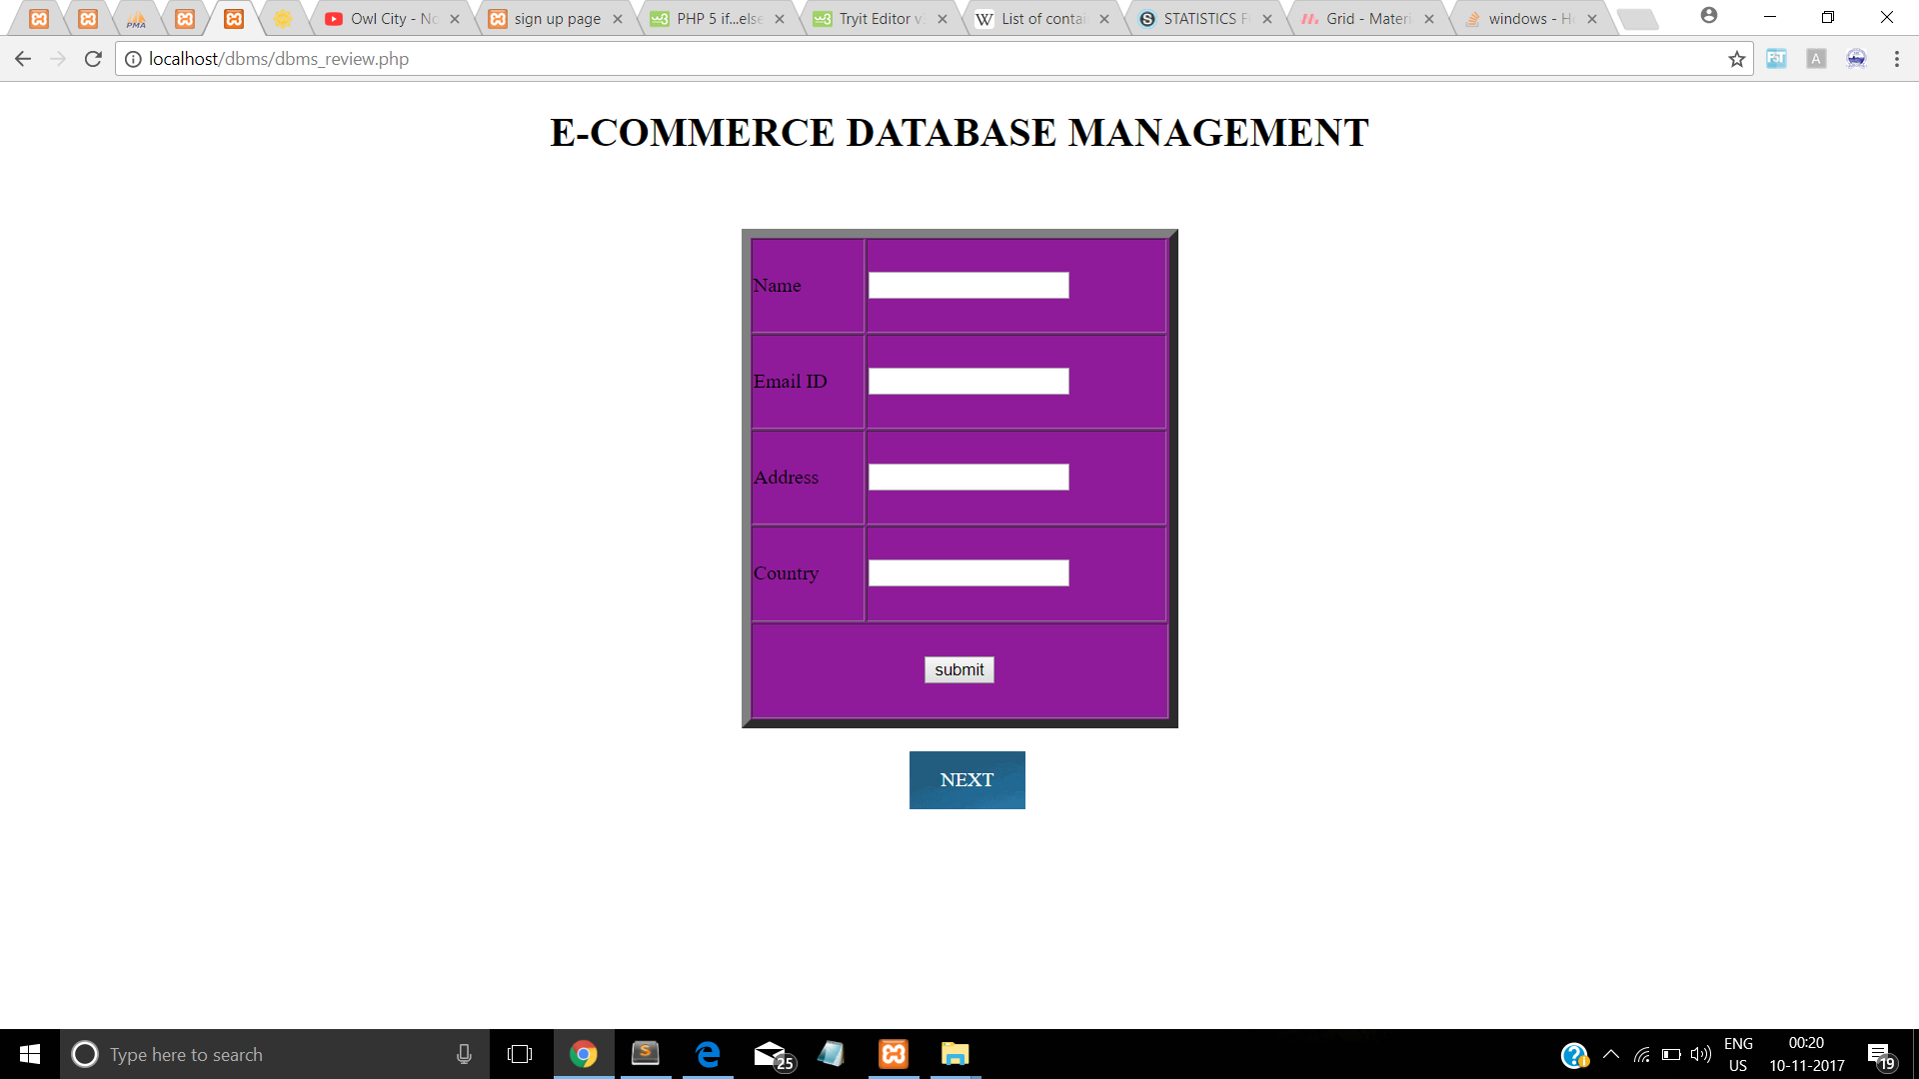

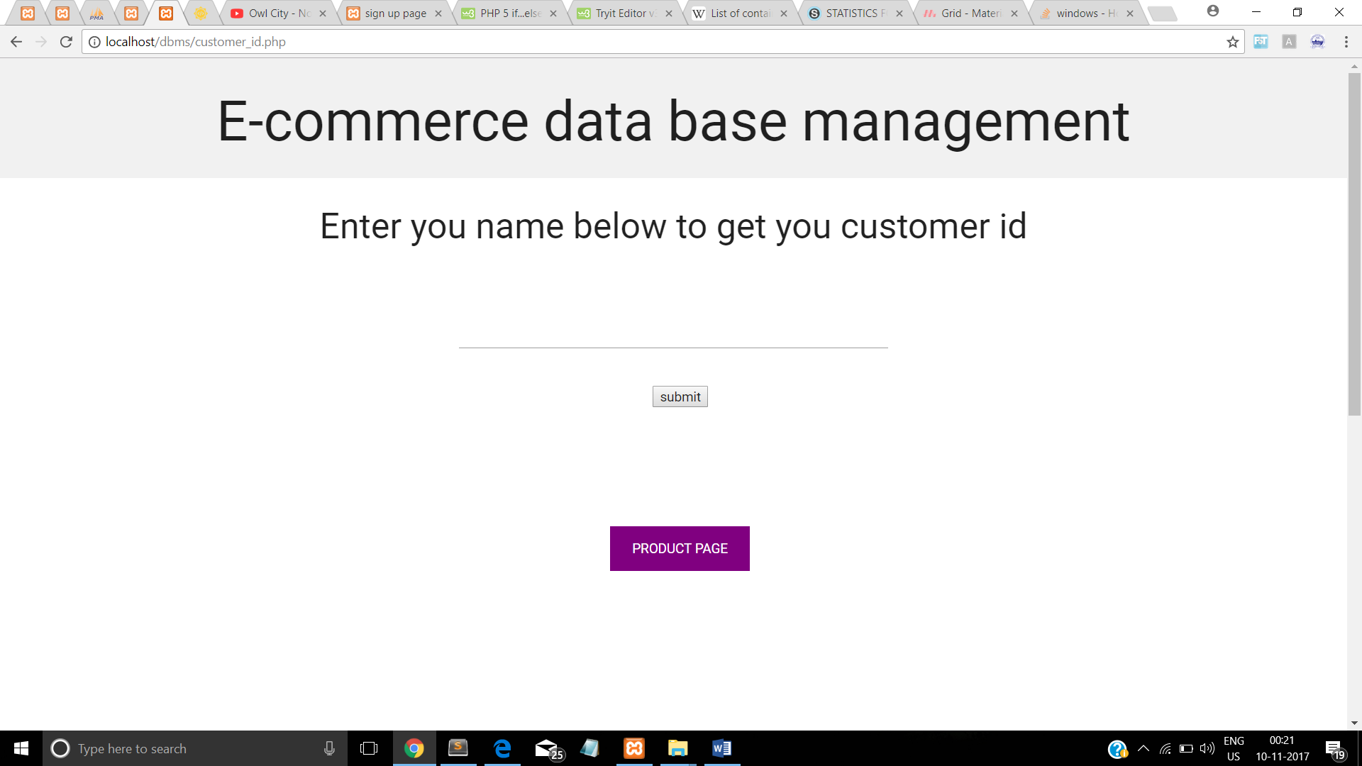

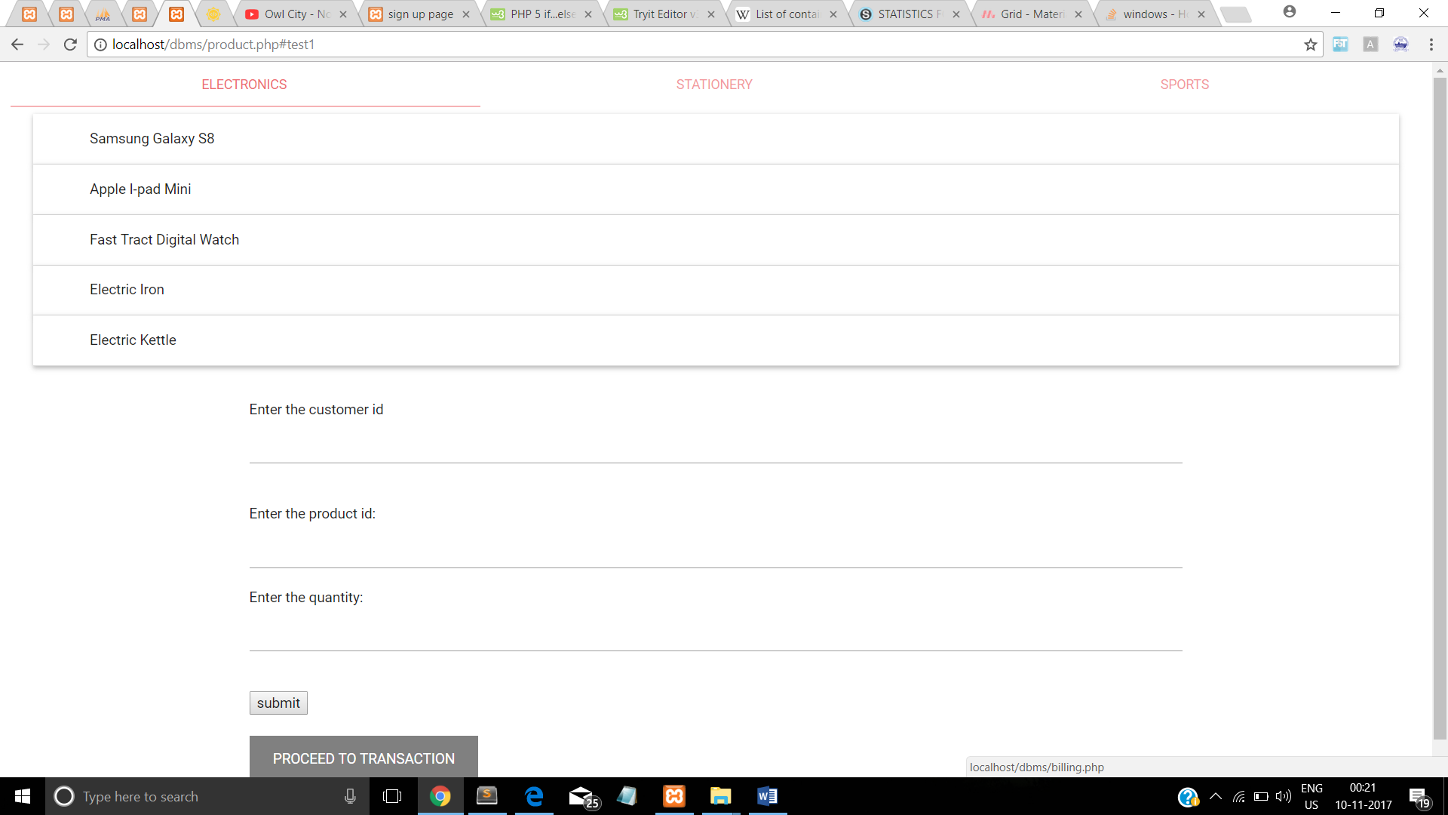

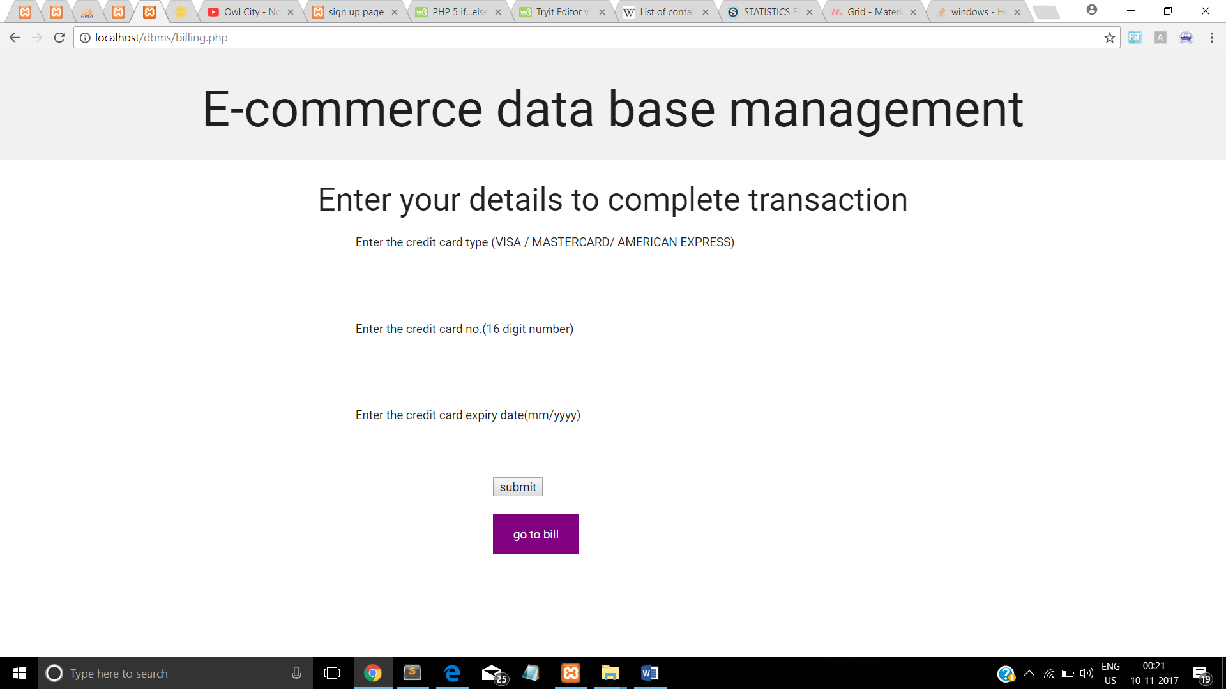

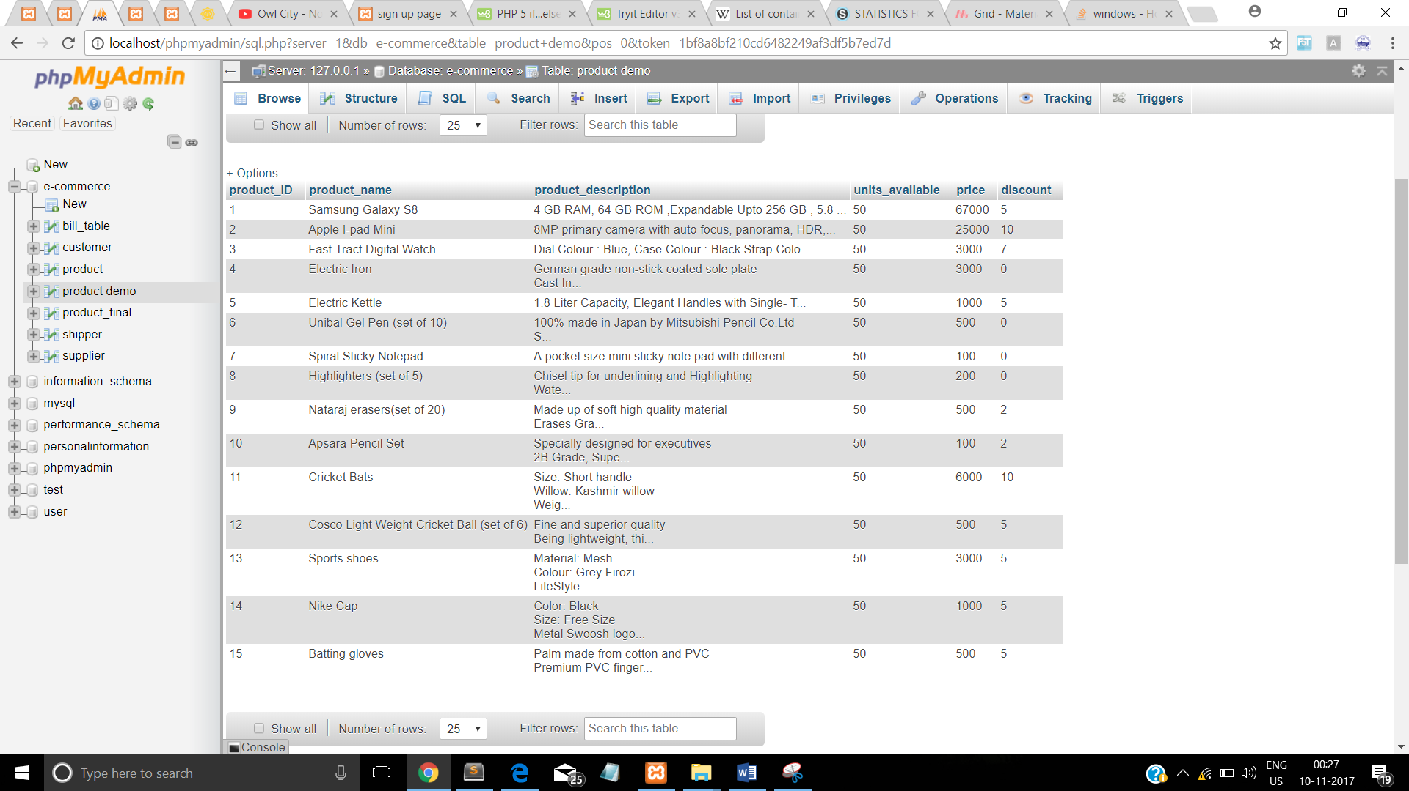

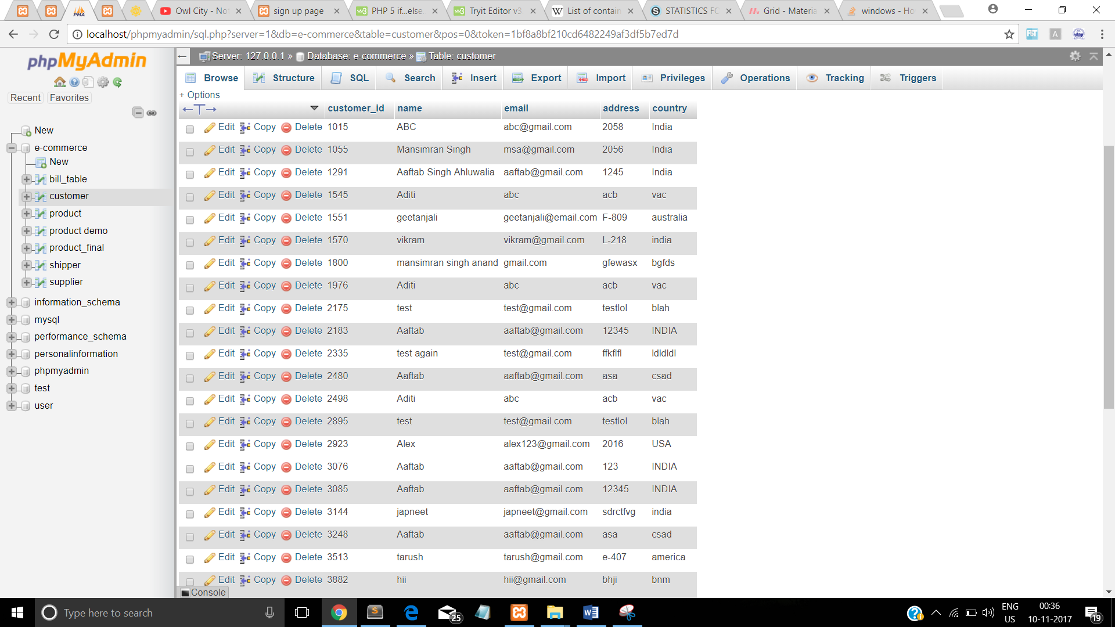

**PROCEDURE**

1. Download the xampp software and install it in the system
2. We have used the sublime text editor is it is very easy to use.
3. For the creating the first page we need to know the customer’s name , contact number, age , email, address and country
4. The entry of values is done in the from of tables
5. In xampp software the table customer is created where the values will be stored
6. Then the user is made to know his customer id which is randomly assigned to him
7. On the next page (page 2 ) the user will enter his name and the customer id is made available to him.
8. Then the user is taken to the third page where the user will enter the product id of the product he wants . from list of 15 products ranging from electronics, home appliances and sports equipment the customer choses 1 product and enters the quantity he wants.
9. Then the user is taken to the next page where he puts his credit card credentials and then he transaction is confirmed.
10. On the last page the bill is shown to him.

**LIMITATIONS**

1. Only few products were available
2. No real time check whether the product is available or not
3. At one time only one product can be chosen.

**REQUIREMENTS:**

In order to develop an e-commerce website, a number of Technologies must be studied and understood. These include multi-tiered architecture, server and client side scripting techniques, implementation technologies, programming language as well as relational databases.

The basic requirements for this project are:

1. **LOCAL HOST SERVER (XAMPP)**
2. **EDITOR (SUBLIME-TEXT/NOTEPAD)**
3. **MySQL Database**
4. **BASIC KNOWLEDGE OF HTML,CSS,JAVASCRIPT,PHP**

In this project, MySQL is used as the backend database. MySQL is an open-source database management system. It is fast, reliable and easy to use.

**Conclusion and future work:**

For the entrepreneur, electronic shopping generates new business opportunities and for the customer, it makes comparative shopping possible.

Making this project was a really good learning experience; we got the feel for the basic development of an E-Commerce Website Database and can now appreciate the amount of work involved in making a full-fledged E-Commerce Website with all its functionalities and secure payment processing and at the same time maintaining an excellent user-friendly environment, for instance Flipkart and Amazon.

Furthering this project will involve improving the Front-End and making it more pleasing, adding more features as well as incorporating a secure payment portal. Although we tried to provide Shipper and Seller option to the Customer we faced certain difficulties and will try to resolve them in future.

**References:**

1. Morrison, M., Morrison, J., and Keys, A. (2002). Integrating Web Sites and Databases. Communications of the ACM, September, Volume 45, Issue 9.
2. Kubilus, N. J. (2000). Designing an e-commerce site for users. September 2000, Crossroads, Volume 7 Issue 1.
3. Diwakar, H., Marathe, M. (2000). The architecture of a one-stop web-window shop. December, ACM SIGecom Exchanges, Volume 2 Issue 1.
4. Wagner, R., Daniels, K., Griffin, G., Haddad, C. and Nasr, J. (1997) JavaScript Unleashed. SAMS Net.
5. How Databases Work with Ecommerce Applications, Understanding 4 Database Types for Ecommerce, How Backend Web Applications Power Ecommerce Sites : ERIC DAVIS

<https://www.practicalecommerce.com/How-Backend-Web-Applications-Power-Ecommerce-Sites>

1. <https://www.practicalecommerce.com/A-Better-Way-to-Store-Ecommerce-Product-Information>