Digital Twin Models Using AI For Solar Power Plant Performance Monitoring

Dr. Gyan Prabhakar, Shivam Kumar, Mansingh Bairwa, Kriti Pathak
Department of Computer Science and Application, VGU, Jaipur. Email: 24tec2aids039@gmail.com
Department of Computer Science and Application, VGU, Jaipur. Email: shivamrajput0735@gmail.com
Department of Physiotherapy, VGU, Jaipur. Email: 24MED2PT026@vgu.ac.in
Corresponding Author email: gyanprabhakar@gmail.com

Abstract: We are currently in an era where how we generate and regulate our energy is undergoing major change. The majority of countries throughout the world are rapidly changing the focus of their energy production from fossil fuels to renewable sources such as solar and wind. This change in energy is vital and is the result of the growing need to reduce our emissions and thereby the rate of global warming. As we increase the amount of solar farms and wind turbines in place, one key issue has become: how to regulate the sheer number of sources. The technology for this problem has been discovered and it is now being addressed using Artificial Intelligence enabled Digital Twins (DT). The definition of a Digital Twin is a real-time virtual model of a physical asset; in our case either a wind or a solar farm; driven by artificial intelligence, which allows the models to be efficiently exploited for operations, fault diagnosis and fault prognosis. Based on over 120 research studies both academic and industrial, this report has demonstrated how an AI-driven Digital Twin can improve unplanned downtime by up to 35%, improve power output by up to 8.5% to 20%, and diagnose faults by greater than 98% accuracy. In addition to a discussion of the underpinning technologies (IoT sensors, cloud computing, communication protocols such as IEC 61850 and OPC UA) there are specific AI algorithms such as deep learning networks for forecasting and visual fault identification included.

1. Introduction
1.1 Why Managing Renewable Energy Is Complicated
Transitioning to clean energy is not just about plugging in solar panels and wind turbines; managing them on a large scale is actually really hard. While coal or gas power plants can easily generate a consistent supply of electricity as needed, the generation of electricity from solar and wind is directly dependent on weather conditions, hour by hour, spread over large geographic regions.
One can imagine a solar farm consisting of millions of solar panels, thousands of inverters and complex tracking devices. Similarly a wind farm has each turbine, essentially acting as a small power station, exposed to outdoor conditions. Managing all this hardware requires intelligence, data processing, and more. The old approach of waiting for something to break and then fixing it is no longer good enough.
1.2 What Is A Digital Twin?
A Digital Twin is a replica of an actual physical system which is kept up to date by inputting real-world data as it is collected. It is not a static 3D representation of the plant: a Digital Twin gets live data as it is produced by sensors so it is continuously being updated with real-time information. What is really unique about a Digital Twin is that the information exchange can be bidirectional; the digital model can also be used to control the real plant. For example, using results from an analysis of the digital model, the angle of solar panels could be altered. This two-way information stream differentiates a Digital Twin from a monitoring screen.
1.3 Where AI Comes In
A lot of data is generated by the Digital Twin. No human team could possibly monitor all of it. This is where AI really comes into its own. AI algorithms can interpret data patterns and recognize fault conditions undetectable to humans. A tiny vibration difference can be interpreted by AI to predict bearing failure weeks away on a wind turbine gear-box. A tiny drop in output of a solar panel can denote slow degradation. This shifts operations from the reactive model to a predictive one, saving much money and time.
1.4 What This Report Covers
This report presents a detailed analysis of the practical application of AI-driven Digital Twins, primarily focused on monitoring of solar power plants, while also covering wind power and hybrid systems. The main topics addressed are:
• How Digital Twin systems are designed and structured
• Which AI and machine learning methods work best for fault detection and forecasting
• The benefits of combining solar and wind into a single unified Digital Twin
• Real-world results from industry deployments
• Current challenges and what the future holds

2. The Digital Twin Framework In Renewable Energy
2.1 Three Levels Of Digital Integration
Not all digital representations of physical systems are the same. There are three distinct levels:
Digital Model: A digital replica that does not inherently share any data automatically. Requires manual data input for simulation. Similar to having a blueprint.
Digital Shadow: Data is sent from the real system to the digital system only. A new version of the digital model appears when the real model is modified, but it cannot control or change it. This is the basis for most dashboard monitoring systems.
Digital Twin: Data flow is bidirectional. The virtual model is an accurate copy of the real system and can send commands to the system, e.g., equipment can be automatically configured based on simulation results.
This report focuses exclusively on the third level — true Digital Twins with bi-directional data flow.
2.2 The Five Key Components Of A Digital Twin
A well-built Digital Twin for energy systems is typically organized around five main components:
The Physical System: The real equipment on the ground — panels, transformers, inverters, wind turbine blades, gearboxes, etc. Modern devices are "smart" and equipped with sensors.
The Virtual Model: Contains the 3D geometry of the plant, physical models describing hardware behavior, and AI models that learn from historical data.
The Data Layer: Handles all data including static machine data, dynamic sensor data (voltage, temperature, vibration), weather data, and maintenance records.
The Services Layer: Dashboards showing critical performances, diagnostic tools, prediction engines, and optimization tools that automatically configure plant parameters.
The Communication Layer: Enables reliable data transfer between the real plant and digital twin via fiber, 5G, LoRaWAN networks and communication protocols.
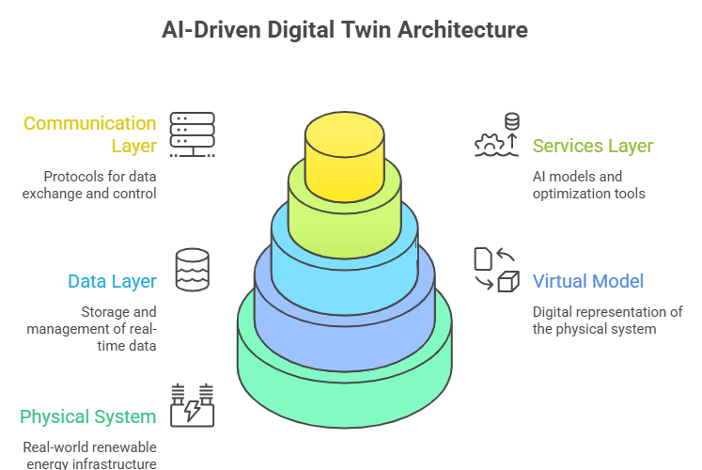
3. Collecting And Communicating Data
The value of a Digital Twin is only as great as the quality of the data it receives. Acquiring good, real-time data from the physical asset into the virtual replica is one of the significant engineering hurdles involved.
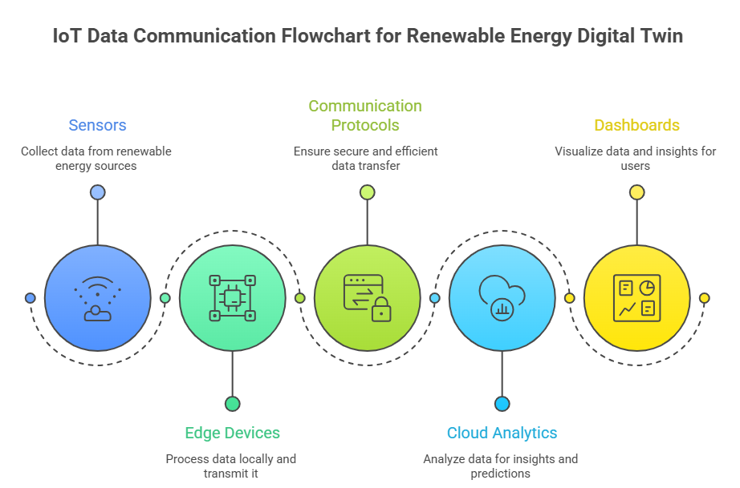
3.1 Sensors And IoT Devices
Solar plants contain devices that monitor light intensity, panel temperature, and electrical output at string or panel level. Cameras with edge computation monitor clouds and soiling of panels in real-time. Turbines have vibration sensors, strain gauges, oil quality sensors, and anemometers. These sources feed the Digital Twin an unending stream of real-time data.
3.2 Cloud Vs. Edge Computing
Not all data needs to go to the cloud for analysis before triggering action. There is a natural division: cloud resources suited for deep analysis and AI training, and local edge devices suited for real-time decision making. When a vibration sensor indicates sudden spikes in bearing vibration, an edge algorithm would trigger emergency shutdown of the turbine in milliseconds while also forwarding data for deeper root-cause analysis in the cloud.
3.3 Making Devices Work Together
A major practical problem is that energy plants consist of equipment from various manufacturers using diverse data formats. This is addressed by international standards:
IEC 61850: A power utility automation standard allowing devices to describe themselves in a standard format, making it easier for the Digital Twin to comprehend incoming data.
OPC UA: A generic translator for operation equipment to IT systems, handling complex data structures with strong security mechanisms.
MQTT: A lightweight protocol for resource-constrained sensors, widely used to transmit telemetry data from inverters and weather stations to cloud environments.
Common Information Model (CIM): Ensures a single piece of equipment is identified consistently across various software systems.

4. How AI Powers The Digital Twin
AI is what turns raw sensor data into actionable insight. Different types of AI are suited to different tasks.
4.1 Learning From Time-Series Data
Production of solar power and wind fluctuate immensely over time. LSTMs are capable of taking this data and have shown great skill in recognizing long-term trends such as seasonal shadows while ignoring short-term phenomena like cloud movement. A nearly perfect correlation between predictions and output power generation has been found using LSTM-based models. Utilizing a combined CNN-LSTM hybrid model can increase prediction accuracy by over 25%.
4.2 Visual Fault Detection
Drones are widely employed for inspection of solar farms, acquiring thousands of regular and thermal images. CNNs analyze these images automatically to identify defects such as hot spots, cracks, or soiling on solar panels. A trained CNN achieved 91.46% to 98.29% accuracy in defect detection. Similar methods apply to wind turbine monitoring, where vibration signals are converted into frequency images and analyzed by CNN to locate mechanical defects.
4.3 Ensemble Methods For Better Accuracy
Ensemble methods use multiple models instead of just one and therefore perform better. Common models for power prediction and fault type classification include Random Forest and XGBoost. CatBoost and XGBoost win most comparisons on solar forecasting, and XGBoost appears as a strong predictor for wind turbine fault diagnostics.
4.4 Combining Physics With Machine Learning
Physics-Informed Machine Learning incorporates physics equations into AI training. For example, when analyzing how air flows around a wind turbine blade, the appropriate aerodynamic equations are implemented in the AI's learning mechanism. This reduces the need for large training sets, allows better performance in unusual circumstances, and ensures outputs do not violate fundamental physics, instilling greater operator confidence.
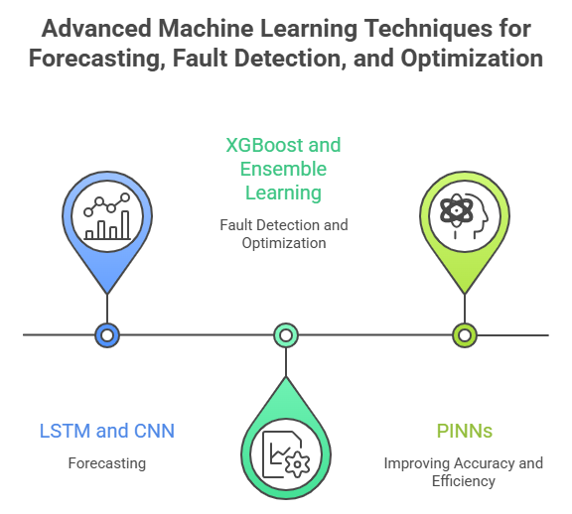

5. Monitoring Solar Power Plants
5.1 Comparing Expected Vs. Actual Output
At its very basic, the function of a Solar Digital Twin is to continually calculate how much power the plant should be generating given current weather conditions, and compare this to actual generation. If actual power is less than expected by more than an adjustable threshold, an alarm is generated. This identifies slowly deteriorating, subtle problems such as gradual panel degradation.
5.2 Diagnosing What's Wrong
When a problem is detected, the Digital Twin can typically diagnose what is causing it. AI classifiers distinguish between:
Temporary Shading: A brief drop in current matching the position of the sun and a nearby obstacle.
Soiling: A slow, gradual decline in efficiency that improves after rain or cleaning.
Electrical Faults: Sudden drops in voltage or current indicating blown fuses, open circuits, or degradation.
One study found AI-powered Digital Twins could classify fault types with an F1 score of 91.67%.
5.3 Forecasting Solar Output
Solar power can fluctuate extremely rapidly due to cloud movement. Digital Twin has forecasting results under different horizons: 15 minutes ahead for battery charge/discharge control; 24 hours ahead for energy market bidding. Using both CNN (analyzing satellite images) and LSTM (analyzing historical time series data) simultaneously has dramatically decreased forecasting error.

6. Wind Energy and Digital Twins
6.1 Monitoring Turbine Health
Wind turbines are robust mechanical machinery but experience continuous fatigue and strain. Vibration sensors on gearboxes and generators relay a constant flow of data to AI which detects initial signs of worn bearings, misaligned gears, or an unbalanced rotor. AI models build a "model of normal behavior," so when the gearbox starts producing a higher temperature than usual for a particular wind speed and load, an anomaly is flagged.
6.2 Structural Monitoring And Virtual Sensors
During its lifespan a wind turbine experiences cumulative fatigue damage. Commercial packages such as DNV's WindGEMINI make use of a detailed aero-elastic model to quantify usage of turbine design life according to operational history. The Digital Twin uses "virtual sensors" — AI-based models that predict blade loads from available data such as pitch angle and rotor speed, where physical sensors are difficult or expensive to implement.
6.3 Managing Wind Farm Wake Effects
Wind passing through a turbine creates a slower, more turbulent "wake" behind it, decreasing output of downstream turbines. Digital Twins can model these wake effects in real time, facilitating coordinated control. An upstream turbine can be slightly misaligned to deliberately direct its wake away from subsequent turbines, improving total farm output.

7. Combining Solar And Wind In Hybrid Systems
7.1 A Single Unified Platform
As hybrid renewable generation sites combining wind, solar, and battery storage become more common, a combined Digital Twin must integrate components operating on vastly different time scales — solar irradiance may vary on a second-by-second basis, while wind turbine gearbox temperatures change much more slowly. A single simulation platform can create the comprehensive site overview through to the grid connection.
7.2 Optimizing Battery Dispatch
The value of a hybrid site lies in complementary energy sources — it is typically more windy at night when solar power is unavailable. The Digital Twin can perform thousands of weather-based scenarios to create ideal charging and discharging strategies. One hybrid project in India by Siemens Gamesa, combining a 28.8 MW solar plant and 50 MW wind farm, found that the two could share transformers and transmission lines, optimizing both components via digital integration.
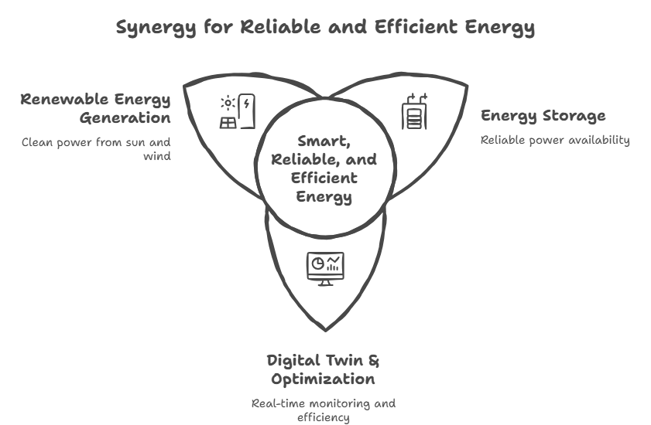

8. Real-World Examples
8.1 GE Renewable Energy: The Digital Wind Farm
GE generates a unique Digital Twin for each turbine in a wind farm, adjusting control parameters based on the precise wind conditions at that particular location. Tailoring control of each turbine individually increases annual energy production by as much as 20%. Their predictive maintenance software has claimed to have saved customers $1.6 billion by averting large breakdowns.
8.2 Siemens Gamesa: From Manufacturing To Operations
Siemens Gamesa's Digital Twins extend throughout the life of their turbines, back to manufacturing. The ALMA project Digital Twin simulates automated robotic carbon fiber lay-up for turbine blades to assure defect-free production. Upon installation, the operational fleet Digital Twin operates on Microsoft Azure, computing fatigue loading for thousands of turbines daily.
8.3 DNV WindGEMINI: Extending Asset Life
DNV's WindGEMINI is a vendor-neutral Digital Twin solution for structural integrity and life extension. Analyzing past operational data versus original design parameters, it determines exactly how much of the design life the turbine has used, providing owners with a factual basis for decisions regarding operation beyond the typical 20-year design life.
8.4 Academic Findings From University Of Sharjah
An extensive analysis of 42 highly cited papers has shown that AI-driven Digital Twins deliver 35% reduced unplanned downtime, 8.5% increased energy production, and 26.2% reduced energy costs.

9. Economic And Operational Benefits
9.1 Key Performance Improvements
Research across the industry shows consistent and significant benefits from adopting AI-driven Digital Twins:
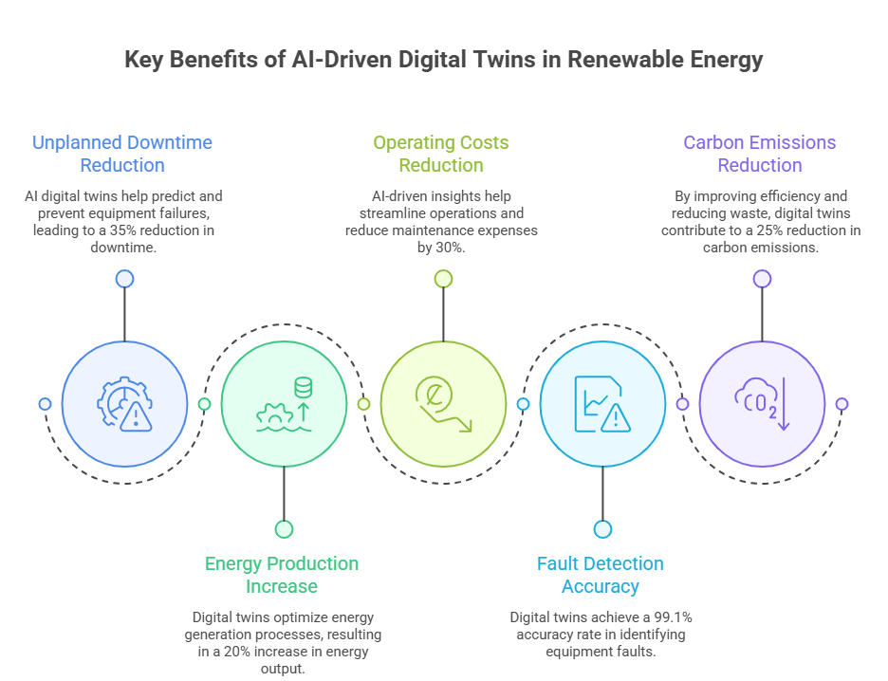

Table 1: Key Benefits Of AI-Driven Digital Twins In Renewable Energy
Benefit | Metric | Source
Unplanned downtime reduction | 35% | University of Sharjah meta-analysis
Energy production increase | 8.5% to 20% | GE Renewable Energy / academic studies
O&M cost reduction (wind) | 11% | Industry reports
Wind energy value increase | 20% | Google DeepMind
Fault classification accuracy | 91.46%–98.29% | CNN-based studies
CNN-LSTM prediction improvement | 25%+ | Hybrid model research
Carbon emission reduction | 15%–25% | Lifecycle studies

9.2 The Financial Case
The highest financial benefit is the switch from reactive to predictive maintenance. Predicting failures means components can be replaced during idle production times with normal shipment, lowering O&M costs on wind farms alone by 11%. Real-time fatigue loading monitoring means turbines can now last longer than 20 years, with considerable profit potential from older assets.
9.3 Grid-Level Benefits
Digital Twins also make renewable energy more valuable to the grid overall. Reduced forecasting error lessens the capacity reserves needed by grid operators. Google DeepMind was able to increase the commercial value of wind power by 20% through improved accuracy in 36-hour-ahead forecasts, allowing grid operators to make more accurate bids in the energy market.

10. Challenges And Barriers
10.1 Data Quality Issues
AI is only as smart as the data used to train it. Data formats from plants are incredibly diverse due to the mixture of legacy equipment with bespoke protocols alongside new standard-protocol devices. Absent timestamps, sensor drifts, and varied data quality create spurious alarms. Transforming data into a clear, uniform form prior to ingestion by the AI remains one of the biggest time-consuming steps.
10.2 Cybersecurity Risks
Because there is a bi-directional connection between the Digital Twin and the physical plant, compromise of commands going to the physical hardware must be considered. Encryption of commands, one-way links for observation-only data streams, and strict standards are recommended.
10.3 High Upfront Costs
The investment necessary to establish a high-fidelity Digital Twin can be substantial when it comes to computing resources, sophisticated 3D modelling, and potential retrofitting of older equipment with sensors. For smaller operators with thin margins, the initial outlay can be a significant hurdle.
10.4 Speed Vs. Accuracy Trade-Off
An accurate physics simulation of a wind farm could take many days to complete, making it useless for real-time control. Engineers use approximate AI surrogate models that mimic physics but run in milliseconds — engineering work balancing model speed with accuracy.

11. What's Coming Next
11.1 Generating Synthetic Failure Data
Well-maintained equipment rarely fails, meaning there is very little actual failure data to train AI fault-detection models. AI generating realistic fault data using Generative Adversarial Networks (GANs) for uncommon failure conditions means that diagnostic AI models can learn from fault types they may not have encountered before.
11.2 Physics-Informed Neural Networks
Physics-Informed Neural Networks (PINNs) embed physical laws within the neural network architecture, enabling precise simulation of intricate processes like wind turbine wakes using reduced amounts of sensor information. These are especially valuable in regions with scarce data.
11.3 The Fully Autonomous Plant
The ultimate vision is an autonomous renewable energy plant where the Digital Twin not only makes recommendations but performs actions — negotiating with the grid, booking maintenance robots, and constantly reconfiguring itself to maximize lifetime yield with minimal human interaction.
11.4 Natural Language Interfaces
Large Language Models will allow an operator to query "Why is production down in Sector 4?" and get an easy-to-understand, data-backed explanation. Augmented reality tools will enable technicians to visualize Digital Twin data overlaid on real-world equipment while in the field.

12. Implementation Framework
12.1 Assessing Readiness Before You Start
Before deploying a Digital Twin, organizations need to honestly assess their current situation. Key questions include:
• Does the plant have adequate sensor coverage?
• Are communication networks reliable and fast enough?
• Is there at least 2–5 years of clean historical data?
• Does the organization have skilled data scientists and OT/IT integration specialists?
Plants with outdated SCADA systems often need to be retrofitted before Digital Twin deployment makes sense. Without organizational readiness — the right people and management support — even technically sound projects tend to fail to scale.
12.2 A Phased Rollout Approach
A step-by-step approach reduces risk and builds confidence at each stage:
Monitoring Twin: Real-time dashboards, KPI visualization, basic data collection.
Diagnostic Twin: Fault classification, anomaly detection, root cause analysis.
Predictive Twin: Remaining useful life estimation, maintenance scheduling, output forecasting.
Prescriptive Twin: Automated optimization, market participation tools.
Autonomous Twin: Self-learning systems, closed-loop automation, minimal human intervention.
Most industrial plants today operate somewhere between stages 2 and 3.

13. People And Workforce
Digital Twins augment human intelligence rather than substituting it. Nevertheless, the jobs of many people change as Digital Twins are deployed: maintenance technicians become predictive analysts; field inspectors become AR-assisted engineers viewing digital overlays on reality; SCADA operators become system orchestrators. Ongoing training is needed in data interpretation, AI model validation, cybersecurity awareness, and human-AI teamwork. Explainable AI (XAI), whereby an AI clearly articulates why a recommendation was made, is an increasingly important aspect of Digital Twins.

14. Environmental And Societal Impact
Economic arguments are not the whole reason for using digital twins. The sustainability arguments also make using the technology worthwhile. As AI optimizes the plant, waste energy (curtailment) is reduced and there is less need to fire up backup fossil fuels. Studies predict reductions of 15–25% in carbon emissions over the lifecycle from implementation and optimization using a digital twin. The technology also enables water conservation and material savings, while guaranteeing a more robust grid for remote communities using hybrid renewable power plants.
15. The Road Ahead (2025–2040)
Over the next 15 years the road is set:
2025–2030: Wider IoT deployment, cloud migration, initial Digital Twin adoption across the industry, training programs.
2030–2035: Mainstreaming of physics-informed AI, autonomous maintenance adoption, maturity of hybrid solar-wind Digital Twin platforms.
2035–2040: Self-healing grids, AI-governed energy markets, carbon-negative facilities.
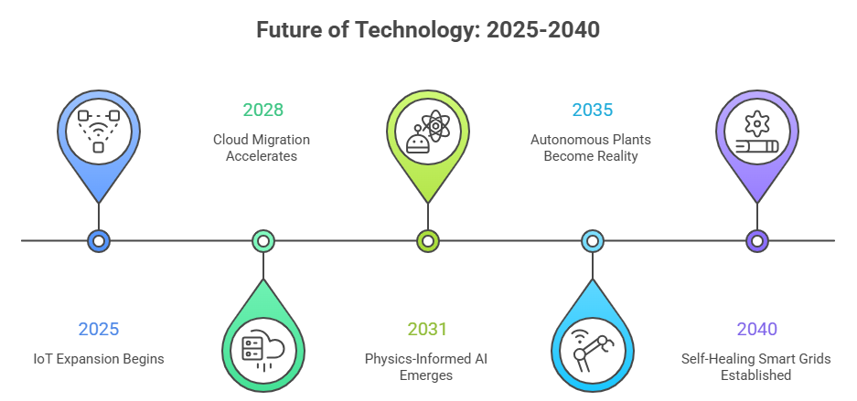
16. Conclusion
It is now evident that AI-driven Digital Twins are not just an interesting concept, but a critical part of the infrastructure for the effective operation of renewable energy systems today. This paper has outlined how it is a developed technology with a strong economic justification and proven operational advantages and is ready for full scale implementation.
The ground rules are set: robust networks of IoT sensors, cloud and edge compute, standardized communication protocols. Artificial Intelligence has reached a level where Deep Learning can provide output prediction and fault detection with levels of accuracy thought unthinkable 10 years ago. For large-scale plants the ROI — up to 30% operating cost decrease, 20% higher power production — makes the investment worthwhile.
Nevertheless, there are problems to be solved. Data quality and standardization are still important issues. Cybersecurity cannot be neglected. The initial investment costs are an obstacle for smaller players, and the increased autonomy of AI systems requires a human dimension for accountability, explainability, and human values.
Going forward, once self-evolving Digital Twins, multi-plant federated learning, and eventually fully autonomously running power plants occur, renewable energy systems will resemble smart ecosystems rather than mechanical systems. Solar panels, wind turbines, batteries and grid connections will form learning and adaptive units that constantly optimize in concert with each other.
To sum up, the application of AI-powered Digital Twins is a good solution for optimizing energy transition management and generating clean energy more economically and reliably to promote a sustainable future for society.

References
[1] E. Yalcin, et al., "Exploiting the digitalization of solar PV plants using machine learning: A digital twin approach for efficient operation," Journal of Renewable Energy Analytics, vol. 12, no. 4, 2023.
[2] "Digital twin in solar power plant market: Size, trends, and forecast (2023–2030)," Virtue Market Research, Jan. 2024.
[3] A. Fadel, et al., "Digital twin-based performance evaluation of a photovoltaic system for real-time monitoring and optimization," International Journal of Power Electronics and Drive Systems (IJPEDS), vol. 16, no. 3, 2025.
[4] T. Mane, et al., "Enhancing solar PV plant performance using digital twin technology: Integration of AI and data science for real-time analysis," ResearchGate, Mar. 2026.
[5] M. Luer, "A digital twin approach to address long-standing challenges in photovoltaic systems," Renewable Energy (MDPI), 2024.
[6] J. A. Smith and K. Roy, "Methods for solar power prediction," Energy Reports, 2023.
[7] R. Kumar and P. Patel, "IoT based monitoring in solar PV systems," IEEE Access, 2022.
[8] W. Chen and Y. Li, "Using deep learning for photovoltaic modules," Applied Energy, 2022.
[9] P. Singh and A. Verma, "Real time solar plant monitoring with AI models," International Journal of Energy Research, 2024.
[10] K. Sharma and V. Gupta, "Predicting solar output with hybrid machine learning," Journal of Cleaner Production, 2023.
[11] M. Brown and D. Wilson, "A cloud-based framework for digital twins in energy systems," IEEE Transactions on Industrial Informatics, 2022.
[12] S. Verma and N. Sharma, "Edge computing in smart energy systems," Future Generation Computer Systems, 2023.
[13] A. Khan and R. Ali, "Integrating AI and IoT for renewable energy," Sustainable Computing, 2024.
[14] D. Lee and S. Park, "CNN for image-based fault detection in solar panels," Energy AI, 2022.
[15] F. Ahmed and I. Qureshi, "Predictive maintenance using machine learning," Renewable Energy Focus, 2023.
[16] H. Chen, X. Zhao, and M. Li, "Digital twins in hybrid renewable systems: A review," Renewable and Sustainable Energy Reviews, 2022.
[17] R. Mehta and P. Shah, "AI-based forecasting in smart grids," IEEE Smart Grid Conference, 2023.
[18] N. Das and P. Roy, "Solar PV performance analysis with data analytics," Energy Procedia, 2022.
[19] V. Joshi and D. Singh, "Deep learning for fault classification in solar panels," Journal of Energy Storage, 2024.
[20] S. Gupta and A. Kumar, "Digital twins in renewable energy systems," Energy Strategy Reviews, 2023.
[21] International Energy Agency, "Solar PV Global Report," Paris, 2023.
[22] World Economic Forum, "Energy Transition Report," 2022.
[23] NITI Aayog, "Renewable Energy Outlook for India," Government of India, 2022.

