LAB MANUAL
of

INFORMATION SECURITY SYSTEMS LABORATORY

B. TECH (CSE) 6th SEMESTER SUBJECT CODE - CSDC 0334



SUBMITTED BY: SUBMITTED TO:
Name: Mansirat Kaur Name: Dr. Kunwar Pal
Roll Number: 23103090 GROUP: G5

DEPARTMENT OFCOMPUTER SCIENCE AND ENGINEERING DR. B.R. AMBEDKAR NATIONAL INSTITUTE OF TECHNOLOGY
JALANDHAR

INDEX

SNo. | Title | Page No. | Signature

Lab Assignment 1
Question 1. Write the program to find prime numbers between 1 to 1000 and also print count.

Code:
#include <iostream> #include <vector> using namespace std; int sieve(int n) {
vector<bool> isPrime(n + 1, true); isPrime[0] = isPrime[1] = false;

for (int i = 2; i * i <= n; i++) { if (isPrime[i]) {
for (int j = i * i; j <= n; j += i) { isPrime[j] = false;}} }
int count = 0;
for (int i = 2; i <= n; i++) { if (isPrime[i]) {
cout << i << " "; count++;} }
cout << endl; return count;
}
int main() {
int n = 1000;
cout << "Total primes = " << sieve(n) << endl;
}

Output:
Question 2. Write the program to implement matrix multiplication of 3*3 matrix.

Code:
#include <iostream> using namespace std; int main() {
int m, n, p;
cin >> m >> n >> p;
int A[m][n], B[n][p], C[m][p];

for(int i = 0; i < m; i++) for(int j = 0; j < n; j++)
cin >> A[i][j]; for(int i = 0; i < n; i++)
for(int j = 0; j < p; j++) cin >> B[i][j];
for(int i = 0; i < m; i++) for(int j = 0; j < p; j++)
C[i][j] = 0;
for(int i = 0; i < m; i++) { for(int j = 0; j < p; j++) {
for(int k = 0; k < n; k++) { C[i][j] += A[i][k] * B[k][j];
}}}
for(int i = 0; i < m; i++) { for(int j = 0; j < p; j++) {
cout << C[i][j] << " "; } cout << endl;}}

Output:
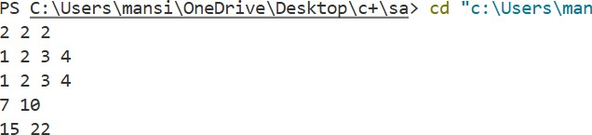
Question 3. Write the program to find the inverse of 3*3 Matrix.

Code:
#include <iostream> using namespace std; int main() {
int n;
cin >> n;
double A[n][2*n]; for(int i = 0; i < n; i++) {
for(int j = 0; j < n; j++) cin >> A[i][j];

for(int j = n; j < 2*n; j++) A[i][j] = (i == j-n);}
for(int i = 0; i < n; i++) { double diag = A[i][i]; if(diag == 0) {
cout << "Inverse does not exist"; return 0;
}
for(int j = 0; j < 2*n; j++) A[i][j] /= diag;
for(int k = 0; k < n; k++) { if(k != i) {
double factor = A[k][i]; for(int j = 0; j < 2*n; j++)
A[k][j] -= factor * A[i][j];
}}}
cout << "Inverse Matrix:\n"; for(int i = 0; i < n; i++) {
for(int j = n; j < 2*n; j++) cout << A[i][j] << " ";
cout << endl;
}}

Output:
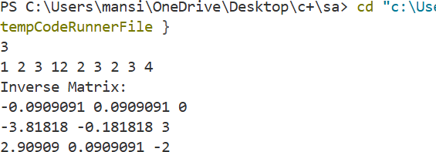

Lab Assignment 2

Question 1. Write a program to implement a substitution cipher.
SOURCE CODE:
#include <bits/stdc++.h>
using namespace std;
int main() {
string all_letrs = "abcdefghijklmnopqrstuvwxyzABCDEFGHIJKLMNOPQRSTUVWXYZ";
map<char, char> dict1; int key = 4;
for (int i = 0; i < all_letrs.length(); i++) {
dict1[all_letrs[i]]= all_letrs[(i + key) % all_letrs.length()];
}
string plain_txt = "I am studying Data Encryption"; string cipher_txt;

for (char& c : plain_txt) {
if (dict1.find(c) != dict1.end()) { cipher_txt += dict1[c];
}
else {
cipher_txt += c;
}}
cout << "Cipher Text is: " << cipher_txt << endl; map<char, char> dict2;
for (int i = 0; i < all_letrs.length(); i++) { dict2[all_letrs[i]]
= all_letrs[(i - key) % all_letrs.length()];
}
string decrypt_txt;
for (char& c : cipher_txt) {
if (dict2.find(c) != dict2.end()) { decrypt_txt += dict2[c];
}
else {
decrypt_txt += c;
}
}
cout << "Recovered plain text : " << decrypt_txt << endl; return 0;

OUTPUT:

Question 2. Write a program to implement a Frequency Analysis of given file.
SOURCE CODE:
#include <iostream>
#include <fstream>
#include <cctype>
#include <iomanip>
using namespace std;

int main() { ifstream file; string filename;
int freq[26] = {0}; char ch;
int totalLetters = 0;

cout << "Enter file name: "; cin >> filename;
file.open(filename); if (!file) {
cout << "Error opening file!" << endl;
return 0;
}

while (file.get(ch)) { if (isalpha(ch)) {
ch = tolower(ch); freq[ch - 'a']++; totalLetters++;
}
}

file.close();
cout << "\nLetter Frequency Analysis:\n"; cout << "Letter Count Percentage\n";

for (int i = 0; i < 26; i++) {
double percent = (totalLetters == 0) ? 0 : (freq[i] * 100.0) / totalLetters; cout << char('A' + i) << " "<< freq[i] << " "
<< fixed << setprecision(2) << percent << "%\n";
}return 0;
}
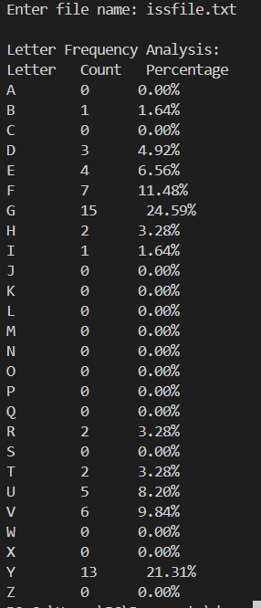
OUTPUT:

Question 3. Write a program to implement an affine cipher.
SOURCE CODE:
#include<bits/stdc++.h> using namespace std;

const int a = 17; const int b = 20;

string encryptMessage(string msg)
{
string cipher = "";
for (int i = 0; i < msg.length(); i++) { if(msg[i]!=' ')
cipher = cipher + (char) ((((a * (msg[i]-'A') ) + b) % 26) + 'A'); else
cipher += msg[i];
}
return cipher;}
int main(void)
{
string msg = "AFFINE CIPHER";

string cipherText = encryptMessage(msg);
cout << "Encrypted Message is : " << cipherText<<endl;
return 0;
}
OUTPUT:

