**Request-Response Cycle :**

Request :

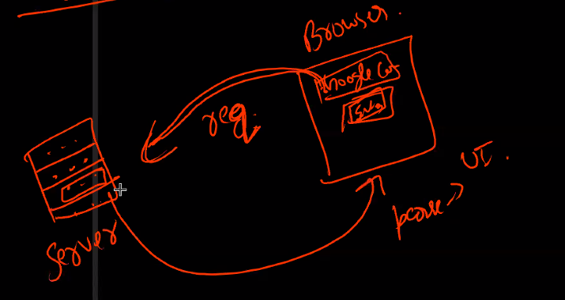

* Browser send request to server than server response browser with parsing and shows in UI form on your screen

*we can pass function as a argument of a function -- it is called call back*

* install request npm from google :-

**[** how to install :

* search request npm on google check install command and paste it on terminal
* than copy code of how to use request command in node paste it in vs code **]**

**callback :**

* file read karvani hoy ane ani size large hoy to aagal ni lines read thati nathi code ma ane time waste thai 6e
* to callback function no use karine a file last ma read thai sake 6e

syntax :

(without callback/callafter input )

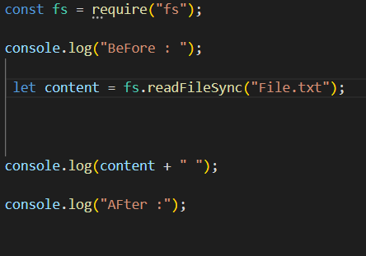

(without callback/callafter output )

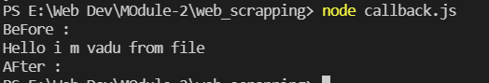

(with callback/callafter input )

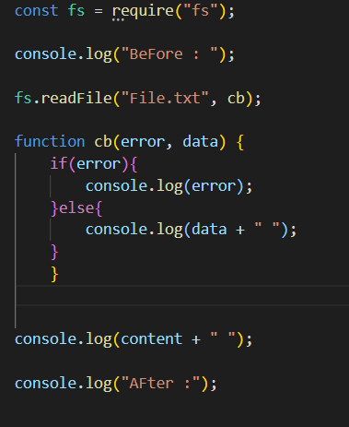

(with callback/callafter output )

