Stacked Ensembles Versus a Single Gradient-Boosted Model for Sepsis Outcome Prediction: A Controlled and Explainable Replication on MIMIC-IV and eICU
Mansoob-e-Zahra, Ijaz Hussain
Department of Computer and Information Sciences
PIEAS
Nilore, Islamabad, Pakistan
ijazhussain@pieas.edu.pk

Abstract: Sepsis risk models must be discriminative and well calibrated. Stacked ensembles are proposed for sepsis outcome prediction from Electronic Health Record (EHR) data, but are seldom compared with a single model on identical folds, with equal per-model tuning and a stated meta-learner. We replicate the EHR-ML stacking framework on MIMIC-IV (2,545 episodes) and eICU (12,688 ICU stays) sepsis cohorts and re-test it on identical patient-grouped cross-validation folds, reporting paired differences with Nadeau–Bengio corrected 95% confidence intervals. With the original meta-learner, eXtreme Gradient Boosting (XGBoost) at library defaults, the stack scores 2.7 to 3.9 Area Under the Receiver Operating Characteristic Curve (AUROC) points (3.2% to 4.9%) below a single XGBoost model, is significantly worse in 17 of 22 settings and is poorly calibrated (calibration slope 0.30 to 0.55). With a regularized or equally tuned meta-learner, the stack is not significantly different from the comparably configured single model in 39 of 44 comparisons (two meta-learners in 22 settings), worse in 5 and never significantly better, also with more diverse base learners or without early deaths. Landmark length-of-stay tasks reach AUROC 0.77 to 0.80, against 0.94 to 0.95 with the original 7-day window, which overlaps the outcome and covers all patients, and leak-free SHapley Additive exPlanations (SHAP) selection keeps AUROC within 0.2 points with 30 features. In the tested implementation, the stacking penalty reflects the untuned meta-learner rather than stacking itself; stacked models should report and regularize their meta-learner and be compared with a single well-configured model.
Index Terms: sepsis, electronic health records, stacked generalization, meta-learner, model calibration, explainable AI, SHAP, MIMIC-IV, eICU
I. Introduction
Sepsis is a life-threatening organ dysfunction caused by a dysregulated host response to infection, and it remains one of the leading causes of morbidity and mortality among critically ill patients worldwide [1], so accurate and well-calibrated risk stratification early in an Intensive Care Unit (ICU) or hospital stay is a valuable aid to clinical decisions.
Early approaches relied on bedside severity scores such as the Simplified Acute Physiology Score II (SAPS II) [2], which combine a small set of physiological and laboratory variables into one risk estimate. These scores are transparent, but their fixed form limits discrimination compared with what full Electronic Health Record (EHR) data allow. The release of large critical-care databases such as MIMIC-IV [3] and eICU [4] moved the field toward supervised machine learning, and gradient-boosted trees, most often eXtreme Gradient Boosting (XGBoost) [5], are now a common choice for sepsis-related mortality prediction on these data [6]. Several studies combine multiple base learners into stacked ensembles [7], [8]. In parallel, SHapley Additive exPlanations (SHAP) [9] are widely used to explain such models on sepsis outcomes [6], [10].
Three gaps can undermine such comparisons: a stacked ensemble and a single model may be evaluated on different folds or tuning budgets without reporting the meta-learner; calibration is often omitted; and length-of-stay feature windows or feature-selection rankings can overlap the outcome period or the test folds.
This paper replicates the EHR-ML framework, a two-layer stacked ensemble whose Level-1 base learners (XGBoost, logistic regression, LightGBM [11] and a Multilayer Perceptron (MLP)) feed a Level-2 meta-learner, on MIMIC-IV and eICU sepsis cohorts, and re-tests its central design choice under a controlled protocol. We contribute: (1) a comparison of stacking and single models on identical folds with five Level-2 options, an equal per-model tuning budget and four Level-1 rosters; (2) calibration analysis with Expected Calibration Error (ECE) and calibration slope; (3) sensitivity analyses for cohort size, early deaths, feature coverage and preprocessing; (4) leakage-safe landmark length-of-stay (LOS) tasks; and (5) SHAP explainability with fold stability and leak-free feature selection.
In a controlled re-implementation, the stacking penalty comes from the default XGBoost meta-learner of the original pipeline rather than from stacking itself, and no stacking variant significantly outperforms a single XGBoost model.
II. Related Work
Severity scores such as SAPS II [2] and the Sequential Organ Failure Assessment (SOFA) score are transparent, but data-driven models often discriminate better: an XGBoost model outperformed conventional scoring systems for 28-day mortality in sepsis-induced coagulopathy [10], and interpretable gradient-boosted models predict early sepsis mortality [12].
On MIMIC-IV and eICU, gradient-boosted trees are often combined with SHAP to identify drivers of mortality; in sepsis-associated acute kidney injury, an XGBoost model validated on eICU ranked lactate and respiratory rate among its main predictors [6]. Stacked ensembles gave the best discrimination among the models compared in one study [8], whereas in a multicenter study stacked and single gradient-boosted models reached similar internal discrimination [13]. Two recent scoping reviews describe the wide range of models, features and evaluation choices in machine-learning sepsis prediction [14], [15].
Unlike these studies, we compare stacking with a single model on identical folds under the same configuration or tuning budget, name the meta-learner, and report calibration and corrected confidence intervals with discrimination.
III. Materials and Methods
Fig. 1 summarizes the replicated pipeline (left) and the analyses added in this study (right).

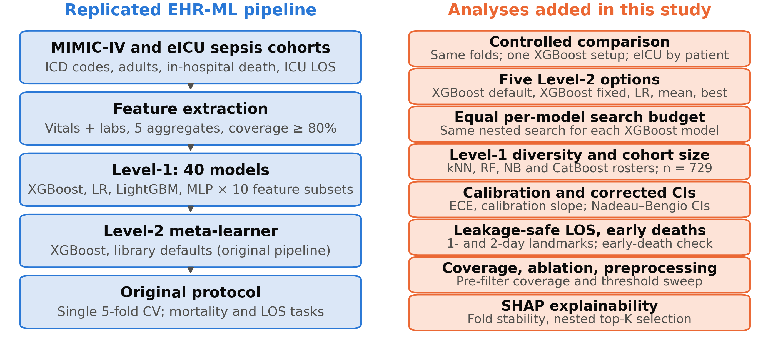
Fig. 1. The replicated EHR-ML pipeline (left) and the analyses added in this study (right). CV: cross-validation; LR: logistic regression; kNN: k-nearest neighbors; RF: random forest; NB: naive Bayes; CI: confidence interval.

A. Data, Cohorts and Prediction Windows
We used MIMIC-IV v3.1 [3], from a single U.S. teaching hospital, and eICU v2.0 [4], a multicenter database, both obtained through PhysioNet under credentialed access. Adult sepsis episodes were identified with the International Classification of Diseases (ICD) codes of the original EHR-ML study [16] (ICD-9 995.91, 995.92, 785.52; ICD-10 A41.9, R65.20, R65.21; eICU: the ICD-9 codes). In MIMIC-IV we kept admissions with sepsis as the principal diagnosis, the first ICU stay per admission, ICU admission within 48 h of hospital admission and the first sepsis admission per patient, which gave 2,545 episodes from 2,545 patients (in-hospital mortality 27.9%), 3.5 times the 729 episodes of [16]. eICU gave 12,688 ICU stays from 10,842 patients (mortality 22.4%). All mortality outcomes are in-hospital death at any time during the admission. MIMIC-IV mortality is predicted from vitals and laboratory values recorded in the first 24 h after hospital admission (2,533 episodes with data) and eICU mortality from the first 72 h of the ICU stay (12,677 stays from 10,835 patients). The 24 h and 72 h refer only to the feature window, not to a prediction horizon; we write MIMIC-IV mortality (24 h data) and eICU mortality (72 h data). Patients who die inside the feature window remain in the cohort (19.9% of MIMIC-IV and 43.4% of eICU deaths), so a model can use measurements taken shortly before death; the tasks measure discrimination from early-admission data, not early warning, and Section III-D tests excluding these deaths. eICU death is a hospital discharge status of Expired; 104 stays with no recorded status are treated as survivors, as in the replicated pipeline, and are checked separately. LOS tasks use MIMIC-IV only and predict an ICU stay longer than 7 or 14 days at a landmark t: features come only from the first t days of the ICU stay, and only patients still in the ICU at t are included (t = 2: 1,470 episodes, prevalence 31.9% and 11.6%; t = 1: 2,067 episodes, 22.7% and 8.2%).
B. Replicated Pipeline and Original Protocol
Vitals and laboratory values in the observation window are aggregated with five statistics (mean, minimum, maximum, first and last value), giving ten feature subsets; values are clipped at the 1st and 99th percentiles, and features recorded in fewer than 80% of episodes are removed (120 features for MIMIC-IV mortality, 55 for eICU, 120 and 145 for the 1- and 2-day LOS landmarks, where coverage was computed on all 2,545 episodes before the landmark restriction). Level-1 trains XGBoost, logistic regression (LR), LightGBM and an MLP on each subset (40 models) with inner 5-fold out-of-fold predictions, and a Level-2 meta-learner combines their probabilities, following stacked generalization [7]. The original pipeline, which we first ran as published with a single 5-fold cross-validation (CV), tuned XGBoost by stepwise grid search (3-fold) on one reference subset (vitals mean) inside each training fold and reused these values for every subset and for LightGBM; LR was grid-searched, the MLP was fixed (two hidden layers of twice the number of inputs, early stopping), and the meta-learner was XGBoost with library defaults (100 trees, depth 6, learning rate 0.3), without tuning. Median imputation was fitted within folds.
C. Controlled Comparison
We use three evaluation protocols and label every result with one of them. P1 is the original protocol (single 5-fold CV, tuned Level-1, default meta-learner; Section IV-A only). P2 is the controlled protocol used for all other results unless stated otherwise: identical outer folds (5-fold CV repeated three times, 15 paired scores per method) and fixed model configurations (Table I, the ablation and the coverage sweep). P3 is P2 with an equal per-model nested search budget for every XGBoost (Section IV-B). In eICU all splits, outer and inner, including every hyperparameter search, are grouped by patient, so no patient contributes to both the data used to fit a model and the data used to evaluate it. In P2, every XGBoost model, whether single, Level-1 or Level-2, uses one fixed configuration (150 trees, depth 3, learning rate 0.05, row and column subsampling 0.8), taken from the standalone model of the original pipeline. Level-1 LR (C = 1), LightGBM (same values) and MLP (two hidden layers of 32 units, early stopping) are also fixed, and Level-1 out-of-fold predictions come from 3-fold inner CV within each training fold. On identical Level-1 outputs we compare five Level-2 options: the default XGBoost meta-learner of the original pipeline, the fixed-configuration XGBoost, LR on logit-transformed probabilities, the unweighted mean of Level-1 outputs, and the best Level-1 model chosen inside the training fold. We call the fixed-configuration XGBoost and LR meta-learners regularized, since both constrain Level-2 capacity relative to the defaults. The reference is a single XGBoost on all features. We report the Area Under the Receiver Operating Characteristic Curve (AUROC), the Area Under the Precision-Recall Curve (AUPRC), ECE with 10 equal-width bins [17], and the calibration slope and calibration-in-the-large from logistic recalibration of the outcome on the logit of the prediction in each test fold. Paired differences are given with Nadeau–Bengio corrected 95% confidence intervals (CIs) [18], which account for overlapping training sets; a difference whose CI excludes zero is called significant. CIs are not adjusted for multiple comparisons, so we rely on patterns that repeat across tasks and settings.
D. Robustness Analyses
Equal per-model search budget: in each outer training fold the single XGBoost, the Level-1 XGBoost (tuned on the reference subset, reused for all subsets and passed to LightGBM, as in the original pipeline) and the Level-2 XGBoost each received the same nested random search of 20 configurations over discrete grids (100 to 500 trees, depth 2 to 6, learning rate 0.01 to 0.1, row and column subsampling, minimum child weight, L2 penalty; 3-fold inner CV), and LR C was grid-searched on the reference subset and on the Level-1 outputs. This equalizes the search per XGBoost model, not the total computational budget: with several tuned models and a fixed MLP, the stack received more search in total than the single model. Level-1 diversity: besides the original roster we used a diverse roster that replaces LightGBM with k-nearest neighbors (kNN), random forest (RF) and Gaussian naive Bayes (NB), and two rosters with CatBoost [19] (150 iterations, depth 4, learning rate 0.05) as a fifth learner or in place of the MLP; standalone CatBoost was also scored. The tuning, roster and CatBoost analyses cover the four main tasks; the 1-day landmark uses the original roster with fixed configurations. Cohort size: the comparison was repeated on ten stratified subsamples of 729 MIMIC-IV episodes, each with three repeats. Early deaths: the comparison was repeated after removing episodes with in-hospital death inside the feature window (140 MIMIC-IV episodes and 1,230 eICU stays). Ablation: the single XGBoost was retrained with vitals only, laboratory values only, mean aggregates only and without clipping. Coverage: the threshold was swept from 50% to 90% on unclipped matrices built without the 80% filter (eICU: with a 50% pre-filter). Software: Python 3.10 with scikit-learn 1.7.2 [20], XGBoost 2.1.4, LightGBM 4.7.0, CatBoost 1.2.10 and SHAP 0.49.1.
E. Explainability and Feature Selection
Two SHAP [9] analyses are kept separate. The descriptive global importance (Section IV-D) uses one fixed-configuration XGBoost fitted on each full cohort, with mean |SHAP| (log-odds) over all its rows; it is not used for feature selection. Rank agreement between cohorts was measured with Spearman correlation over the 55 features present in both matrices. Stability and selection use P2 folds with two repeats (10 folds, eICU grouped by patient): in each training fold an XGBoost is fitted on the full training data, features are ranked by mean |SHAP| on 600 training rows drawn at random (fixed seed, both cohorts), and the Jaccard overlap of the top-20 sets is computed across folds. XGBoost is then retrained on the top 10, 20, 30 and 40 features of that fold and scored on the held-out fold, so the ranking never sees test data.
IV. Results
A. Replication Under the Original Protocol
Under the original protocol P1 (single 5-fold CV, folds not grouped by patient), the stack reached AUROC 0.813 on MIMIC-IV mortality (24 h data), against 0.85 reported in [16] on a different, 729-episode cohort (4.3% lower), and 0.828 on eICU mortality (72 h data). The original LOS results (AUROC 0.946 and 0.918) used a 7-day feature window chosen by maximum AUROC, which overlaps the outcome period; they are replaced by the landmark tasks in Section IV-C.

TABLE I. Controlled Comparison (Protocol P2): AUROC Difference From the Single XGBoost Model (Points, 95% Nadeau–Bengio CI) and ECE
Method | MIMIC-IV mortality (24 h data) |  | eICU mortality (72 h data) |  | LOS>7 (day-2 landmark) |  | LOS>14 (day-2 landmark)
 | ΔAUROC, points (95% CI) | ECE | ΔAUROC, points (95% CI) | ECE | ΔAUROC, points (95% CI) | ECE | ΔAUROC, points (95% CI) | ECE
Single XGBoost (AUROC) | 0.834 (ref.) | 0.039 | 0.853 (ref.) | 0.020 | 0.782 (ref.) | 0.055 | 0.795 (ref.) | 0.036
Stack, default XGBoost meta* | −3.26 (−5.38, −1.14) | 0.120 | −2.71 (−3.51, −1.91) | 0.066 | −3.87 (−7.27, −0.46) | 0.175 | −3.25 (−7.36, +0.86) | 0.092
Stack, fixed-config. XGBoost meta | −0.51 (−1.84, +0.82) | 0.037 | −0.32 (−0.82, +0.17) | 0.017 | −1.58 (−4.30, +1.15) | 0.064 | −0.21 (−3.58, +3.17) | 0.041
Stack, LR meta | −0.16 (−1.22, +0.90) | 0.040 | −0.27 (−0.67, +0.13) | 0.018 | −0.53 (−2.76, +1.69) | 0.071 | +0.44 (−3.08, +3.97) | 0.041
Mean of Level-1 outputs | +0.02 (−0.60, +0.65) | 0.081 | −1.97 (−2.57, −1.38) | 0.104 | −1.42 (−3.38, +0.54) | 0.092 | −0.47 (−2.99, +2.05) | 0.063
Best Level-1 model | −6.20 (−8.31, −4.08) | 0.044 | −5.96 (−6.86, −5.07) | 0.020 | −1.57 (−4.00, +0.87) | 0.046 | −0.50 (−4.48, +3.49) | 0.028
P2: 15 paired scores per method (5-fold CV repeated 3 times; eICU splits grouped by patient); one fixed XGBoost configuration for all models; original Level-1 roster; eICU: 12,677 stays; LOS tasks: MIMIC-IV at the 2-day landmark. *Meta-learner of the original pipeline. A negative difference means the method is worse than the single XGBoost.

B. Stacking Versus a Single Model
Table I gives the controlled comparison. With the default meta-learner the stack is 2.7 to 3.9 AUROC points below the single XGBoost model (3.2% to 4.9% relative), with CIs excluding zero on three of four tasks, and it is poorly calibrated: ECE 0.066 to 0.175 against 0.020 to 0.055, calibration slope 0.30 to 0.55 against 0.80 to 1.15, and calibration-in-the-large +0.32 to +1.17, so its predictions are too extreme and, on average, too low. Replacing only the meta-learner removes most of the gap: with LR the difference is −0.5 to +0.4 points and with the fixed-configuration XGBoost −1.6 to −0.2 points, all CIs including zero, and ECE (0.017 to 0.071) is close to that of the single model; the mean and best-model combiners do not beat it (Table I). AUPRC leads to the same conclusions (on LOS>7 the fixed-configuration XGBoost meta-learner also loses 4.2 AUPRC points, CI excluding zero).
When every XGBoost receives the same per-model search budget (P3), tuning changed the single model's AUROC by +0.2 to +1.2 points, significantly only on eICU (AUROC 0.837 on MIMIC-IV and 0.856 on eICU). The tuned stacks were not significantly different on MIMIC-IV (−0.02 and +0.45 points) or on either LOS task, but were 0.9 (CI −1.4 to −0.4) and 0.7 points (CI −1.1 to −0.3) lower on eICU, and the default meta-learner remained 2.9 to 6.5 points lower on every task. Against the untuned single model, the tuned LR stack was +0.8 points better on MIMIC-IV (CI excluding zero), but it was not significantly better than the tuned single model.
Over all 22 task, roster and tuning settings, the default meta-learner was significantly worse than the single model in 17 and never better (2.0 to 6.5 points lower). The two regularized or tuned meta-learners, each against the single model of the same protocol, were not significantly different in 39 of 44 comparisons, significantly worse in 5 and never significantly better; the losses were eICU under P3 (−0.9 and −0.7 points), LOS>7 at the 1-day landmark (−2.6 and −3.2) and the diverse roster with an LR meta-learner on LOS>7 (−2.6). The diverse roster lowered the correlation between algorithms on the same subset (MIMIC-IV 0.90 to 0.83) without making any stack better, and standalone CatBoost was not significantly different from XGBoost on any of six tasks (−0.7 to +0.6 points). At n = 729 (ten draws) the regularized stacks averaged −0.8 and −1.3 points (no draw excluding zero) and the default meta-learner −3.0 (one draw excluding zero); this size is underpowered. Removing deaths inside the feature window lowered single-model AUROC to 0.800 (MIMIC-IV) and 0.772 (eICU) and also lowered prevalence, suggesting that early deaths are comparatively easy to predict, but the comparison was unchanged: the default meta-learner remained 3.7 and 4.7 points lower, and the regularized stacks were within 0.7 points (only the fixed-configuration XGBoost on eICU, −0.6, had a CI excluding zero). Excluding the 104 eICU stays without a recorded discharge status also left the comparison unchanged (single XGBoost 0.853; default meta-learner −2.8 points; regularized −0.3 and −0.2, CIs including zero).
C. Leakage-Safe Length of Stay
At the 2-day landmark the single XGBoost reached AUROC 0.782 for LOS>7 and 0.795 for LOS>14 (AUPRC 0.598 and 0.352; prevalence 31.9% and 11.6%); the 1-day landmark gave 0.778 and 0.768. In the original five-repeat runs, the same model with the 7-day window reached 0.952 and 0.938. This gap mixes removed post-landmark information with a different population (patients still in the ICU), so it is not a pure leakage estimate; on a fixed population, however, stacked AUROC for LOS>7 rose steadily from 0.763 (1-day window) to 0.946 (7-day window), as expected when the window overlaps the outcome.

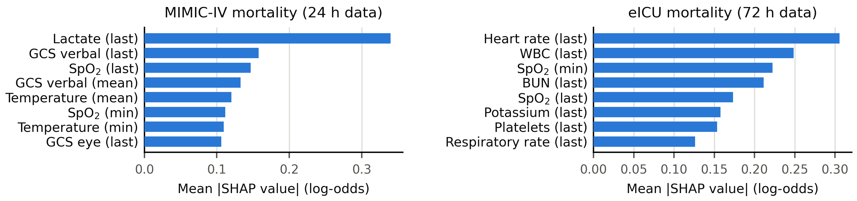
Fig. 2. Top 8 features by mean |SHAP value| for the fixed-configuration XGBoost fitted on each full cohort (descriptive, not used for selection): MIMIC-IV mortality (24 h data, left) and eICU mortality (72 h data, right).

D. Explainability
Fig. 2 shows global SHAP importance. On MIMIC-IV the last lactate value dominates (mean |SHAP| 0.34), followed by the last Glasgow Coma Scale (GCS) verbal score and peripheral oxygen saturation (SpO₂); on eICU the last heart rate leads (0.31), followed by white-blood-cell count. Rank agreement over the 55 shared features is moderate (Spearman ρ = 0.51, 95% CI 0.28 to 0.68), and the two cohorts use different window anchors (hospital versus ICU admission). Top-20 sets are moderately stable across training folds on MIMIC-IV (mean Jaccard 0.61) and more stable on eICU (0.85). With nested selection, 30 features stay within 0.2 points of the full set on both cohorts (CIs including zero); 20 features lose 0.4 points on MIMIC-IV (CI including zero) and 0.3 on eICU (CI excluding zero), and 10 features lose 2.3 and 1.4 points.
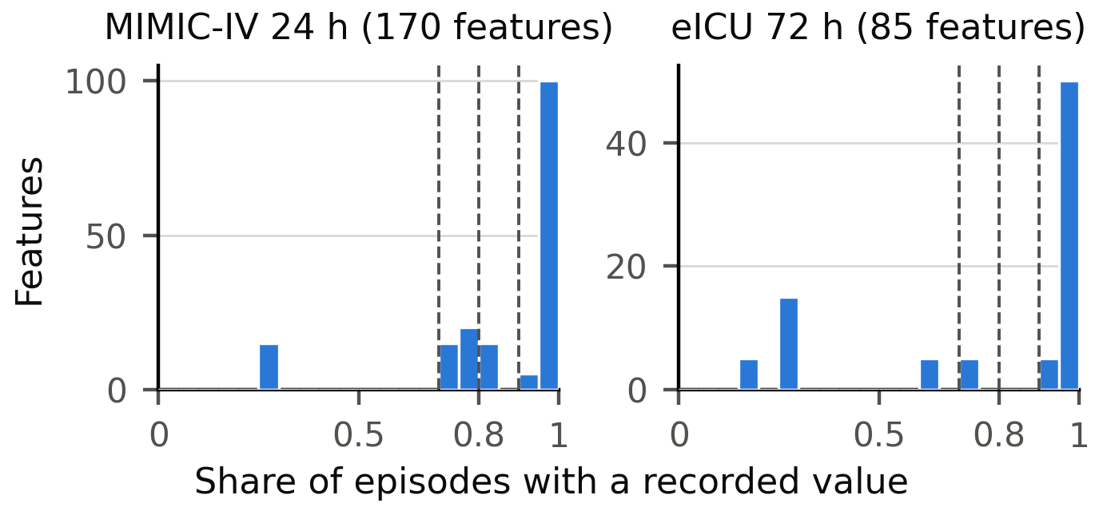
Fig. 3. Per-feature coverage before filtering for the MIMIC-IV 24 h and eICU 72 h feature windows; dashed lines mark 70%, 80% and 90%.
E. Ablation, Preprocessing and Feature Coverage
In the ablation (P2), keeping only vitals lowered AUROC by 3.4 and 6.1 points on the mortality tasks and by 2.9 points on LOS>7 (CIs excluding zero), with a smaller, non-significant loss on LOS>14 (1.6 points). Keeping only laboratory values lowered AUROC on every task (4.6 to 7.2 points), and using mean aggregates alone lowered it by 0.7 to 6.0 points. Removing clipping changed AUROC by at most 0.2 points (all CIs including zero).
Fig. 3 shows feature coverage before filtering: 10 of 85 eICU features have 60% to 80% coverage and all 55 retained ones at least 90%. Lowering the eICU threshold to 70% (60 features) or 60% (65 features) raised AUROC by +0.3 and +0.6 points (CIs +0.1 to +0.4 and +0.4 to +0.9), while on MIMIC-IV the 70% and 90% thresholds changed AUROC by +0.3 and −0.8 points with CIs including zero. The 80% default is adequate for MIMIC-IV and slightly conservative for eICU.
V. Discussion
The controlled comparison does not support the first analysis's claim that stacking itself limits performance. The large, consistent loss appears with the default XGBoost meta-learner (100 trees, depth 6, learning rate 0.3), whose inputs are strongly correlated; its calibration slope well below one indicates over-confident predictions, consistent with overfitting at Level-2. With LR or the fixed-configuration XGBoost the stack is not significantly different from the single model in most settings, but it was never significantly better, even with less correlated base learners, a matched per-model tuning budget or CatBoost. The original pipeline also tuned its Level-1 models, which we did not re-run with other meta-learners, so our attribution applies to the controlled re-implementation.
In these cohorts a single well-configured gradient-boosted model was an adequate, simpler choice; other cohorts, feature sets and stacking designs need external testing. A stacked alternative should report its meta-learner, regularize or tune it with the same per-model budget as the baseline, and be compared on the same folds with calibration.
VI. Limitations
Sepsis was identified from ICD codes, as in [16], rather than by Sepsis-3 criteria [1], and the data did not pass through the original EHR-QC pipeline with the Observational Medical Outcomes Partnership Common Data Model (OMOP-CDM), which may explain the gaps in Section IV-A, consistent with the limited transportability of clinical prediction models [21], [22]. The controlled comparison used fixed Level-1 configurations except in the P3 analysis; clipping thresholds and coverage filters were computed on the full matrix (neither uses the outcome, and removing clipping did not change AUROC). The cohort-size analysis and LOS tasks used MIMIC-IV only, and all results are retrospective and internal.
VII. Conclusion
This study replicated the EHR-ML stacked ensemble for sepsis mortality and length-of-stay prediction on MIMIC-IV and eICU and re-tested it on identical folds with corrected confidence intervals. In a controlled re-implementation, the 2.7 to 3.9 point AUROC loss and the poor calibration of the stack were produced by its default XGBoost meta-learner; with a regularized or per-model-tuned meta-learner the stack was not significantly different from a comparably configured single XGBoost model in most settings and was never significantly better. Future work will validate these results through the EHR-QC/OMOP-CDM pipeline and on external, multi-institutional data.
References
[1] M. Singer et al., "The Third International Consensus Definitions for Sepsis and Septic Shock (Sepsis-3)," JAMA, vol. 315, no. 8, pp. 801–810, 2016.
[2] J.-R. Le Gall, S. Lemeshow, and F. Saulnier, "A new Simplified Acute Physiology Score (SAPS II) based on a European/North American multicenter study," JAMA, vol. 270, no. 24, pp. 2957–2963, 1993.
[3] A. E. W. Johnson et al., "MIMIC-IV, a freely accessible electronic health record dataset," Scientific Data, vol. 10, no. 1, art. 1, 2023.
[4] T. J. Pollard et al., "The eICU Collaborative Research Database, a freely available multi-center database for critical care research," Scientific Data, vol. 5, art. 180178, 2018.
[5] T. Chen and C. Guestrin, "XGBoost: A scalable tree boosting system," in Proc. 22nd ACM SIGKDD Int. Conf. Knowledge Discovery and Data Mining, San Francisco, CA, USA, 2016, pp. 785–794.
[6] S. Chen, J. Fan, E. Pishgar, K. Alaei, G. Placencia, and M. Pishgar, "Machine learning-based prediction of ICU mortality in sepsis-associated acute kidney injury patients using MIMIC-IV database with validation from eICU database," arXiv:2502.17978, 2025.
[7] D. H. Wolpert, "Stacked generalization," Neural Networks, vol. 5, no. 2, pp. 241–259, 1992.
[8] X. Liu, H. Niu, and J. Peng, "Improving predictions: Enhancing in-hospital mortality forecast for ICU patients with sepsis-induced coagulopathy using a stacking ensemble model," Medicine, vol. 103, no. 14, art. e37634, 2024.
[9] S. M. Lundberg and S.-I. Lee, "A unified approach to interpreting model predictions," in Advances in Neural Information Processing Systems 30 (NeurIPS), 2017, pp. 4765–4774.
[10] S. Zhou et al., "Interpretable machine learning model for early prediction of 28-day mortality in ICU patients with sepsis-induced coagulopathy: development and validation," Eur. J. Med. Res., vol. 29, no. 1, art. 14, 2024.
[11] G. Ke, Q. Meng, T. Finley, T. Wang, W. Chen, W. Ma, Q. Ye, and T.-Y. Liu, "LightGBM: A highly efficient gradient boosting decision tree," in Advances in Neural Information Processing Systems 30 (NeurIPS), 2017, pp. 3146–3154.
[12] Y. Wang, Z. Gao, Y. Zhang, Z. Lu, and F. Sun, "Early sepsis mortality prediction model based on interpretable machine learning approach: development and validation study," Intern. Emerg. Med., vol. 20, no. 3, pp. 909–918, 2025.
[13] J. Lei, J. Zhai, Y. Zhang, J. Qi, and C. Sun, "Supervised machine learning models for predicting sepsis-associated liver injury in patients with sepsis: development and validation study based on a multicenter cohort study," J. Med. Internet Res., vol. 27, art. e66733, 2025.
[14] S. Rawat, H. Shanmugam, and L. Airen, "Machine learning and deep learning models for early sepsis prediction: a scoping review," Indian J. Crit. Care Med., vol. 29, no. 6, pp. 516–524, 2025.
[15] S. Bomrah, M. Uddin, U. Upadhyay, M. Komorowski, J. Priya, E. Dhar, S.-C. Hsu, and S. Syed-Abdul, "A scoping review of machine learning for sepsis prediction: feature engineering strategies and model performance, a step towards explainability," Crit. Care, vol. 28, art. 180, 2024.
[16] Y. Ramakrishnaiah, N. Macesic, G. I. Webb, A. Y. Peleg, and S. Tyagi, "EHR-ML: A data-driven framework for designing machine learning applications with electronic health records," International Journal of Medical Informatics, vol. 196, art. 105816, 2025.
[17] C. Guo, G. Pleiss, Y. Sun, and K. Q. Weinberger, "On calibration of modern neural networks," in Proc. 34th Int. Conf. Machine Learning (ICML), 2017, pp. 1321–1330.
[18] C. Nadeau and Y. Bengio, "Inference for the generalization error," Machine Learning, vol. 52, no. 3, pp. 239–281, 2003.
[19] L. Prokhorenkova, G. Gusev, A. Vorobev, A. V. Dorogush, and A. Gulin, "CatBoost: Unbiased boosting with categorical features," in Advances in Neural Information Processing Systems 31 (NeurIPS), 2018, pp. 6638–6648.
[20] F. Pedregosa et al., "Scikit-learn: Machine learning in Python," J. Mach. Learn. Res., vol. 12, pp. 2825–2830, 2011.
[21] B. Van Calster, E. W. Steyerberg, L. Wynants, and M. van Smeden, "There is no such thing as a validated prediction model," BMC Med., vol. 21, art. 70, 2023.
[22] A. A. H. de Hond, V. B. Shah, I. M. J. Kant, B. Van Calster, E. W. Steyerberg, and T. Hernandez-Boussard, "Perspectives on validation of clinical predictive algorithms," npj Digit. Med., vol. 6, art. 86, 2023.

