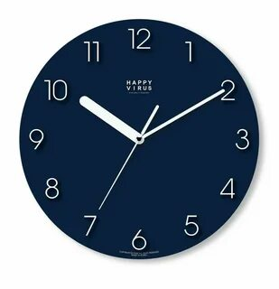 **Clocks**

Details

**Analog-Clock**

MPM Quality Blue Silver Wall Clock - Design Wall Clock 3D Large Numbers Wall Clock Blue Modern 30cm Office

Rs. 7896

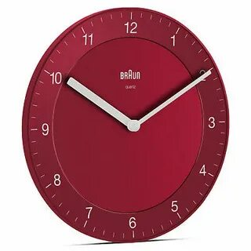 **Clocks**

Details

**Analog-Clock**

BC06W wall clock has an easy-to-read dial layout and a timeless design, honouring Rams's 10 principles.

Rs. 4567

 **Clocks**

Details

**Analog-Clock**

Blue wall clock with luxurious gold roman numerals arrives ready to hang for easy decorating or gift giving.

Rs. 9693

 **Clocks**

Details

**Analog-Clock**

This is a minimalist analog wall clock with a white face. It has bold black markers and slim teal hands.

Rs. 7865

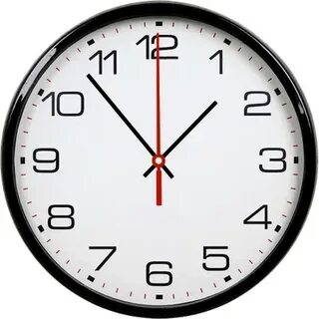 **Clocks**

Details

**Analog-Clock**

A classic wall clock with bold black numbers, black hands, and a red second hand on a white face.

Rs. 5689

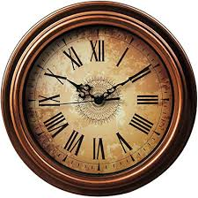**Clocks**

Details

**Analog-Clock**

A vintage clock with a bronze frame, Roman numerals, and ornate black hands.

Rs. 8798

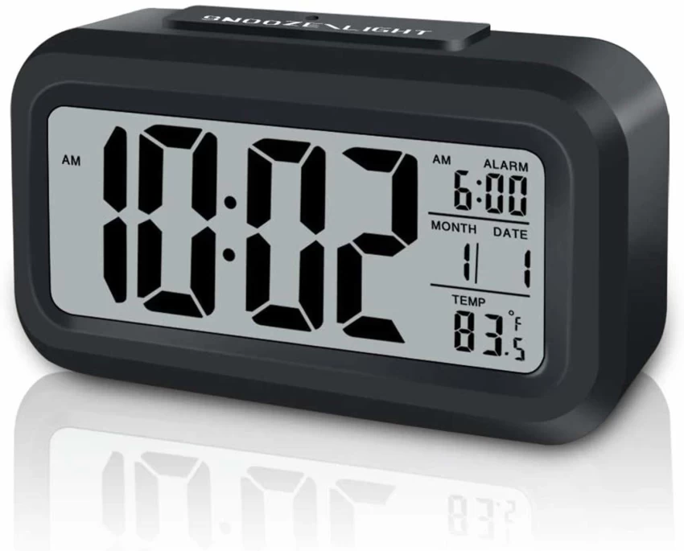**Clocks**

Details

**Digital-Clock**

A Mini Music Digital Alarm Clock with Backlight Temperature Week Month Date Display Snooze Desktop Table Clocks 12/24H LED Clock

Rs. 8456

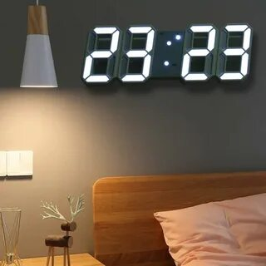

**Clocks**

Details

**Digital-Clock**

1pc Led 3d Wall Clock, Standing Timepiece for Living Room Decoration

Rs. 3658

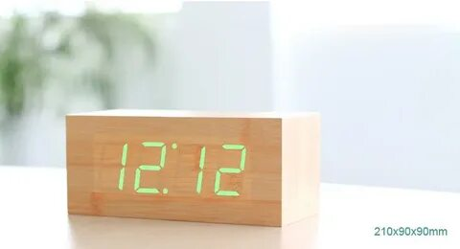**Clocks**

Details

**Digital-Clock**

Led Wooden Alarm Clock Voice Control Digital Clock with Temperature Date Display for Bedroom Living Room Home Decor Gift

Rs. 4568

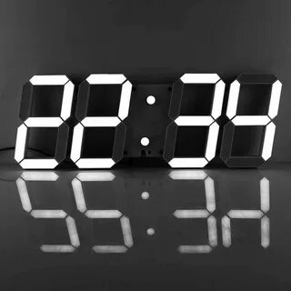**Clocks**

Details

**Digital-Clock**

3D LED Wall Clock 6'' digits Remote Control Digital Timer Nightlight Watch Alarm Clock for Warehouse Office Home Living Room

Rs.6565

**Clocks**

Details

**Digital-Clock**

Wall-clock Clock LED Living Room Wall Clock Simple Electronic Clock Digital Clock Wall Clocks(C)

Rs. 8895

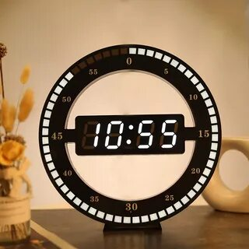**Clocks**

Details

**Digital-Clock**

3D LED Digital Wall Clock Electronic Night Glow Round Wall Clocks Automatically Adjust Brightness Desktop Clock EU Plug

Rs. 1269

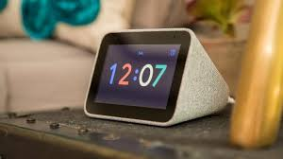

**Clocks**

Details

**Smart-Clock**

Lenovo Revealed Simplified Google Assistant-Powered Smart Clock

Rs. 7845

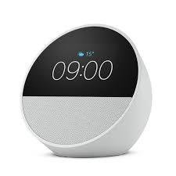**Clocks**

Details

**Smart-Clock**

Amazon Echo Spot Smart Alarm Clock Speaker with Alexa Glacier White 2024 Release

Rs. 9162

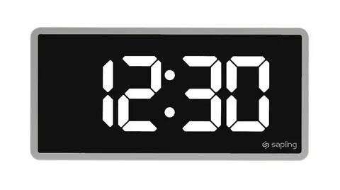**Clocks**

Details

**Smart-Clock**

Double-Sided Led 3d Technology Luminous Smart Electronic Mute Wall Clock Temperature Date Multi-Function Jump Second Clock

Rs. 8374

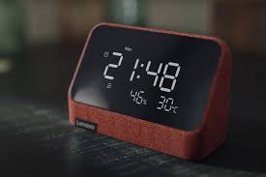**Clocks**

Details

**Smart-Clock**

Introducing Lenovo Smart Clock Essential with Alexa Built-in at CES 2022

Rs. 7365

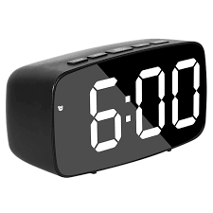**Clocks**

Details

**Smart-Clock**

TFUFR LED Digital Alarm Clock with Temperature Calendar Date Snooze Adjustable Brightness Voice Control

Rs. 6431

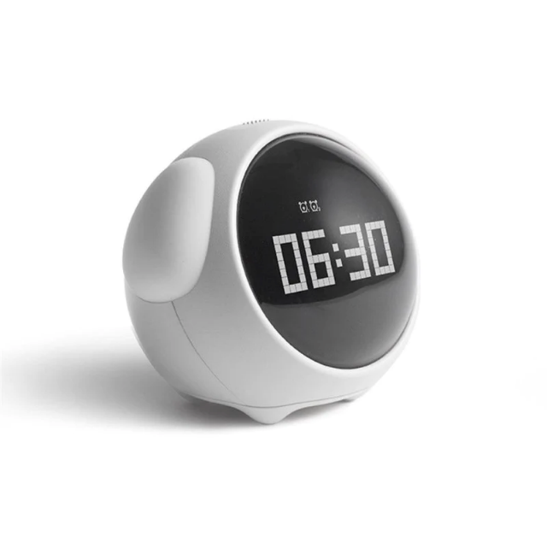**Clocks**

Details

**Smart-Clock**

Cute Multifunction Electronic Digital Emoticon Kids Gift Alarm Clock Led Night Wake Up Light Table Clock Bedroom Decoration

Rs.9456