**Men’s Watch**

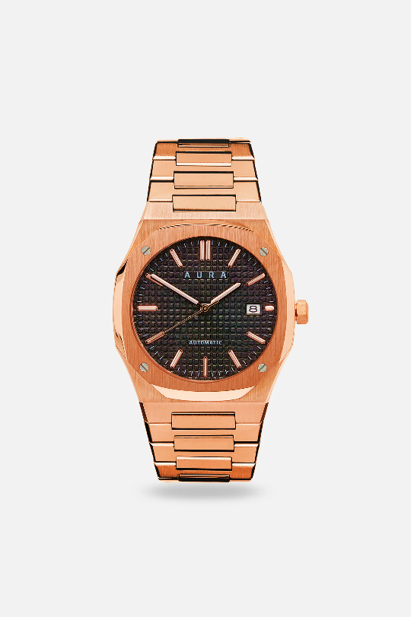Details

**Analog -Watch**

The Aura Date 41mm stands out as our most classic design, embodying sophistication and luxury with its timeless elegance. For a more relaxed style, it can easily be matched with an FKM strap.

Rs.50,400.00

**Men’s Watch**

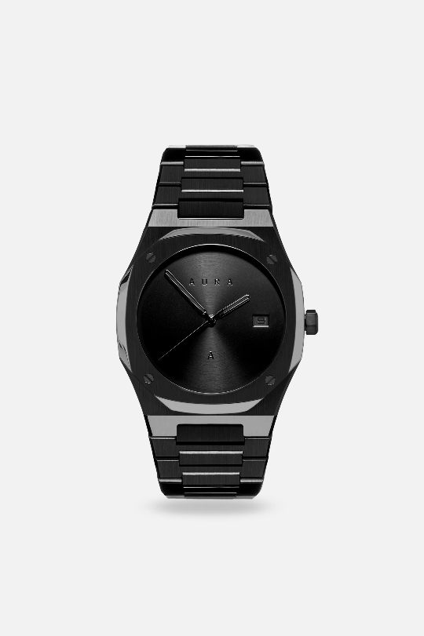Details

**Analog -Watch**

Introducing the Skeleton 001: Black, a masterpiece of modern watch design. This timepiece is distinguished by its captivating self-winding transparent skeleton movement, which offers a mesmer.

Rs.103,700.00

**Men’s Watch**

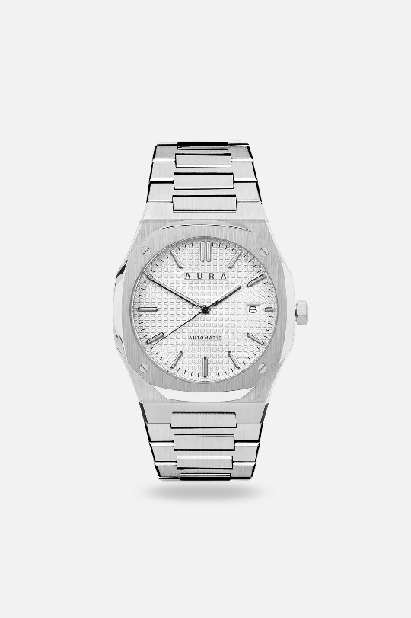Details

**Analog -Watch**

The Aura Date stands out as our most classic design, embodying sophistication and luxury with its timeless elegance. For a more relaxed style, it can easily be matched with an FKM strap.

Rs.88,900.00

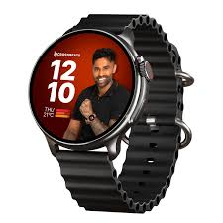**Men’s Watch**

Details

**Digital-Watch**

CrossBeats Aura Round 1.46" Super AMOLED Smart Watch, Always On, Advanced AI ENC Bluetooth Calling, in-Built Games, Fast Charge, Rotating Crown, 123+ Sports Modes, 454 × 454 Pixel (Black, Black)

22,800.00

**Men’s Watch**

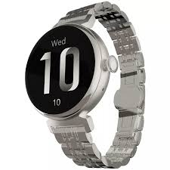Details

**Digital-Watch**

Introducing the Skeleton 001: Black, a masterpiece of modern watch design. This timepiece is distinguished by its captivating self-winding transparent skeleton movement, which offers a mesmer.

35,600.00

**Men’s Watch**

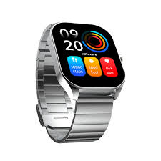Details

**Digital-Watch**

The Aura Date stands out as our most classic design, embodying sophistication and luxury with its timeless elegance. For a more relaxed style, it can easily be matched with an FKM strap.

Rs.19,500.00

**Women’s Watch**

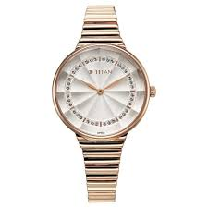Details

**Analog-Watch**

CrossBeats Aura Round 1.46" Super AMOLED Smart Watch, Always On, Advanced AI ENC Bluetooth Calling, in-Built Games, Fast Charge, Rotating Crown, 123+ Sports Modes, 454 × 454 Pixel (Black, Black)

28,500.00

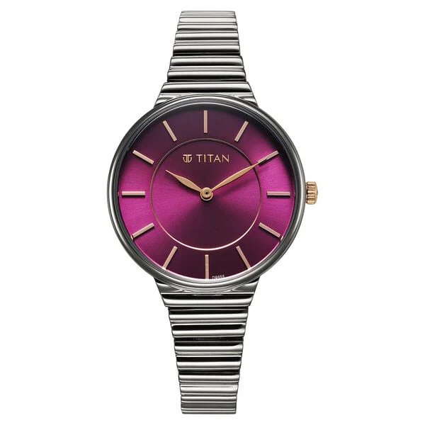**Women’s Watch**

Details

**Analog-Watch**

Introducing the Skeleton 001: Black, a masterpiece of modern watch design. This timepiece is distinguished by its captivating self-winding transparent skeleton movement, which offers a mesmer.

39,800.00

**Women’s Watch**

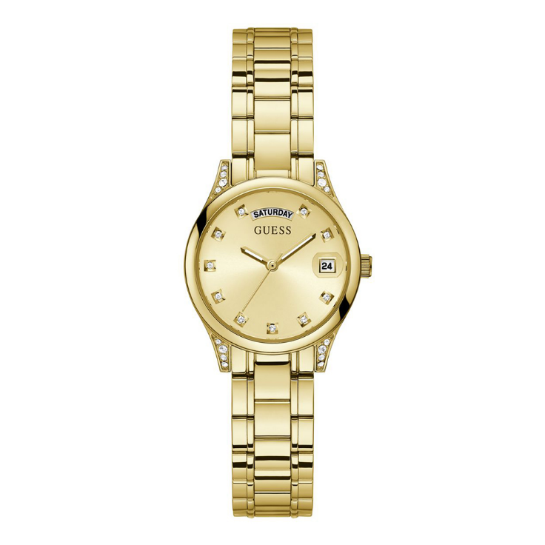Details

**Analog-Watch**

The Aura Date stands out as our most classic design, embodying sophistication and luxury with its timeless elegance. For a more relaxed style, it can easily be matched with an FKM strap.

Rs.13,700.00

**Women’s Watch**

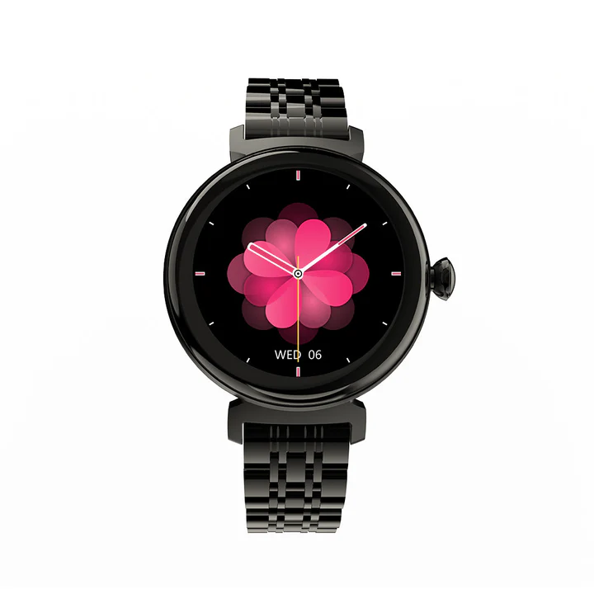Details

**Digital-Watch**

CrossBeats Aura Round 1.46" Super AMOLED Smart Watch, Always On, Advanced AI ENC Bluetooth Calling, in-Built Games, Fast Charge, Rotating Crown, 123+ Sports Modes, 454 × 454 Pixel (Black, Black)

Rs17,500

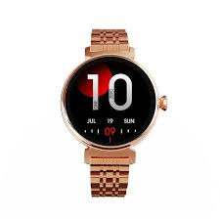**Women’s Watch**

Details

**Digital-Watch**

Introducing the Skeleton 001: Black, a masterpiece of modern watch design. This timepiece is distinguished by its captivating self-winding transparent skeleton movement, which offers a mesmer.

19,800.00

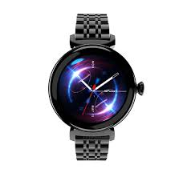**Women’s Watch**

Details

**Digital-Watch**

The Aura Date stands out as our most classic design, embodying sophistication and luxury with its timeless elegance. For a more relaxed style, it can easily be matched with an FKM strap.

Rs.22,700.00

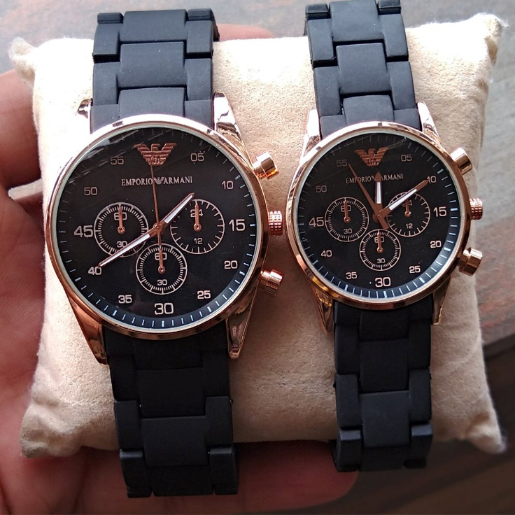**Couple Watch**

Details

**Analog-Watch**

A 1-pair set for ladies and gents features a rubber strap with a clip lock, a stainless-steel dial, and is water-resistant. It comes in a free gift box.

Rs17,500

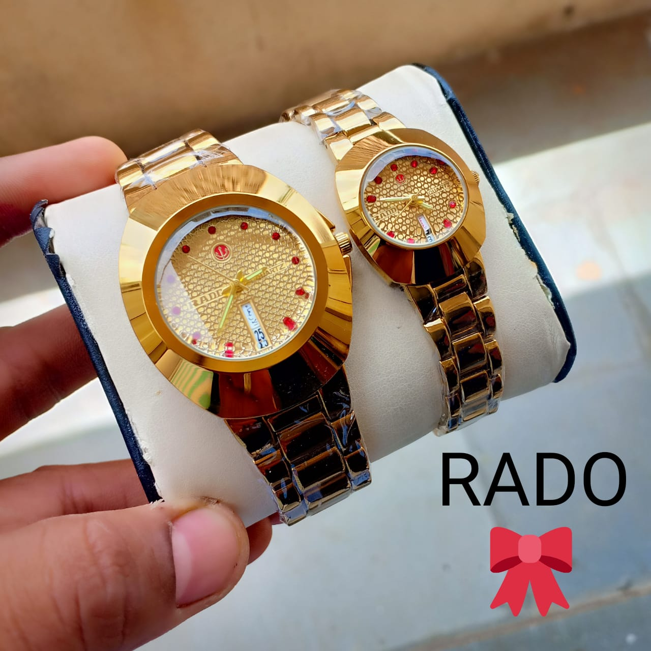**Couple Watch**

Details

**Analog-Watch**

The RADO Couple Watches feature a golden finish, scratch-resistant sapphire crystal, water resistance, and luminous hands, combining elegance and durability for any occasion.

19,800.00

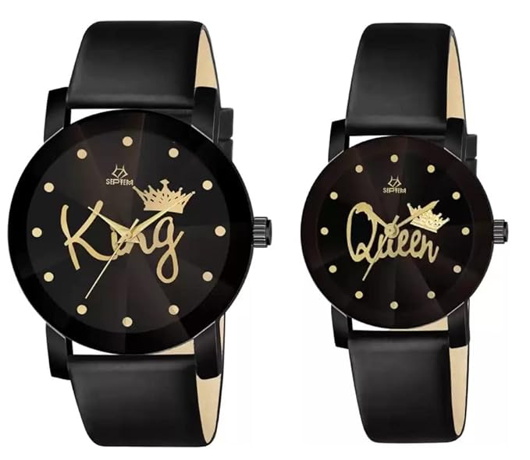**Couple Watch**

Details

**Analog-Watch**

The JOSSYFY Unisex Couple Watches are beautifully designed and inspired by the timeless King and Queen theme. This set symbolizes elegance and unity.

Rs.22,700.00