# COMSATS UNIVERSITY ISLAMABAD

# Attock Campus



Department Of Computer Science

|  |  |
| --- | --- |
| **Course** | Data Structure |
| **Instructor** | Muhammad Kamran |
| **Assignment No** | 02 |
| **Program** | BS-(SE) |
| **Semester** | 04 |

**Submitted From:**

|  |  |
| --- | --- |
| **Name** | **Registration No** |
| Mansoor Ahmad | FA23-BSE-037 |

CODE:

#include <iostream>

using namespace std;

struct Patient {

string name;

int priority;

};

Patient patients[100];

int total = 0;

void addPatient() {

Patient p;

cout << "Enter patient name: ";

cin >> p.name;

cout << "Enter emergency level (1 = High, 2 = Medium, 3 = Low): ";

cin >> p.priority;

int i = total - 1;

while (i >= 0 && patients[i].priority > p.priority) {

patients[i + 1] = patients[i];

i--;

}

patients[i + 1] = p;

total++;

cout << "Patient added successfully!\n";

}

void treatPatient() {

if (total == 0) {

cout << "No patients to treat.\n";

return;

}

cout << "Treating: " << patients[0].name << " (Priority: " << patients[0].priority << ")\n";

for (int i = 1; i < total; i++) {

patients[i - 1] = patients[i];

}

total--;

}

void showPatients() {

if (total == 0) {

cout << "No patients in the queue.\n";

return;

}

cout << "\nCurrent Patients in Queue:\n";

for (int i = 0; i < total; i++) {

cout << i + 1 << ". " << patients[i].name << " (Priority: " << patients[i].priority << ")\n";

}

}

int main() {

int choice;

do {

cout << "\n--- Hospital Menu ---\n";

cout << "1. Add Patient\n";

cout << "2. Treat Patient\n";

cout << "3. Show Patients\n";

cout << "4. Exit\n";

cout << "Enter choice: ";

cin >> choice;

if (choice == 1) {

addPatient();

} else if (choice == 2) {

treatPatient();

} else if (choice == 3) {

showPatients();

} else if (choice == 4) {

cout << "Goodbye!\n";

} else {

cout << "Invalid choice.\n";

}

} while (choice != 4);

return 0;

}

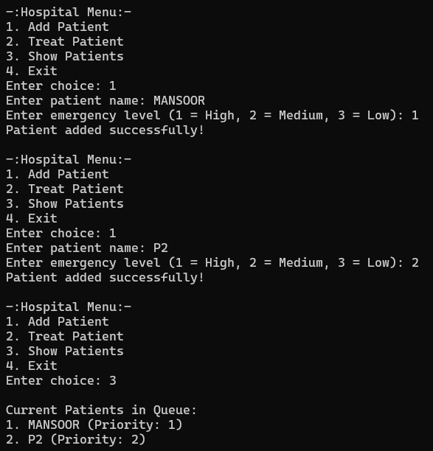OUTPUT:

