ASG Airlines
End-to-End Data Engineering Case Study

Documentation submitted for NeoStats Data Engineering Internship - Use Case Round
Submitted by: M M Mohamed Mansoor
GitHub repo: https://github.com/Mansoor4123/neostats-usecase

1. Introduction
ASG Airlines operates flights across multiple Indian cities and collects operational data through its booking platforms, scheduling systems, and airport logs. This data, however, contains real-world quality issues: corrupted flight identifiers, missing values, inconsistent time formats, and unhandled overnight flight scenarios.
This document describes the end-to-end pipeline built to ingest, clean, standardize, and transform the raw operational data into an analytics-ready dataset, protect sensitive passenger information, and present the results through an interactive Power BI dashboard.

1.1 A note on the dataset
The written problem statement describes only the columns of the flights table (flight_id, airline, source, destination, departure_time, arrival_time). However, the actual workbook provided contains four related sheets - flights, bookings, payments, and passengers - connected through flight_id, booking_id, and passenger_id. Since all four tables were part of the data actually provided, all four were used throughout this pipeline rather than treating flights in isolation. This allowed for a richer set of KPIs (revenue, cancellation rate, payment behaviour) and a more realistic relational data model.

2. Dataset Overview
The source data consists of four related tables:
Table | Rows | Key Columns
flights | 1,020 | flight_id, airline, source, destination, departure_time, arrival_time
bookings | 1,000 | booking_id, passenger_id, flight_id, booking_date, status, passport_number
payments | 1,000 | payment_id, booking_id, amount, payment_method
passengers | 1,039 | passenger_id, first_name, last_name, age, gender, email, phone, aadhaar_id, date_of_birth

All four tables were verified byte-for-byte against the original Excel workbook before being uploaded for processing, ensuring no data was altered or lost during file conversion.

3. Architecture
The problem statement lists Azure Data Factory, Synapse, and Databricks as acceptable Azure tools ('Preferred: Azure (ADF / Synapse / Databricks)'). Databricks alone was chosen as the single processing engine for this pipeline, for the following reasons:
- A single Databricks notebook can perform ingestion, cleaning, transformation, and export - covering the full pipeline without needing a separate orchestration tool.
- Azure Data Factory's primary value is scheduling and orchestrating recurring pipeline runs, which was not required for this one-time batch processing use case.
- Synapse's primary value is large-scale SQL warehousing, which was not required since the final Gold tables are exported directly to Power BI.
- Databricks runs on Apache Spark, a distributed processing engine - meaning the same code that processed ~5,000 rows here would scale to a cluster processing millions of rows without being rewritten.

3.1 Storage access approach
Direct access to Azure Data Lake Storage using a storage account key was attempted first, but Databricks Serverless Compute restricts this type of raw credential-based access for security and governance reasons. Unity Catalog Volumes were used instead - Databricks' own recommended pattern for bringing files into a workspace, which avoids managing storage keys directly inside notebook code.
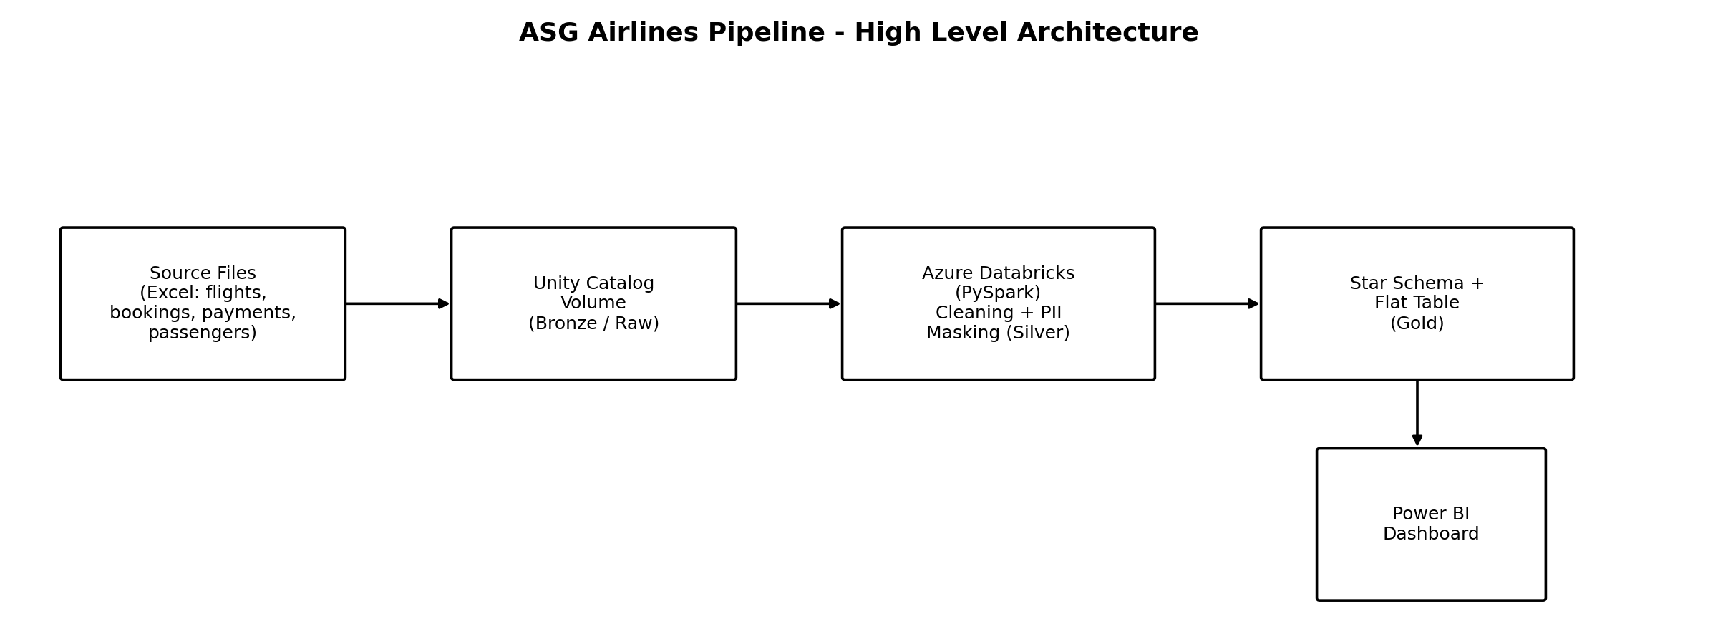
Figure 1: High-level pipeline architecture (Bronze -> Silver -> Gold -> Power BI)

4. Data Flow
The pipeline follows a standard Bronze / Silver / Gold layering. Bronze holds the raw files exactly as provided. Silver applies cleaning rules table by table. Gold contains a proper star schema plus one flattened table built specifically for easy Power BI consumption.
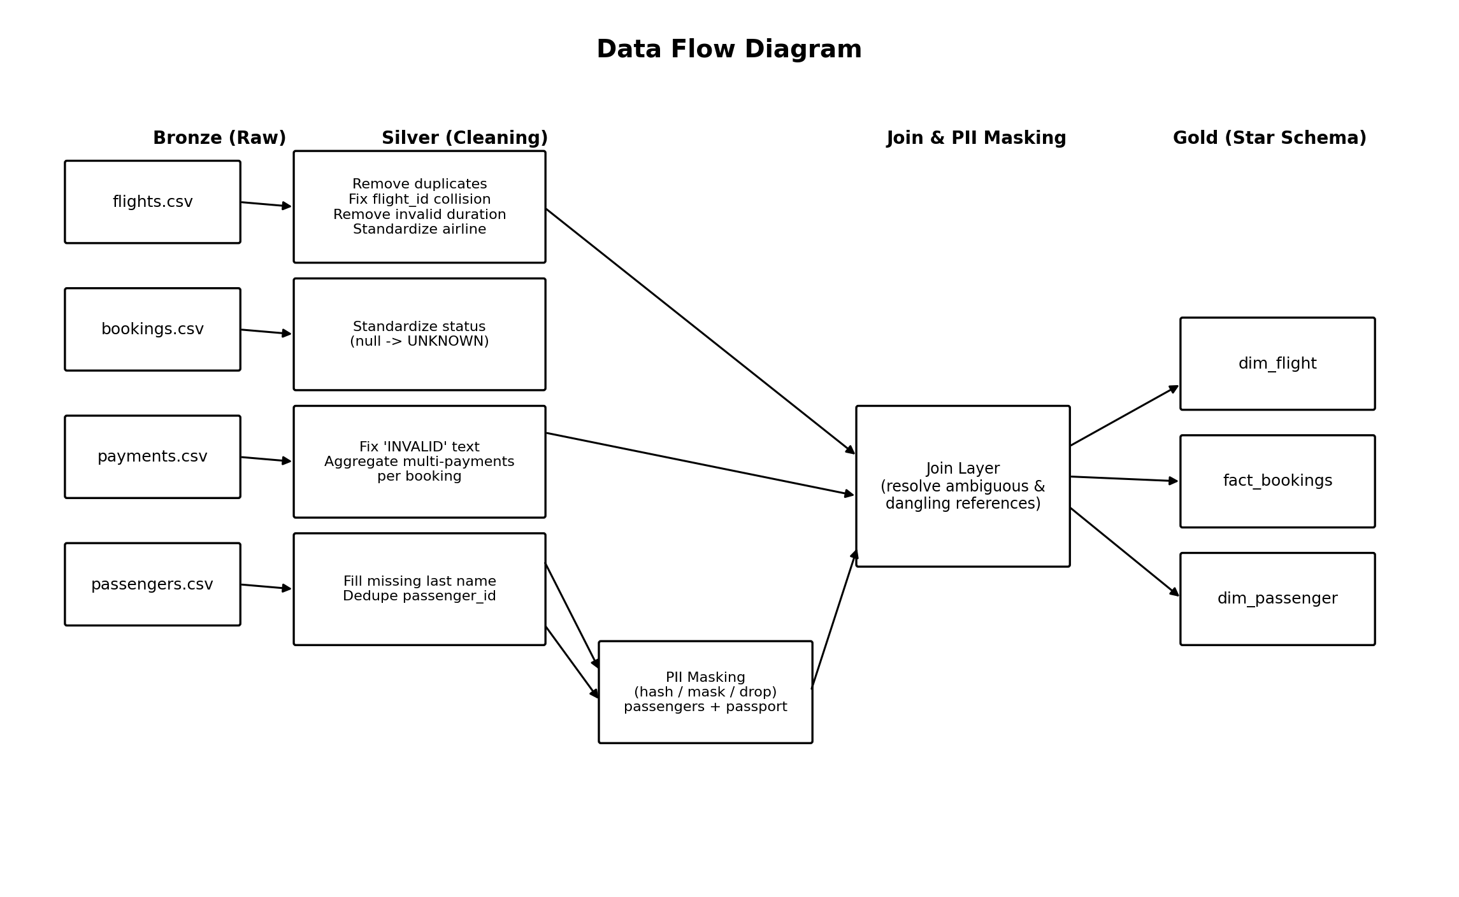
Figure 2: Data flow from raw source files through cleaning, PII masking, and joins into the Gold layer

5. Data Model
The cleaned and joined data is organised as a star schema: one fact table (fact_bookings) connected to two dimension tables (dim_flight and dim_passenger). This avoids repeating flight and passenger details across every booking row, and directly reflects a requirement listed in the internship job description (data modeling concepts such as normalization, primary and foreign keys, and entity-relationship diagrams).
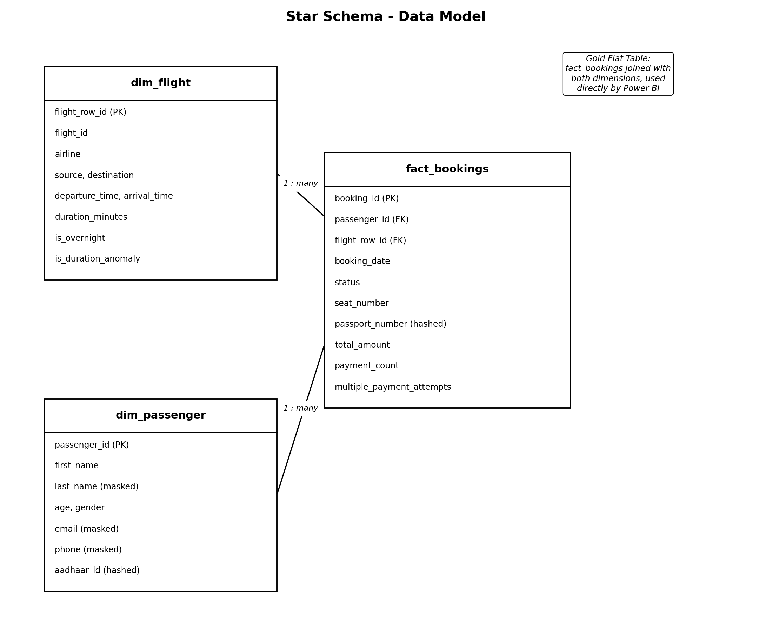
Figure 3: Star schema - fact_bookings linked to dim_flight and dim_passenger
For the Power BI dashboard itself, a single flattened table (joining fact_bookings with both dimensions) was also produced. Building visuals from one table is simpler and less error-prone for report authoring than managing relationships across three tables, while the star schema above remains the documented, normalized source of truth for the data model.

6. Data Cleaning Logic and Assumptions
Every cleaning step below follows the same approach: first check what is actually wrong with the data (rather than assuming), then apply a fix, with the reasoning stated explicitly. Row counts are given at each step to show exactly what each rule affected.

6.1 flights table
Exact duplicate rows
1,020 raw rows reduced to 1,005 distinct rows. 15 rows were complete duplicates of another row (every column identical), most likely the same flight event logged twice upstream (booking platform and scheduling system both reporting it). These were dropped directly.
Reused flight identifier (flight_id collision)
After removing exact duplicates, the flight_id '6F250' still appeared twice - but the two rows described genuinely different flights (different route, different departure/arrival time). This matches the problem statement's mention of 'corrupted flight identifiers'. Rather than deleting either row, a surrogate key (flight_row_id) was added to every flight record, giving each row a guaranteed-unique identifier while keeping the original flight_id for reporting purposes.
Invalid negative flight duration
One flight (SJ192) had an arrival time roughly 19 hours before its departure time. This is not a normal overnight (cross-day) flight - a flight cannot arrive before it departs. This record was treated as invalid and excluded from the clean dataset, since its timestamps could not be trusted for any duration or route analysis.
Inconsistent 'missing airline' values
The airline column had two different representations of the same missing state: blank/null values (39 rows) and the literal text 'UNKNOWN' (30 rows). Both were standardized into a single 'UNKNOWN' category so that the airline distribution KPI does not undercount missing values by treating them as two separate categories.
Overnight flight flag
The problem statement explicitly calls out unhandled overnight (cross-day) flight scenarios. An is_overnight flag was added (true when the arrival date differs from the departure date). Duration itself was calculated using full timestamps (not just time-of-day), so it is already correct across day boundaries - this flag exists purely for visibility and dashboard filtering, not to fix a calculation error.

6.2 bookings table
The status column contained 45 blank/null values and a separate 'INVALID' category not part of the normal booking lifecycle (CONFIRMED, CANCELLED, PENDING). Null values were standardized to 'UNKNOWN' (same approach as the airline column). 'INVALID' was deliberately kept as its own category rather than merged with 'UNKNOWN', since it most likely represents a booking the source system itself flagged as broken - a different situation from the status simply not being recorded.

6.3 payments table
Missing and invalid amounts
48 payment records had a blank amount, and a further 30 contained the literal text 'INVALID' instead of a number. Both were treated as the same underlying problem (the amount is not usable) and converted to a proper null using a safe cast that turns unparseable values into null rather than failing the whole calculation. These rows were kept (not deleted), and simply excluded from any sum/average that depends on a valid amount.
Multiple payment records per booking (key assumption)
370 bookings had exactly one payment record, but 267 bookings had between 2 and 6 payment records each, with different amounts and different payment methods. There is no status or timestamp field in the data to indicate whether these represent legitimate split payments or failed retry attempts that were logged anyway.
Assumption stated explicitly: all payment records for a booking were treated as real amounts and summed into a single total per booking, rather than guessing which single record to keep. A separate flag (multiple_payment_attempts) was also added so this stays visible as a distinct, investigable data point on the dashboard rather than being silently absorbed into a revenue figure.

6.4 passengers table
Missing last names
10 passengers had no last name recorded. Since no KPI depends on passenger names, these were filled with 'Unknown' rather than guessed.
passenger_id was not actually unique
36 passenger_ids were found to have 2-3 conflicting rows each - not exact duplicates, but different versions of what appears to be the same person (identical name, age, and gender, but different email, phone, and Aadhaar number). One case had a corrupted entry (first and last name merged together with a blank last name field). Since bookings link to passengers by passenger_id, this posed the same risk as the flight_id collision: a booking could match multiple conflicting passenger records during a join.
Because the demographic facts actually used on the dashboard (name, age, gender) were consistent across each person's duplicate rows, the fix was to keep exactly one clean row per passenger_id - preferring the row with a complete last name, so the corrupted entry was not kept by accident.

6.5 Referential integrity checks on the join
Two additional issues were found only after attempting to join the tables together, and are worth documenting separately since they would not appear from looking at any single table alone:
- Ambiguous flight reference: 2 bookings referenced the colliding flight_id '6F250'. Joining directly on flight_id would have matched each of these bookings to both flights, silently duplicating them. These 2 bookings were set aside separately rather than guessed at.
- Dangling flight reference: 1 booking (B1636) referenced the SJ192 flight that had already been removed for having an invalid negative duration. Left unresolved, this booking would have carried blank flight details straight into the reporting layer. It was set aside alongside the ambiguous bookings above.
In total, 5 out of 1,000 bookings could not be reliably linked to exactly one valid flight and were excluded from route/duration-specific analysis, while the remaining 997 bookings (and 1,004 valid flights) form the basis of the star schema and dashboard.

7. PII Masking and Access Control
The passengers and bookings tables contain personally identifiable information, including government identity numbers (Aadhaar, passport), contact details, and date of birth. A tiered approach was used rather than applying one technique to every field uniformly, since different fields carry different risk and different (or no) analytical need.
Field | Technique | Reasoning
aadhaar_id, passport_number | One-way hash (SHA-256) | Government ID numbers, never needed in plain text for any analysis. Hashing is irreversible.
email, phone | Partial masking | Occasionally useful for record matching, so fully hashing would remove that utility. Only a small portion is kept visible.
last_name | Partial masking (first letter retained) | Retains enough for readability in a table without exposing the full name.
date_of_birth, emergency_contact_name/phone | Dropped entirely from the analysis-ready layer | Not required by any stated KPI - no reason to carry sensitive data forward that nothing uses.

7.1 Access control
In addition to masking, access to the underlying data is restricted at the storage layer: all storage containers and the Unity Catalog Volume are set to private access, with no public/anonymous access permitted. Only users granted explicit permissions on the Azure subscription and Databricks workspace can reach the raw data at all - the masking above is a second, independent layer of protection on top of this access restriction, so that even an authorized user working in the analytics layer does not see plain-text sensitive values unless specifically required.

8. KPIs and Power BI Dashboard
The dashboard is organized into four pages, as suggested in the problem statement, built from the Gold-layer flat table exported from the pipeline. Each page includes KPI cards and at least one slicer for interactive filtering.

8.1 Duration Analysis
Average flight duration overall, and broken down by route, so unusually long or short routes are immediately visible. Includes an airline slicer.
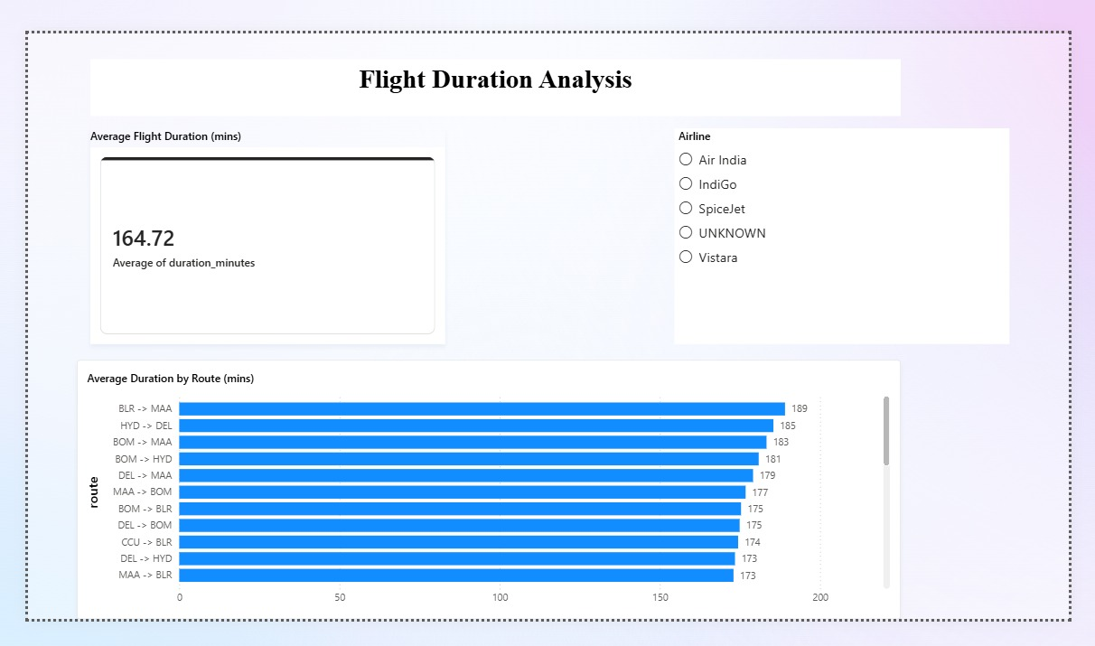
Figure 4: Duration Analysis page

8.2 Route Performance
Total distinct flights and routes, traffic by route, and revenue by route (using the joined payments data - a KPI only possible because the full relational dataset was used, not just flights). Includes a source-city slicer.
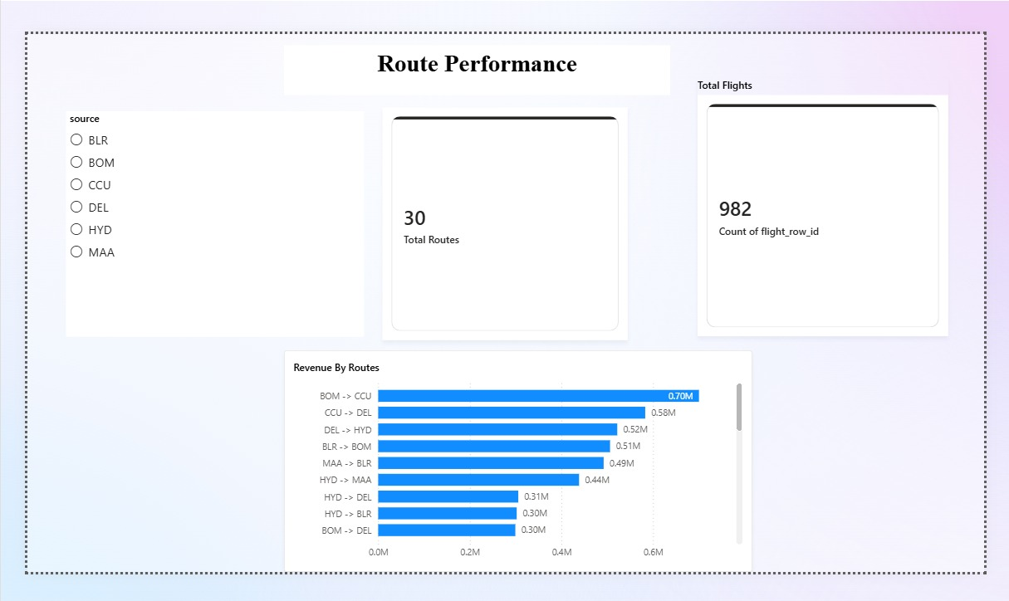
Figure 5: Route Performance page

8.3 Airline Trends
Number of airlines, flight distribution by airline, revenue by airline, and a summary table combining flight count, average duration, and revenue per airline. Includes a booking-date slicer.
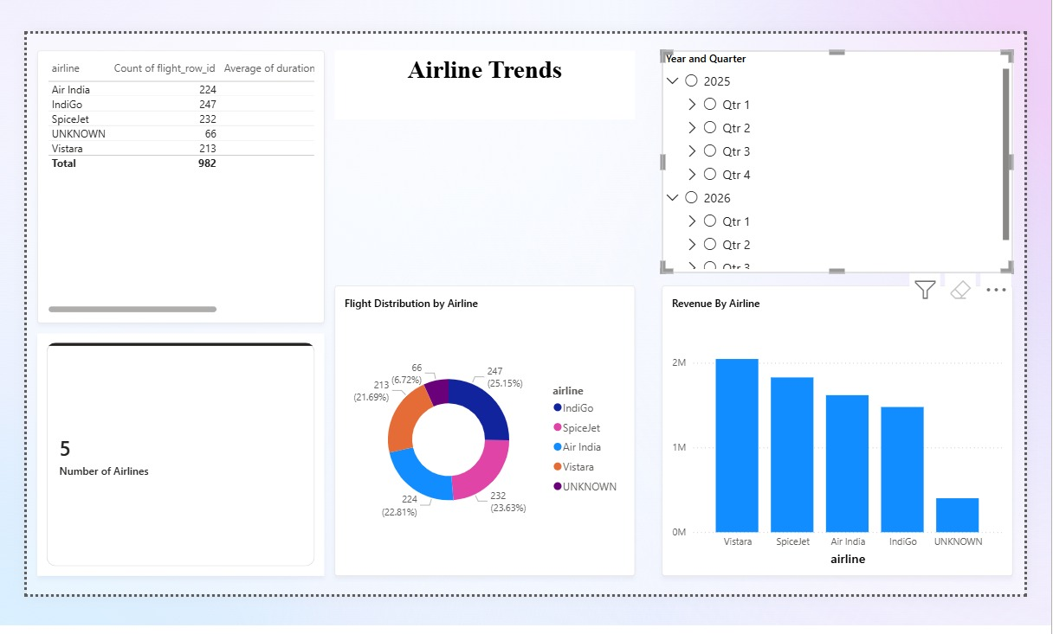
Figure 6: Airline Trends page

8.4 Delay and Anomaly Insights
The problem statement asks for a 'Delays / Anomalies' KPI, but the dataset has no separate 'scheduled time' field to compare against actual time, so a traditional delay calculation is not possible with the data given. As a documented substitute, flights whose duration is more than two standard deviations from their route's average duration are flagged as anomalies - exactly one flight met this threshold in the dataset, a genuine statistical outlier rather than a forced result. This page also surfaces the multiple-payment-attempts flag and cancellation rate (31%) as additional operational anomalies worth investigating.
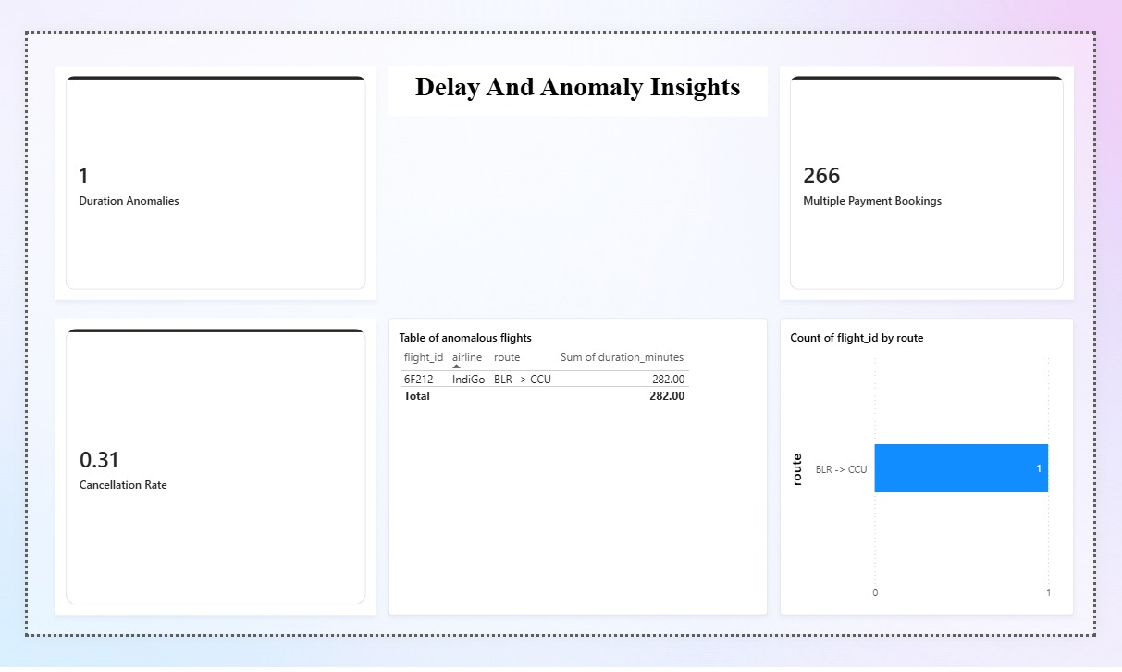
Figure 7: Delay and Anomaly Insights page

9. Scalability and Production Considerations
The dataset used in this exercise is small (a few thousand rows), so the pipeline's scalability was addressed through architectural choices and documented design decisions rather than by testing against a larger dataset.
- Compute engine: PySpark on Databricks distributes work across a cluster, unlike a single-machine tool such as pandas. The same transformation code used here would scale to a multi-node cluster processing millions of records without being rewritten.
- Data modeling: the star schema (fact + dimension tables) avoids repeating flight and passenger details on every row, which becomes increasingly important as booking volume grows.
- Partitioning (production recommendation, not implemented at this data volume): partitioning the Gold layer by departure date would let future queries scan only relevant partitions instead of the full dataset.
- Incremental loading (production recommendation): a real, continuously-operating pipeline would process only new or changed records each run (for example, using booking_date as a watermark) rather than reprocessing full history every time, as this notebook does for a one-time batch submission.

10. Tools and Technologies Used
- Azure Storage (ADLS Gen2) and Unity Catalog Volumes - data landing zone
- Azure Databricks (Serverless Compute) with PySpark - ingestion, cleaning, transformation, PII masking, and export
- Power BI Desktop - dashboard and KPI visualization
- Python (pandas) - local verification of every transformation before and after running it in Databricks

11. Conclusion
This pipeline was built to go beyond surface-level cleaning: every anomaly documented above was found by actively checking the data rather than assuming what was wrong with it, including two referential-integrity issues (the ambiguous and dangling flight references) that only became visible once the tables were joined together, and a passenger identifier collision that required the same scrutiny as the flight identifier collision described in the original problem statement.
The result is a working, verified, end-to-end pipeline - from raw Excel files through a documented star schema to an interactive four-page Power BI dashboard - along with an explicit record of every assumption made along the way.

Appendix: Evidence of Azure and Databricks Execution
The screenshots below were taken directly during the actual build of this pipeline in the Azure Portal and Databricks workspace, showing the real resources created under an Azure for Students subscription.
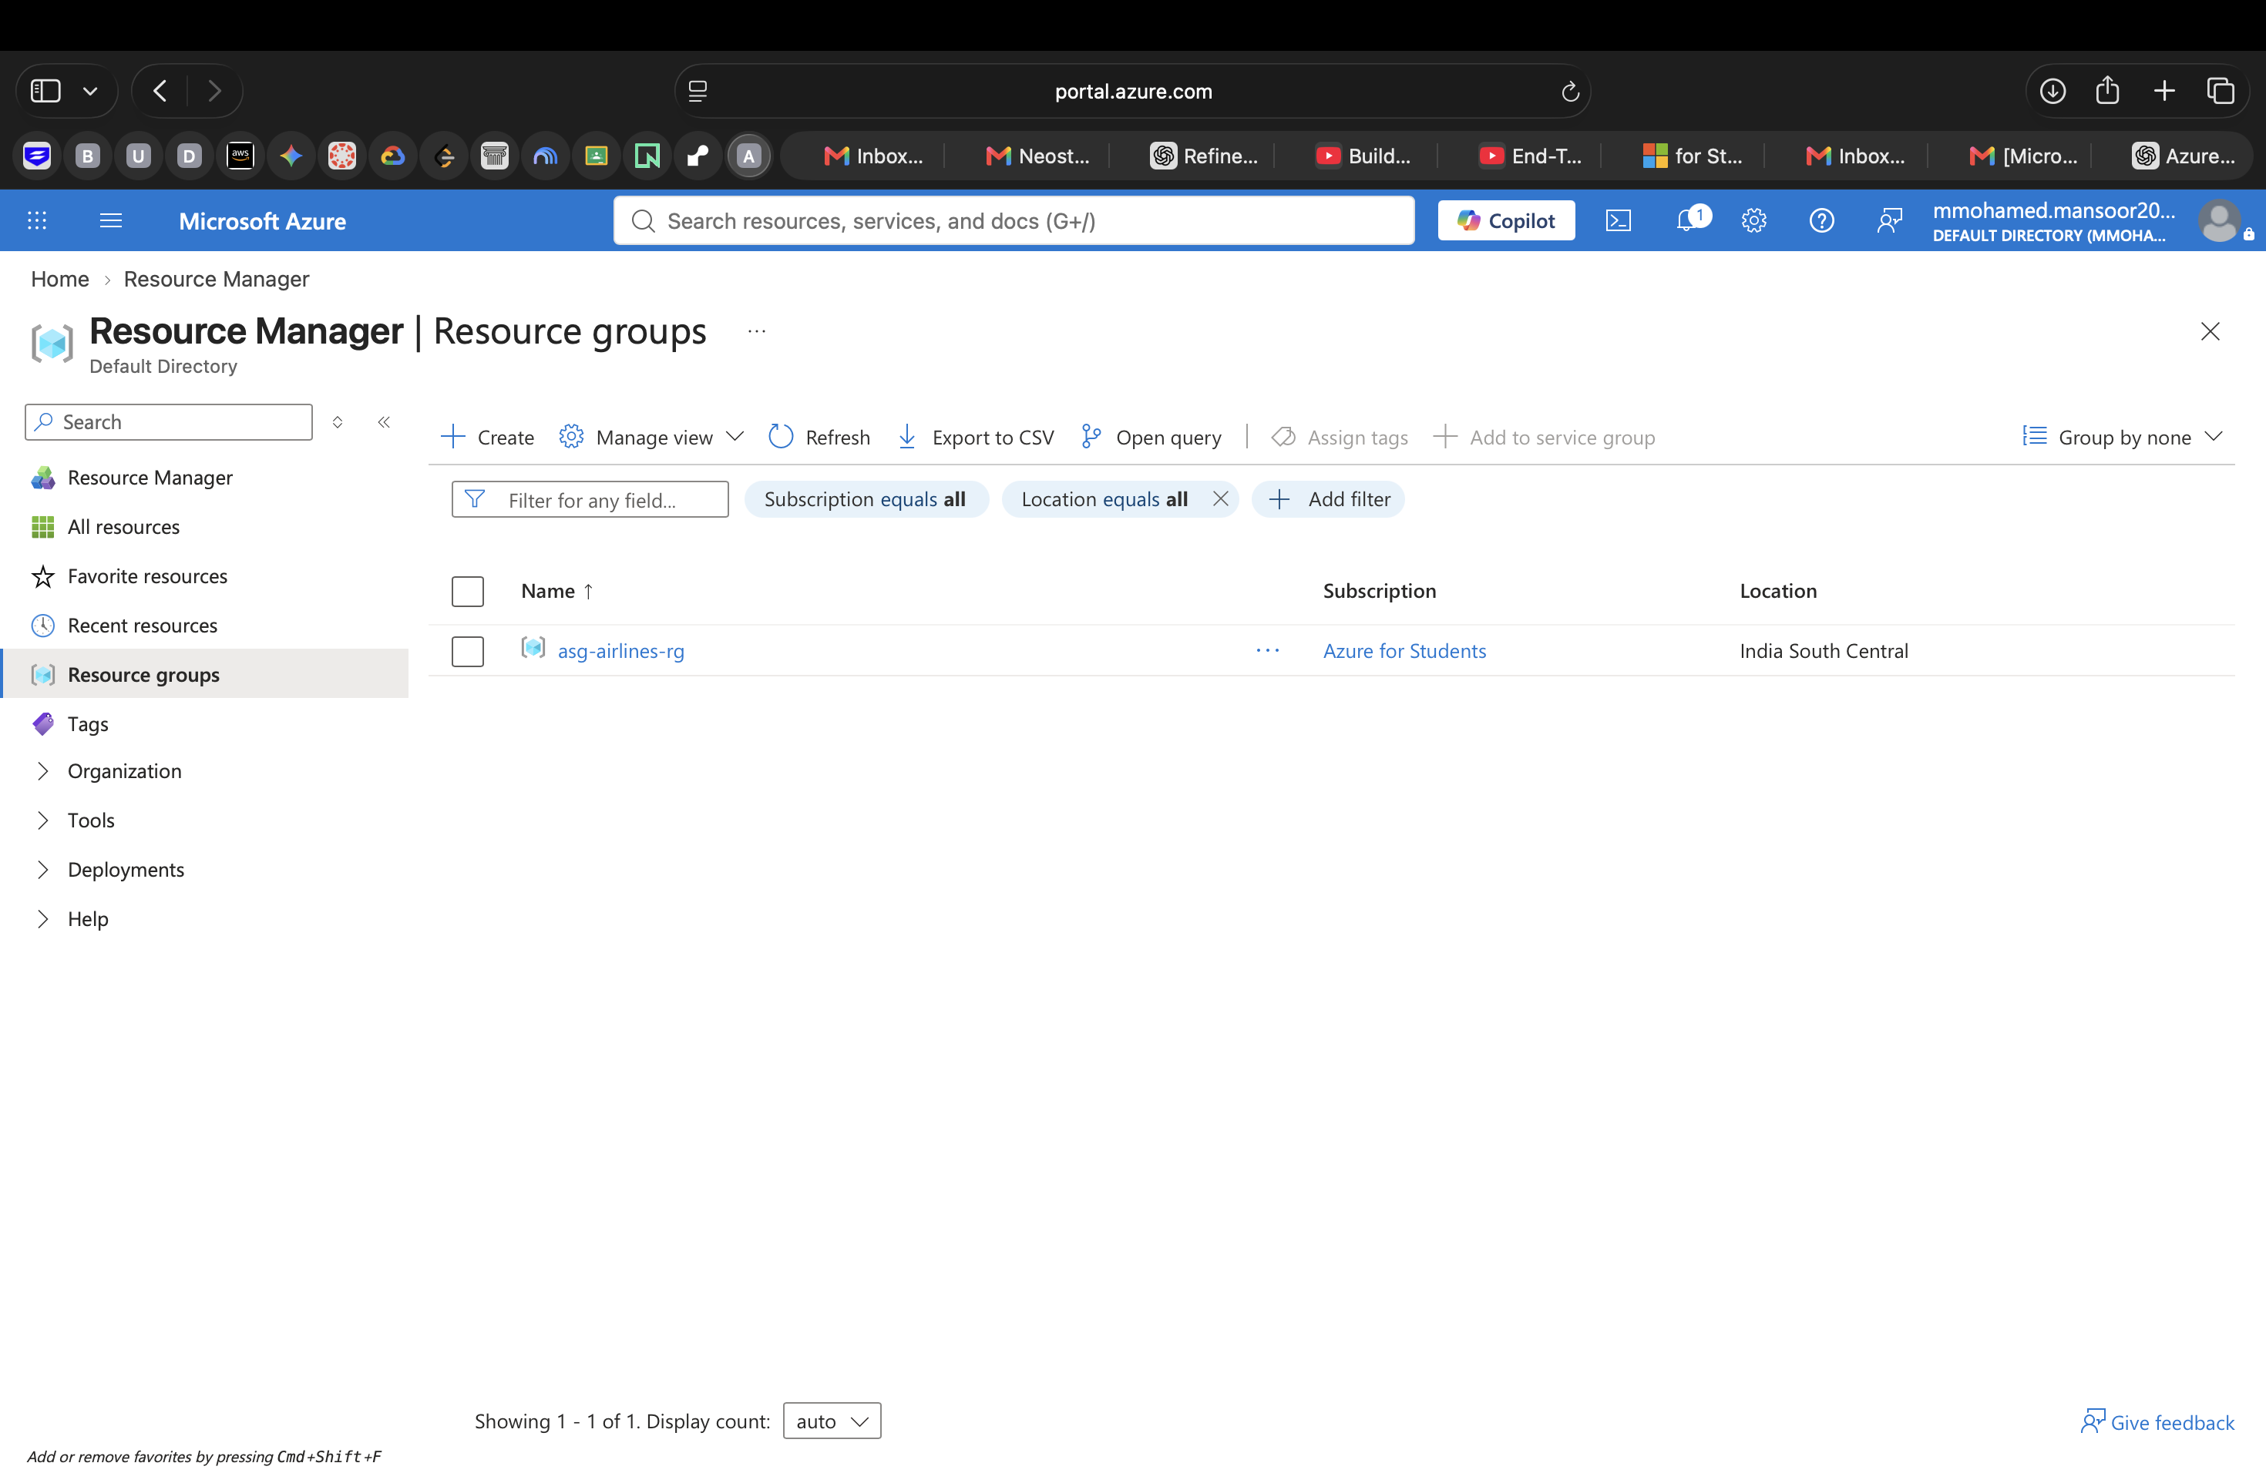
Figure A1: Resource group 'asg-airlines-rg' created under the Azure for Students subscription (India South Central region)
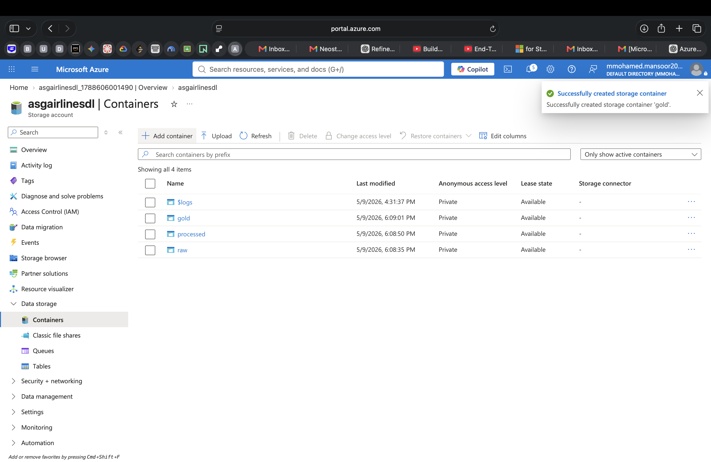
Figure A2: Storage account 'asgairlinesdl' with the raw, processed, and gold containers created for the Bronze/Silver/Gold layers
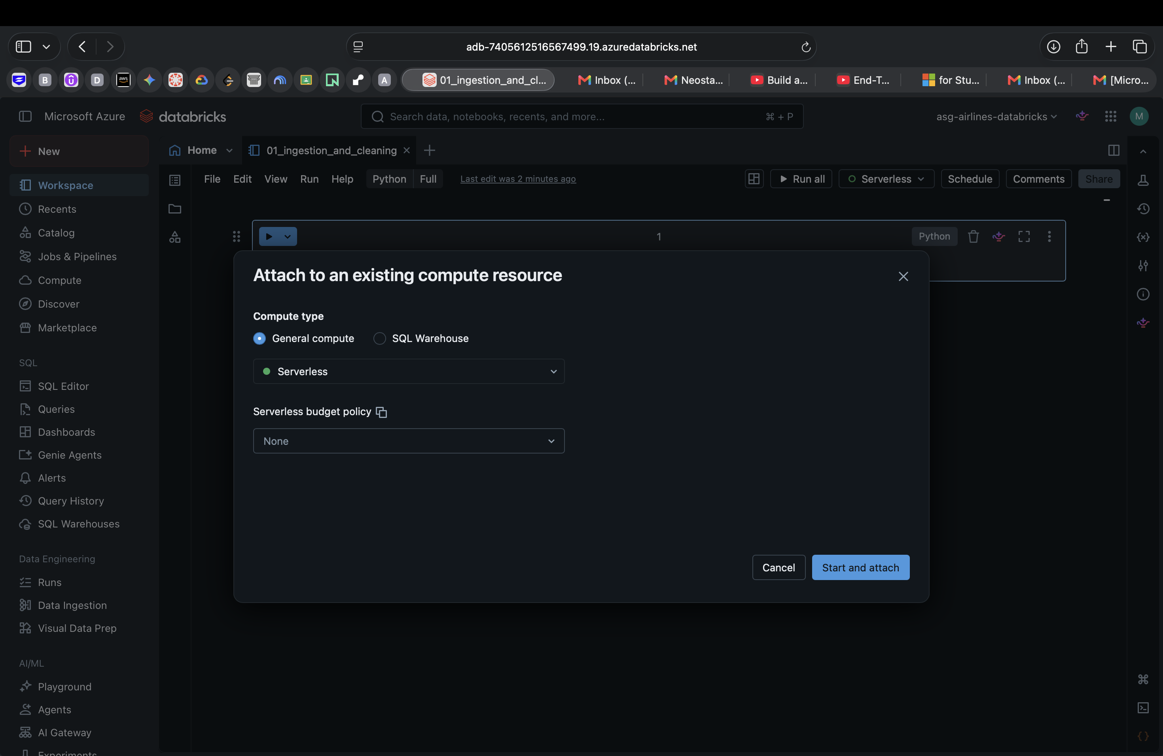
Figure A3: The Databricks workspace (asg-airlines-databricks) with the pipeline notebook attached to Serverless compute
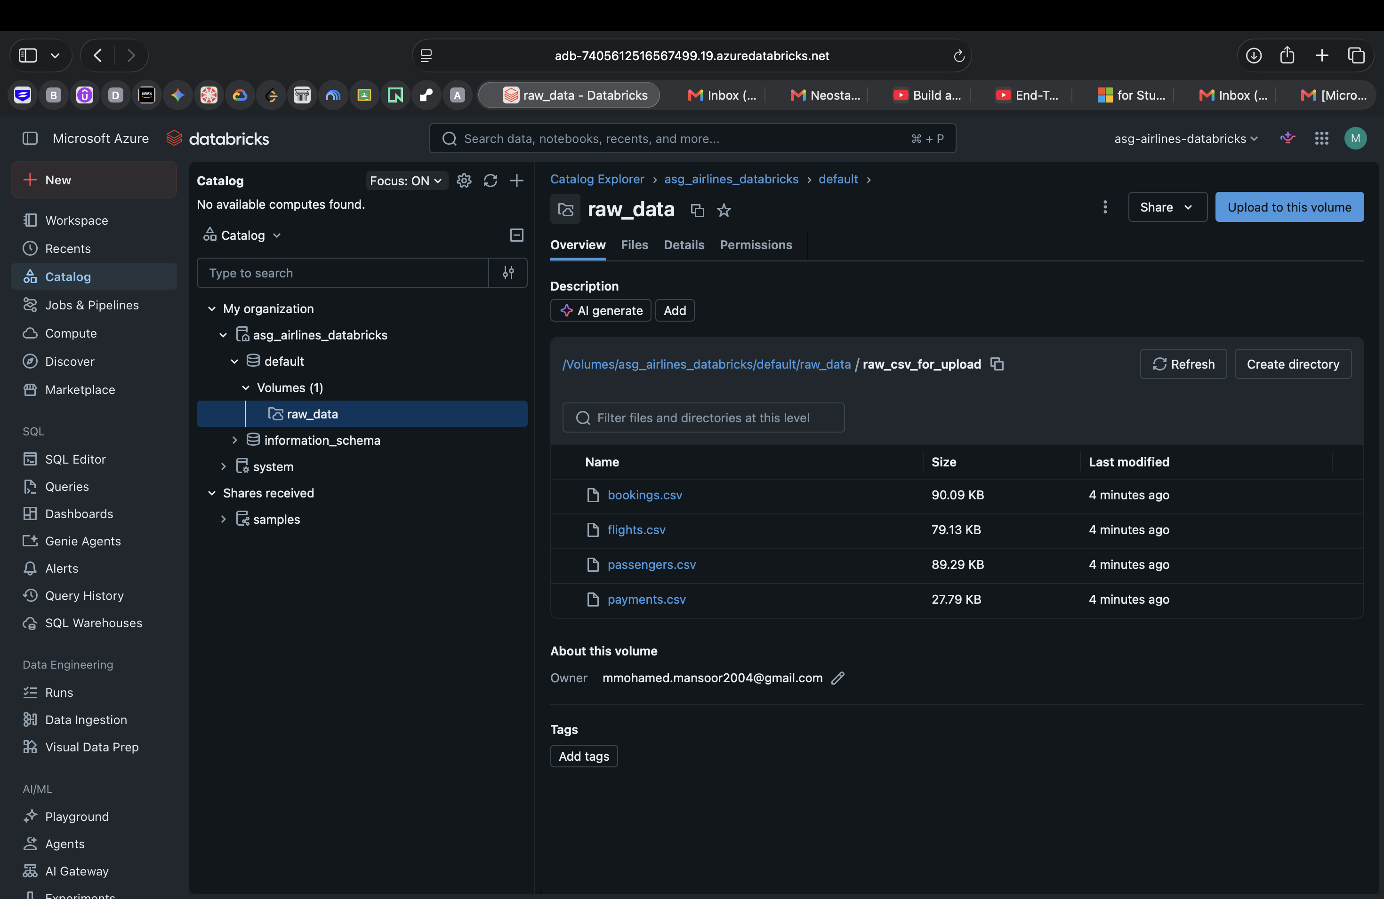
Figure A4: Unity Catalog Volume showing the 4 raw source files actually uploaded and used by the notebook
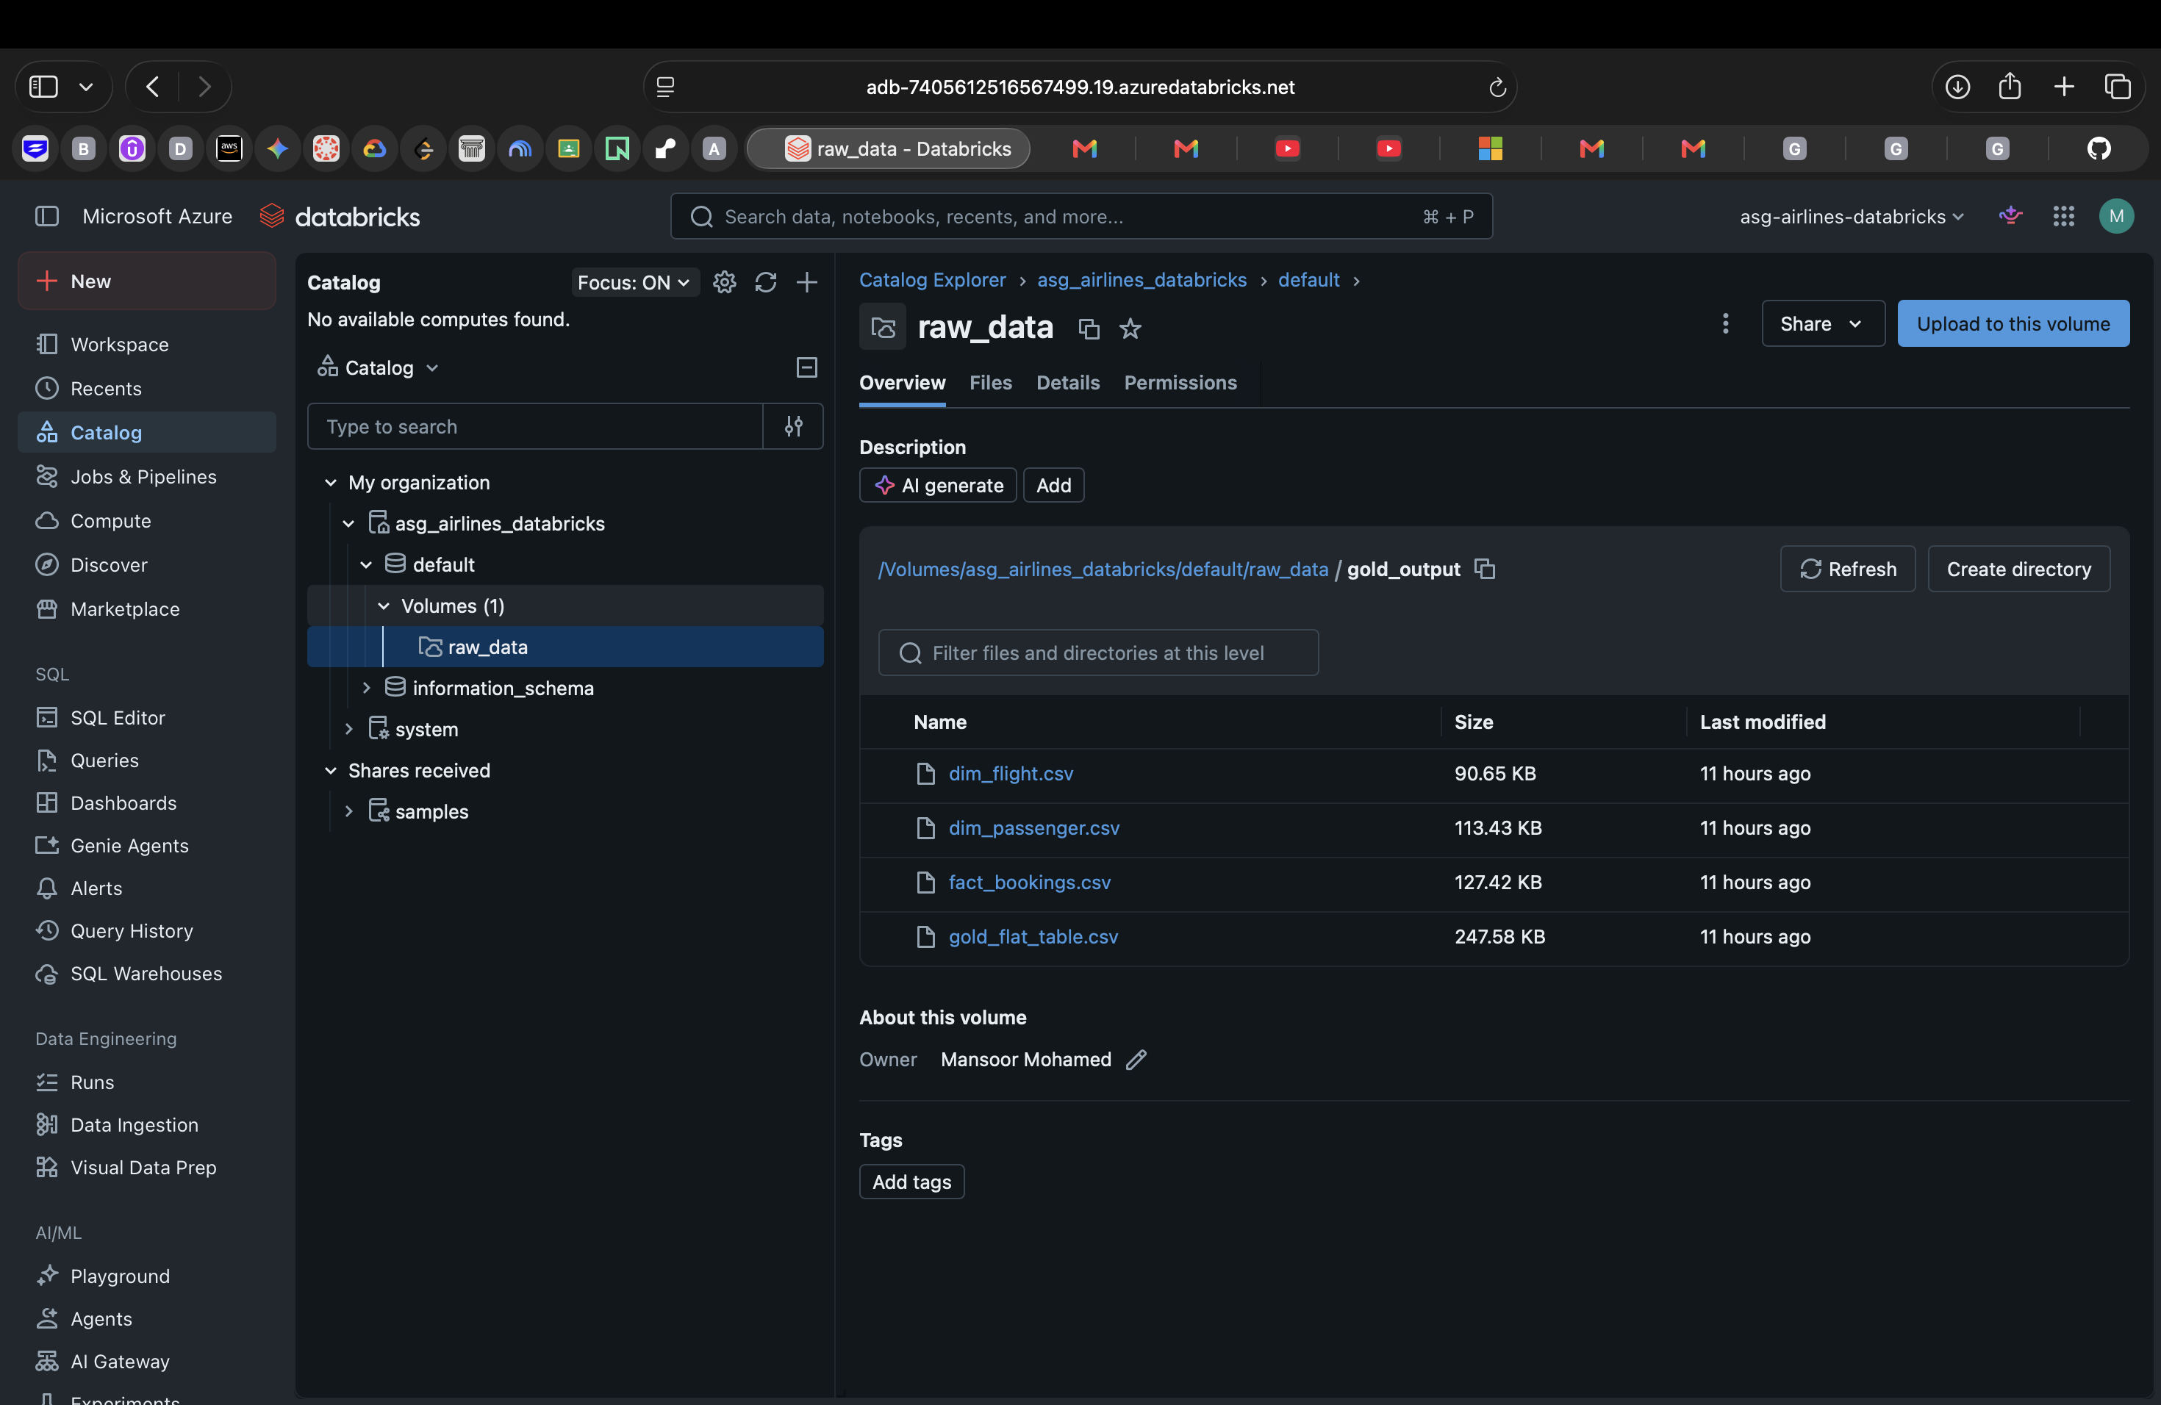
Figure A5: The completed pipeline notebook (asg_airlines_pipeline) in the Databricks workspace
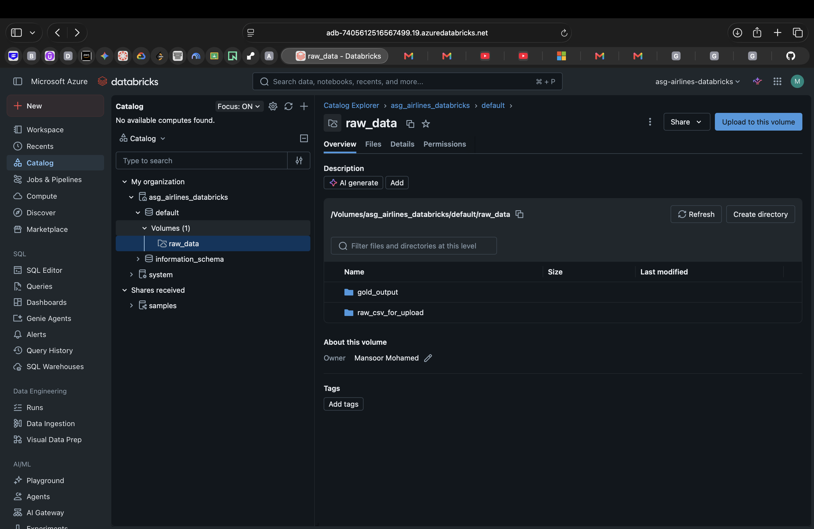
Figure A6: Unity Catalog volume showing both the raw input folder and the gold_output folder produced by the notebook run
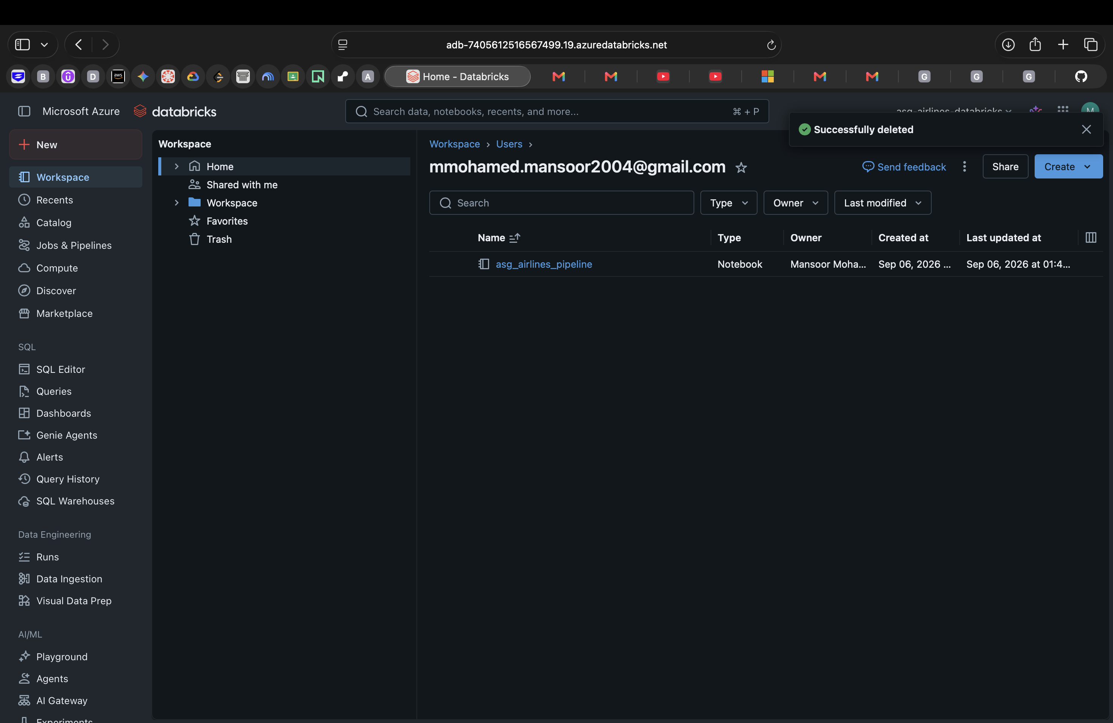
Figure A7: The 4 exported Gold-layer files (fact_bookings, dim_flight, dim_passenger, gold_flat_table) inside gold_output, confirming the pipeline actually executed end-to-end

