Asian Paints Ltd
Discounted Cash Flow (DCF) Valuation Report
FCFF Approach | Forecast Period FY2027–FY2031
Prepared: August 2026

1. Purpose of this report
This report summarises a Discounted Cash Flow (DCF) valuation model built for Asian Paints Ltd, India's largest decorative paints company. The model estimates the company's fair or intrinsic value per share using the Free Cash Flow to Firm (FCFF) method, and compares that value against the current market price. The full working model is available in the accompanying Excel file, Asian_Paints_DCF_Valuation_Model.xlsx.

2. Methodology at a glance
The model follows a standard five-step FCFF valuation approach:
- Build a 10-year historical financial statement (FY2017–FY2026) to understand revenue, margin, and capital efficiency trends.
- Estimate the company's Return on Invested Capital (ROIC) and Reinvestment Rate to derive an intrinsic (fundamental) growth rate.
- Compute the Weighted Average Cost of Capital (WACC) using a peer-comparable beta approach.
- Project FCFF for five years (FY2027F–FY2031F) and discount them to present value using the mid-year convention.
- Calculate a Terminal Value using the Gordon Growth (perpetuity) method, discount it back, and derive equity value per share.

3. Historical financial performance (FY2017–FY2026)
Asian Paints has grown revenue from ₹15,062 Cr in FY2017 to ₹35,584 Cr in FY2026, a roughly 10% CAGR over the decade, though growth has been uneven — a strong post-pandemic rebound (FY2022 sales grew 34%) was followed by a slowdown, with FY2025 sales actually declining 4.5% amid weak demand and rising competition. Profitability has also been volatile: EBITDA margins ranged from a low of ~16.5% (FY2022, hit by raw material inflation) to a high of ~22.4% (FY2021).
Metric | FY2021 | FY2022 | FY2023 | FY2024 | FY2025 | FY2026
Sales (₹ Cr) | 21,713 | 29,101 | 34,489 | 35,495 | 33,906 | 35,584
Sales growth | 7.4% | 34.0% | 18.5% | 2.9% | -4.5% | 4.9%
EBITDA margin | 22.4% | 16.5% | 18.2% | 21.4% | 17.7% | 18.8%
EBIT margin | 19.9% | 13.9% | 15.5% | 18.5% | 14.8% | 16.5%*
*EBIT for FY2026 (₹6,129.5 Cr) is taken from the ROIC schedule and is the base year for the 5-year forecast.
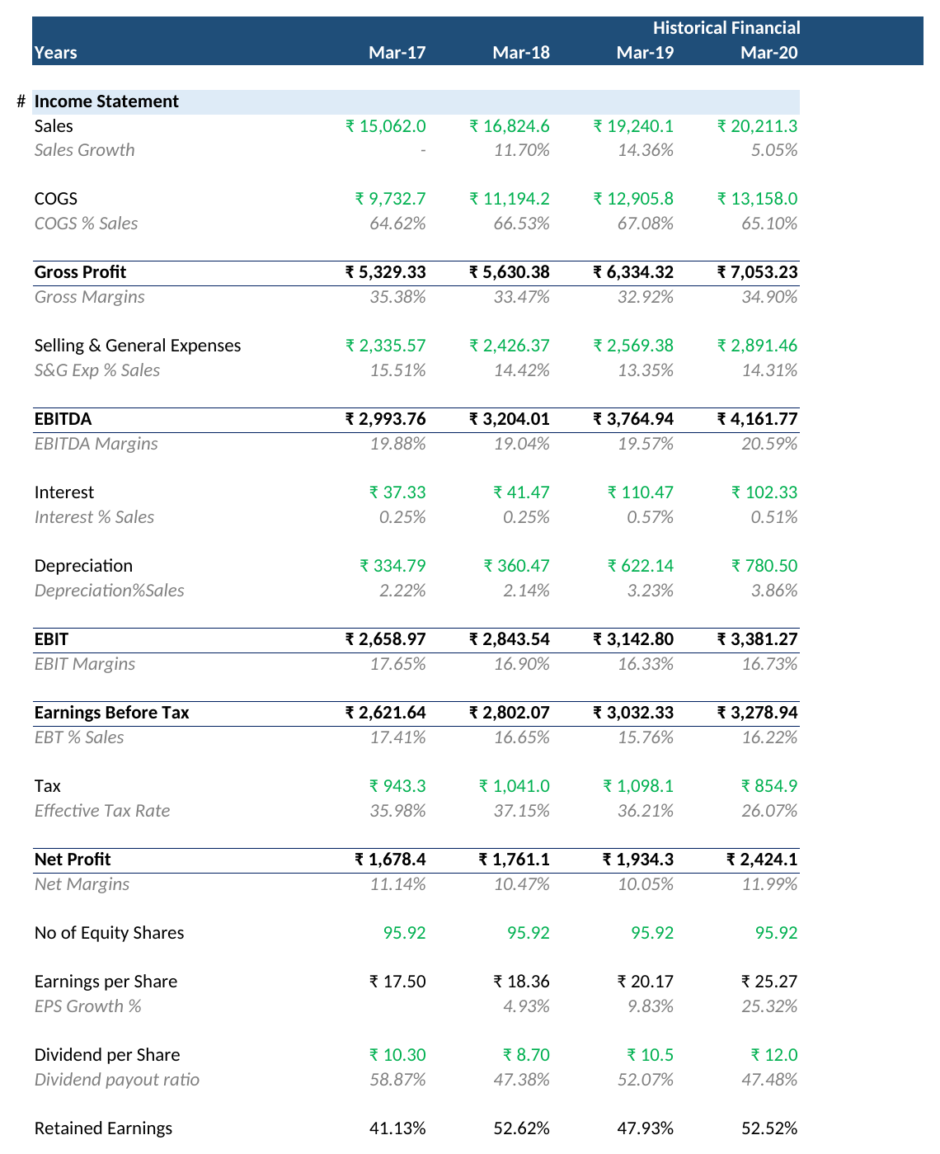
Figure 1 — Extract of the Historical Financial Statement tab (Income Statement, FY2017–FY2020 shown).

4. Growth assumptions — ROIC and reinvestment
The model derives its growth assumptions fundamentally, rather than assuming an arbitrary growth rate. It calculates:
- Return on Invested Capital (ROIC): averaged around 33%–55% over FY2021–FY2026, reflecting Asian Paints' asset-light, high-margin business model. FY2026 ROIC stands at 38.4%.
- Reinvestment Rate: the 5-year median reinvestment rate is 45.5% (i.e. the company reinvests about 45.5% of its after-tax operating profit back into the business).
- Intrinsic Growth Rate = ROIC × Reinvestment Rate, which works out to a 5-year median of 23.5% — this is the 'Expected Growth' figure used to drive the near-term FCFF forecast.
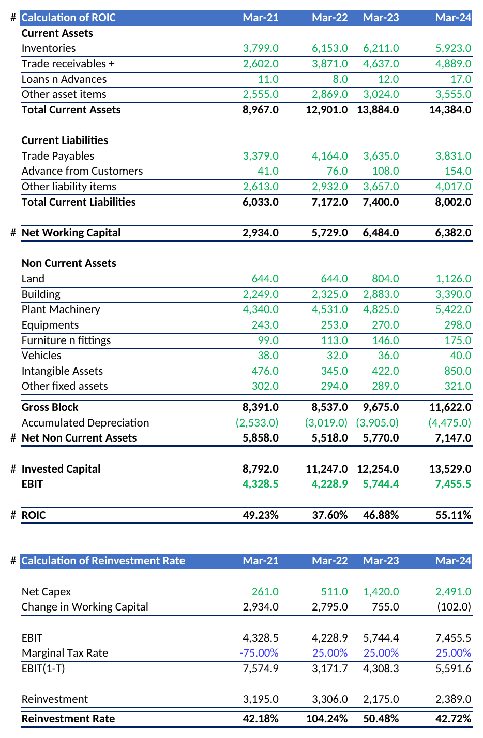
Figure 2 — ROIC and Reinvestment Rate calculation (FY2021–FY2024 shown).

5. Cost of capital (WACC)
The discount rate is built bottom-up using a peer set of five listed Indian paint companies (Asian Paints, Berger Paints, Kansai Nerolac, JSW Dulux/Akzo Nobel India, and Indigo Paints):
Component | Value
Risk-free rate | 6.85%
Equity risk premium | 9.60%
Peer median unlevered beta | 0.86
Re-levered beta (target D/E) | 1.10
Cost of Equity | 17.38%
Pre-tax cost of debt | 9.72%
After-tax cost of debt | 6.80%
Target capital structure (Equity : Debt) | 93.5% : 6.5%
WACC | 16.69%
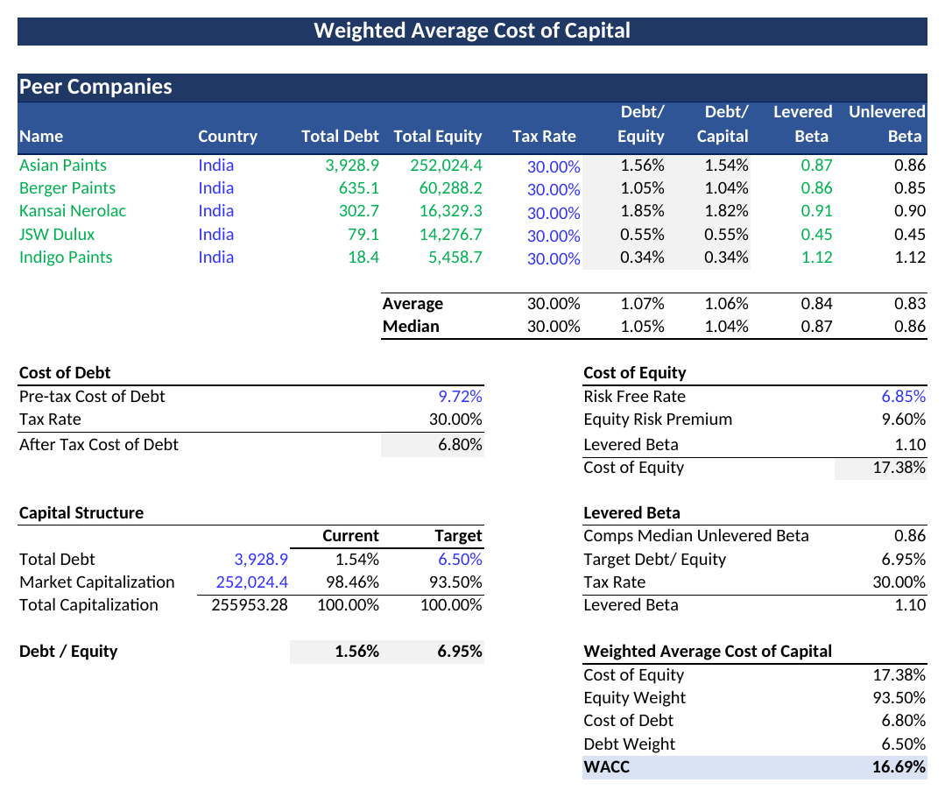
Figure 3 — WACC build-up, peer comparables, cost of equity and cost of debt.
A WACC of 16.7% is on the higher side for a large, stable consumer company — it is driven mainly by the market's long-run 16.4% average total return (used to derive the 9.6% equity risk premium) and a re-levered beta above 1.0. A reader may want to sanity-check this discount rate against alternative sources (e.g. a Damodaran-style India ERP) as part of due diligence.

6. DCF valuation output
Using FY2026 EBIT of ₹6,129.5 Cr as the base, the model grows EBIT at 23.5% for the explicit forecast period, applies a 25% tax rate and a 45.5% reinvestment rate to derive Free Cash Flow to Firm (FCFF), and discounts each year using the mid-year convention at a 16.69% WACC:
 | FY27F | FY28F | FY29F | FY30F | FY31F
EBIT (₹ Cr) | 7,573 | 9,356 | 11,558 | 14,280 | 17,642
FCFF (₹ Cr) | 3,093 | 3,821 | 4,721 | 5,832 | 7,206
PV of FCFF (₹ Cr) | 2,863 | 3,031 | 3,209 | 3,398 | 3,597
Terminal value is calculated on FY2032 FCFF (₹8,902 Cr) using a 5.38% terminal growth rate (a proxy for long-term nominal GDP growth), giving a Terminal Value of ₹78,689 Cr, which discounts back to a present value of ₹39,283 Cr.
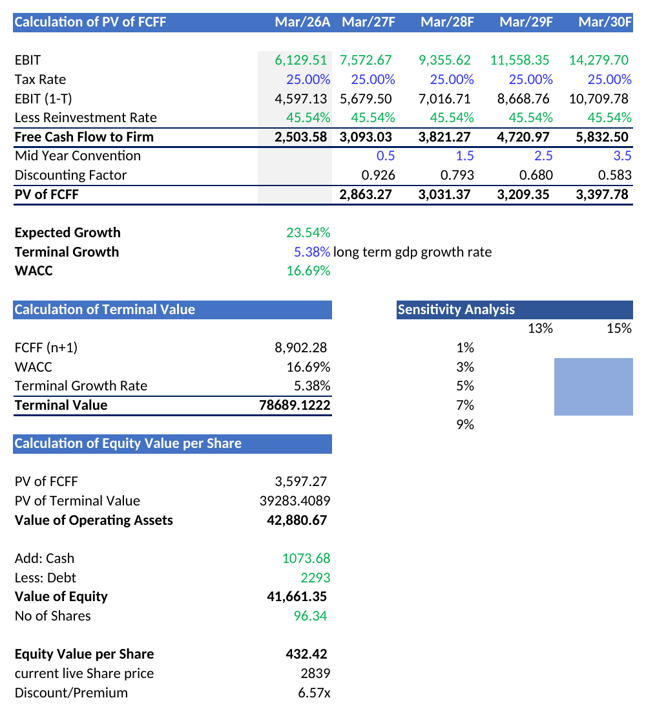
Figure 4 — DCF build: FCFF forecast, terminal value, and equity value per share.
Value of Operating Assets | ₹42,881 Cr
Add: Cash | ₹1,074 Cr
Less: Debt | ₹2,293 Cr
Value of Equity | ₹41,661 Cr
Shares Outstanding | 96.34 Cr
Intrinsic Equity Value per Share | ₹432.42
Current Market Price (as of model date) | ₹2,839

7. Valuation outcome
On the model's own inputs, the DCF implies an intrinsic value of ₹432 per share, against a current market price of ₹2,839 — the model's output cell labels this gap as a 'Discount/Premium' of 6.57x, meaning the market price is about 6.6 times the DCF value. In plain terms: if this model's assumptions hold, Asian Paints' stock looks materially expensive relative to its fundamentals.
That said, a gap of this size is unusually large even for a conservative DCF, and is worth treating as a signal to double-check assumptions rather than a final verdict — see the caveats below.

8. Observations and points worth double-checking
- Sum of explicit-period cash flows: The 'PV of FCFF' figure feeding the equity bridge (₹3,597 Cr) picks up only the final forecast year's discounted cash flow, not the sum of all five years (₹2,863 + ₹3,031 + ₹3,209 + ₹3,398 + ₹3,597 = ₹16,099 Cr). Correcting this would raise the intrinsic value per share to roughly ₹560–₹565 — directionally similar, but worth fixing for accuracy.
- Even after that correction, the DCF value remains well below the market price (about 5x), so the core conclusion — that the market is pricing in materially higher growth and/or a lower discount rate than this model assumes — does not change.
- High near-term growth rate: the 23.5% 'Expected Growth' figure is a historical 5-year median and is materially higher than Asian Paints' recent actual sales growth (2.9% in FY2024, -4.5% in FY2025). A reader may want to test a lower, more conservative near-term growth assumption.
- WACC sensitivity: because the terminal value is ~92% of total enterprise value, the valuation is highly sensitive to small changes in WACC and terminal growth — the built-in sensitivity table in the DCF tab is a good starting point for stress-testing this.
- The model uses a single-stage high growth rate for all 5 forecast years rather than fading growth down towards the terminal rate, which tends to inflate FCFF in the later forecast years.

9. Conclusion
This DCF model provides a fundamentals-driven, bottom-up estimate of Asian Paints' intrinsic value using a peer-based WACC and a ROIC-driven growth framework. Under the model's current assumptions, the stock appears significantly overvalued relative to its discounted cash flows. However, given the sensitivity of DCF outputs to growth and discount rate assumptions — and the technical note on the FCFF summation above — this should be read as one data point for further research, not a standalone investment recommendation. Readers are encouraged to open the accompanying Excel model and stress-test the key assumptions (growth rate, WACC, and terminal growth) for themselves.
Disclaimer: This report and the accompanying Excel model are for educational and informational purposes only. They do not constitute investment advice, and all figures are sourced from historical company filings and the model builder's own assumptions. Please do independent research or consult a licensed financial advisor before making any investment decisions.

