ITC Ltd.
Historical Financial Statements & Ratio Analysis, FY2017–FY2026
Prepared as part of Project: Historical FS — ITC | 10-year history + LTM + FY27–FY31 forecast

1. Purpose
This report summarises a 10-year historical financial model built for ITC Ltd., one of India's largest diversified conglomerates (FMCG, hotels, paperboards, agri-business, and IT). The model restates ITC's reported financials into a clean, formula-linked set of statements, adds common-size and ratio analysis, and layers on a simple trendline forecast through FY2031.
As with the underlying workbook, all figures are in ₹ Crore unless otherwise noted (per-share figures in ₹). The reporting period runs FY2017 (year ended 31 March 2017) through FY2026, plus a trailing-twelve-month (LTM) column and the ten most recent quarters.

2. What's in the Model
- Historical FS — full Income Statement, Balance Sheet, and Cash Flow Statement for FY2017–FY2026 and LTM, with a built-in balance-sheet check (confirmed TRUE for every year — Assets = Liabilities + Equity).
- Common Size Statement — every income statement line as a % of Sales, every balance sheet line as a % of Total Assets, for quick year-on-year cost-structure comparison.
- Ratio Analysis — growth rates, margins, returns (ROE, ROCE), working-capital turnover and days, and cash-flow coverage ratios, each with a 10-year mean and median.
- Forecasting — Sales, EBITDA, and EPS projected FY2027–FY2031 using Excel's FORECAST() function — a linear trendline regression fit to the 10 years of historical data, not a bottom-up business forecast.
- Data Sheet — the raw source data (annual and quarterly P&L, balance sheet, cash flow, share price) that every other tab pulls from. Marked "please do not make any changes" in the original file — this is the single source of truth.

3. Income Statement Trend
Revenue, profitability, and per-share earnings all grew steadily over the decade, with a dip in FY2021 (COVID-affected year) and a strong rebound in FY2022–FY2023:
Metric | FY17 | FY20 | FY23 | FY26 | 10-yr CAGR
Sales | 42,768 | 49,388 | 70,919 | 78,868 | ~7.0%
EBITDA | 15,470 | 19,344 | 25,704 | 27,306 | ~6.5%
EBIT | 14,317 | 17,699 | 23,895 | 25,595 | ~6.6%
Net Profit | 8,719 | 13,175 | 17,379 | 18,495 | ~8.7%
EPS (₹) | 7.18 | 10.72 | 13.98 | 14.76 | ~8.4%

Sales grew from ₹42,768 Cr in FY17 to ₹78,868 Cr in FY26 — roughly a 7% compound annual growth rate. Net Profit grew faster, at roughly 8.7% CAGR, reflecting some margin expansion and operating leverage over the period. EPS nearly doubled, aided modestly by a small increase in share count (from ~1,215 Cr to ~1,253 Cr shares over the decade).

4. Margin Trend
Margins have been broadly stable, with EBITDA margin oscillating in a 34%–39% band and net margin in a 20%–27% band across the decade:
Margin | FY17 | FY20 | FY23 | FY26 | 10-yr Mean
Gross Margin | 48.7% | 50.7% | 46.0% | 45.7% | 47.2%
EBITDA Margin | 36.2% | 39.2% | 36.2% | 34.6% | 36.3%
EBIT Margin | 33.5% | 35.8% | 33.7% | 32.5% | 33.6%
Net Profit Margin | 20.4% | 26.7% | 24.5% | 23.5% | 23.2%

Gross and EBITDA margins peaked around FY2020 and have eased modestly since, consistent with rising raw material costs (raw material cost as a % of sales rose from ~36% in FY17 to ~44–45% in FY25–26 per the common-size statement).

5. Balance Sheet & Returns
ITC's balance sheet is notably conservative — the company carries almost no debt, and what borrowings exist are small relative to its asset base:
Metric | FY17 | FY20 | FY23 | FY26
Total Assets (₹ Cr) | 55,898 | 77,311 | 85,831 | 93,637
Borrowings (₹ Cr) | 45.7 | 277.5 | 306.0 | 2,399.1
Cash & Bank (₹ Cr) | 2,967 | 7,277 | 4,880 | 3,009
Return on Equity | 18.8% | 20.2% | 25.1% | 25.5%
Return on Capital Employed | 30.8% | 27.0% | 34.4% | 34.4%
Interest Coverage | 292x | 217x | 307x | 301x

Interest coverage has stayed above 200x throughout the decade — Interest expense is a rounding error next to EBIT. Return on Equity improved from ~19% to ~25–26% over the period, and Return on Capital Employed has generally trended up, both pointing to efficient, high-return capital use even as the balance sheet has grown. Borrowings did jump from ₹303 Cr (FY25) to ₹2,399 Cr (FY26) — still trivial relative to Total Assets (~2.6%), but worth watching if the trend continues.

6. Working Capital & Cash Flow
- Cash Conversion Cycle has ranged roughly 43–90 days across the decade, with FY2026 at the high end (~90 days) — driven mainly by rising Inventory Days (from ~135 days in FY17 to ~159 days in FY26).
- Cash from Operating Activities has grown from ₹10,627 Cr (FY17) to ₹18,464 Cr (FY26), consistently the primary source of cash.
- Cash from Financing Activities has been consistently negative (₹(16,147) Cr in FY26) — almost entirely dividend payouts, consistent with ITC's high dividend payout ratio (mostly 95–125% of earnings across the period, reflecting its status as a mature, cash-generative business returning capital to shareholders).

7. Forecast (FY2027–FY2031)
The Forecasting tab projects Sales, EBITDA, and EPS forward using a linear trendline regression (Excel's FORECAST() function) fitted to the 10 years of historical actuals — not a bottom-up, assumption-driven forecast. It's best read as "what a straight-line continuation of the last decade's trend looks like," not a business plan:
Metric | FY26 (Actual) | FY27F | FY29F | FY31F
Sales (₹ Cr) | 78,868 | 82,755 | 91,506 | 100,257
EBITDA (₹ Cr) | 27,306 | 36,299 | 40,492 | 44,685
EPS (₹) | 14.76 | 16.04 | 17.86 | 19.67

On this basis, Sales are projected to reach roughly ₹100,257 Cr and EPS roughly ₹19.67 by FY2031 — both implying continued growth at a pace similar to the historical average (~5% per year in the later forecast years, tapering slightly as the trendline flattens).

8. A Data Note Worth Flagging
The model carries two different "Net Profit" figures for FY2025 that don't match, and it's worth understanding why before using either in isolation:
- The Historical FS tab shows FY2025 Net Profit of ₹17,250 Cr (net margin 22.9%) — in line with the surrounding years.
- The Data Sheet / Common Size tabs show FY2025 Net Profit of ₹34,747 Cr (common-size net margin spikes to 46.1%), driven by an Other Income line of ₹17,803 Cr that year — many multiples of the ₹2,000–3,300 Cr Other Income seen in every other year.
This gap is almost certainly a one-off/exceptional gain flowing through Other Income in FY2025 (ITC completed a large corporate restructuring — the demerger of its Hotels business — around this time, which is a plausible source of such a gain, though this hasn't been independently verified against ITC's FY2025 annual report). Whichever Net Profit figure is used downstream, it should be used consistently — mixing the two across different ratios will distort year-on-year comparisons. Recommend reconciling the two before relying on FY2025 profitability figures for valuation work.

9. Files in This Project
- ITC_Historical_Financial_Statements.xlsx — the live, formula-driven Excel model (5 tabs: Historical FS, Common Size Statement, Ratio Analysis, Forecasting, Data Sheet).
- README.md — repo overview and instructions for using/updating the model.
- This report (Report.docx) — narrative summary of the numbers, trends, and the FY2025 data caveat above.

Appendix A — Historical Financial Statements
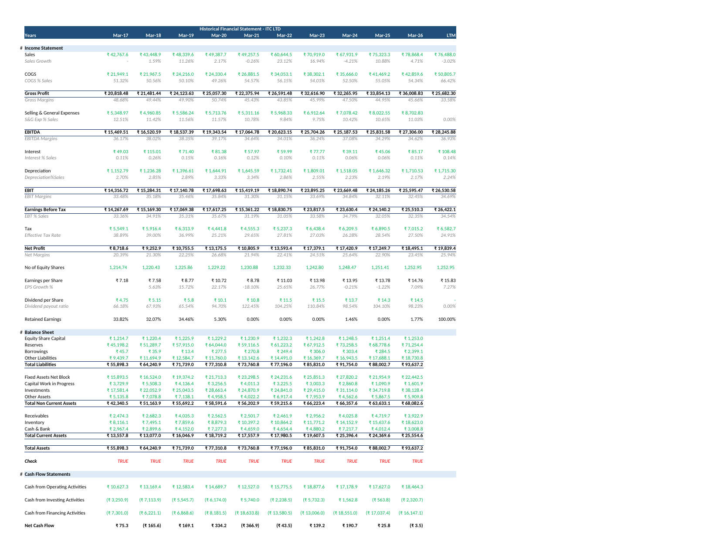
Income Statement, Balance Sheet, and Cash Flow — FY2017–FY2026 + LTM.

Appendix B — Common Size Statement
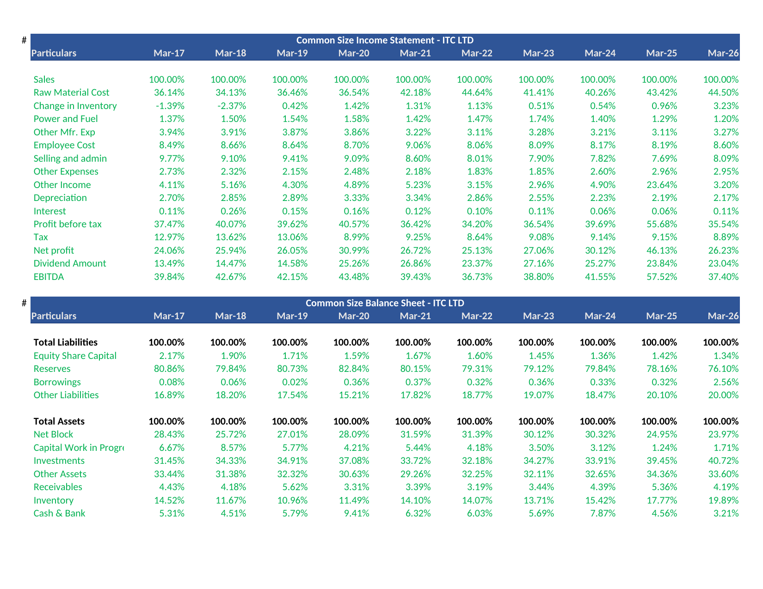
Income Statement and Balance Sheet, every line as a % of Sales / Total Assets.

Appendix C — Ratio Analysis
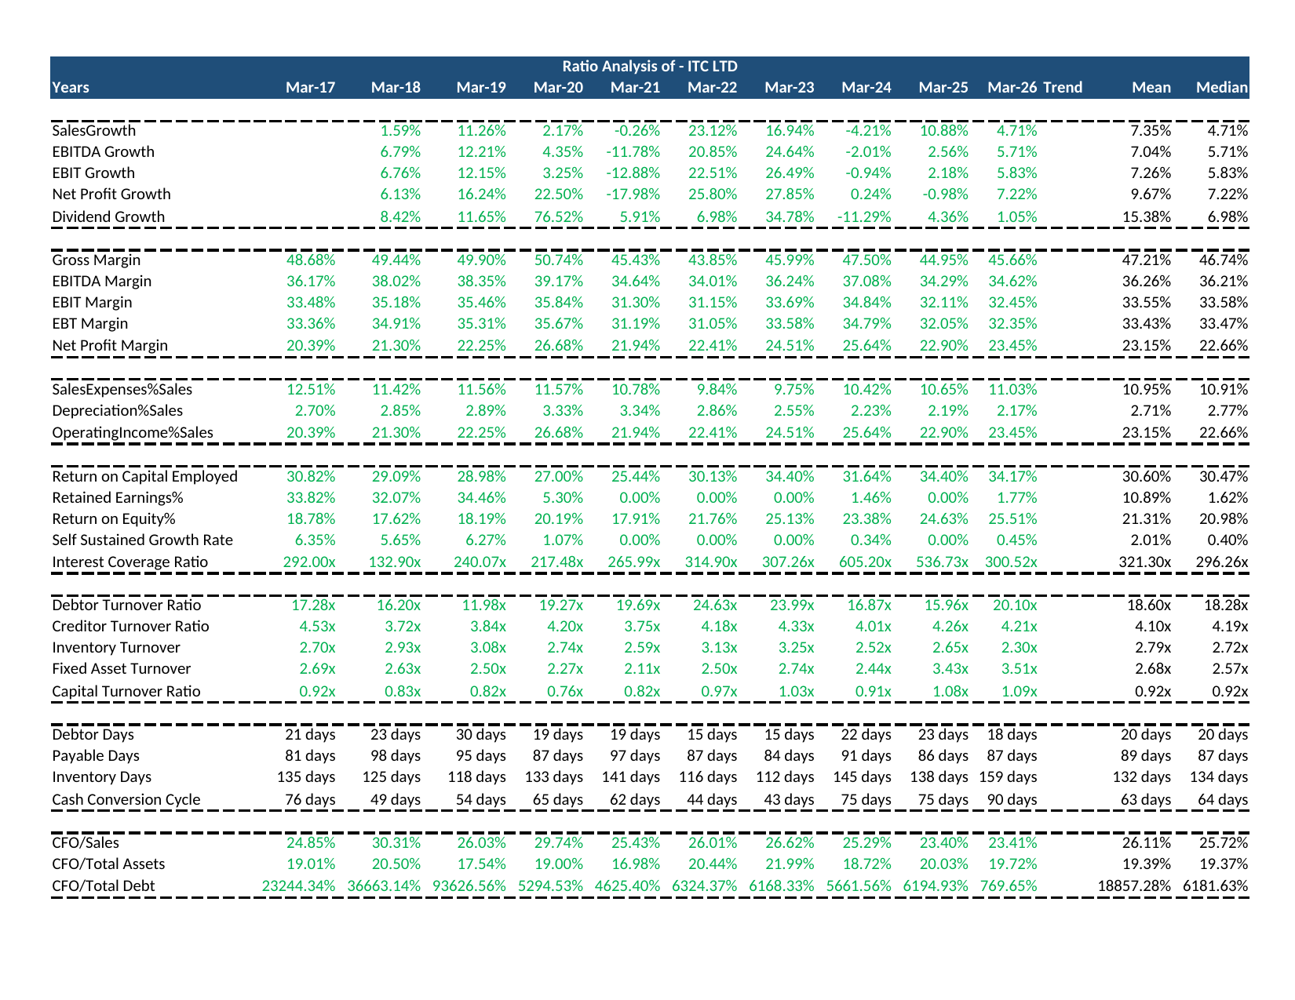
Growth, margin, returns, turnover, working-capital, and cash-flow coverage ratios, with 10-year mean/median.

Appendix D — Forecasting
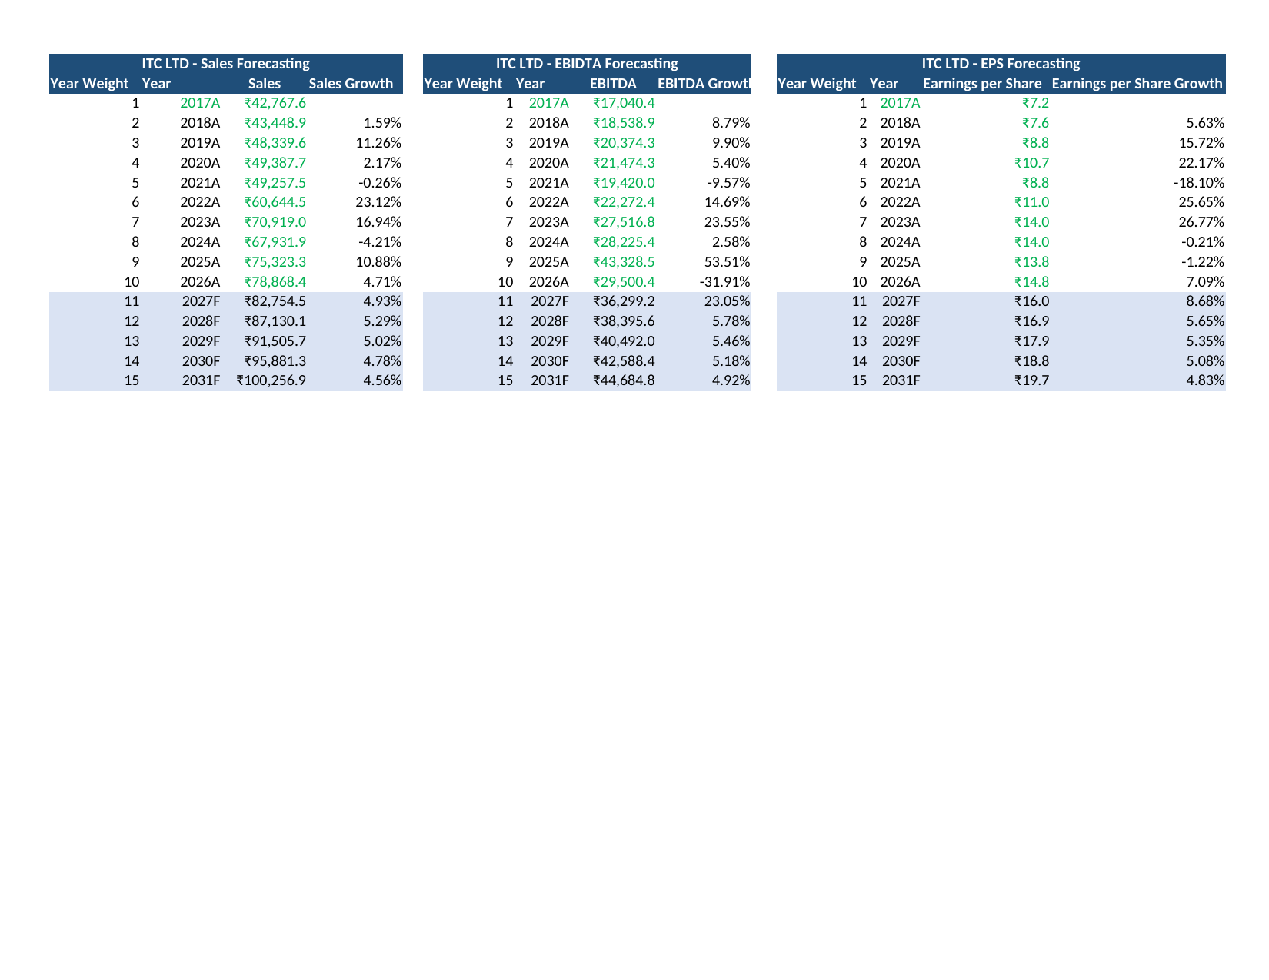
Sales, EBITDA, and EPS trendline forecast, FY2027–FY2031.

Appendix E — Raw Data Sheet
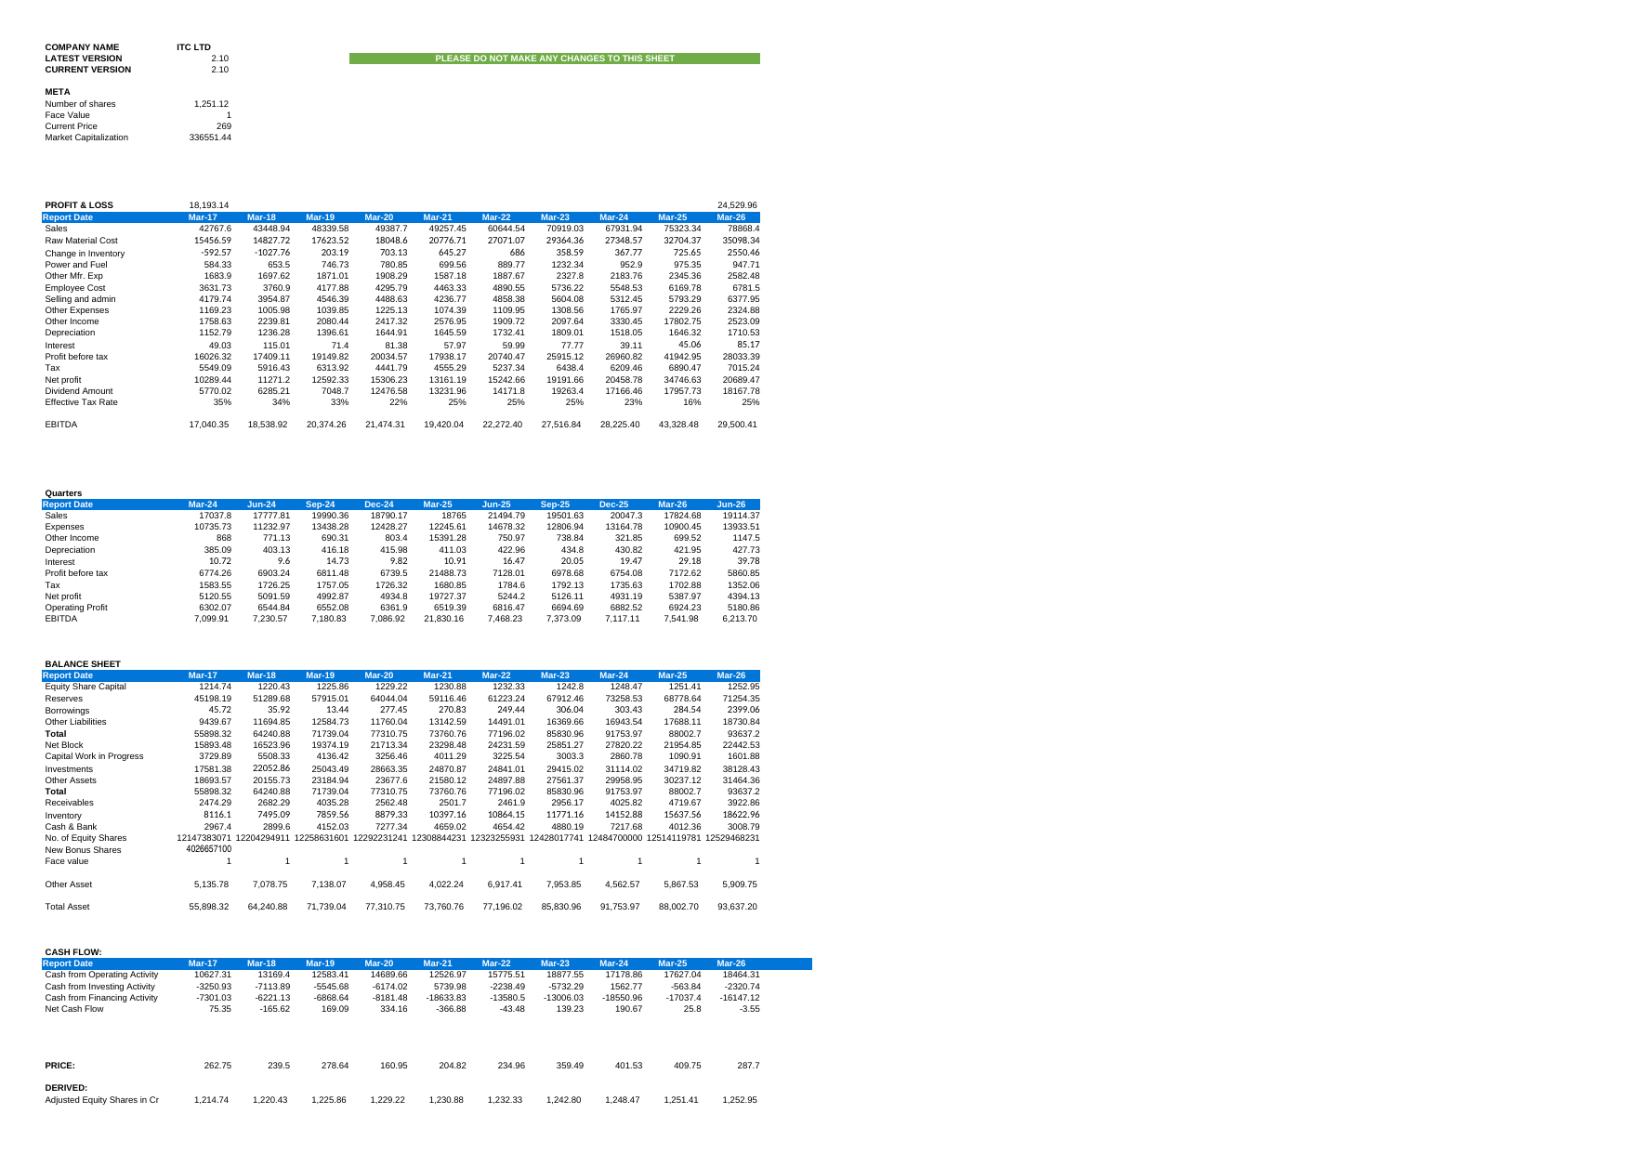
Raw source data feeding every other tab — annual and quarterly financials, share price.

