**QUERIES**

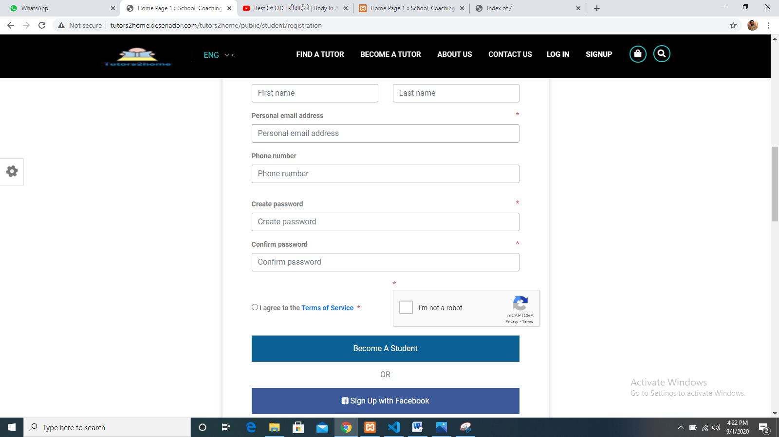

* After registration jump directly to the login page

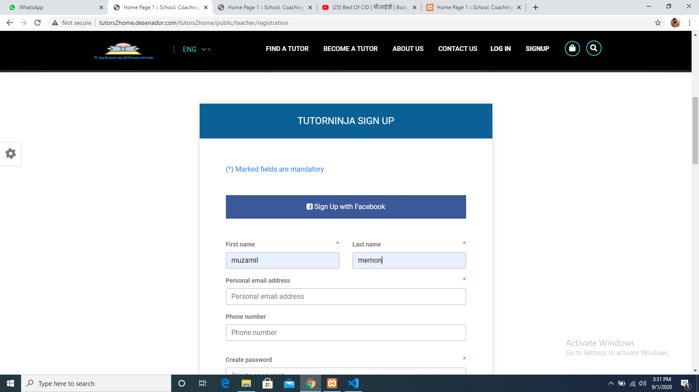

* Change tutorninja to tutor

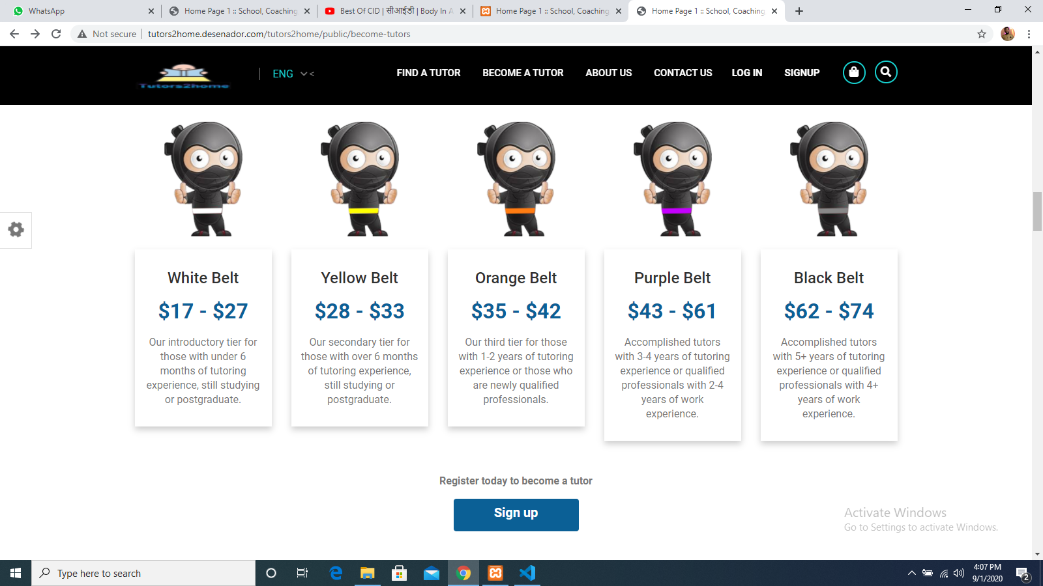

* Image size not equal

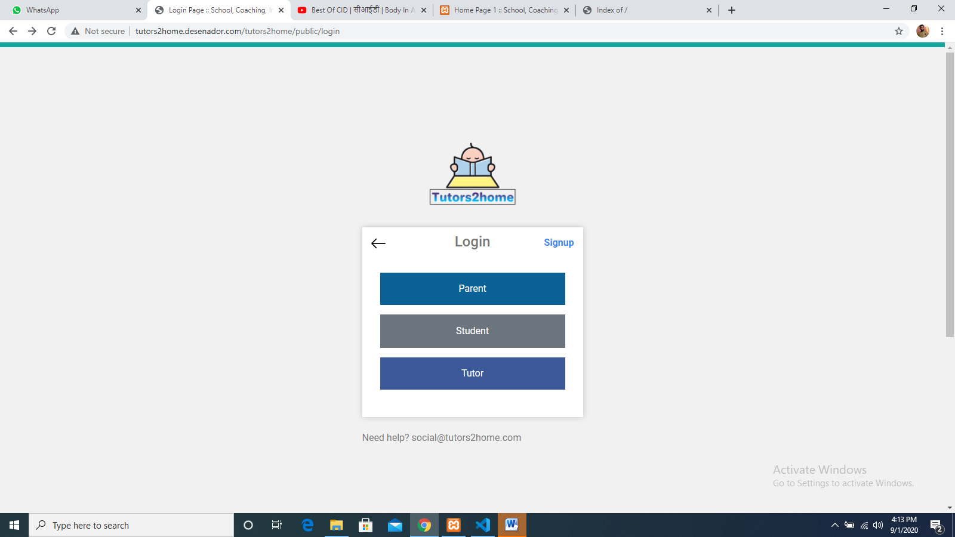

* Change the links in logo & arrow

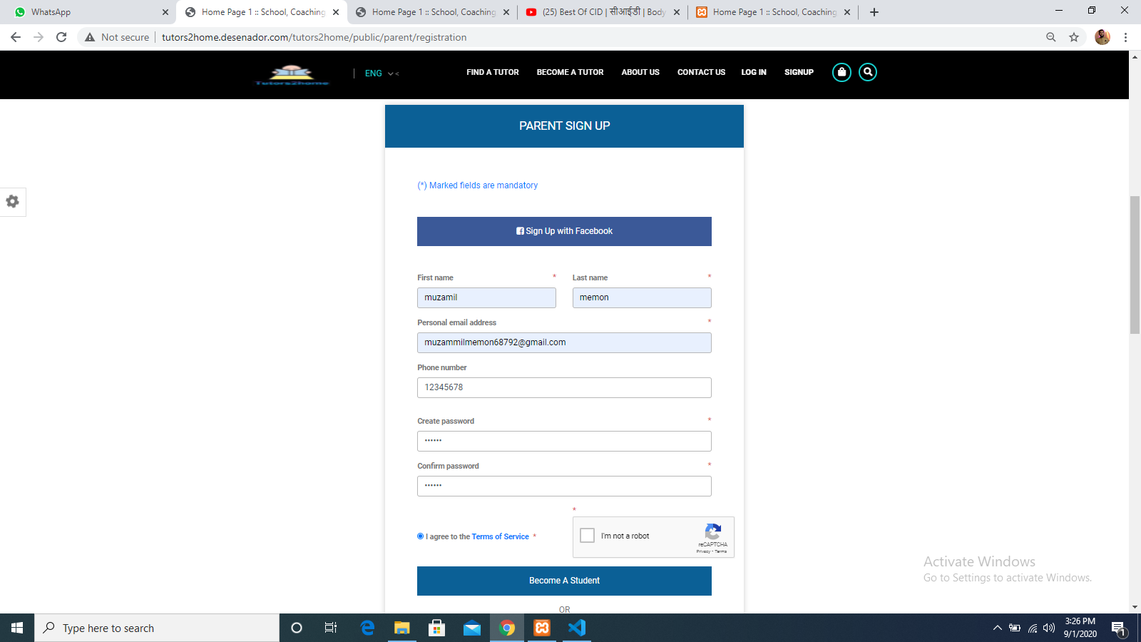

* Change become a student to parent

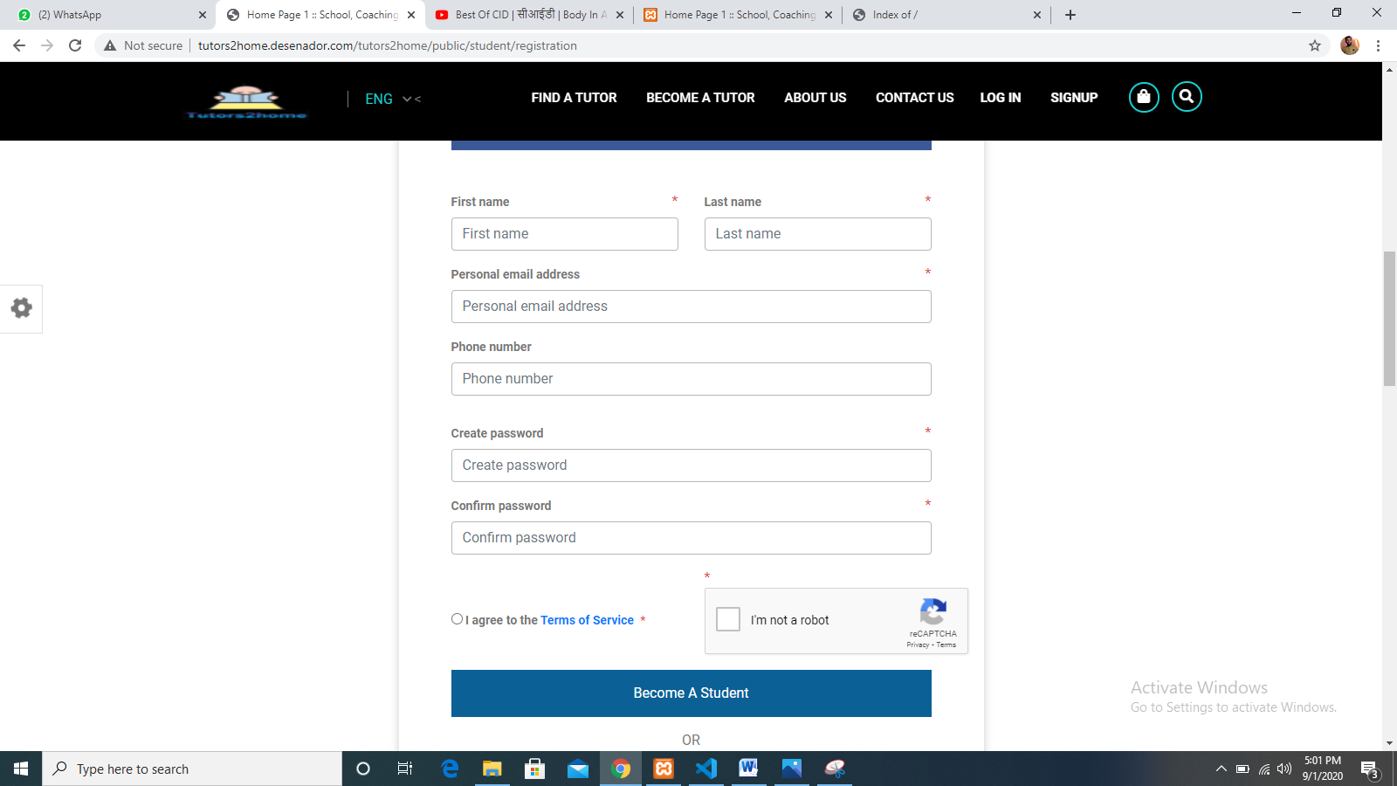

* add the following fields
  1. Gender
  2. Date of birth
  3. Upload image



* In become a tutor page , all signup buttons are not working