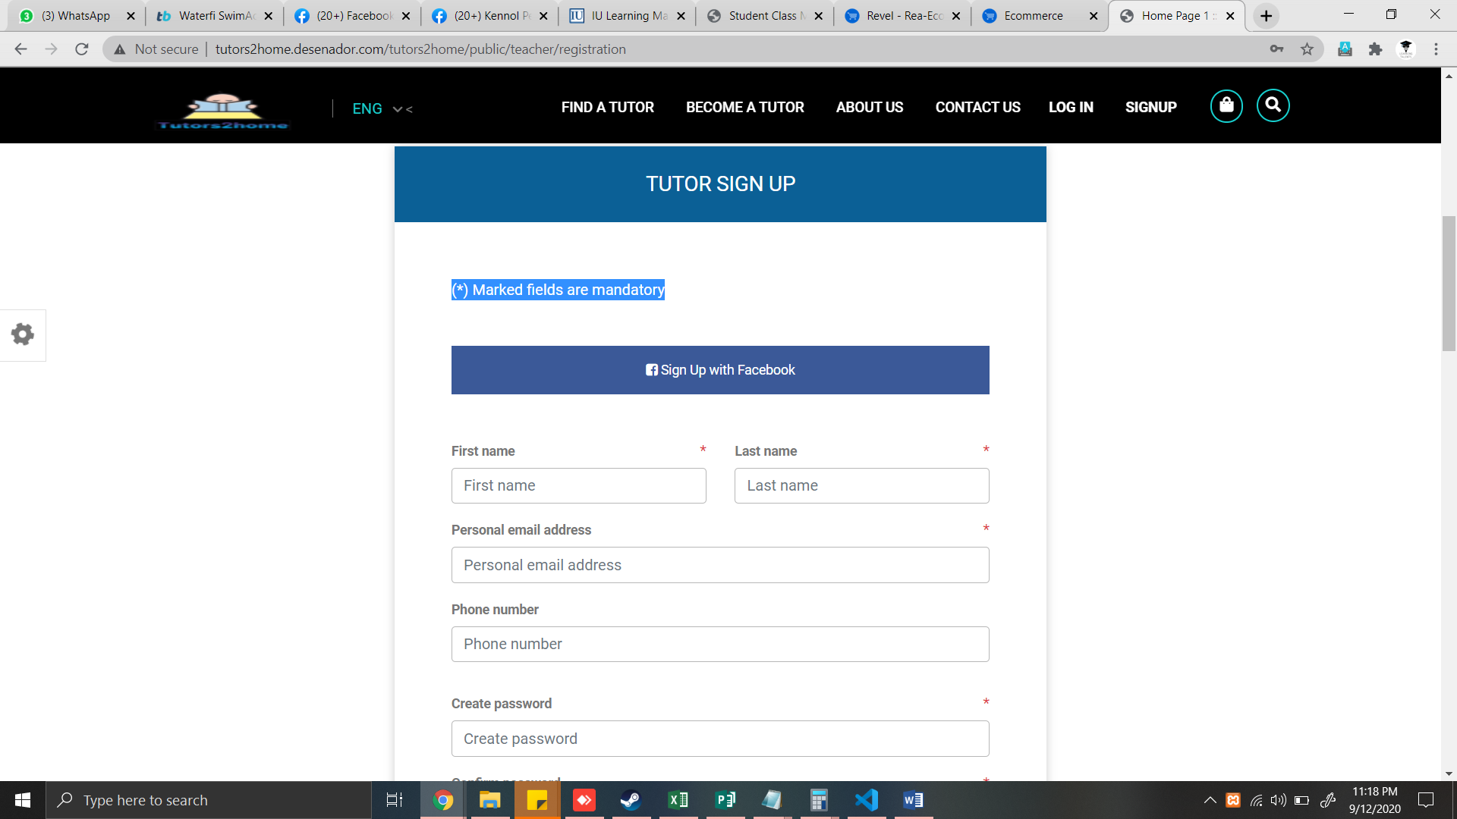

* Remove deadly spaces
* Remove facebook signup

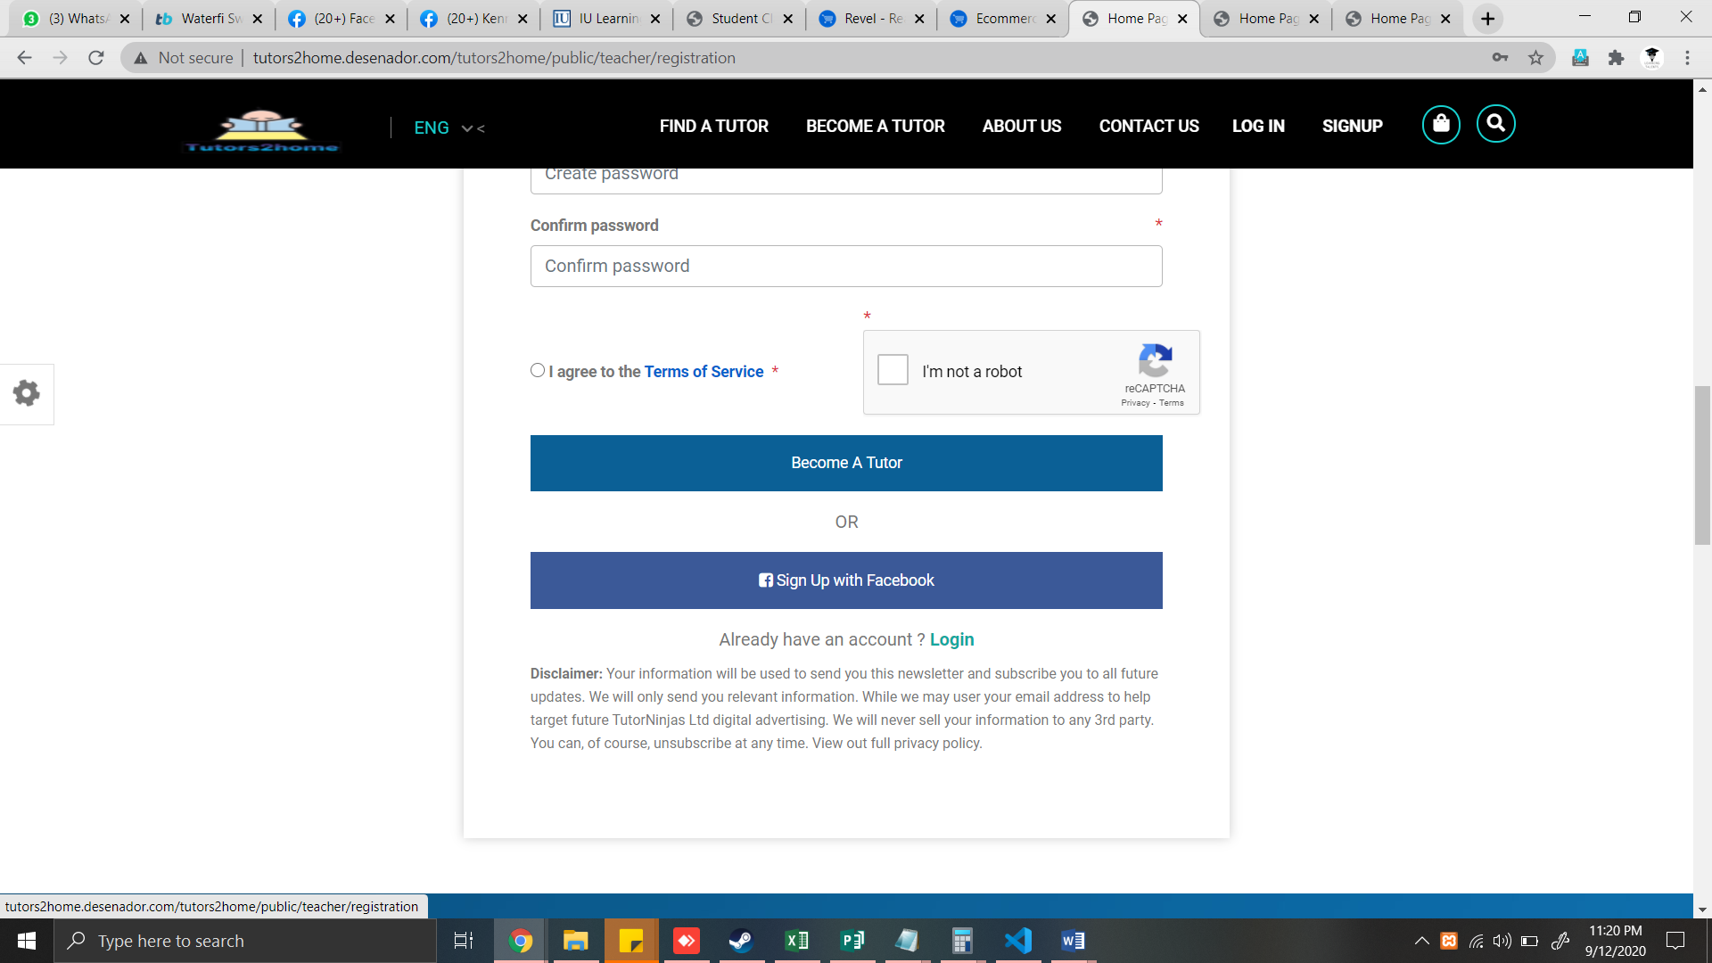

* Remove recaptcha
* Remove facebook button
* Create terms of services

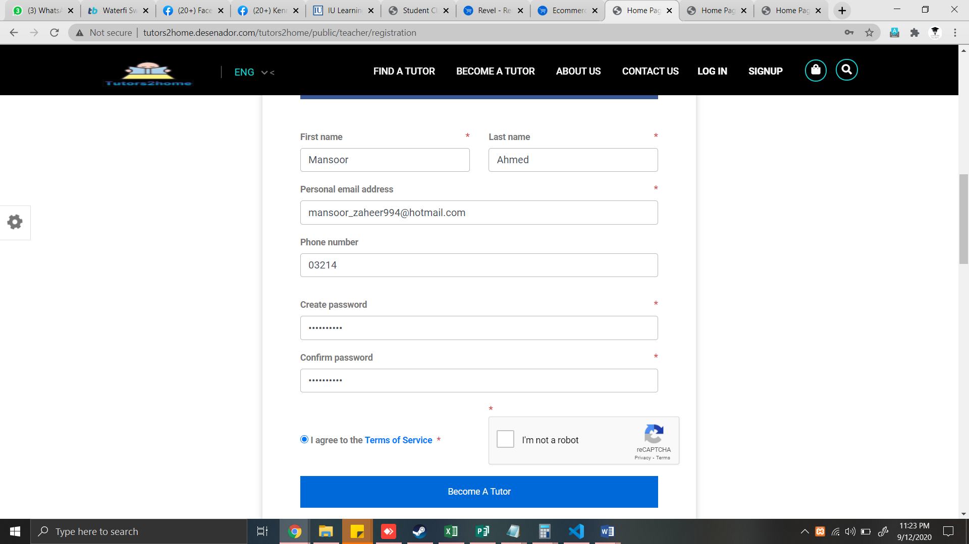

* After register tutor, it will redirect to tutor dashboard
* Check and Apply frontend validation with javascript and html
* If registeration error previouse filled values should be filled automatically

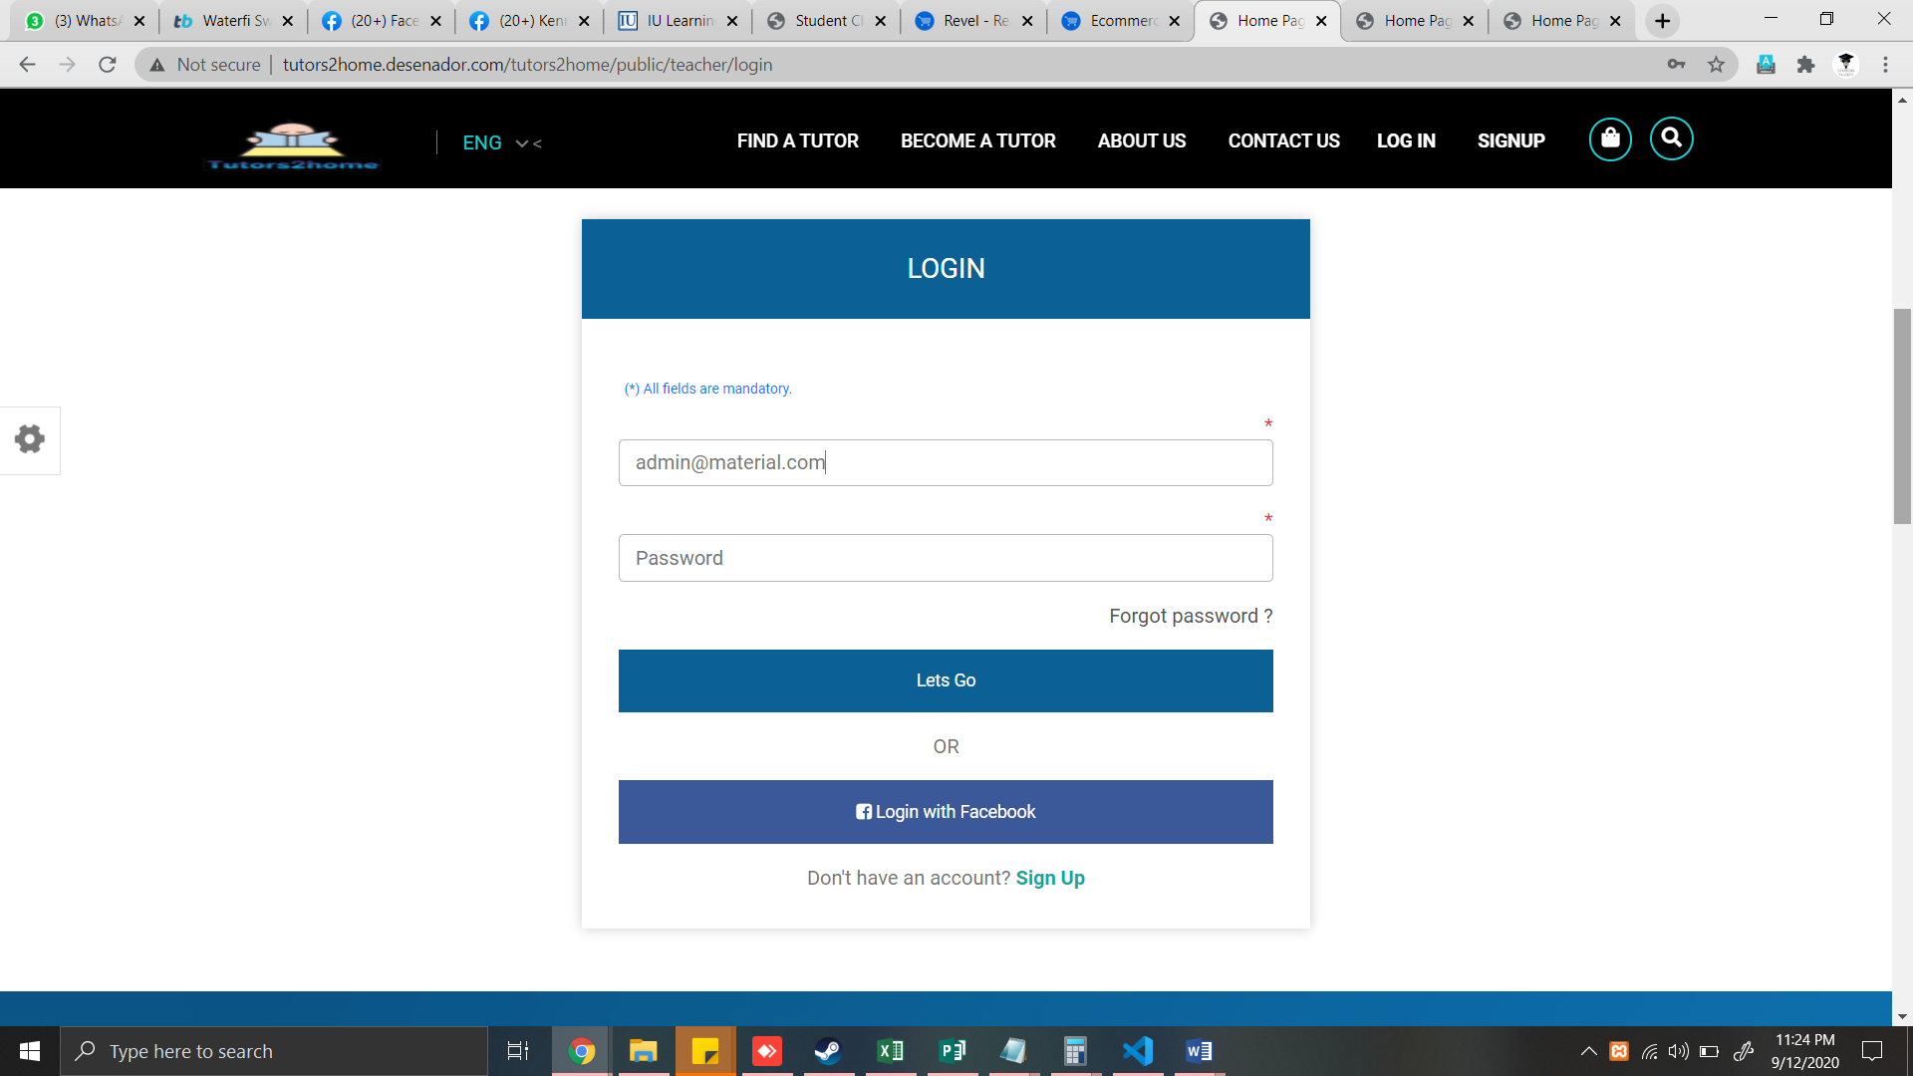

* Remove auto text from fields & apply placeholder
* Remove Facebook button
* Forgot password not working

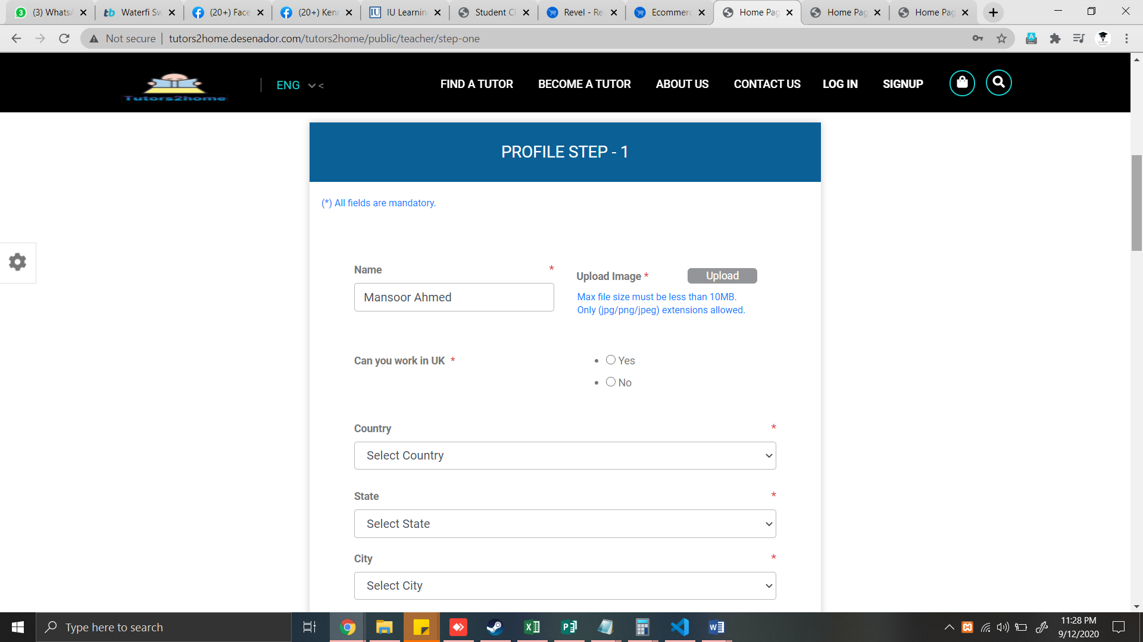

* Remove deadly space
* Align radio button horizontally

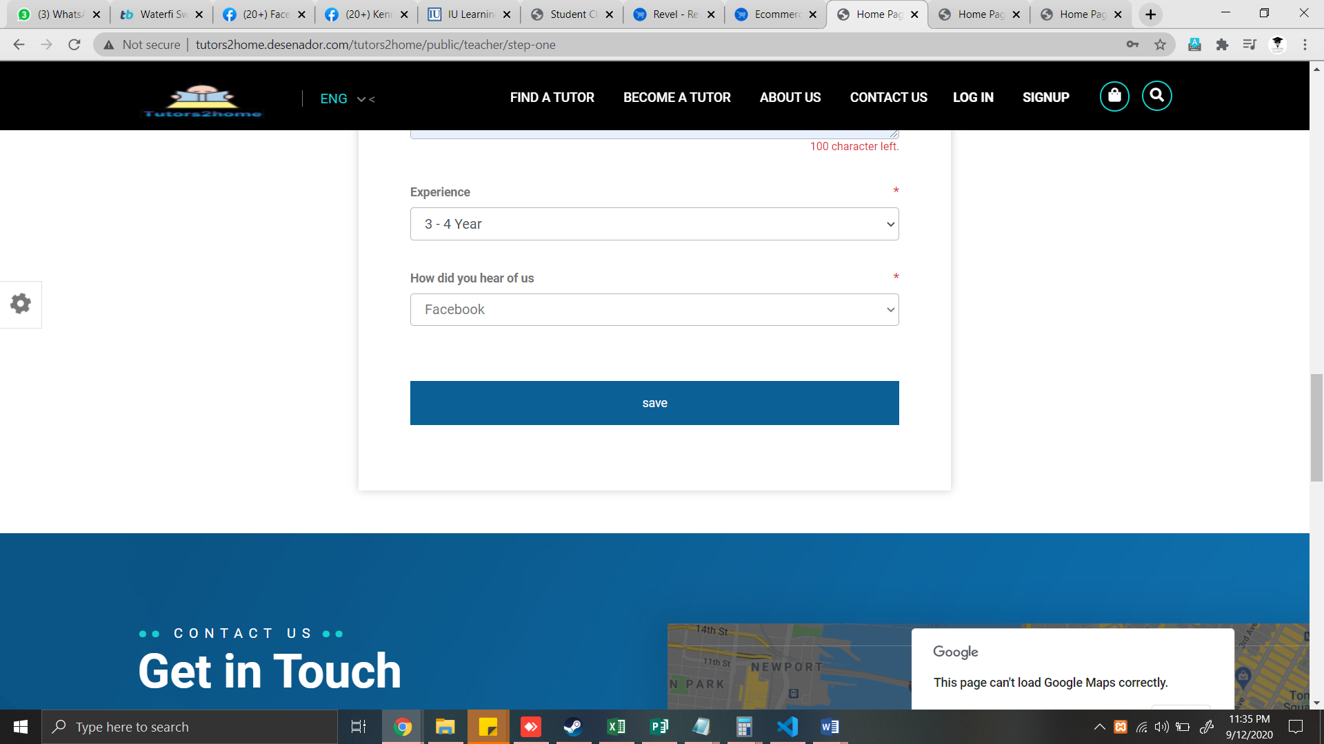

* Remove deadly space
* error previouse filled values should be filled automatically
* apply html and javascript validation

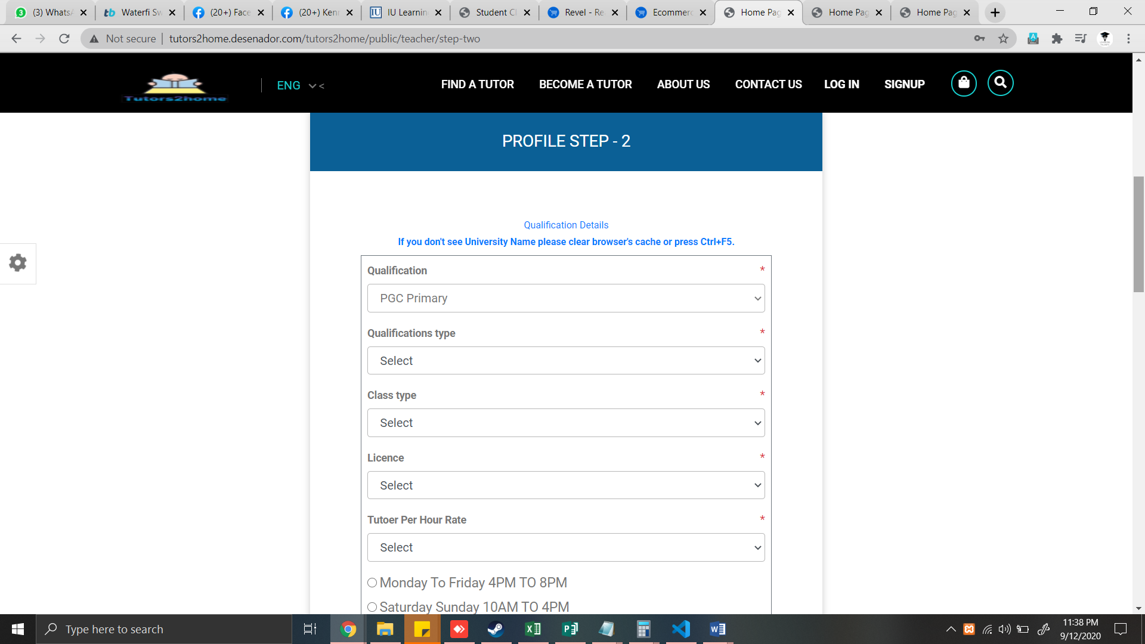

* remove deadly space

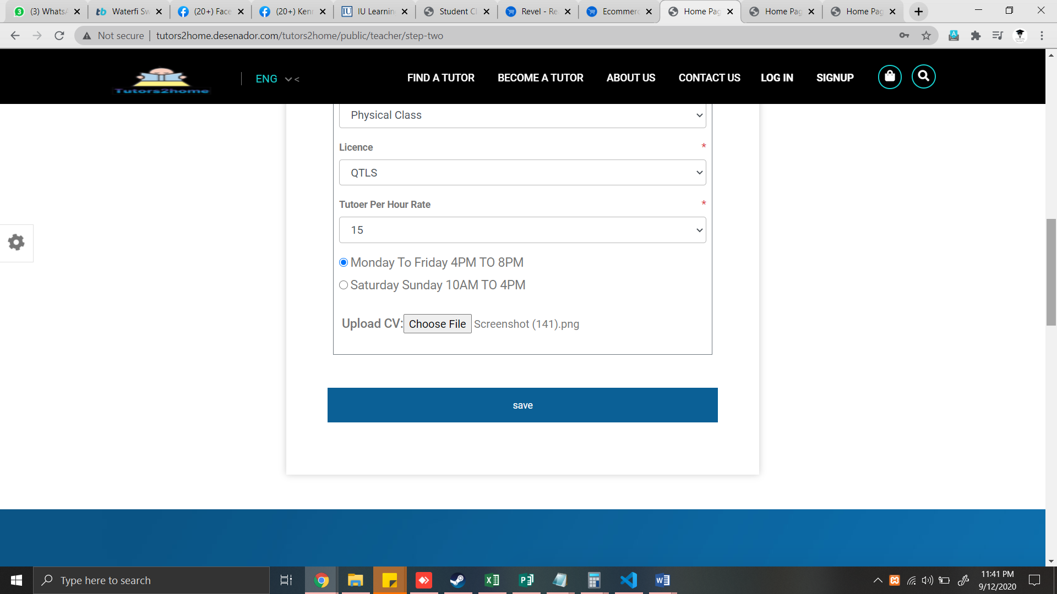

* please allow only .pdf and .docx format
* remove deadly space

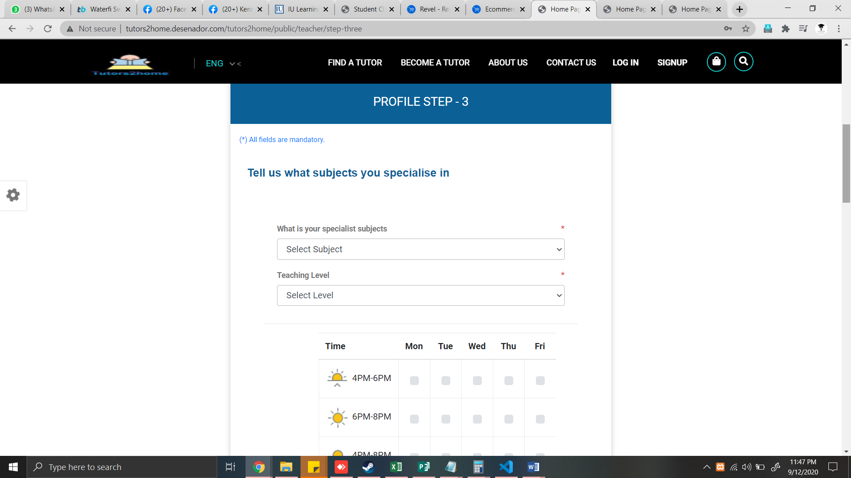

* remove deadly space
* make time table operational
* add multi subject experties

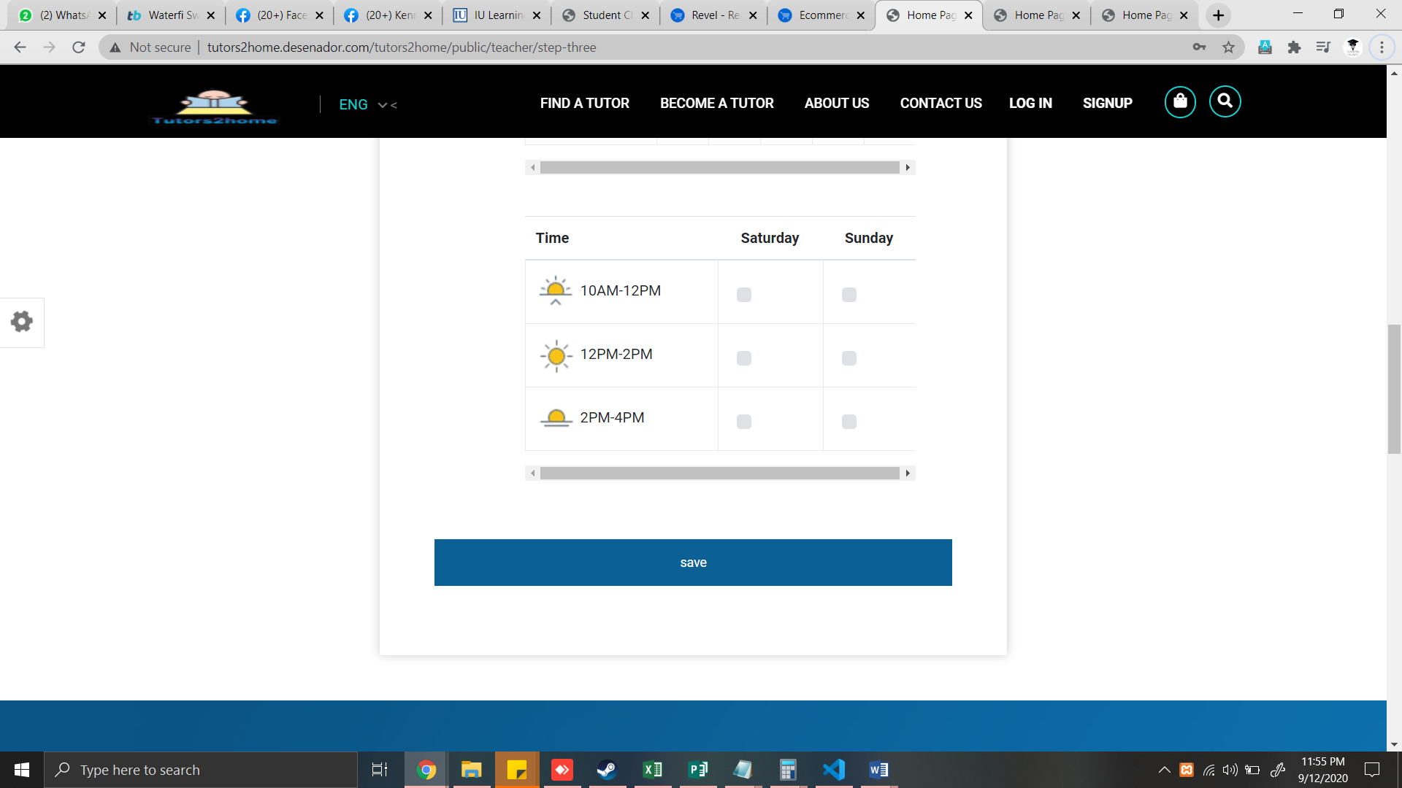

* make table operational
* remove deadly space

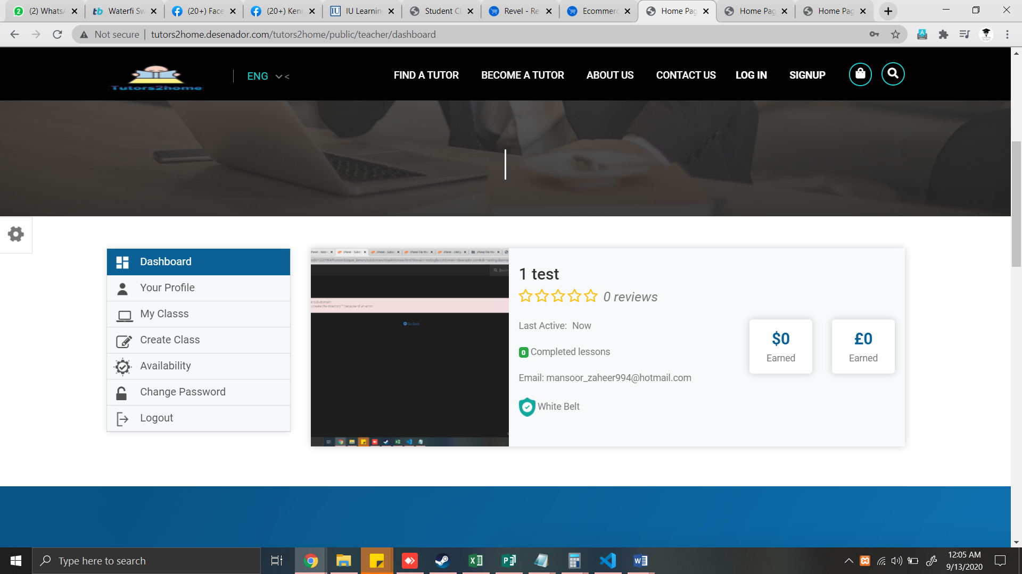

* remove white belt option
* remove completed lesson