**METAMORPHIC ROCKS**

Metamorphic rocks have been modified by heat, pressure, and chemical processes, usually while buried deep below Earth's surface. Exposure to these extreme conditions has altered the mineralogy, texture, and chemical composition of the rocks.Metamorphic rocks are created by the physical or chemical alteration by heat and pressure of an existing igneous or sedimentary material into a denser form. Due to the action of plate tectonics, compression, stress and shearing forces over long periods of time, rocks can be essentially warped and deformed, causing them to be compacted into a smaller volume of space. As a consequence, metamorphic rocks are always more dense than their original material, and also much less susceptible to erosional breakdown. As the Earth's plates move over geologic time, a plate containing igneous or sedimentary rock may become sub ducted under another plate. The sheer weight of the material above it can cause the rock to undergo metamorphism. In some cases, heat from the Earth's interior can melt the rock slightly, in a process termed "contact metamorphism." Examples of metamorphic rocks are schist (converted basalt), quartzite (compressed sandstone), and marble (compressed limestone or dolomite). Shown here is a sample of gneiss, the product of metamorphosed granite.

**Formation of Metamorphic Rocks:**

Mud and clay quietly settle on the ocean floor. As more mud and clay settle on top of it, the weight of the sediments “squeezes” the water from the mud and clay on the bottom. It becomes cemented together by chemical interactions and it becomes a sedimentary rock called shale.The shale is put under moderate pressure and low temperature due to burial or plate movements. The new pressure and temperatures changed the chemical makeup of the shale into the metamorphic rock called slate.

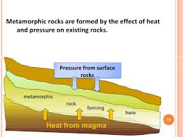

**Minerals of metamorphic rocks:**

* **Mica Schist -** This rock is highly metamorphosed shale. All schists exhibit shistose structure; the generally parallel alignment of micaceous minerals.
* **Slate -** The low-grade metamorphism of shale results in slate.
* **Quartzite -** The "parent rock" of quartzite is quartz sandstone.
* **Gneiss -** All gneisses exhibit gneissic structure that is, alternating layers of granular minerals and micaceous minerals.
* **Garnet Schist -** Shale that undergoes complete recrystallization due to metamorphism often contains high-pressure minerals such as garnet or andalusite.
* **Marble -** This rock results when lime stones or certain dolomites are metamorphosed**.**

**Foliation:**

Foliation is defined as a pervasive planar structure that results from the nearly parallel alignment of sheet silicate minerals and/or compositional and mineralogical layering in the rock. Most foliation is caused by the preferred orientation of phylosilicates, like clay minerals, micas, and chlorite. Preferred orientation develops as a result of non-hydrostatic or differential stress acting on the rock (also called deviatoric stress). We here review the differences between hydrostatic and differential stress.

There are two basic types of metamorphic rocks:

1) foliated metamorphic rocks such as gneiss, phyllite, schist and slate which have a layered or banded appearance that is produced by exposure to heat and directed pressure; and,

2) non-foliated metamorphic rocks such as marble and quartzite which do not have a layered or banded appearance. Pictures and brief descriptions of some common types of metamorphic rocks are provided below.

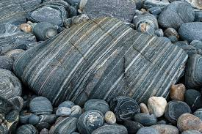

**TYPES OF METAMORPHIC ROCKS:**

* **Amphibolite**: Amphibolite is a non-foliated metamorphic rock that forms through recrystallization under conditions of high viscosity and directed pressure. It is composed primarily of amphibole and plagioclase, usually with very little quartz.

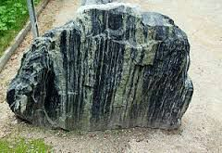

* **Gneiss**: Gneiss is foliated metamorphic rock that has a banded appearance and is made up of granular mineral grains. It typically contains abundant quartz or feldspar minerals.

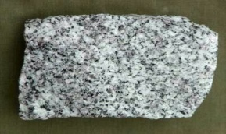

* **Hornfels**: Hornfels is a fine-grained nonfoliated metamorphic rock with no specific composition. It is produced by contact metamorphism. Hornfels is a rock that was "baked" while near a heat source such as a magma chamber, sill or dike.

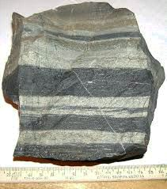

* **Marble**: Marble is a non-foliated metamorphic rock that is produced from the metamorphism of limestone. It is composed primarily of calcium carbonate.

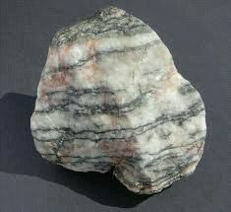

* **Phyllite**: Phyllite is a foliate metamorphic rock that is made up mainly of very fine-grained mica. The surface of phyllite is typically lustrous and sometimes wrinkled. It is intermediate in grade between slate and schist.

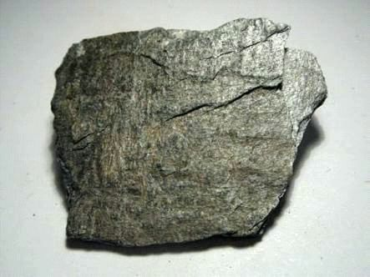

* **Quartzite**: Quartzite is a non-foliated metamorphic rock that is produced by the metamorphism of sandstone. It is composed primarily of quartz.

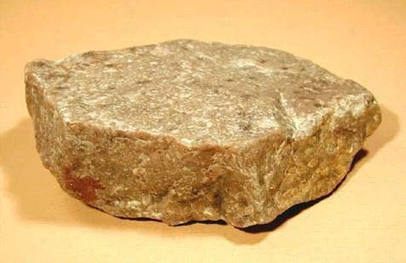

* **Schist:**

1. **(Chlorite Schist)**: Schist is metamorphic rock with well-developed foliation. It often contains significant amounts of mica which allow the rock to split into thin pieces. It is a rock of intermediate metamorphic grade between phyllite and gneiss.
2. **(Garnet Schist)**: Schist is metamorphic rock with well-developed foliation. It often contains significant amounts of mica which allow the rock to split into thin pieces. It is a rock of intermediate metamorphic grade between phyllite and gneiss.
3. **(Muscovite Schist):** Schist is metamorphic rock with well-developed foliation. It often contains significant amounts of mica which allow the rock to split into thin pieces. It is a rock of intermediate metamorphic grade between phyllite and gneiss.

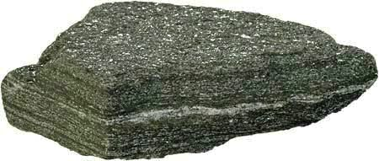

* **Slate**: Slate is a foliated metamorphic rock that is formed through the metamorphism of shale. It is a low grade metamorphic rock that splits into thin pieces.

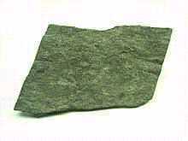



**METAMORPHISM**

Metamorphism is defined as follows: The mineralogical and structural adjustment of solid rocks to physical and chemical conditions that have been imposed at depths below the near surface zones of weathering and diagenesis and which differ from conditions under which the rocks in question originated.The word "Metamorphism" comes from the Greek: meta = change, morph = form, so metamorphism means to change form. In geology this refers to the changes in mineral assemblage and texture that result from subjecting a rock to conditions such pressures, temperatures, and chemical environments different from those under which the rock originally formed.Metamorphism, therefore occurs at temperatures and pressures higher than 200oC and 300 MPa. Rocks can be subjected to these higher temperatures and pressures as they are buried deeper in the Earth. Such burial usually takes place as a result of tectonic processes such as continental collisions or subduction.

**Grade of Metamorphism:**

As the temperature and/or pressure increases on a body of rock we say the rock undergoesprograde metamorphism or that the grade of metamorphism increases. Metamorphic grade is a general term for describing the relative temperature and pressure conditions under which metamorphic rocks form.

* Low-grade metamorphism takes place at temperatures between about 200 to 320oC, and relatively low pressure. Low grade metamorphic rocks are generally characterized by an abundance of hydrous minerals. With increasing grade of metamorphism, the hydrous minerals begin to react with other minerals and/or break down to less hydrous minerals.
* High-grade metamorphism takes place at temperatures greater than 320oC and relatively high pressure. As grade of metamorphism increases, hydrous minerals become less hydrous, by losing H2O, and non-hydrous minerals become more common.

**Types of Metamorphism:**

* Contact Metamorphism

Contact metamorphism occurs adjacent to igneous intrusions and results from high temperatures associated with the igneous intrusion. Since only a small area surrounding the intrusion is heated by the magma, metamorphism is restricted to the zone surrounding the intrusion, called ametamorphic or contact aureole. Outside of the contact aureole, the rocks are not affected by the intrusive event. The grade of metamorphism increases in all directions toward the intrusion. Because the temperature contrast between the surrounding rock and the intruded magma is larger at shallow levels in the crust where pressure is low, contact metamorphism is often referred to as high temperature, low pressure metamorphism. The rock produced is often a fine-grained rock that shows no foliation, called ahornfels.

* Regional Metamorphism

Regional metamorphism occurs over large areas and generally does not show any relationship to igneous bodies. Most regional metamorphism is accompanied by deformation under non-hydrostatic or differential stress conditions. Thus, regional metamorphism usually results in forming metamorphic rocks that are strongly foliated, such as slates, schists, and gniesses. The differential stress usually results from tectonic forces that produce compressional stresses in the rocks, such as when two continental masses collide. Thus, regionally metamorphosed rocks occur in the cores of fold/thrust mountain belts or in eroded mountain ranges. Compressive stresses result in folding of rock and thickening of the crust, which tends to push rocks to deeper levels where they are subjected to higher temperatures and pressures.

* Cataclastic Metamorphism

Cataclastic metamorphism occurs as a result of mechanical deformation, like when two bodies of rock slide past one another along a fault zone. Heat is generated by the friction of sliding along such a shear zone, and the rocks tend to be mechanically deformed, being crushed and pulverized, due to the shearing. Cataclastic metamorphism is not very common and is restricted to a narrow zone along which the shearing occurred.

* Hydrothermal Metamorphism

Rocks that are altered at high temperatures and moderate pressures by hydrothermal fluids are hydrothermally metamorphosed. This is common in basaltic rocks that generally lack hydrous minerals. The hydrothermal metamorphism results in alteration to such Mg-Fe rich hydrous minerals as talc, chlorite, serpentine, actinolite, tremolite, zeolites, and clay minerals. Rich ore deposits are often formed as a result of hydrothermal metamorphism.

* Burial Metamorphism

When sedimentary rocks are buried to depths of several hundred meters, temperatures greater than 300oC may develop in the absence of differential stress. New minerals grow, but the rock does not appear to be metamorphosed. The main minerals produced are often the Zeolites. Burial metamorphism overlaps, to some extent, with diagenesis, and grades into regional metamorphism as temperature and pressure increase.

* Impact Metamorphism

When an extraterrestrial body, such as a meteorite or comet impacts with the Earth or if there is a very large volcanic explosion, ultrahigh pressures can be generated in the impacted rock. These ultrahigh pressures can produce minerals that are only stable at very high pressure, such as the SiO2 polymorphs coesite and stishovite. In addition they can produce textures known as shock lamellae in mineral grains, and such textures as shatter cones in the impacted rock.

**Classification of Metamorphic Rocks**

Classification of metamorphic rocks is based on mineral assemblage, texture, protolith, and bulk chemical composition of the rock. Each of these will be discussed in turn, then we will summarize how metamorphic rocks are classified.

1. **Texture**

In metamorphic rocks individual minerals may or may not be bounded by crystal faces. Those that are bounded by their own crystal faces are termed idioblastic. Those that show none of their own crystal faces are termed xenoblastic. From examination of metamorphic rocks, it has been found that metamorphic minerals can be listed in a generalized sequence, known as thecrystalloblastic series, listing minerals in order of their tendency to be idioblastic. In the series, each mineral tends to develop idioblastic surfaces against any mineral that occurs lower in the series. This series is listed below:

rutile, sphene, magnetite tourmaline kyanite, staurolite, garnet, andalusite epidote, zoisite, lawsonite, forsterite pyroxenes, amphiboles, wollastonite micas, chlorites, talc, stilpnomelane, prehnite dolomite,calcite scapolite, cordierite, feldspars quartz

This series can, in a rather general way, enable us to determine the origin of a given rock. For example a rock that shows euhedral plagioclase crystals in contact with anhedral amphibole, likely had an igneous protolith, since a metamorphic rock with the same minerals would be expected to show euhedral amphibole in contact with anhedral plagioclase.

Another aspect of the crystalloblastic series is that minerals high on the list tend to formporphyroblasts (the metamorphic equivalent of phenocrysts), although K-feldspar (a mineral that occurs lower in the list) may also form porphyroblasts. Porphyroblasts are often riddled with inclusions of other minerals that were enveloped during growth of the porphyroblast. These are said to have a poikioblastic texture.

Most metamorphic textures involve foliation. Foliation is generally caused by a preferred orientation of sheet silicates. If a rock has a slatey cleavage as its foliation, it is termed a slate, if it has a phyllitic foliation, it is termed a phyllite, if it has a shistose foliation, it is termed aschist. A rock that shows a banded texture without a distinct foliation is termed a gneiss. All of these could be porphyroblastic (i.e. could contain porhyroblasts).

A rock that shows no foliation is called a hornfels if the grain size is small, and a granulite, if the grain size is large and individual minerals can be easily distinguished with a hand lens.

1. **Protolith**

Protolith refers to the original rock, prior to metamorphism. In low grade metamorphic rocks, original textures are often preserved allowing one to determine the likely protolith. As the grade of metamorphism increases, original textures are replaced with metamorphic textures and other clues, such as bulk chemical composition of the rock, are used to determine the protolith.

1. **Bulk Chemical Composition**

The mineral assemblage that develops in a metamorphic rock is dependent on the pressure and temperature reached during metamorphism.The composition of any fluid phase present during metamorphism, and the bulk chemical composition of the rock.

Just like in igneous rocks, minerals can only form if the necessary chemical constituents are present in the rock (i.e. the concept of silica saturation and alumina saturation applies to metamorphic rocks as well). Based on the mineral assemblage present in the rock one can often estimate the approximate bulk chemical composition of the rock. Some terms that describe this general bulk chemical composition are as follows:

* Pelitic. These rocks are derivatives of aluminous sedimentary rocks like shales and mudrocks. Because of their high concentrations of alumina they are recognized by an abundance of aluminous minerals, like clay minerals, micas, kyanite, sillimanite, andalusite, and garnet.
* Quartzo-Feldspathic. Rocks that originally contained mostly quartz and feldspar like granitic rocks and arkosic sandstones will also contain an abundance of quartz and feldspar as metamorphic rocks, since these minerals are stable over a wide range of temperature and pressure. Those that exhibit mostly quartz and feldspar with only minor amounts of aluminous minerals are termed quartzo-feldspathic. Phlogopite (Mg-rich biotite), chlorite, and tremolite. At even higher grades anhydrous minerals like diopside, forsterite, wollastonite, grossularite, and calcic plagioclase.
* Basic. Just like in igneous rocks, the general term basic refers to low silica content. Basic metamorphic rocks are generally derivatives of basic igneous rocks like basalts and gabbros. They have an abundance of Fe-Mg minerals like biotite, chlorite, and hornblende, as well as calcic minerals like plagioclase and epidote.
* Magnesian. Rocks that are rich in Mg with relatively less Fe, are termed magnesian. Such rocks would contain Mg-rich minerals like serpentine, brucite, talc, dolomite, and tremolite. In general, such rocks usually have an ultrabasic protolith, like peridotite, dunite, or pyroxenite.
* Ferriginous. Rocks that are rich in Fe with little Mg are termed ferriginous. Such rocks could be derivatives of Fe-rich cherts or ironstones. They are characterized by an abundance of Fe-rich minerals like greenalite (Fe-rich serpentine), minnesotaite (Fe-rich talc), ferroactinolite, ferrocummingtonite, hematite, and magnetite at low grades, and ferrosilite, fayalite, ferrohedenbergite, and almandine garnet at higher grades.
* Manganiferrous. Rocks that are characterized by the presence of Mn-rich minerals are termed manganiferrous. They are characterized by such minerals as Stilpnomelane and spessartine.

**Classification**

Classification of metamorphic rocks depends on what is visible in the rock and its degree of metamorphism. Note that classification is generally loose and practical such that names can be adapted to describe the rock in the most satisfactory way that conveys the important characteristics. Three kinds of criteria are normally employed. These are:

1. Mineralogical - The most distinguishing minerals are used as a prefix to a textural term. Thus, a schist containing biotite, garnet, quartz, and feldspar, would be called a biotite-garnet schist. A gneiss containing hornblende, pyroxene, quartz, and feldspar would be called a hornblende-pyroxene gneiss. A schist containing porphyroblasts of K-feldspar would be called a K-spar porphyroblastic schist.
2. Chemical - If the general chemical composition can be determined from the mineral assemblage, then a chemical name can be employed. For example a schist with a lot of quartz and feldspar and some garnet and muscovite would be called a garnet-muscovite quartzo-feldspathic schist. A schist consisting mostly of talc would be called a talc-magnesian schist.
3. Protolithic - If a rock has undergone only slight metamorphism such that its original texture can still be observed then the rock is given a name based on its original name, with the prefix meta- applied. For example: metabasalt, metagraywacke, meta-andesite, metagranite

**Stress and Preferred Orientation**

Pressure increases with depth of burial, thus, both pressure and temperature will vary with depth in the Earth. Pressure is defined as a force acting equally from all directions. It is a type of stress, called hydrostatic stress or uniform stress. If the stress is not equal from all directions, then the stress is called a differential stress. Normally geologists talk about stress as compressional stress. Thus, if a differential stress is acting on the rock, the direction along which the maximum principal stress acts is called s1, the minimum principal stress is calleds3, and the intermediate principal stress direction is called s2. Note that extensional stress would act along the direction of minimum principal stress.If differential stress is present during metamorphism, it can have a profound effect on the texture of the rock. Rounded grains can become flattened in the direction of maximum compressional stress.Minerals that crystallize or grow in the differential stress field may develop a preferred orientation. Sheet silicates and minerals that have an elongated habit will grow with their sheets or direction of elongation orientated perpendicular to the direction of maximum stress.

This is because growth of such minerals is easier along directions parallel to sheets, or along the direction of elongation and thus will grow along s3 or s2, perpendicular to s1.Since most phyllosilicates are aluminous minerals, aluminous (pelitic) rocks like shales, generally develop a foliation as the result of metamorphism in a differential stress field. Example - metamorphism of a shale (made up initially of clay minerals and quartz)Shales have fissility that is caused by the preferred orientation of clay minerals with their {001} planes orientated parallel to bedding. Metamorphic petrologists and structural geologists refer to the original bedding surface as SO.

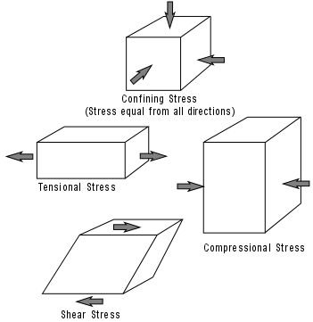

**Metamorphism and Deformation**

Most regionally metamorphosed rocks (at least those that eventually get exposed at the Earth's surface) are metamorphosed during deformational events. Since deformation involves the application of differential stress, the textures that develop in metamorphic rocks reflect the mode of deformation, and foliations or slatey cleavage that develop during metamorphism reflect the deformational mode and are part of the deformational structures.

The deformation involved in the formation of fold-thrust mountain belts generally involves compressional stresses. The result of compressional stress acting on rocks that behave in a ductile manner (ductile behavior is favored by higher temperature, higher confining stress [pressure] and low strain rates) is the folding of rocks. Original bedding is folded into a series of anticlines and synclines with fold axes perpendicular to the direction of maximum compressional stress. These folds can vary in their scale from centimeters to several kilometers between hinges. Note that since the axial planes are oriented perpendicular to the maximum compressional stress direction, slatey cleavage or foliation should also develop along these directions. Thus, slatey cleavage or foliation is often seen to be parallel to the axial planes of folds, and is sometimes referred to axial plane cleavage or foliation.

**Metamorphic Differentiation**

As discussed above, gneisses, and to some extent schists, show compositional banding or layering, usually evident as alternating somewhat discontinuous bands or layers of dark colored ferromagnesian minerals and lighter colored quartzo-feldspathic layers. The development of such compositional layering or banding is referred to as metamorphic differentiation. Throughout the history of metamorphic petrology, several mechanisms have been proposed to explain metamorphic differentiation.Preservation of Original Compositional Layering. In some rocks the compositional layering may not represent metamorphic differentiation at all, but instead could simply be the result of original bedding. For example, during the early stages of metamorphism and deformation of interbedded sandstones and shales the compositional layering could be preserved even if the maximum compressional stress direction were at an angle to the original bedding.In such a case, a foliation might develop in the shale layers due to the recrystallization of clay minerals or the crystallization of other sheet silicates with a preferred orientation controlled by the maximum stress direction.Here, it would be easy to determine that the compositional layers represented original bedding because the foliation would cut across the compositional layering.In highly deformed rocks that have undergone both folding and shearing, it may be more difficult to determine that the compositional layering represents original bedding. As shearing stretches the bedding, individual folded beds may be stretched out and broken to that the original folds are not easily seen.

Similarly, if the rock had been injected by dikes or sills prior to metamorphism, these contrasting compositional bands, not necessarily parallel to the original bedding, could be preserved in the metamorphic rock.

Transposition of Original Bedding. Original compositional layering a rock could also become transposed to a new orientation during metamorphism. The diagram below shows how this could occur. In the initial stages a new foliation begins to develop in the rock as a result of compressional stress at some angle to the original bedding. As the minerals that form this foliation grow, they begin to break up the original beds into small pods. As the pods are compressed and extended, partly by recrystallization, they could eventually intersect again to form new compositional bands parallel to the new foliation.

Solution and Re-precipitation. In fine grained metamorphic rocks small scale folds, called kink bands, often develop in the rock as the result of application of compressional stress. A new foliation begins to develop along the axial planes of the folds. Quartz and feldspar may dissolve as a result of pressure solution and be reprecipitated at the hinges of the folds where the pressure is lower. As the new foliation begins to align itself perpendicular to s1, the end result would be alternating bands of micas or sheet silicates and quartz or feldspar, with layering parallel to the new foliation.

**Preferential Nucleation.** Fluids present during metamorphism have the ability to dissolve minerals and transport ions from one place in the rock to another.

Thus felsic minerals could be dissolved from one part of the rock and preferentially nucleate and grow in another part of the rock to produce discontinuous layers of alternating mafic and felsic compositions.

**Migmatization.** As discussed previously, migmatites are small pods and lenses that occur in high grade metamorphic terranes that may represent melts of the surrounding metamorphic rocks. Injection of the these melts into pods and layers in the rock could also produce the discontinuous banding often seen in high grade metamorphic rocks. The process would be similar to that described in 4, above, except that it would involve partially melting the original rock to produce a felsic melt, which would then migrate and crystallize in pods and layers in the metamorphic rock. Further deformation of the rock could then stretch and fold such layers so that they may no longer by recognizable as migmatites.

**LOCATION OF METAMORPHIC ROCKS**

Metamorphic rocks are most often found in mountainous regions though they can be seen wherever there are signs of geological upheaval in an area. This type of rock is formed by the transformation of another rock type, a change that is usually triggered by tremendous heat, pressure or other violent phenomena. The forces that cause metamorphic rocks to form are so great that they change not only the appearance but also the chemical composition of an existing rock.Gems and precious stones are some examples of metamorphic rocks. These stones are found deep underground or inside mountains. Precious stones usually form from igneous rock that has been metamorphosed by the weight of the earth pressing down on it over time. These stones are relatively rare because the process of forming them takes so much time and because they can be difficult to find and access.Metamorphic rocks are also often found near the sites of living or extinct volcanoes. The heat caused by magma venting from the volcano can trigger chemical reactions that cause rocks to undergo metamorphosis. These types of metamorphic rocks are found at much shallower depths because the heat from the magma serves as a replacement for the heat generated by intense pressure.

**MECHANISM**

The changes in a rock that include metamorphism begin with digenesis (conversion of a loose sediment into a rock), pass through the mineral and textural changes of metamorphism, and end with the melting of the rock. Metamorphism is a two way street, however. Prograde metamorphism begins with cold, fluid (water) rich rocks and proceeds to hot and dry rocks. But, if the temperature and pressure decline then the rock undergoes retrograde metamorphism as the rocks and minerals adjust to the reduced temperature and pressure. Prograde and retrograde metamorphism are not balanced processes. Prograde metamorphism takes place faster, and produces more dramatic change because of the presence of water in the rocks (see explanation of The Difference Water Makes). Retrograde metamorphism, beginning with a dry rock, is slower, and does not produce as dramatic a change.And, of course, retrograde metamorphism can never take you back to the parent rock. Igneous and sedimentary rocks can only be produced by igneous and sedimentary processes.

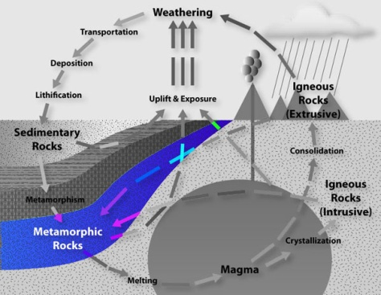

There are two main mechanisms of metamorphism,

* HEAT:

There are two sources of heat, one comes from the geothermal gradient - the increase in temperature that occurs with increase in depth in the earth. The average Geothermal Gradient is approximately 1 degree C for every 30 meters (~100 feet) of depth, although under local conditions it may vary from this ideal.The second source of heat is from intrusive bodies of magma, such as Batholiths. As these bodies cool they release heat to the surrounding country rock, leading to metamorphism.At the extreme end of metamorphism melting takes place. The melting temperature for a rock ranges from a low of 700-800 degrees C to as high at 1000 degrees C. The melting temperature is controlled by a number of things. For example, the composition of the parent rock. Take a Granite vs a Basalt parent rock, both being metamorphosed. Because a basalt crystallizes at a higher temperature than a granite (i.e. is higher in Bowen"S Reactions Series), it takes more temperature to melt a basalt.

But other factors are equally important in determining melting temperature. Pressure: the higher the pressure, i.e. the deeper the rock is, the more temperature it takes to melt it. Conversely, a very deep, hot rock brought to the surface quickly will melt very quickly because of the decrease in pressure. It is akin to what happens in a pressure cooker. The increasing pressure in the cooker causes the water to boil at a higher temperature, thus the food cooks more quickly, but if the pressure is suddenly released the water flashes to steam.

Fluids are also important in melting. The more fluids there are, typically water, but others as well, the easier it is for the rock to melt. Fluids allow the chemicals to move more quickly and easily, and the increased mobility makes for easier melting. Conversely, a dry rock is very hard to get to change. Without the fluids chemical changes are just harder to take place.

* PRESSURE:

There are two types of pressure involved in metamorphism: confining pressure and directed pressure. Confining pressure (also hydrostatic) is equal in all directions and comes

from the weight of the overlying rock - buial. It is analagous to the pressure you feel when diving deep in a swimming pool - it presses in on you equally on all surfaces. Directed pressure (stress) is not equal in all directions and is associated with mountain building processes when rock is squeezed, crumpled, and stretched as one continent slides over the edge of another. Pressure not only influences the rate and degree of metamorphism, with deeply buried rocks requiring more time and heat to undergo a particular metamorphic processs, pressure also causes textural changes in the rock (more later) - how large the crystals are and their orientations - that are so distinctive of metamorphic rocks.

The sum total of metamorphic processes, then, are:

1. New mineral compositions, some typical of igneous rocks and some unique to metamorphic rocks.

2. New textures unique to metamorphic rocks.

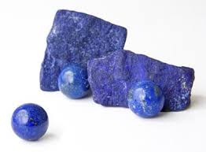

**REFERENCES**

* Playstore.com
* Study.com
* The changing earth by Monroe
* www.geology.com